|  |
| --- |
| Tehnical university of cluj-napoca |
| BANK MANAGEMENT SYSTEM-WEB APPLICATION |
| *-READ ME FILE-* |
|  |
| **Andreea Onaciu** |
| **4/15/2017** |

|  |
| --- |
|  |

Contents

*1. Prerequisites…………………………………………………………………………2*

*2. Installation Process…………………………………………………………………3*

*3. How to use the application*

*3.1 Administrator*

*3.1.1 Login…………………….……………………………………………….3*

*3.1.2 Log out…………………………………………………………………...4*

*3.1.3 Add employee…………………………………………………………. 5*

*3.1.4 Delete employee………………………………………………………..6*

*3.1.5 Update employee………………………………………………………8*

*3.1.6 See employees…………………………………………………………9*

*3.1.7 See employee report………………………………………………….10*

*3.2 Employee*

*3.2.1 Login…………………………………………………………………….11*

*3.2.2 Log out………………………………………………………………….11*

*3.2.3 Add client………………………………………………………………11*

*3.2.4 Update client…………………………………………………………..12*

*3.2.5 View client……………………………………………………………..13*

*3.2.6 Add account…………………………………………………………...14*

*3.2.7 Update account information………………………………………….14*

*3.2.8 Delete account………………………………………………………...15*

*3.2.9 View account…………………………………………………………..15*

*3.2.10 Transfer money between accounts………………………………..16*

*3.2.11 Pay utilities bills………………………………………………………17*

1. Prerequisites

For using the application the following programs need to be available on your computer : Java Development Kit, MySql Workbench and Tomcat server.

* 1. Installing Java Development Kit

You can download the JDK from this link: <http://www.oracle.com/technetwork/java/javase/downloads/jdk8-downloads-2133151.html>

Select the appropriate version according to your operating system and click on “Accept licence agreement”.Then simply run the executable you downloaded and follow the installation steps.

* 1. Installing MySql Workbench

You can download MySql Workbench from this link:

<https://dev.mysql.com/downloads/workbench/>

Pay attention to select the version appropriate to you operating system and follow the installation steps described here:

<https://dev.mysql.com/doc/refman/5.7/en/installing.html>

After the finishing the installation process, open the workbench and add a new connection by clicking on the “+” button near MySql Connections give a new connection name of your choice and set the username: “root” and the password “bankAssignment”.

* 1. Installing TomCat Server

To install Tom Cat server first you have to install the JDK. For downloading the server you can access the following link:

<https://tomcat.apache.org/download-70.cgi>

Download the appropriate archive according to your operating system, after that unzip it and to be able to start the server you have to set the environment variables:

-right click MyComputer

->Properties ->Advanced system settings ->Advanced Menu -> Environement Variables->New-> Variable name: JAVA_HOME Variable value: here you have to enter the path of the jdk file that you installed in the step 1.1-> Ok.

To start the server enter in the bin folder of the archive and double click the startup.bat file. A terminal should appear showing that the server has started. To close the server double click on the shoutDown.bat file also found in the bin folder.

1. Installation process

* To actually start the application, first enter in the config folder of the tomcat server, open tomcat-users.xml file and copy the username and password.
* Start the server and access on your browser the address: <http://localhost:8080/> , a web page of the apache tomcat server should appear;
* Click on the Manager App button in the right part of the screen and an authentication window should appear asking for the username and password you copied from the tomcat-users.xml file, click log in.
* A tomcat application manager should appear, go to the deploy section and press Choose file, select the .war file of the application, which you can find in the target folder. Then click deploy.

1. How to use the application
   1. Administrator
      1. *How to: Login*

The login page is the first page of the application. For the administrator to login, he should enter his credentials in the login fields:

Username: admin

Password: administrator

Login page:

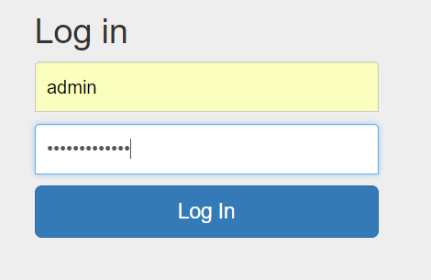

If the credentials are correctly introduced the following menu should appear:

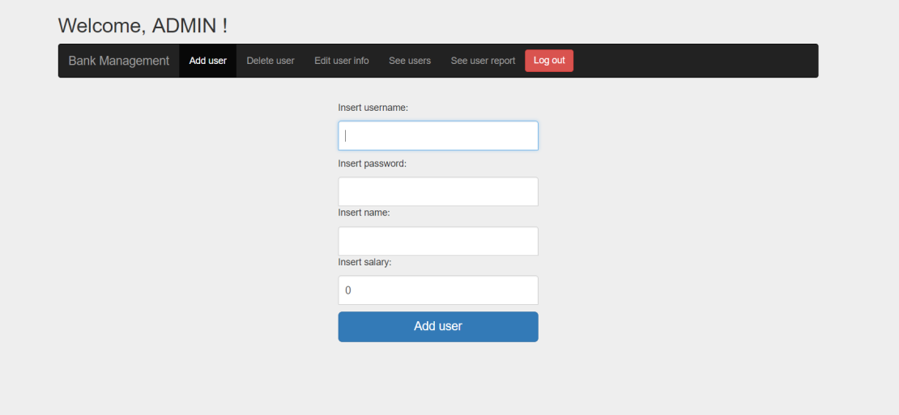

If the credentials are incorrectly introduced the following message will appear:

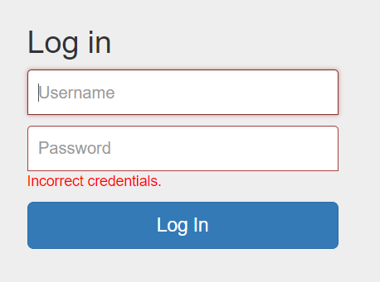

Try to introduce again the credentials, with more attention.

* + 1. *How to: Log out*

To log out from the application press the logout button in the right of the menu. It will bring you back to the login page.

* + 1. *How to: Add employee*

To add an employee press the “Add user” button from the menu. This form will appear:

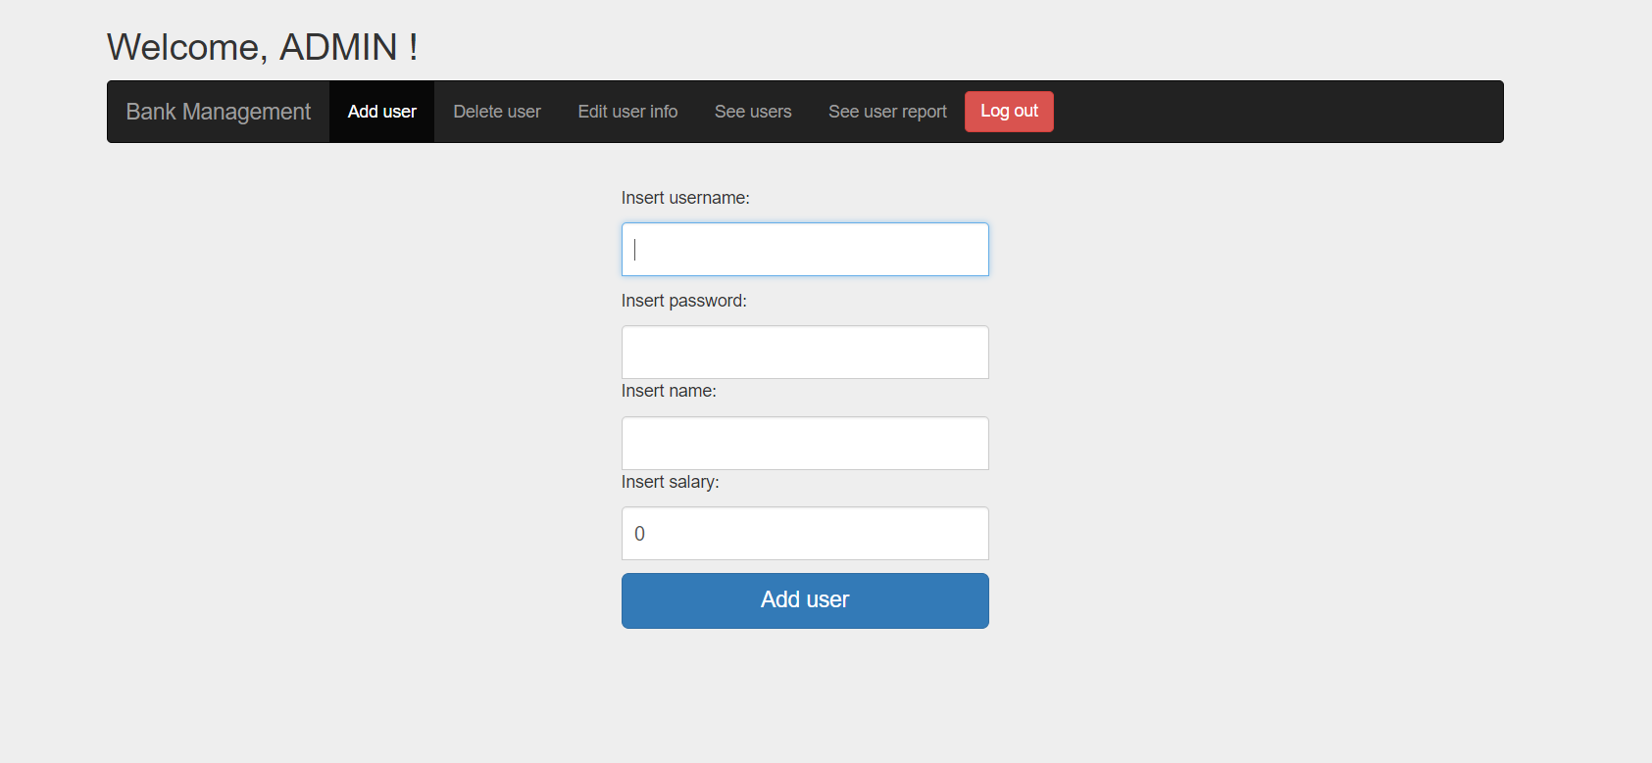

To add an employee all the fields must be completed respecting the following constraints:

-username length greater than 3;

-password length greater than 3;

-name length greater than 3 and unique;

-positive salary value;

If the employee is added successfully the following message will appear:

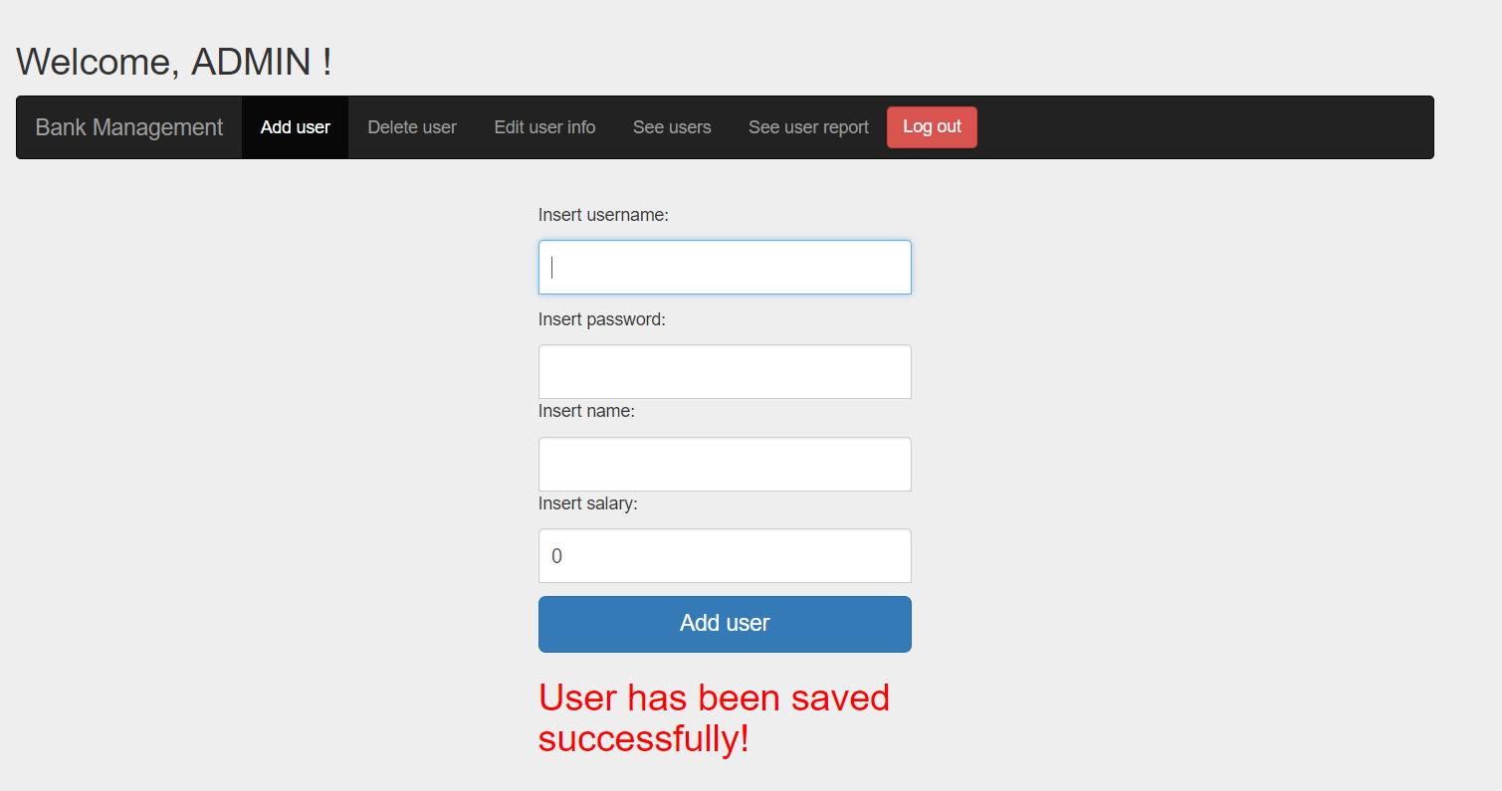

If the data you entered for the new employee is incorrect a message saying what you did wrong will appear:

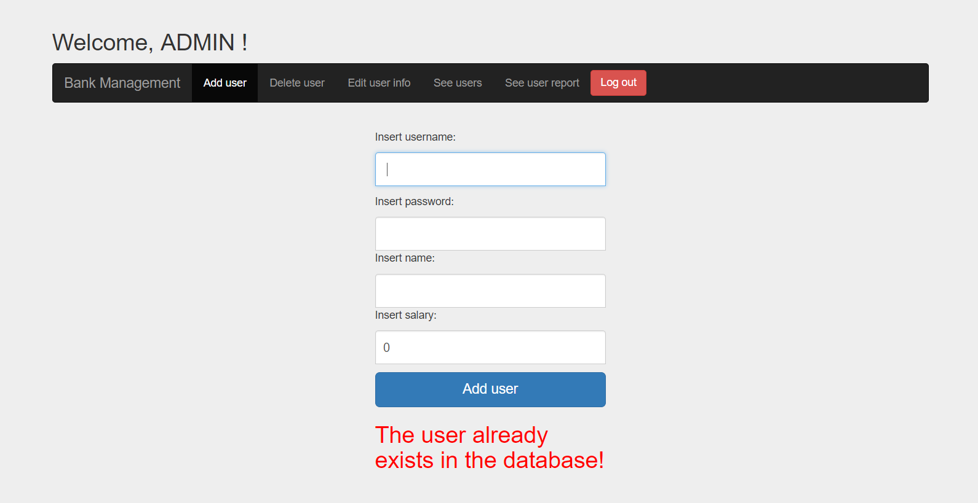

* + 1. *How to: Delete employee*

To delete an employee enter in the delete user menu:

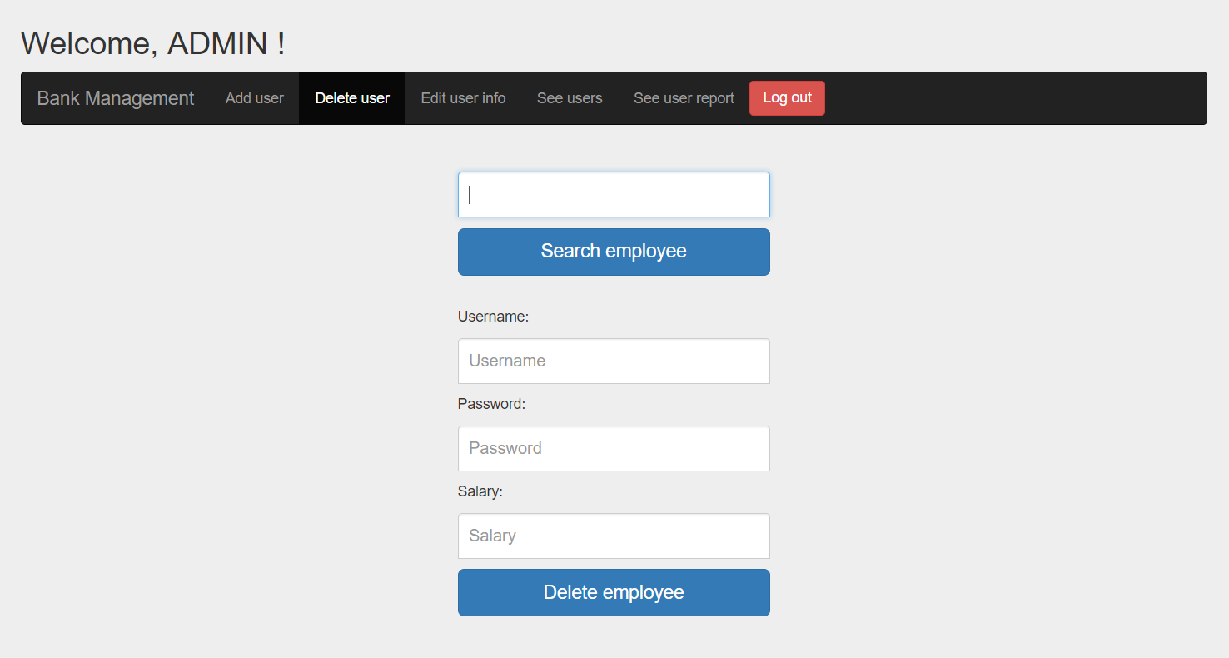

Enter the name of the employee you want to delete then press search. If the employee is in the database the information fields will be filled:

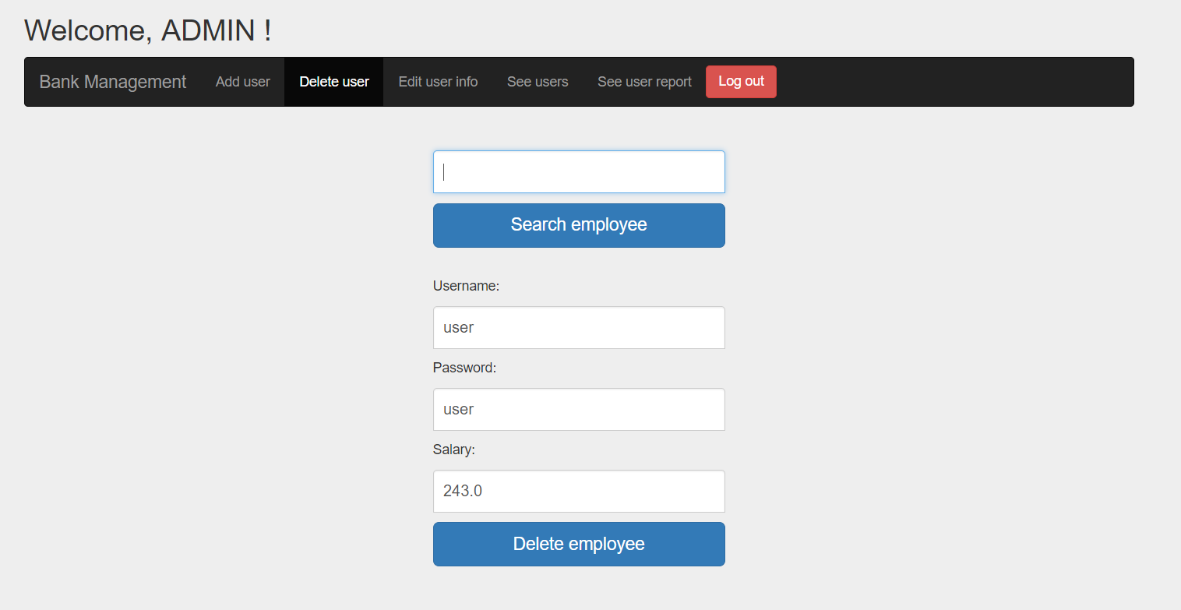

If there is no employee with this name the following message will appear:

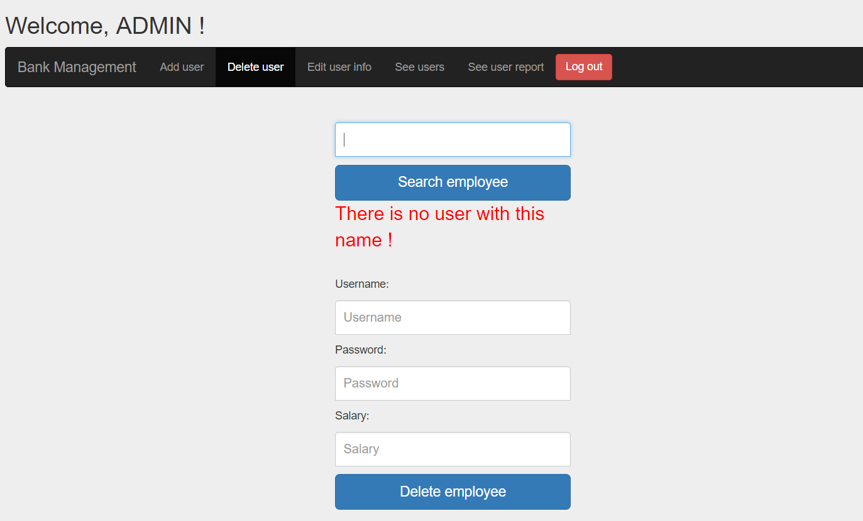

To delete the employee press the delete button, the following message will appear:

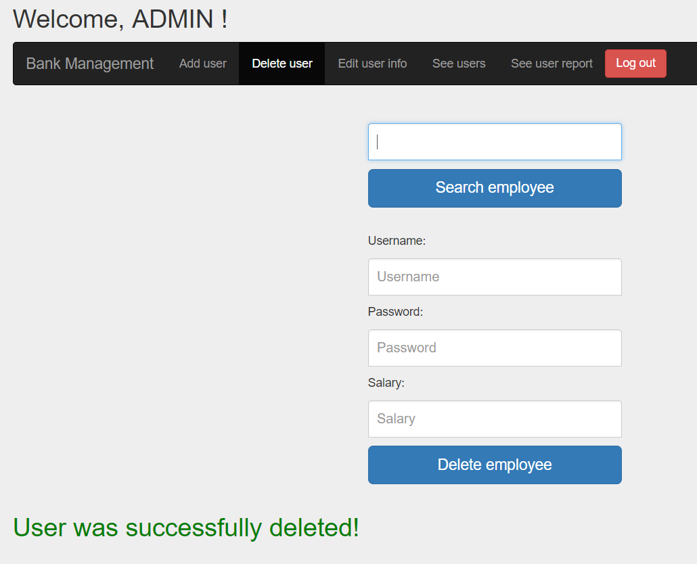

* + 1. *How to: Update employee*

To edit employee information enter the update employee menu.

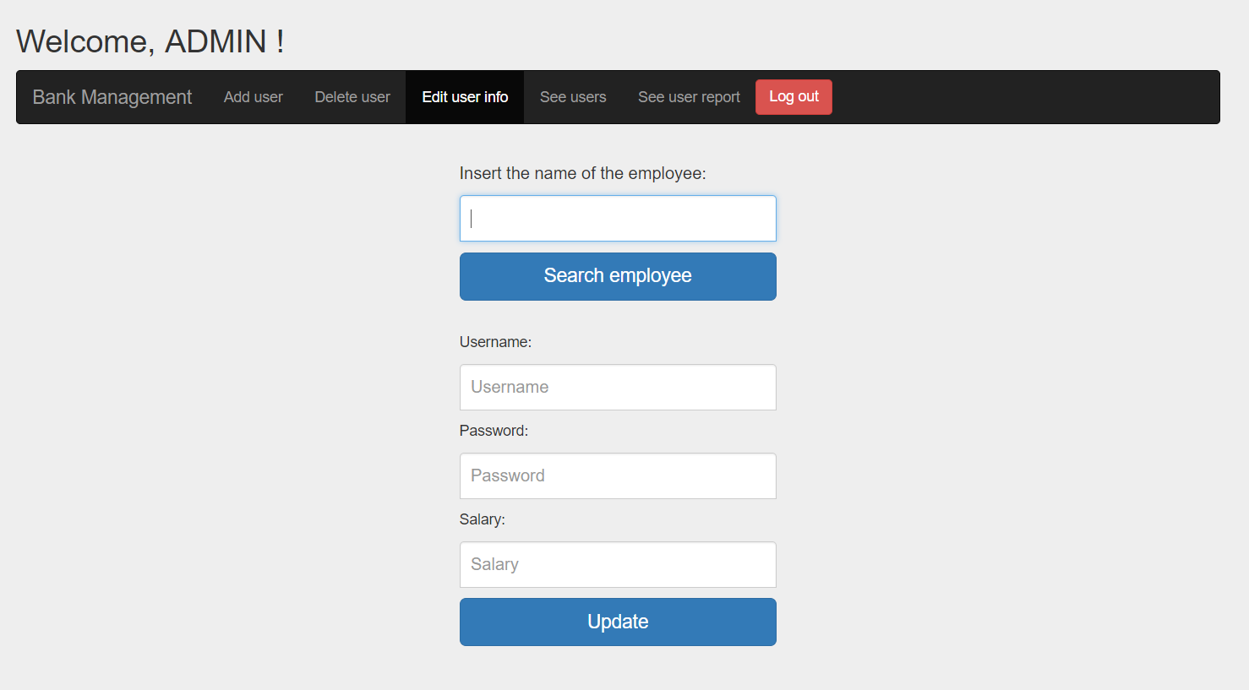

Search the employee by writing correctly its name in the first field and then press the search button. The fields should be filled with the employee information. If the name is not correctly an error message will be shown. You can update username, password and salary fields. Respecting the constraints mentioned at the Add employee use case (3.1.3). If updated was done correctly this message will appear:

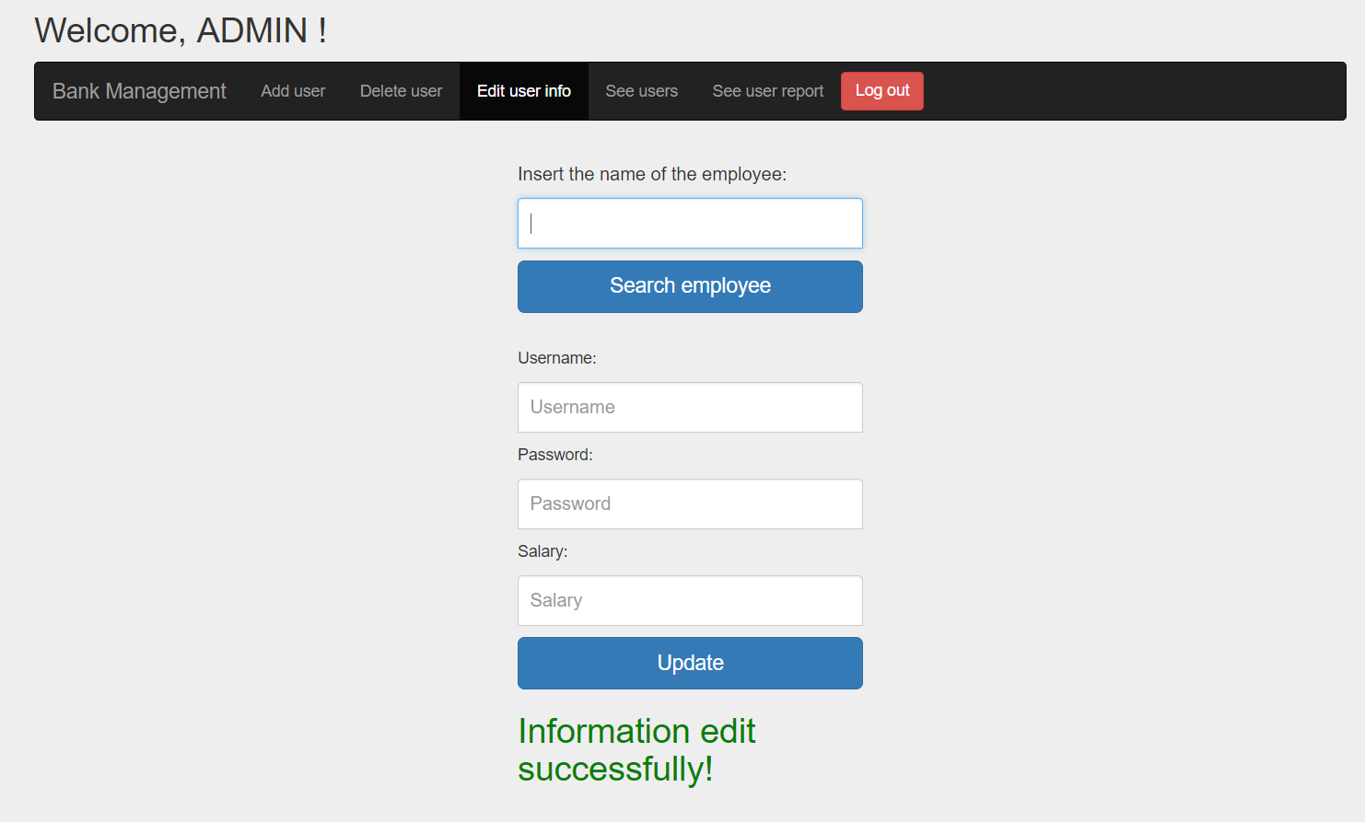

If incorrect information is placed:

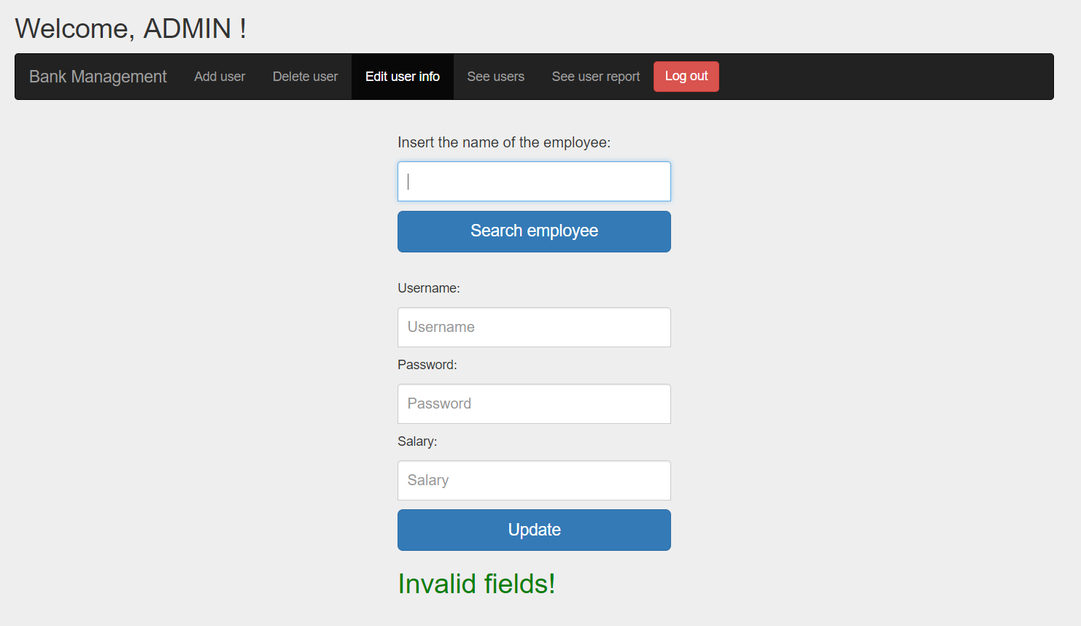

* + 1. *How to: See employees*

Too see all the employees enter in the “See users” menu:

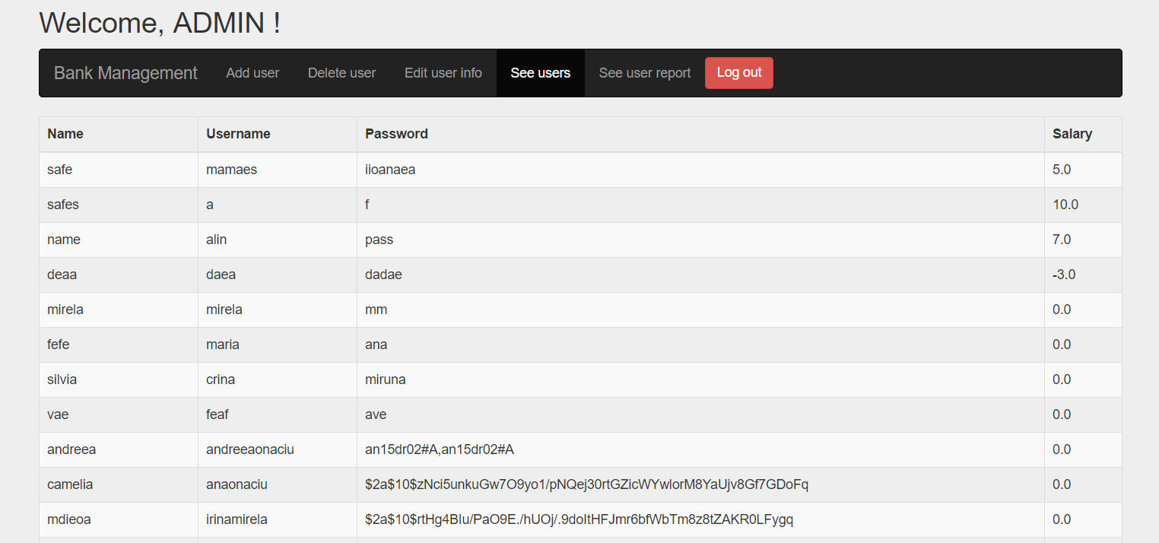

* + 1. *How to: See employee report*

To see employee report enter in the “See user report” menu.

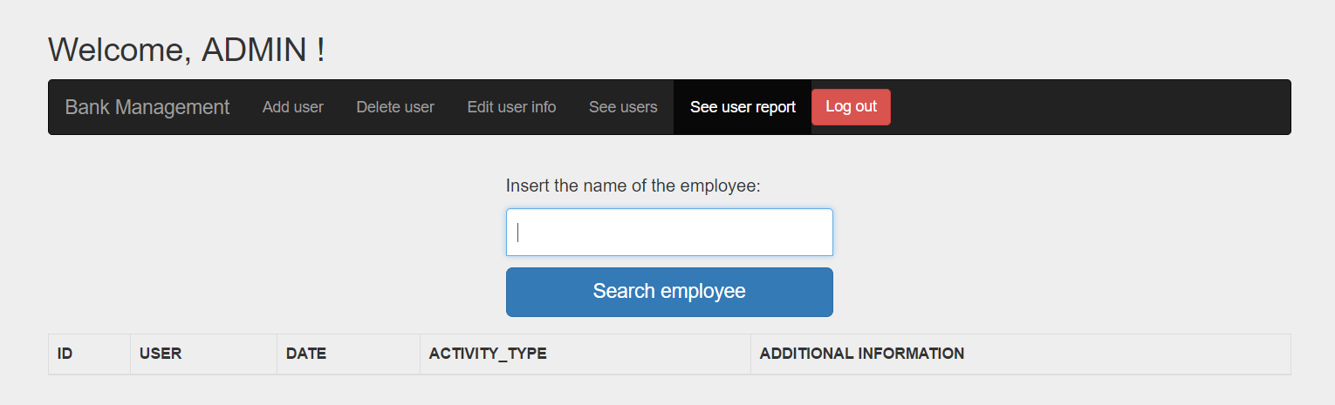

Enter the name of the employee and press search. If the name is correct, the following page will be displayed:

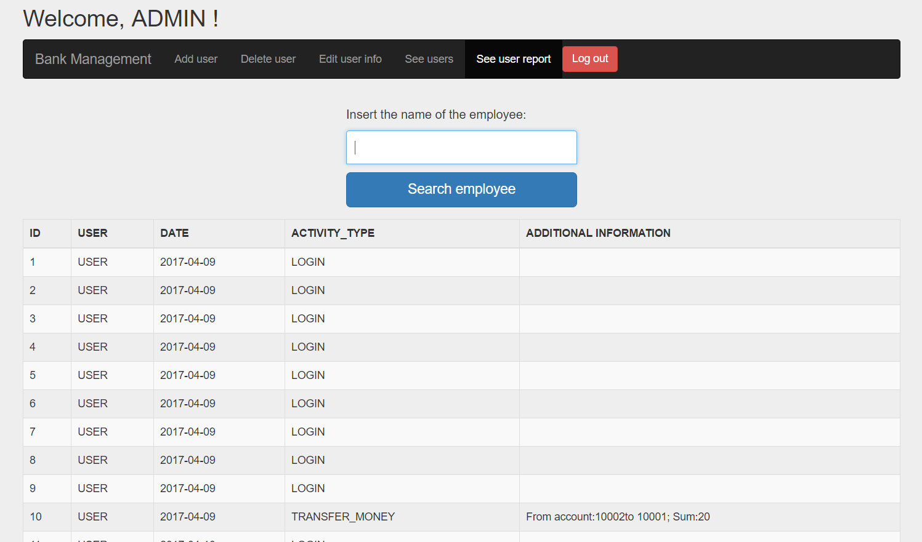

If the name is written incorrectly the following message will appear:

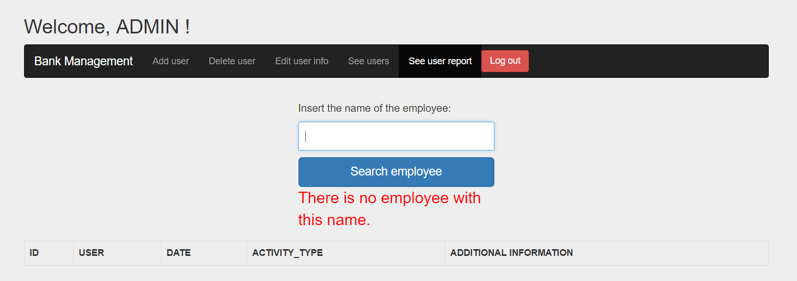

* 1. Employee
     1. *How to: Login*

The login credentials for an employee are its username and password provided by the administrator. Write the username and password in the fields:

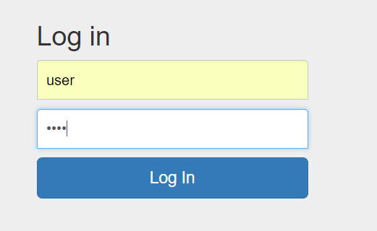

If the credentials are correct the following menu should appear:

If the login is made incorrectly the following message should appear:

Try again with more attention.

* + 1. *How to: Logout*

To log out from the application press the logout button in the right of the menu. It will bring you back to the login page.

All the client operations are found in the “Client operations” menu.

* + 1. *How to: Add client*

Select “add client” from the client operations menu.

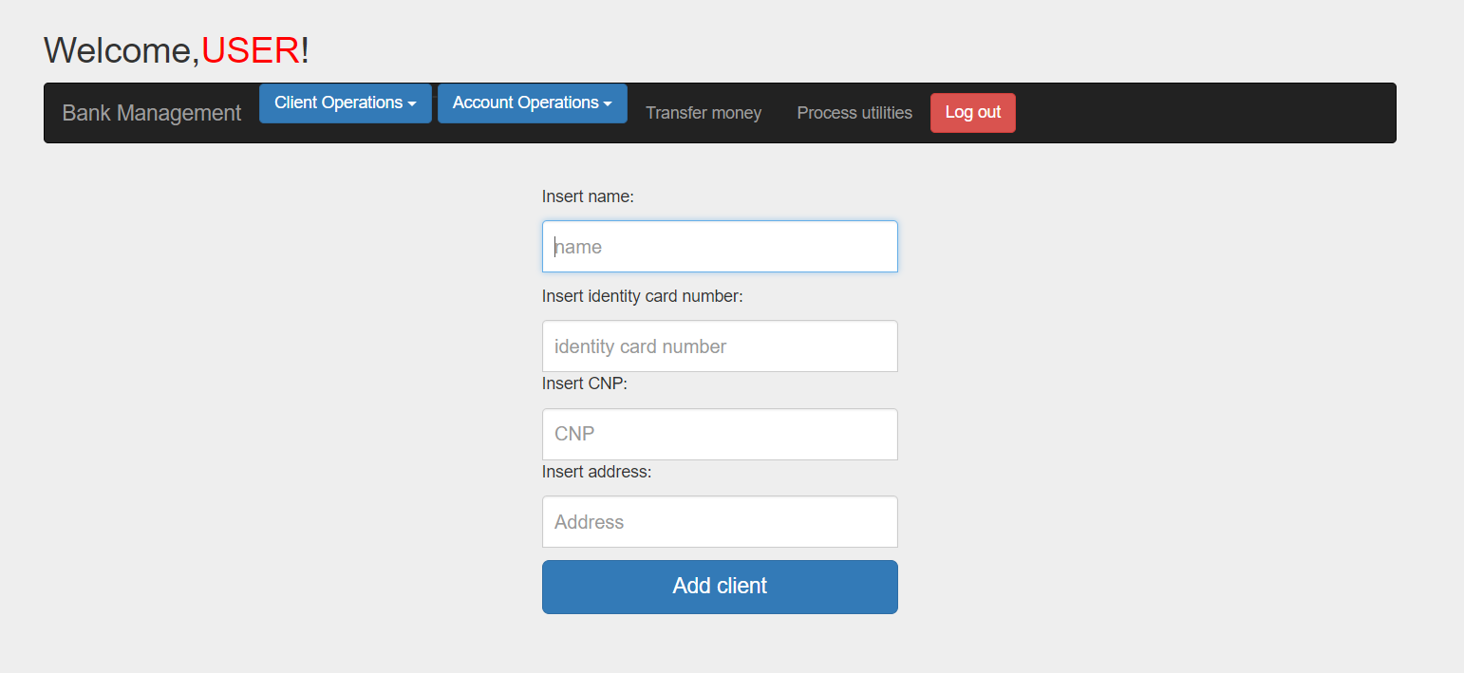

Enter client information respecting the following constraints:

-> name length greater than 3 and only letters;

-> identity card number form only by numbers and having the length equal with 6;

-> valid CNP;

-> all the fields are mandatory;

Click add client, a success message should be shown if the constraints are met, otherwise an error message showing which is the error is shown. 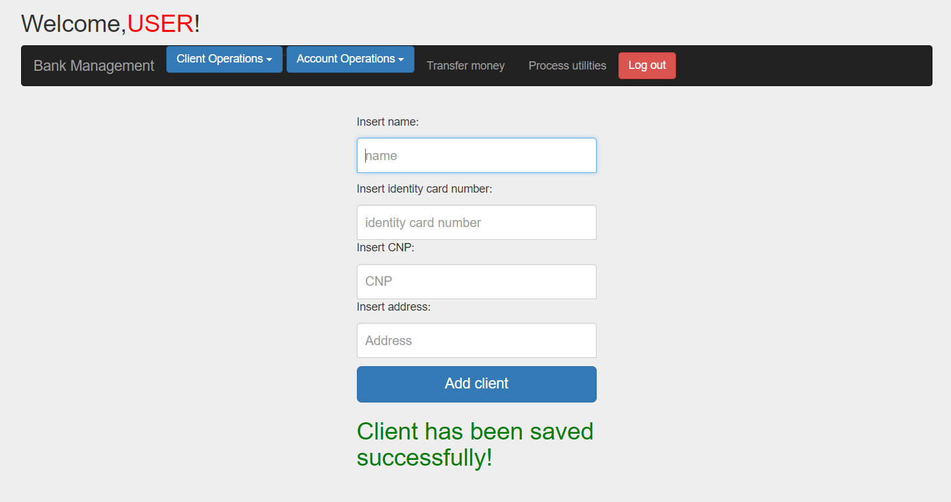

* + 1. *How to: Update client information*

Select the “update client” menu.

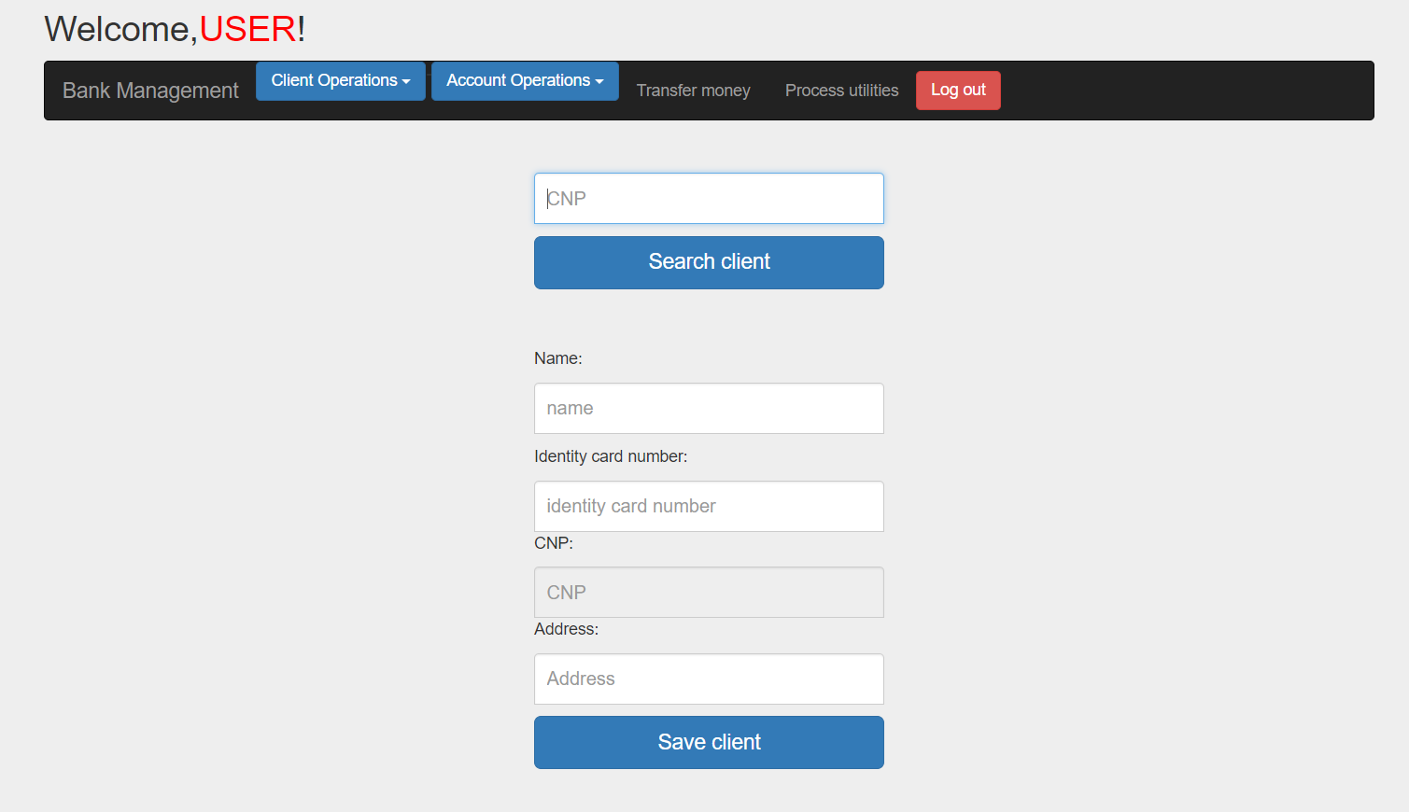

Search client by entering his CNP. You can update his name, identity number and address. Press update to save the new information. The new data must respect the constraints written at the point 3.2.2.

* + 1. *How to: View client*

To visualize the client information select the “View client” menu.

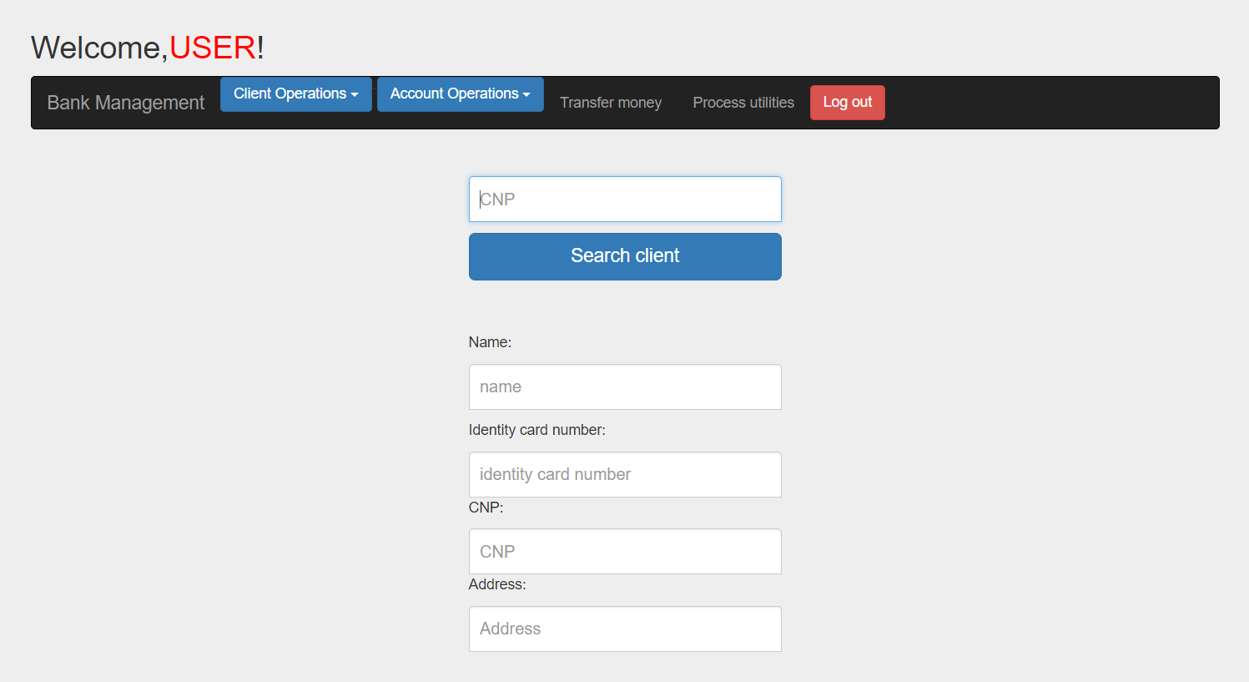

Enter the CNP of the client and a table with his accounts will be provided, if the CNP is written correctly otherwise an error message will be shown. 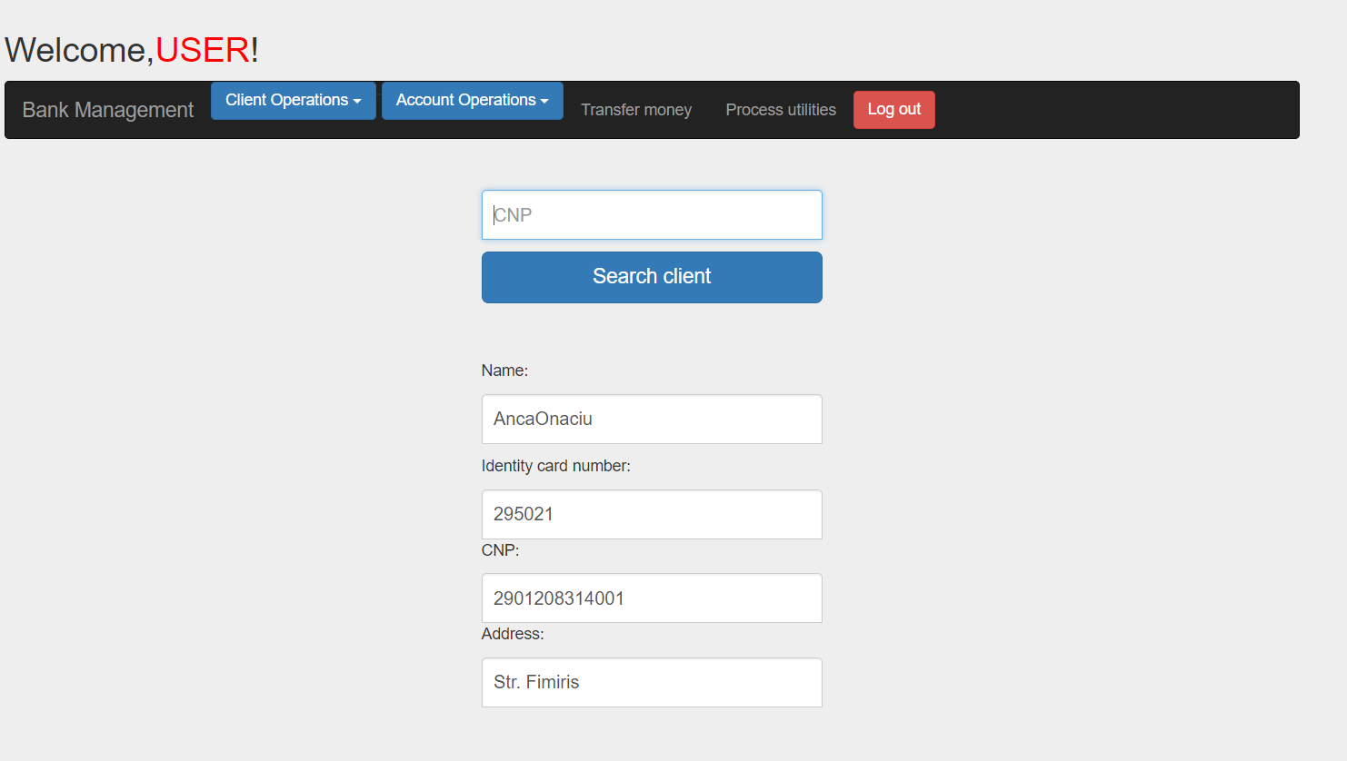

Error:

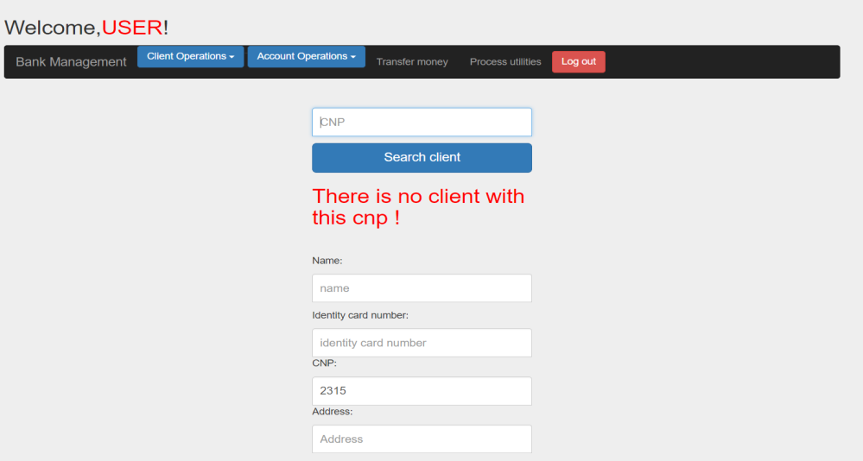

All the account operations are found in the “Account operations” menu.

* + 1. *How to: Add account*

To add an account select the “Add account” submenu from the account operation menu.

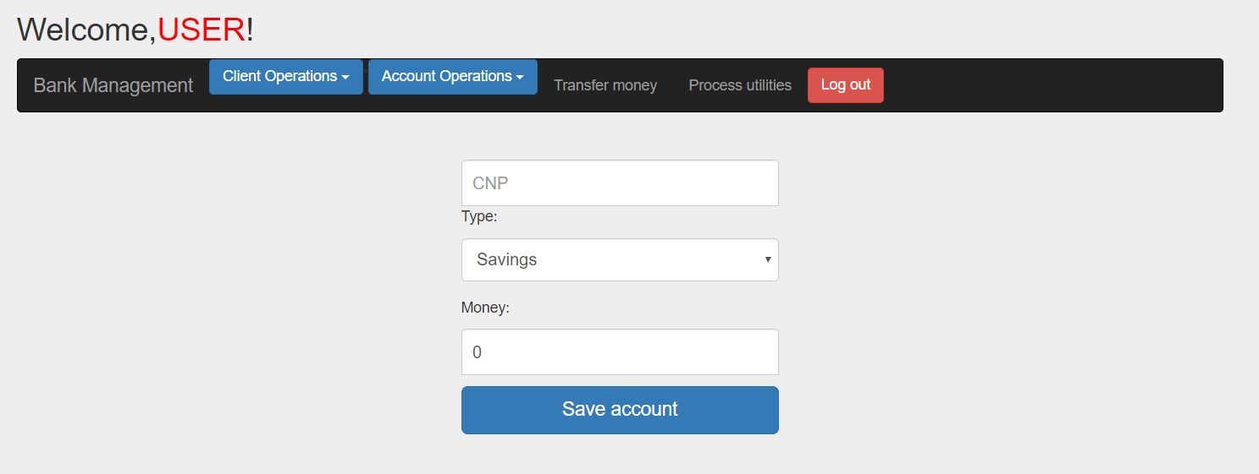

Complete all the form with valid information that respects the following constraints:

-> the CNP is of an existing client;

-> the sum of money to deposit is positive;

-> all the fields are mandatory;

And select the account type. Click on save account and the following message should appear including the account id:

If invalid information is provided an error message will be shown saying what information is invalid.

* + 1. *How to: Edit account information*

To edit an account enter in the account operation menu and click on the “Update account” submenu.

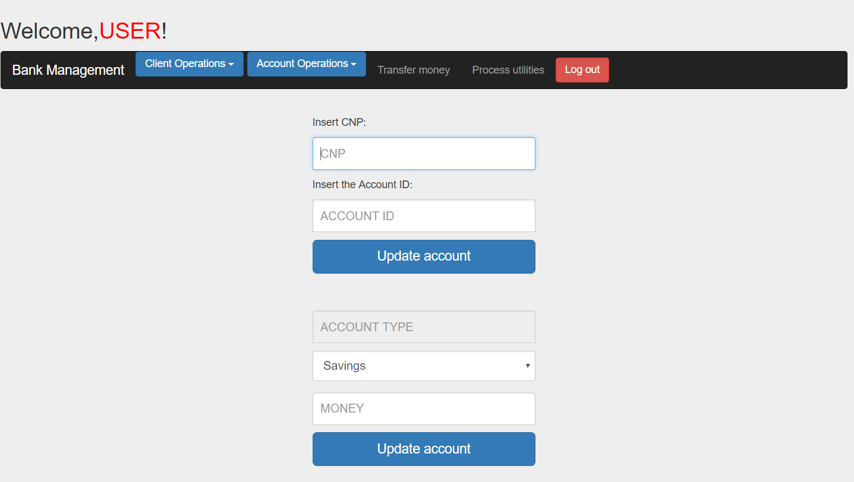

Enter the account id and the cnp of the client who’s account you want to edit. If this information is correct the type and sum fields will be updated with the account information. Edit these fields with the information you want to edit respecting the constraints written at the point 3.2.5. Press update and a success message should appear if the information is correctly otherwise an error message saying what is wrong will appear.

* + 1. *How to: Delete account*

To delete an account click the “Delete account” submenu. The following page will appear:

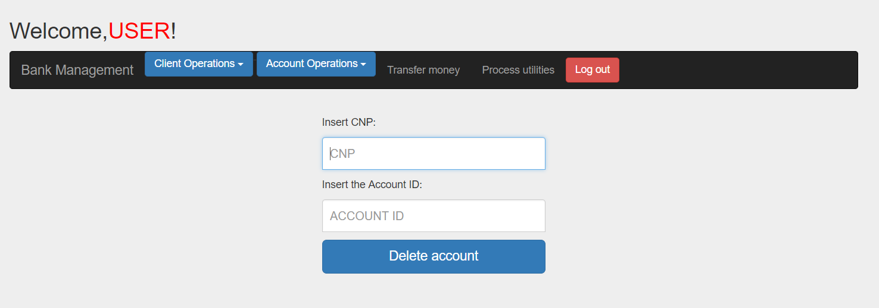

Enter the CNP of the client and the account ID, if there are valid by pressing delete the account will be delete if the CNP and account ID exists in the database and the account belongs to the client. A success/ error message will appear telling what is wrong.

* + 1. *How to: View account information*

To see the accounts of a certain client go the “View account” submenu and enter the client CNP.

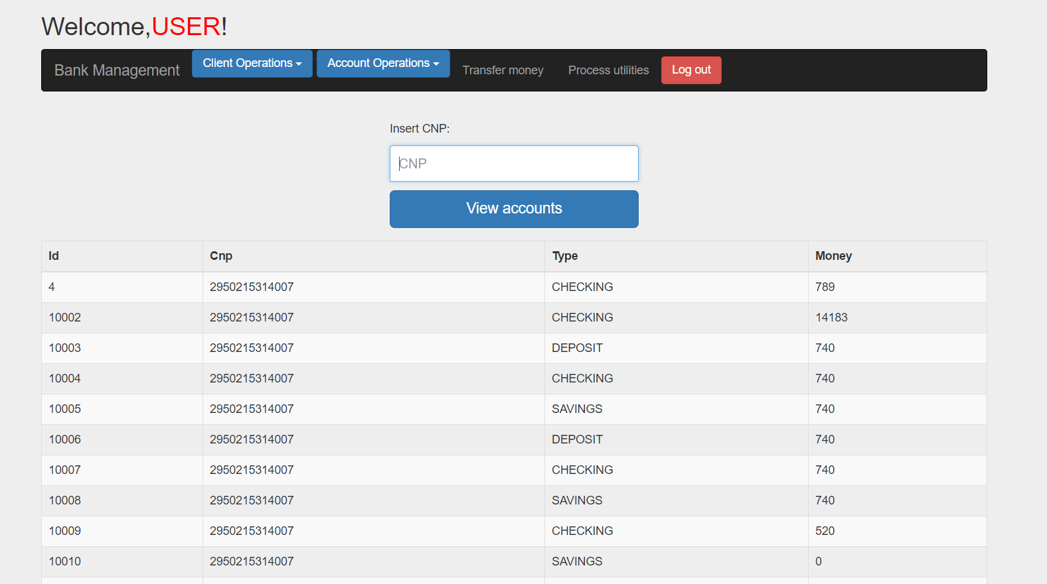

* + 1. *How to: Transfer money between accounts*

To transfer money between two accounts enter in the “Transfer money” menu. A form will appear:

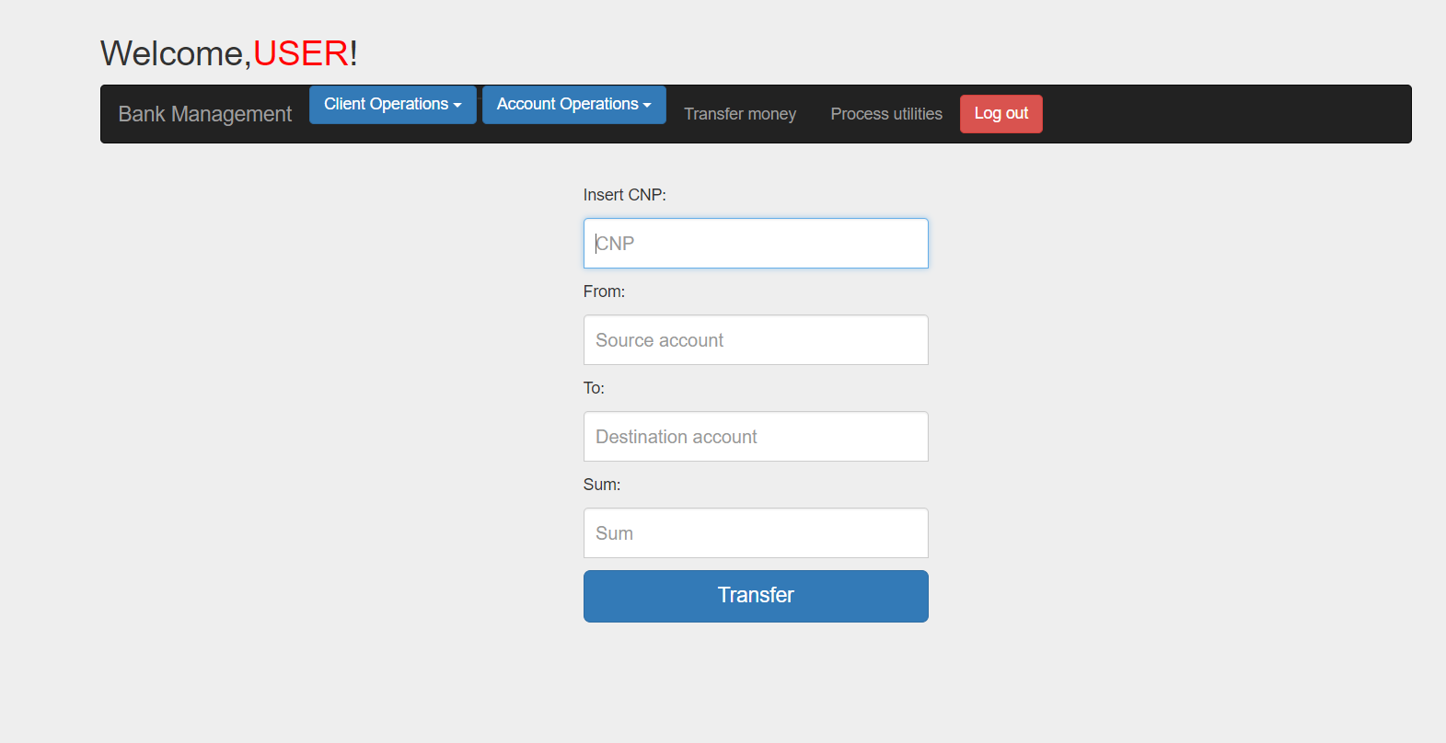

Complete all the fields with valid information:

-> the CNP of the client who wants to transfer money;

-> the account ID from where the money is transferred must be of the client who’s CNP is written above;

-> the account where the money should be transferred: has to be a valid account that exists in the bank;

-> a positive sum of money to transfer that is smaller or equal with the sum existing in the source account;

->All the fields are mandatory;

Press transfer to execute the transfer. If all the constraints specified above are satisfied the money will be transferred and a success message will be shown, otherwise an error message will appear.

* + 1. *How to: Pay utility bills*

Enter in the pay utilities bills.

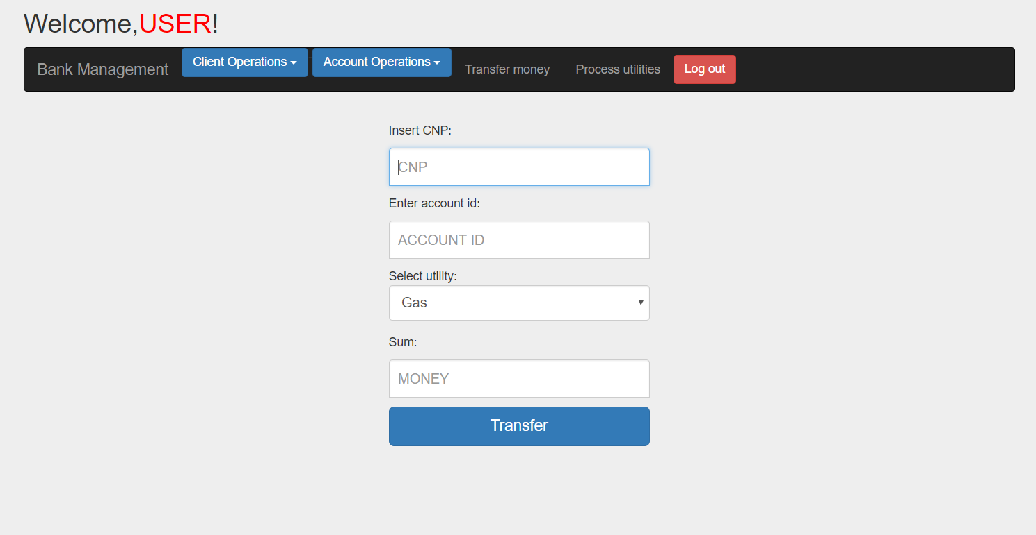

Complete all the forms with valid information:

* Enter the CNP of the client who wants to pay;
* Enter the account id of the client, from where the money will be taken;
* Select the type of the utility he wants to pay;
* Enter a positive amount of money that has to be available on the account and which the client wants to transfer to the utility;

If all these constraints are satisfied when pressing the pay utilities button the money will be transferred and a success message will be shown, otherwise an error message will appear.