Bookstore Management System

Analysis and Design Document

Student: Onaciu Andreea

**Group: 30434**

Table of Contents

1. Requirements Analysis 3

1.1 Assignment Specification 3

1.2 Functional Requirements 3

1.3 Non-functional Requirements 3

2. Use-Case Model 3

3. System Architectural Design 3

4. UML Sequence Diagrams 3

5. Class Design 3

6. Data Model 3

7. System Testing 3

8. Bibliography 3

1. Requirements Analysis

# Assignment Specification

Use Java/C# API to design and implement an application for the employees of a book store. The application should have two types of users (a regular user represented by the book store employee and an administrator user) which have to provide a username and a password in order to use the application.

# Functional Requirements

The regular user can perform the following operations:

* Search books by genre, title, author.
* Buy books.

The administrator can perform the following operations:

* CRUD on books (book information: title, author, genre, quantity, and price).
* CRUD on regular users’ information.-done
* Generate two types of reports files, one in pdf format and one in csv format, with the books out of stock.

# Non-functional Requirements

• Secure access of confidential data.

• 24X7 availability

• Better component design to get better performance at peak time

• Flexible service based architecture will be highly desirable for future extensions.

2. Use-Case Model

**2.1 Administrator use case diagram**

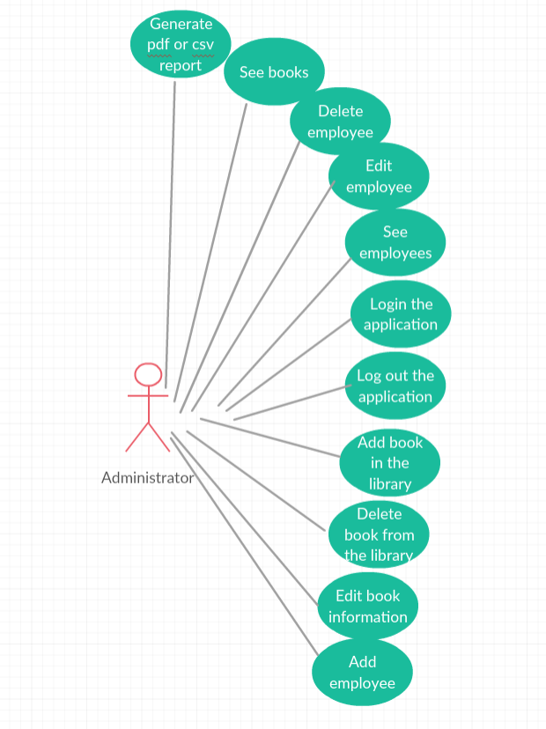

**2.2 Employee use case diagram**

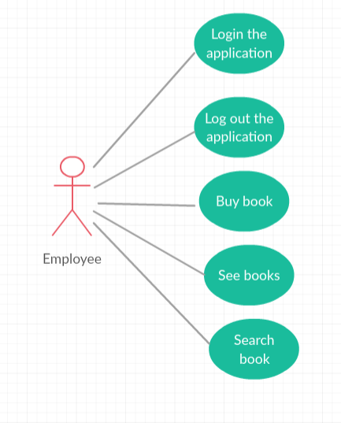

Use case: Add book

Level: summary level;

Primary actor: administrator;

Main success scenario: provide valid information for the new book;

Extensions: if invalid information is provided the book should not be saved.

Use case: Update book

Level: summary level;

Primary actor: administrator;

Main success scenario: search the book who’s information you want to edit based on the ISBN code and provide valid information for the new book;

Extensions: if invalid information is provided the book should not be saved.

Use case: Delete book

Level: summary level;

Primary actor: administrator;

Main success scenario: search the book you want to delete by introducing the ISBN of the book then select the option to delete it;

Extensions: if invalid information is provided for theISBN, a message should be shown;

Use case: View books

Level: summary level;

Primary actor: administrator ,employee;

Main success scenario: select view books menu, a table with all the books should appear;

Extensions:-;

Use case: Search book

Level: summary level;

Primary actor: employee;

Main success scenario: search book based on title, author and/or genre, by pressing the search button only books that respect the search criteria should be shown.

Extensions: if invalid information or there is no book respecting that criteria is provided no book should not be shown.

Use case: Buy book

Level: summary level;

Primary actor: employee;

Main success scenario: by pressing the buy button of the book you want to buy the quantity of the book decreases and a message telling that the book was bought successfully should be shown.

Extensions: books that are not available the user may not be able to bought them.

Use case: Add employee

Level: summary level;

Primary actor: administrator;

Main success scenario: provide valid information for the new employee;

Extensions: if invalid information is provided the employee should not be saved.

Use case: Update employee

Level: summary level;

Primary actor: administrator;

Main success scenario: search the employee who’s information you want to edit and provide valid information for the new employee;

Extensions: if invalid information is provided the employee should not be saved.

Use case: Delete employee

Level: summary level;

Primary actor: administrator;

Main success scenario: search the employee you want to delete and press the delete button;

Extensions: if invalid information is provided no employee should be deleted.

Use case: See employees

Level: summary level;

Primary actor: administrator;

Main success scenario: a list with all the employees should be provided;

Extensions:-;

Use case: See book reports

Level: summary level;

Primary actor: administrator;

Main success scenario: press the button according to which format you want to generate the report: csv or pdf type. The report should generate a file containing the books out of stock.

Extensions: if files are not able to be generated an invalid message should be shown.

3. System Architectural Design

**3.1 Architectural Pattern Description**

The project will be developed in a layered architecture pattern used in the majority of spring web applications. It respects the principles of Separation of concerns and The Keep It Simple Stupid (KISS) principle. The layers of the application will be:

* The repository layer is the lowest layer of a web application. It is responsible of communicating with the used data storage.
* The service layer resides below the web layer. It acts as a transaction boundary and contains both application and infrastructure services. The application service provides the public API of the service layer. They also act as a transaction boundary and are responsible of authorization. The infrastructure services contain the “plumbing code” that communicates with external resources such as file systems, databases, or email servers. Often these methods are used by more than a one application service.
* The web layer is the uppermost layer of a web application. It is responsible of processing user’s input and returning the correct response back to the user. The web layer must also handle the exceptions thrown by the other layers. Because the web layer is the entry point of our application, it must take care of authentication and act as a first line of defense against unauthorized users.

The benefits of this kind of architecture is that it is a low coupling architecture, it offers the possibility of improving performance (sometimes).The maintenance of your application is easier because of the low coupling between layers. Adding more functionality to your application is made easier. Layers make your application more testable.

**3.2 Diagrams**

3.2.1 Conceptual architecture design

In the figure it can be seen how the architecture is structured on layers: presentation layer, controller layer, service layer, data access layer, database layer.

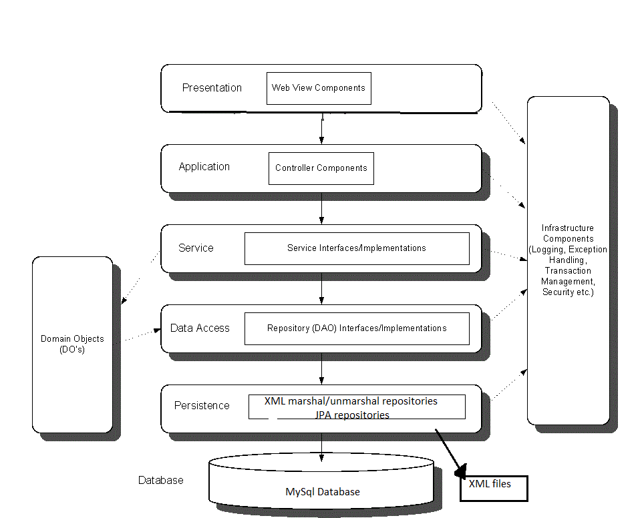

3.2.2 Package diagram

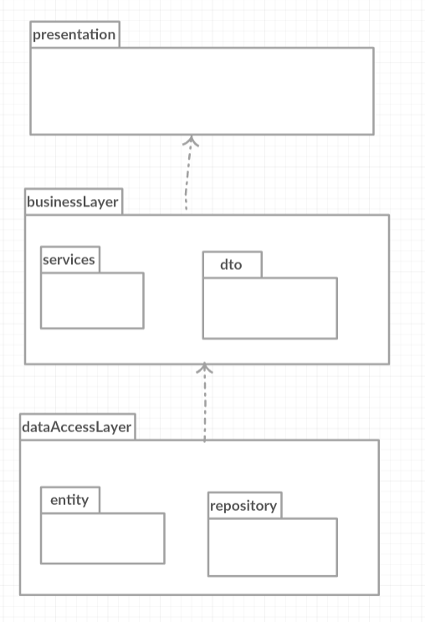

3.2.3 Component diagram

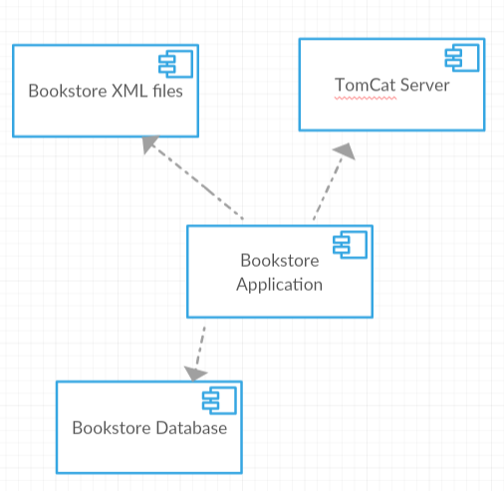

3.2.4 Deployment diagram

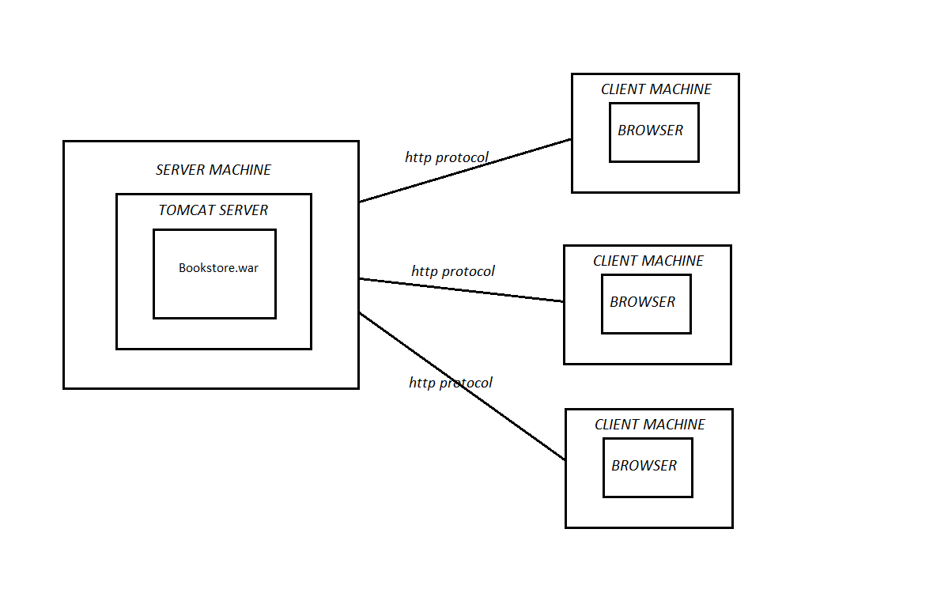

4. UML Sequence Diagrams

Add Employee sequence diagram

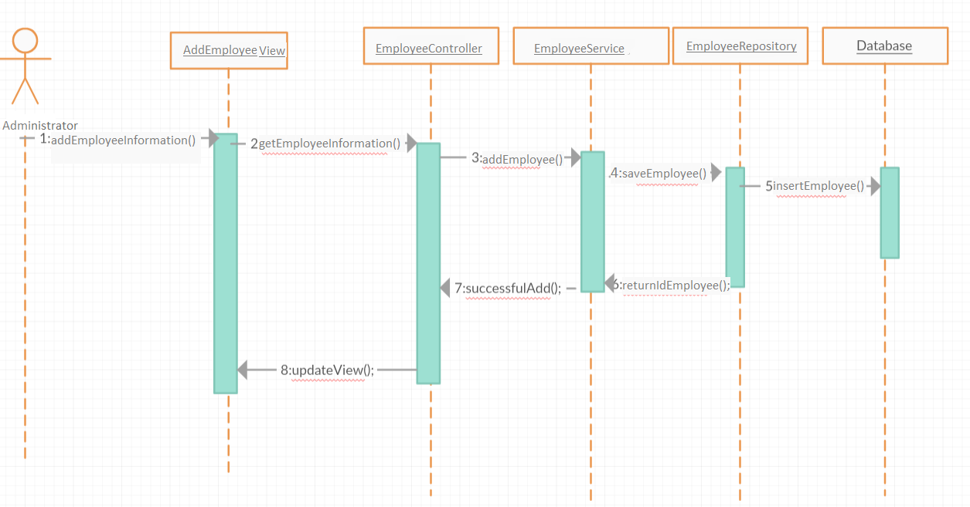

5. Class Design

**5.1 Design Patterns Description**

For developing the application I used as some design patterns for each layer, some of them are used due to the frameworks in which the application is made. For the data access level I used the Spring Hibernate framework which uses the Data Model design pattern and Proxy Pattern. At runtime, Hibernate dynamically generates proxies from the entity code through bytecode generation. These proxies are aware of the ORM functionality and implement the object lifecycle, while pretending to belong the class that the programmer created.

The business logic is created using the Services layer pattern, services for each domain model entity, they include all the needed logic to provide information for the user information and for saving into the database.

The presentation layer is created using MVC pattern. The Model handles the state of the application. The View is the representation of the user interface. User actions on the View are sanded to the Controller.

**5.2 UML Class Diagram**

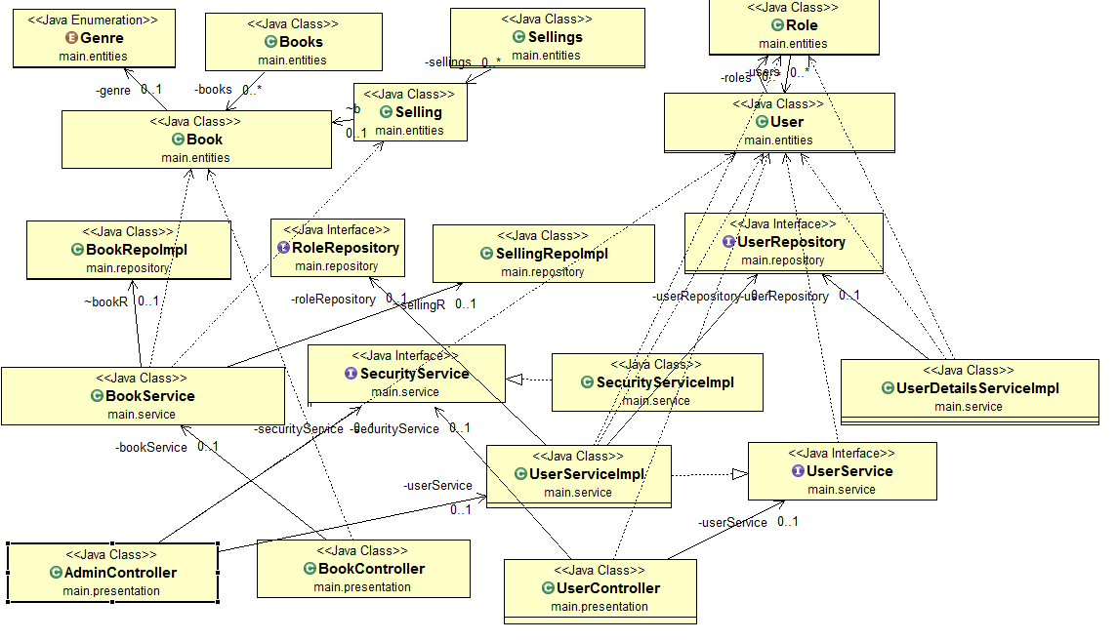

Services classes:

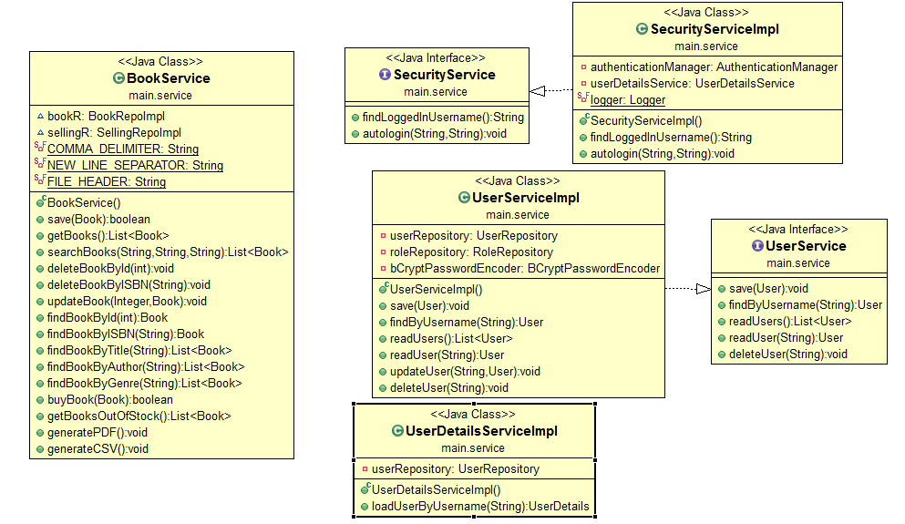

Entities:

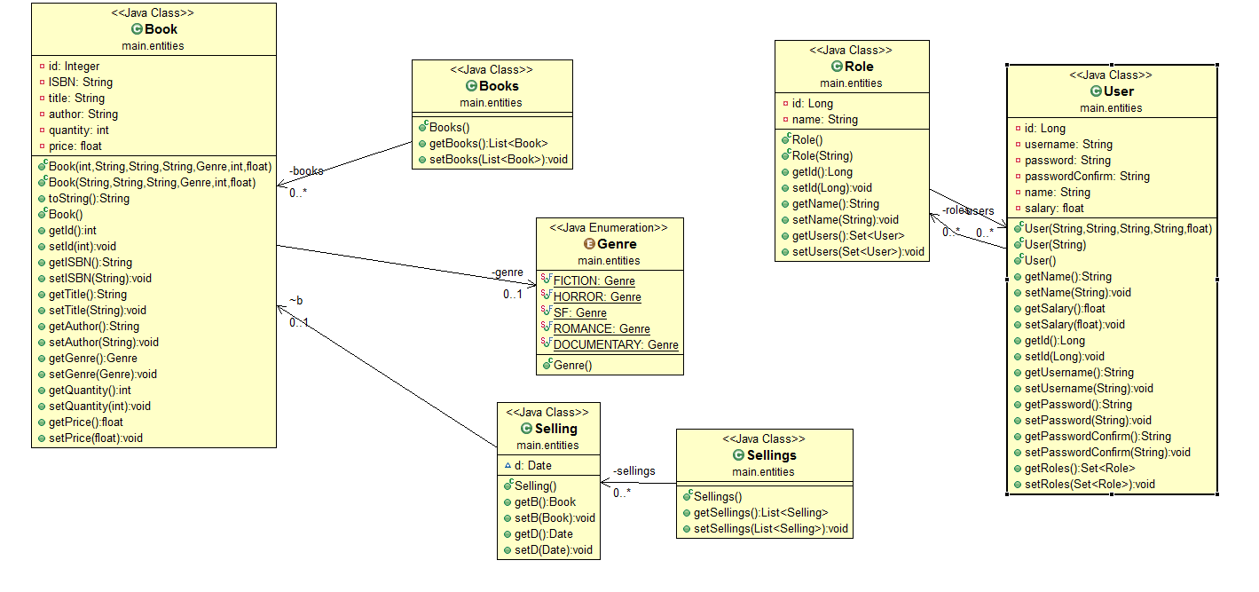

6. Data Model

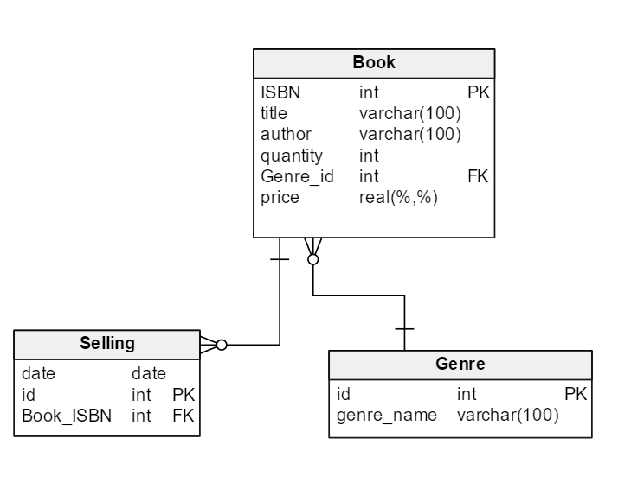

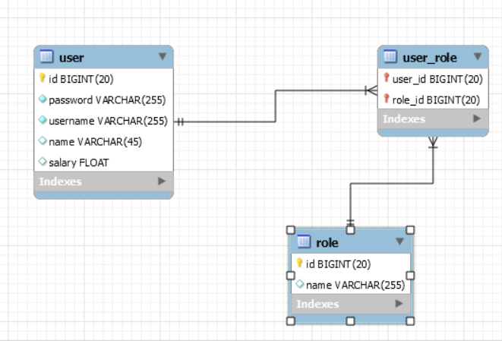

7. System Testing

For testing the system the following strategies were used: unit testing, validation testing and testing methods like boundary analysis. The system contains unit tests for the Book Service of the application.

Validation testing is made in the business logic of the application by testing each user input to have correct and valid values, if invalid values are placed then an error message which communicates the error is shown. The validation methods contain quantity, price, ISBN validation, saving username and password validation, available book selling.

Example: Login Test Scenario

* Black box

-Verify that the login screen is having option to enter username and password with submit button and option of forgot password.

-Verify that user is able to login with valid username and password.

-Verify that user is not able to login with invalid username and password.

-Verify that validation message gets displayed in case user leaves username or password field as blank

-Verify that the password is in encrypted form when entered

-For security point of view, in case of in correct credentials user is displayed the message like "incorrect username or password" instead of exact message pointing at the field that is incorrect.

-Verify if the password can be copy-pasted or not.

* White box testing

-Test method which tests the login method from the UserService. The test tests the validity of the username and password, the existence in the db and retrival of correct messages.

8. Bibliography

* <https://zeekat.nl/articles/mvc-for-the-web.html>
* <http://stackoverflow.com/questions/2637114/what-are-the-benefits-of-an-n-layered-architecture>