|  |
| --- |
| Tehnical university of cluj-napoca |
| BOOKSTORE - WEB APPLICATION |
| *-READ ME FILE-* |
|  |
| **Andreea Onaciu** |
| **5/2/2017** |

|  |
| --- |
|  |

Contents

*1. Prerequisites…………………………………………………………………………2*

*2. Installation Process…………………………………………………………………3*

*3. How to use the application*

*3.1 Administrator*

*3.1.1 Login…………………….……………………………………………….3*

*3.1.2 Log out…………………………………………………………………..5*

*3.1.3 Add employee…………………………………………………………. 5*

*3.1.4 Delete employee………………………………………………………. 7*

*3.1.5 Update employee……………………………………………………….8*

*3.1.6 See employees…………………………………………………………11*

*3.1.7 Generate pdf/csv file for books out of stock…….…………………..11*

*3.1.8 Add book………………………………………………………………..13*

*3.1.9 Edit book………………………………………………………………..14*

*3.1.10 Delete book……………………………………………………………17*

*3.1.11 See books……………………………………………………………..18*

*3.2 Employee*

*3.2.1 Login…………………………………………………………………….18*

*3.2.2 Log out………………………………………………………………….19*

*3.2.3 Search book……………………………………………………………19*

*3.2.4 Buy book….. …………………………………………………………..21*

1. Prerequisites

For using the application the following programs need to be available on your computer : Java Development Kit, MySql Workbench and Tomcat server.

* 1. Installing Java Development Kit

You can download the JDK from this link: <http://www.oracle.com/technetwork/java/javase/downloads/jdk8-downloads-2133151.html>

Select the appropriate version according to your operating system and click on “Accept licence agreement”.Then simply run the executable you downloaded and follow the installation steps.

* 1. Installing MySql Workbench

You can download MySql Workbench from this link:

<https://dev.mysql.com/downloads/workbench/>

Pay attention to select the version appropriate to you operating system and follow the installation steps described here:

<https://dev.mysql.com/doc/refman/5.7/en/installing.html>

After the finishing the installation process, open the workbench and add a new connection by clicking on the “+” button near MySql Connections give a new connection name of your choice and set the username: “root” and the password “bankAssignment”.

* 1. Installing TomCat Server

To install Tom Cat server first you have to install the JDK. For downloading the server you can access the following link:

<https://tomcat.apache.org/download-70.cgi>

Download the appropriate archive according to your operating system, after that unzip it and to be able to start the server you have to set the environment variables:

-right click MyComputer

->Properties ->Advanced system settings ->Advanced Menu -> Environement Variables->New-> Variable name: JAVA_HOME Variable value: here you have to enter the path of the jdk file that you installed in the step 1.1-> Ok.

To start the server enter in the bin folder of the archive and double click the startup.bat file. A terminal should appear showing that the server has started. To close the server double click on the shoutDown.bat file also found in the bin folder.

1. Installation process

* To actually start the application, first enter in the config folder of the tomcat server, open tomcat-users.xml file and copy the username and password.
* Start the server and access on your browser the address: <http://localhost:8181/> , a web page of the apache tomcat server should appear;
* Click on the Manager App button in the right part of the screen and an authentication window should appear asking for the username and password you copied from the tomcat-users.xml file, click log in.
* A tomcat application manager should appear, go to the deploy section and press Choose file, select the .war file of the application, which you can find in the target folder. Then click deploy.

1. How to use the application
   1. Administrator
      1. *How to: Login*

The login page is the first page of the application. For the administrator to login, he should enter his credentials in the login fields:

Username: mirunapopescu

Password: mirunapopescu

Login page:

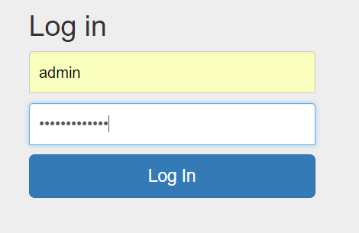

If the credentials are correctly introduced the following menu should appear:

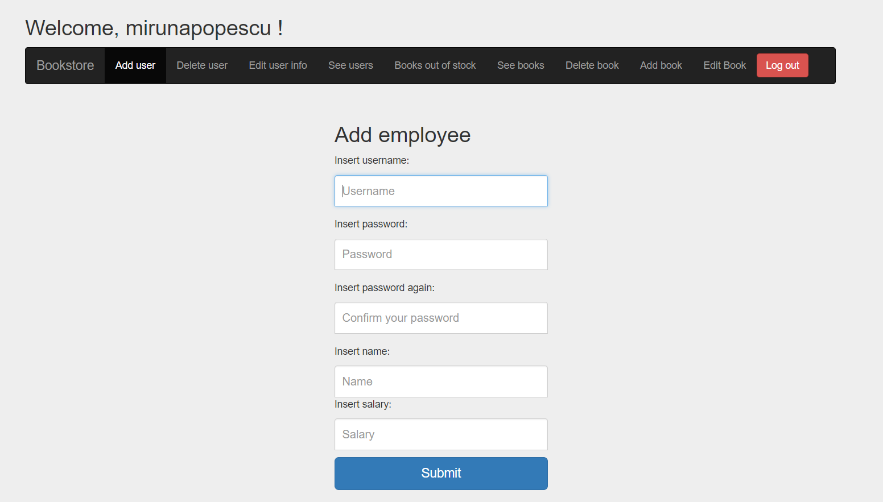

If the credentials are incorrectly introduced the following message will appear:

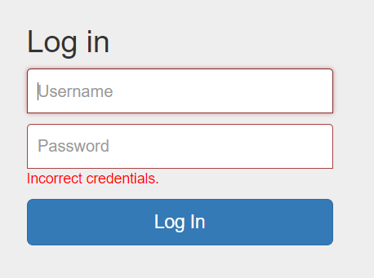

Try to introduce again the credentials, with more attention.

* + 1. *How to: Log out*

To log out from the application press the logout button in the right of the menu. It will bring you back to the login page.

* + 1. *How to: Add employee*

To add an employee press the “Add user” button from the menu. This form will appear:



To add an employee all the fields must be completed respecting the following constraints:

-username length greater than 3;

-password length greater than 3;

-name length greater than 3 and unique;

-positive salary value;

If the employee is added successfully the following message will appear:

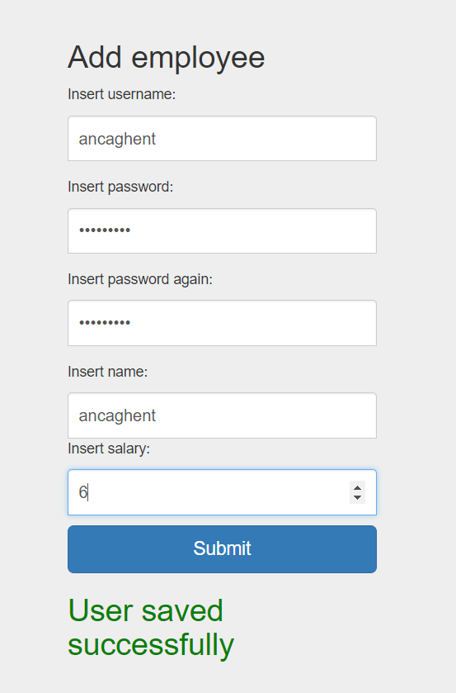

If the data you entered for the new employee is incorrect a message saying what you did wrong will appear:

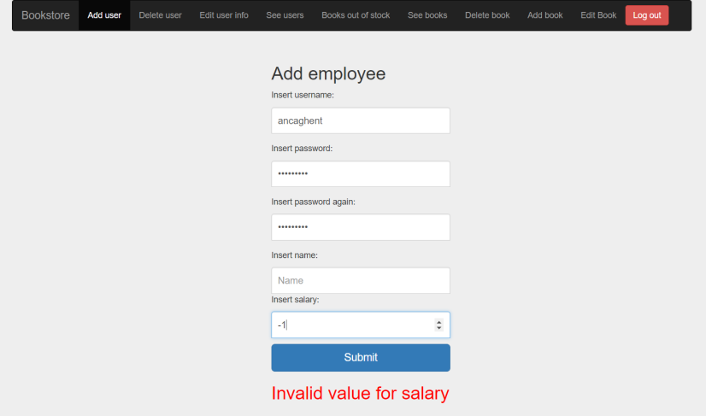

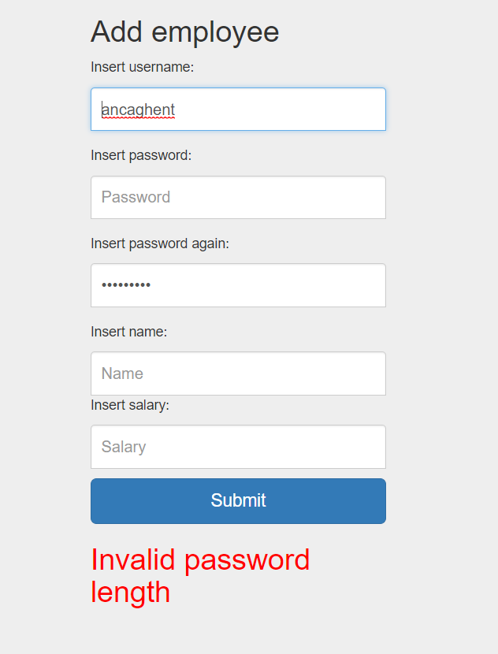 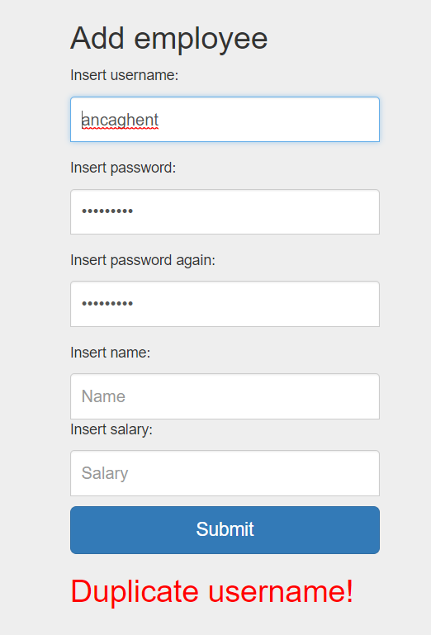

* + 1. *How to: Delete employee*

To delete an employee enter in the delete user menu:

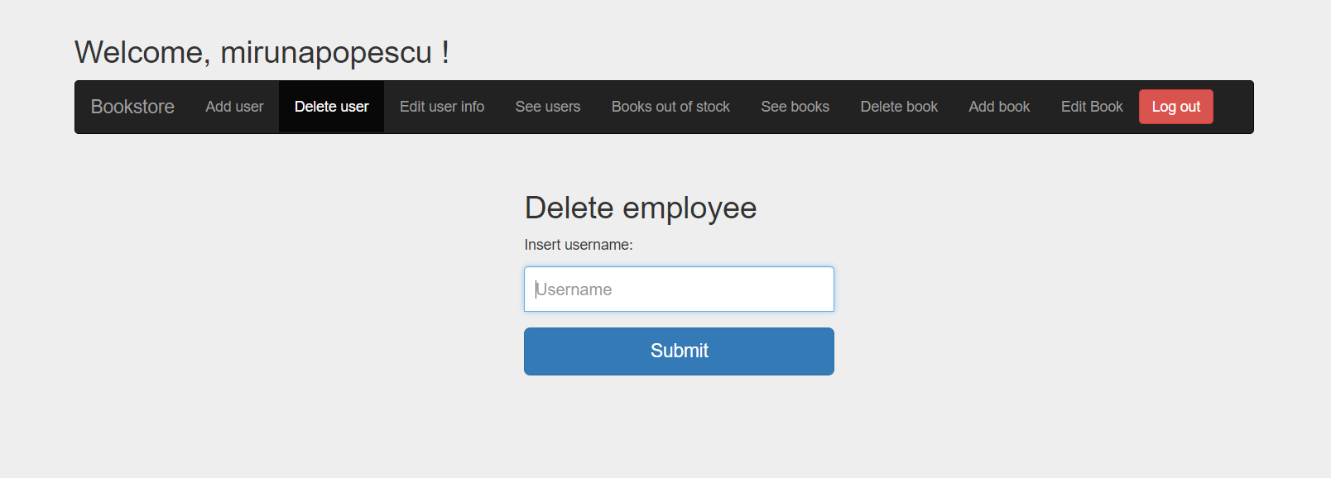

If there is no employee with this username the following message will appear:

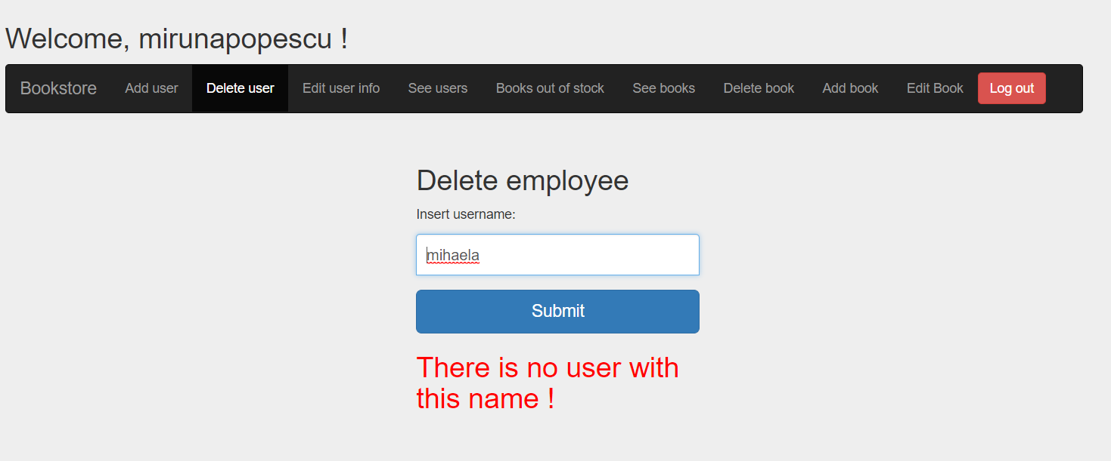

To delete the employee press the delete button, the following message will appear:

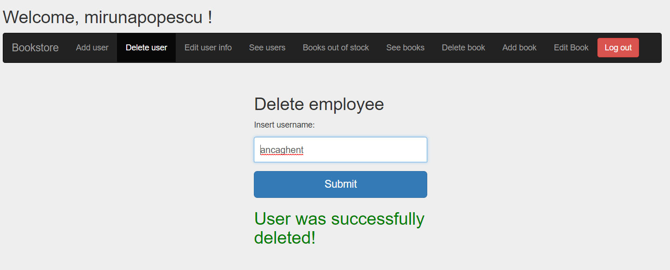

* + 1. *How to: Update employee*

To edit employee information enter the update employee menu.

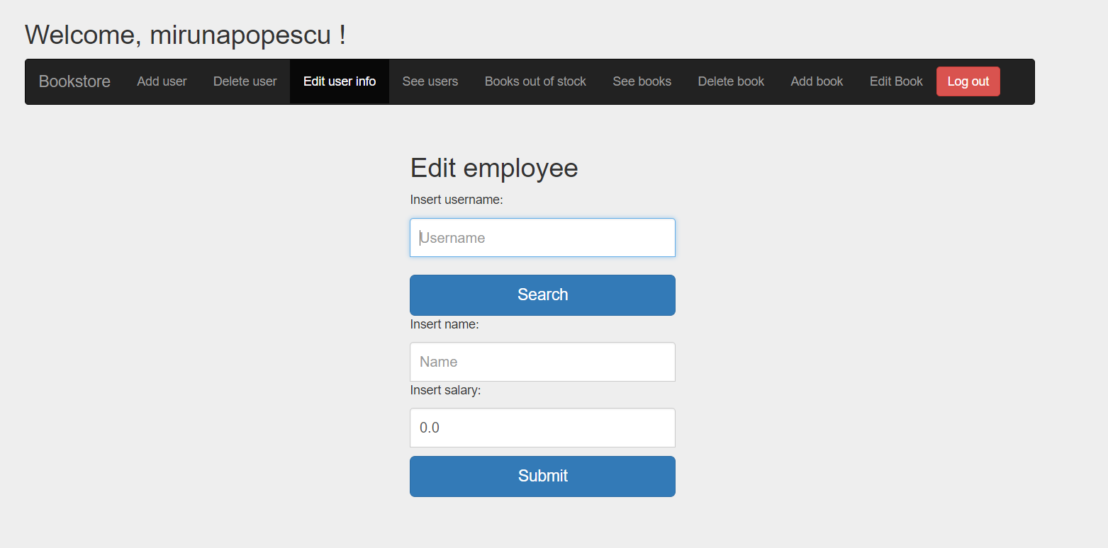

Search the employee by writing correctly its username in the first field and then press the search button. The fields should be filled with the employee information.

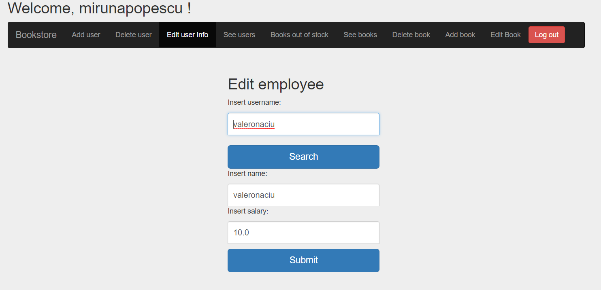

If the username is not correctly an error message will be shown.

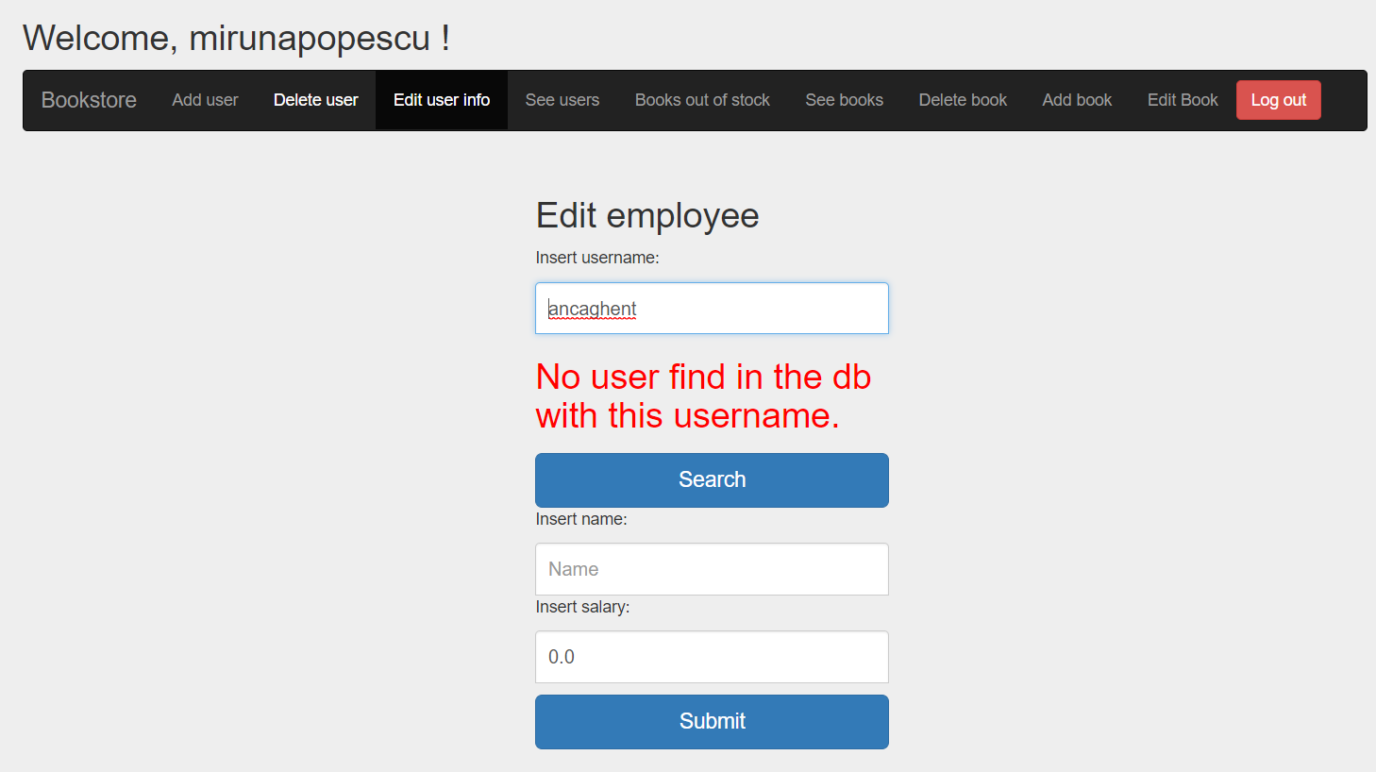

You can update username, password and salary fields. Respecting the constraints mentioned at the Add employee use case (3.1.3). If updated was done correctly this message will appear:

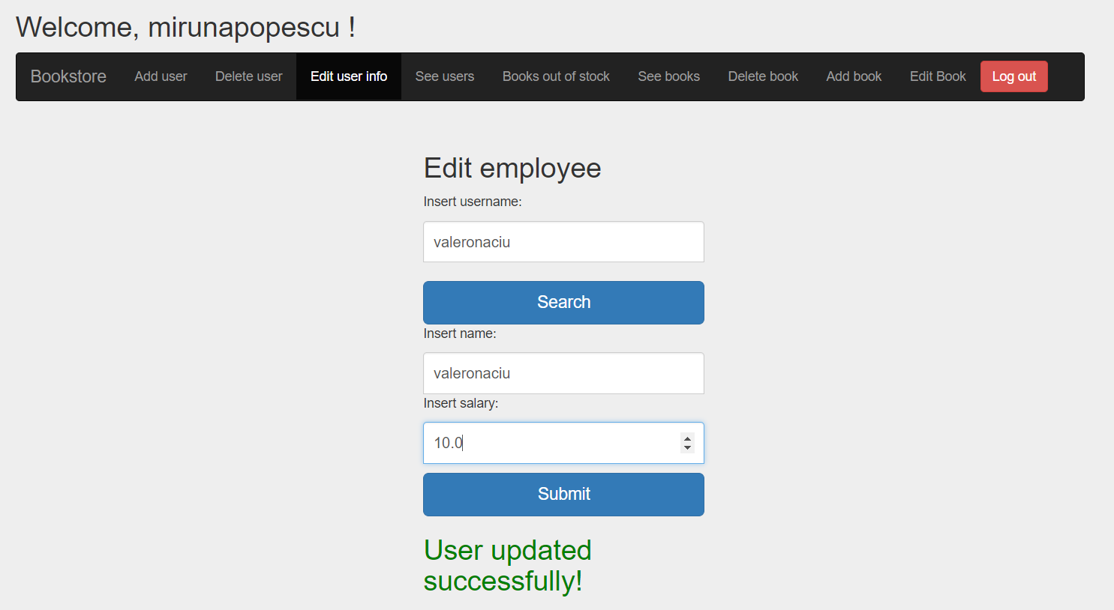

If incorrect information is placed:

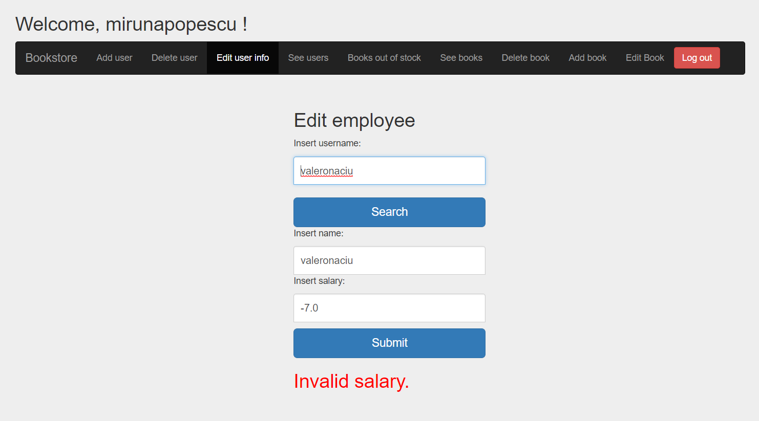

* + 1. *How to: See employees*

Too see all the employees enter in the “See users” menu:

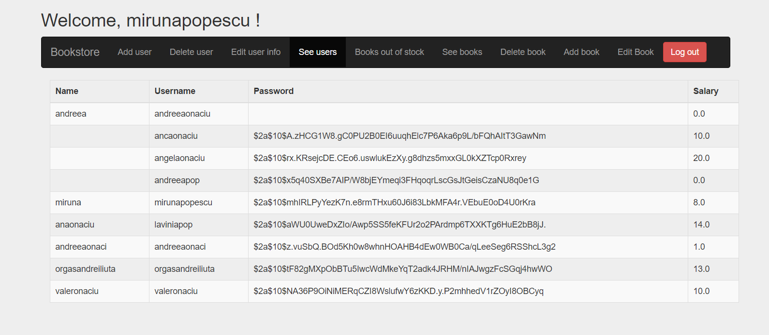

* + 1. *How to: Generate PDF/CSV file for books out of stock*

To see the books that are out of stock enter “Books out of stock” menu.

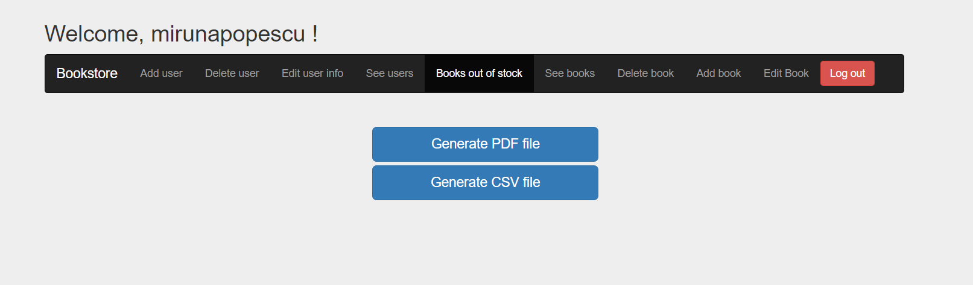

Here you have 2 buttons: one for pdf file generation another one for csv file format. According to which one you press the following message should appear:

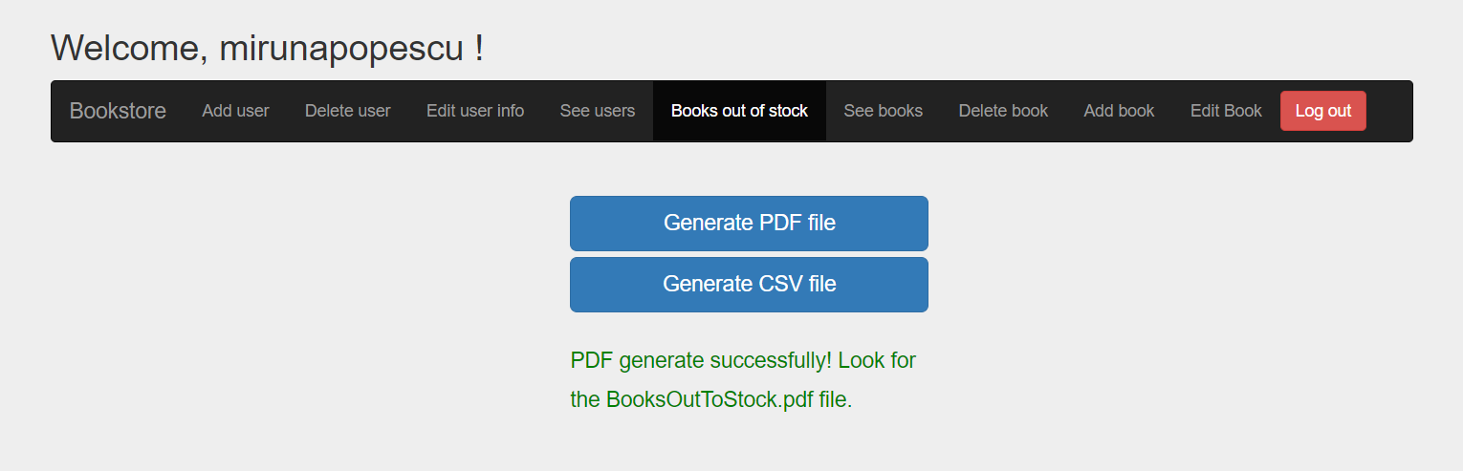

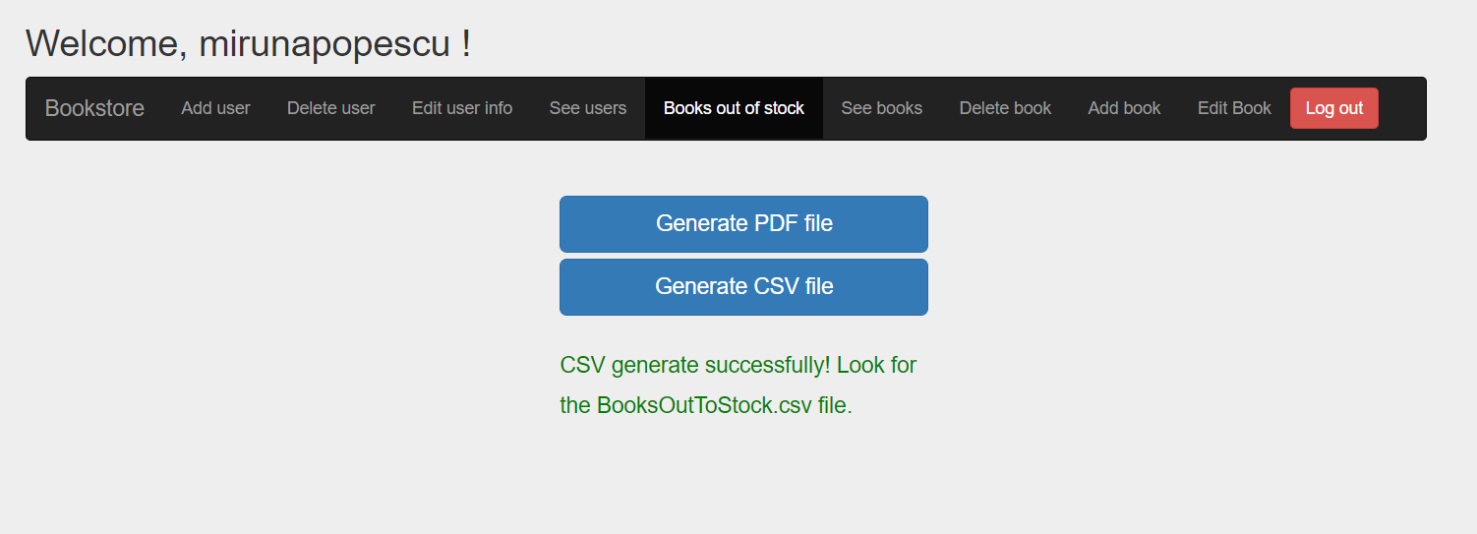

The files can be found in the directory of the project, they should be closed when the button is pressed. They will be updated each time you press the button.

Example of PDF file:

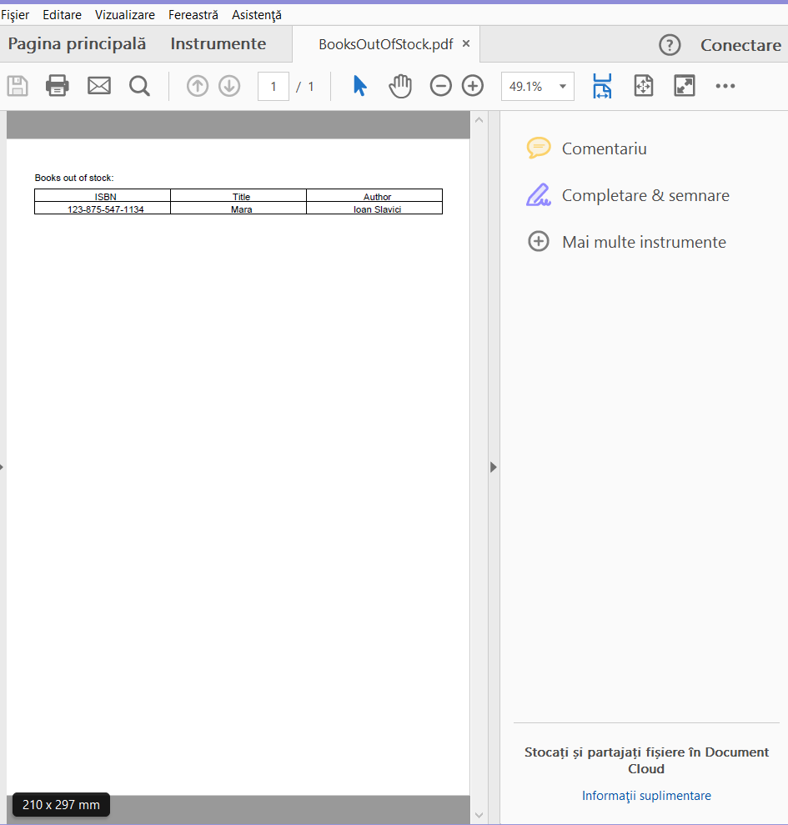

Example of .CSV content:

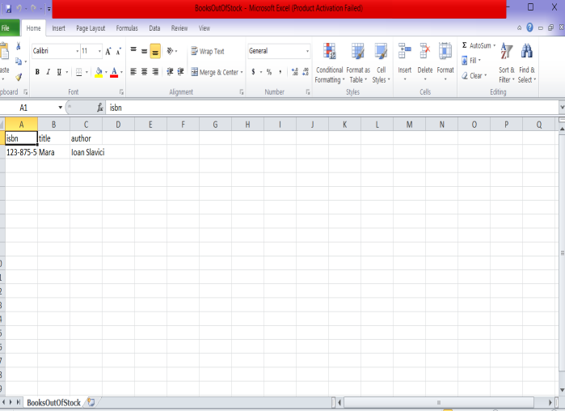

* + 1. *How to: Add book*

Select “add book” from the administrator operations menu.

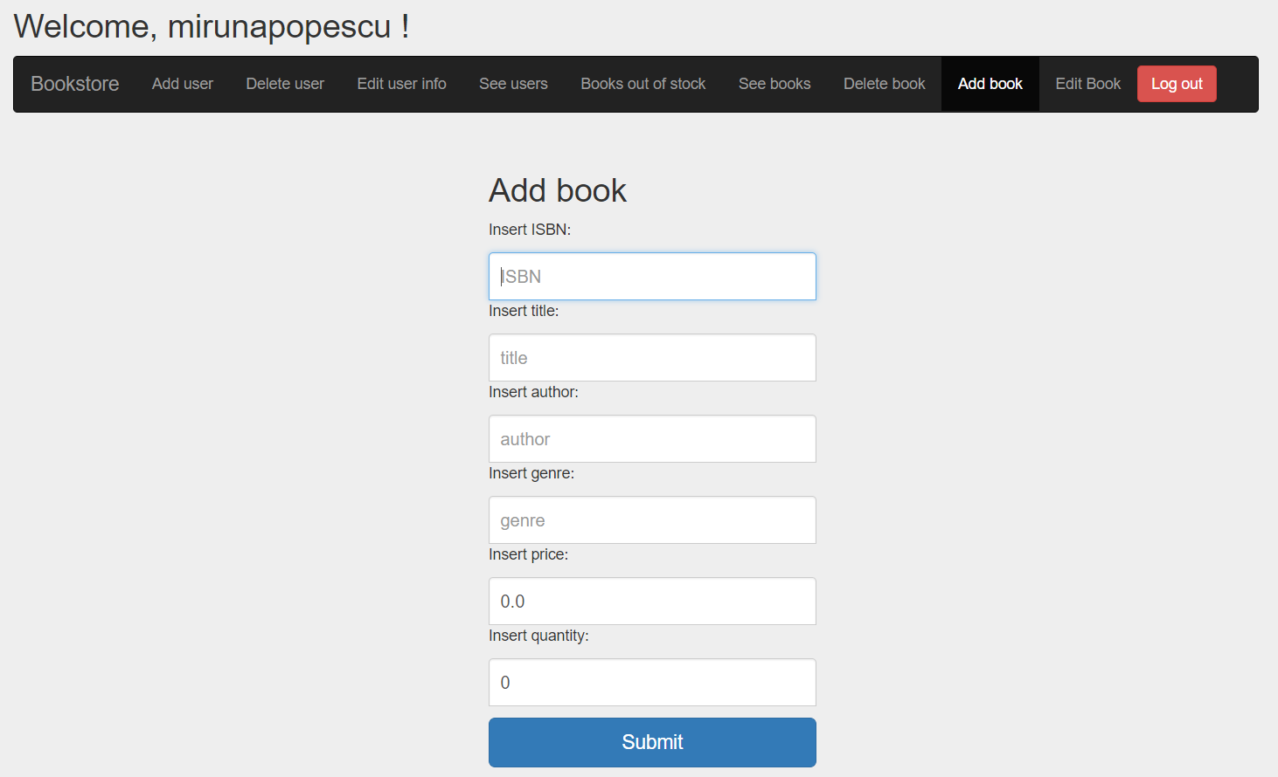

Enter book information respecting the following constraints:

-> ISBN should be 16 characters long;

-> genre must be in the following categories: FICTION, DOCUMENTARY, ROMANCE;

-> positive quantity value ;

-> positive price value ;

-> all the fields are mandatory;

Click submit, a success message should be shown if the constraints are met:

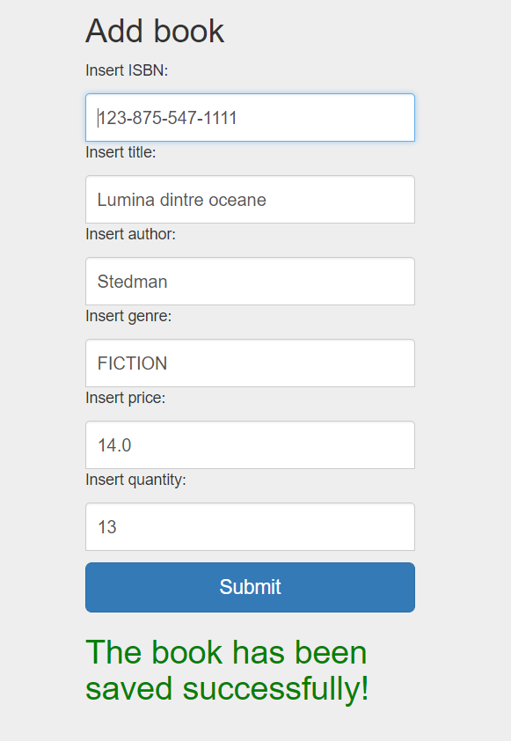

Otherwise an error message showing which is the error is shown.

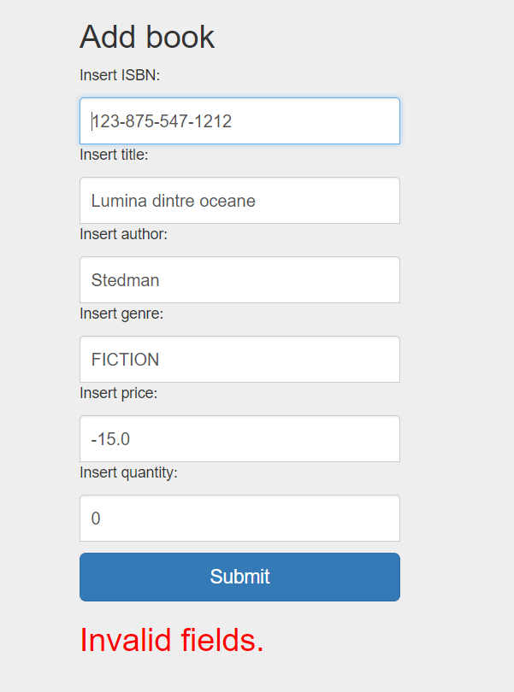

* + 1. *How to: Update book information*

Select the “update book” menu.

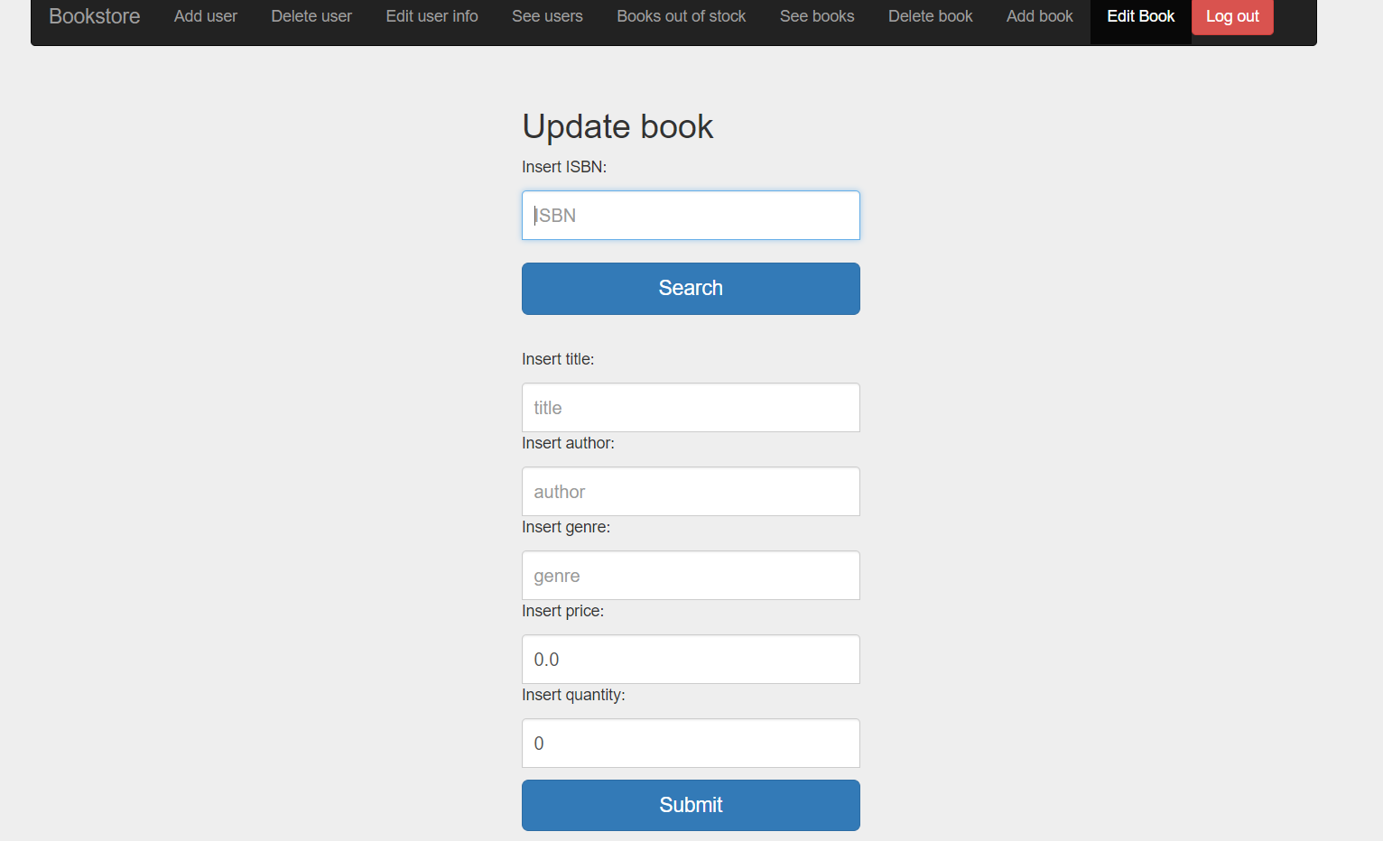

Search client by entering its ISBN.

Valid search:

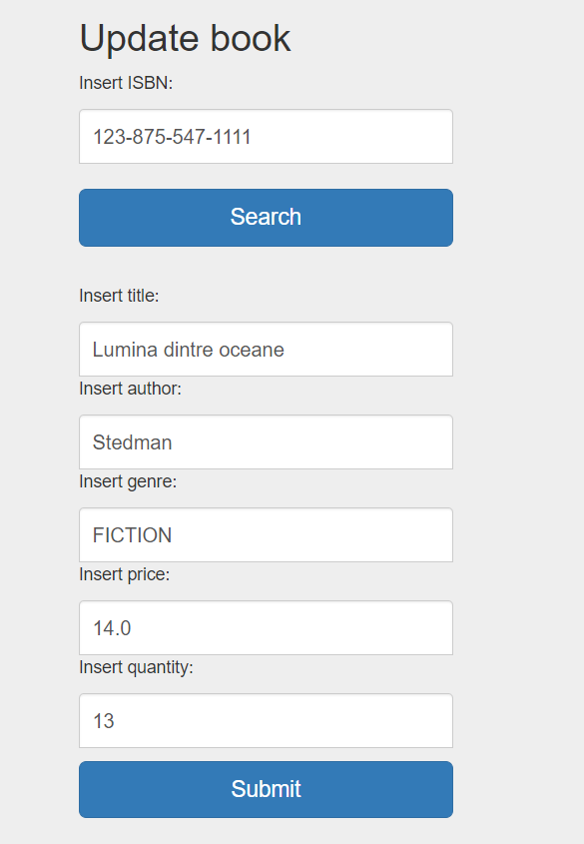

Invalid search:

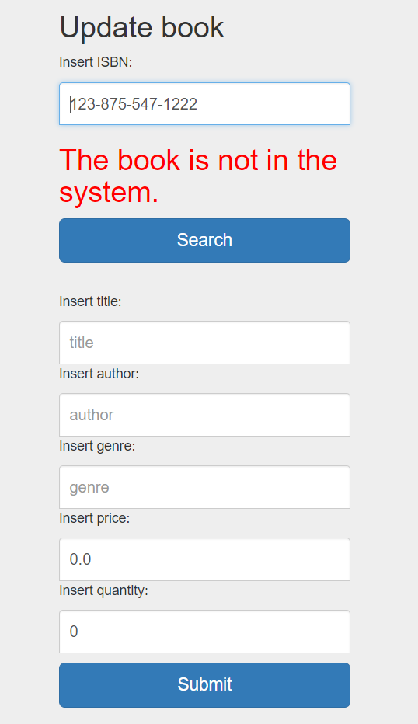

Press update to save the new information. The new data must respect the constraints written at the point 3.1.8.

Valid:

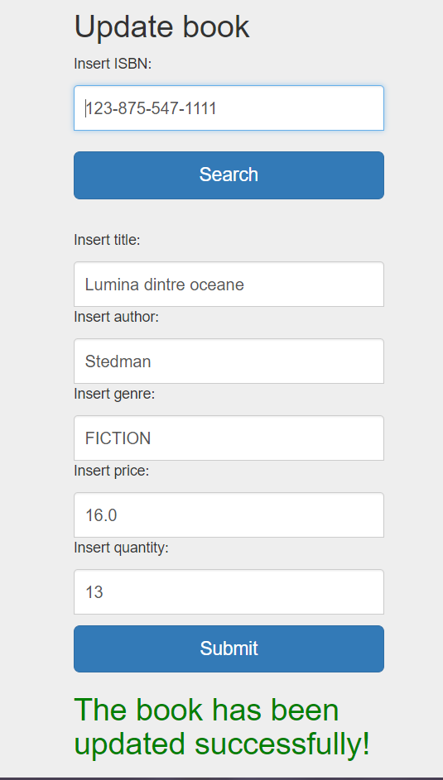

Invalid:



* + 1. *How to: Delete book*

First enter the “Delete book” menu:

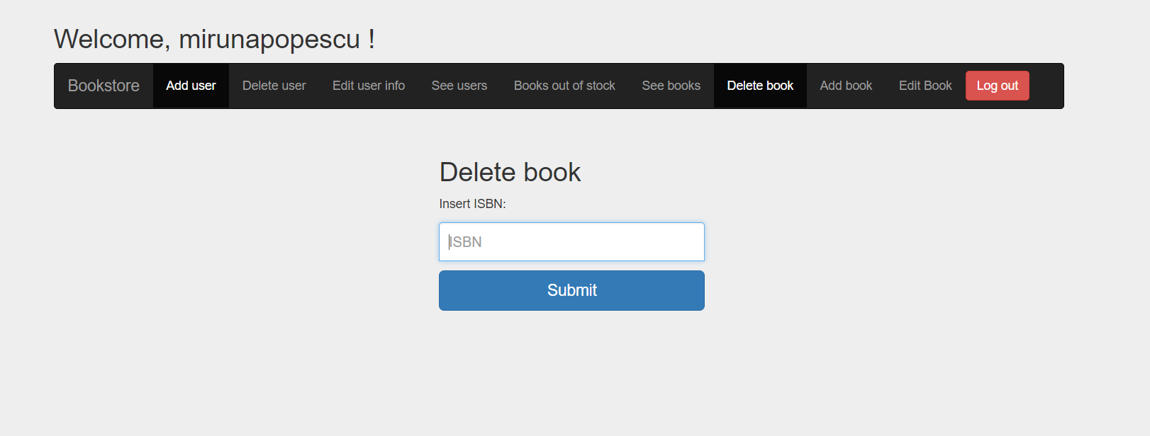

Enter the ISBN of the book you want to delete. If the ISBN is correct by pressing the Submit button the book will be deleted and success message will be shown like in the image:

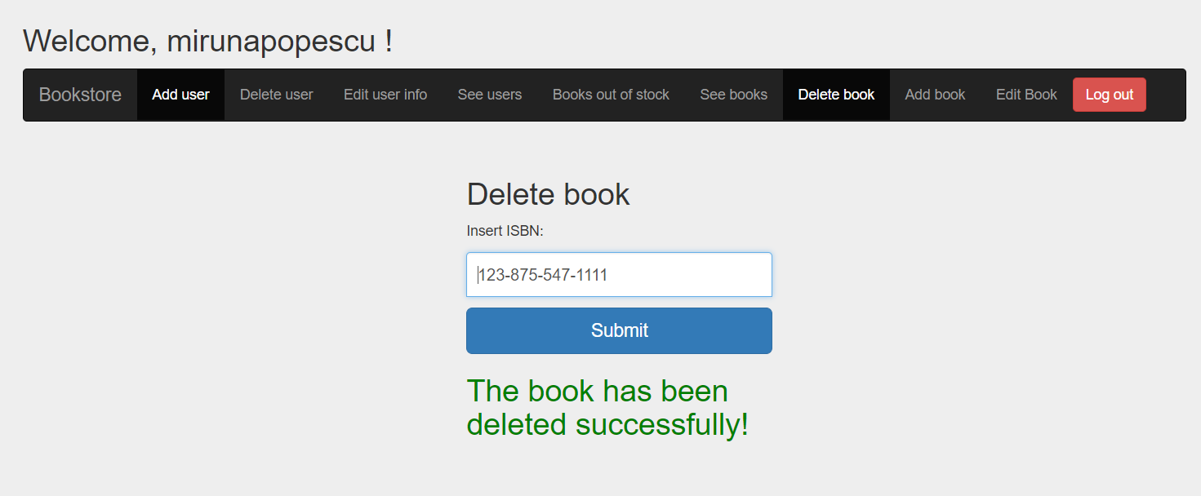

If the ISBN is incorrect the following message will be shown:

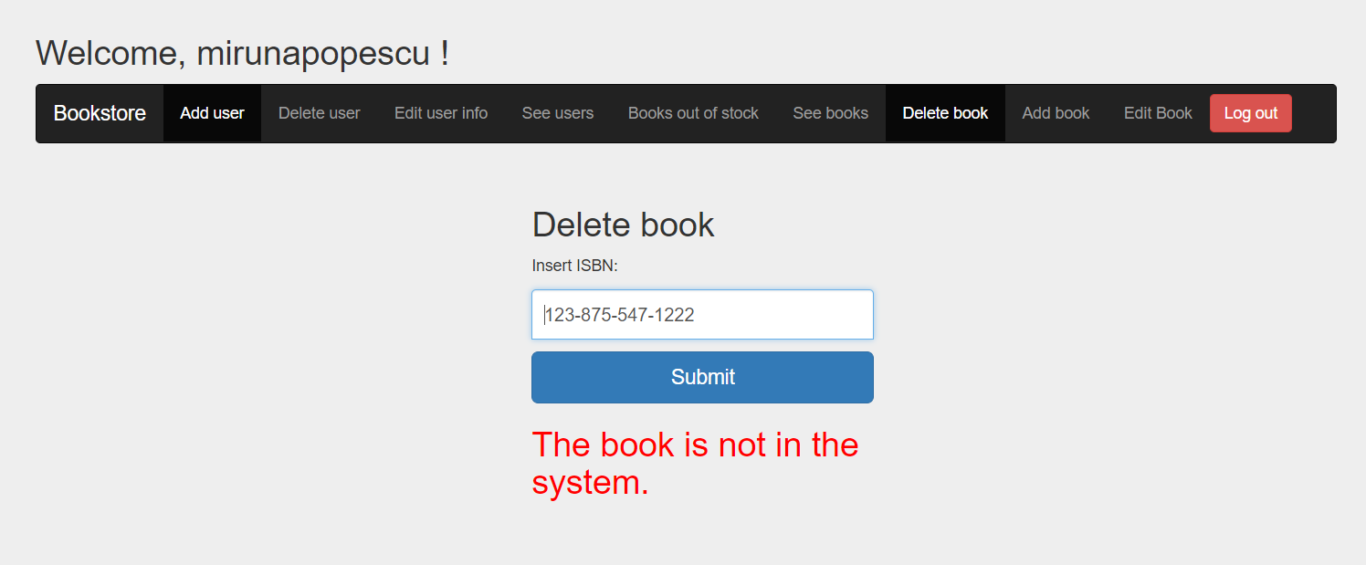

* + 1. *How to: See books*

To visualize all the books in the system and information about them enter the “See books” menu:

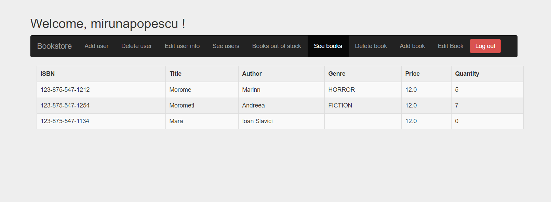

* 1. Employee
     1. *How to: Login*

The login credentials for an employee are its username and password provided by the administrator. Write the username and password in the fields:

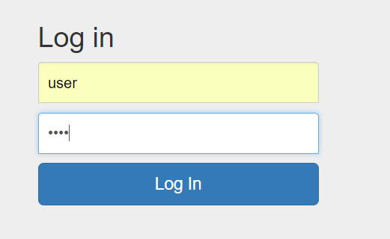

If the credentials are correct the following menu should appear:

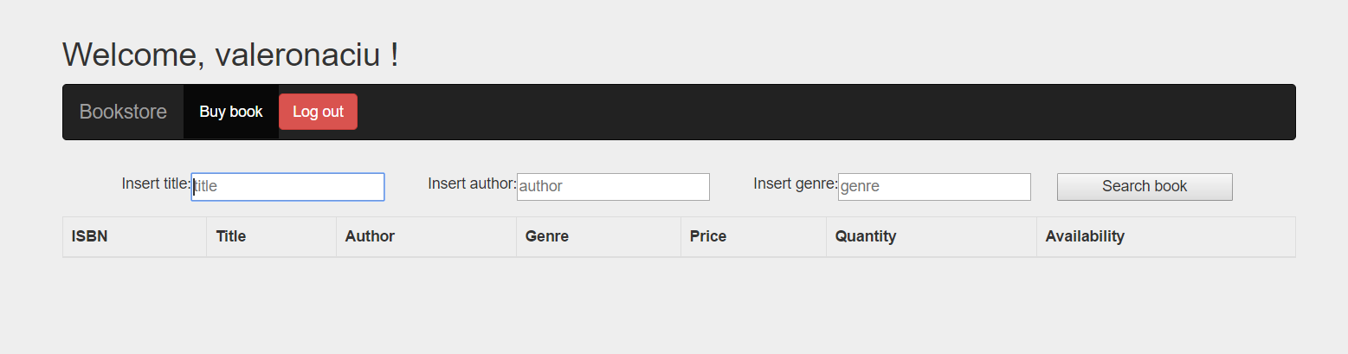

If the login is made incorrectly the following message should appear:

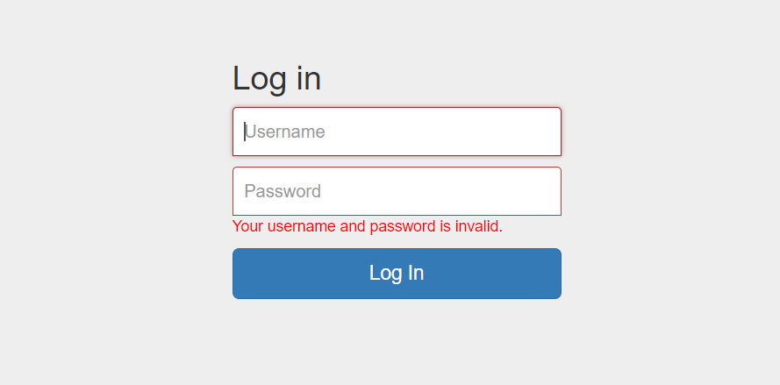

Try again with more attention.

* + 1. *How to: Logout*

To log out from the application press the logout button in the right of the menu. It will bring you back to the login page.

* + 1. *How to: Search books*

The books can be searched by title, author and/or by genre. All the books respecting these constraints will be shown in the table. Enter the title/author/genre or two of them or all of them and press search.

Example:

Searching by genre

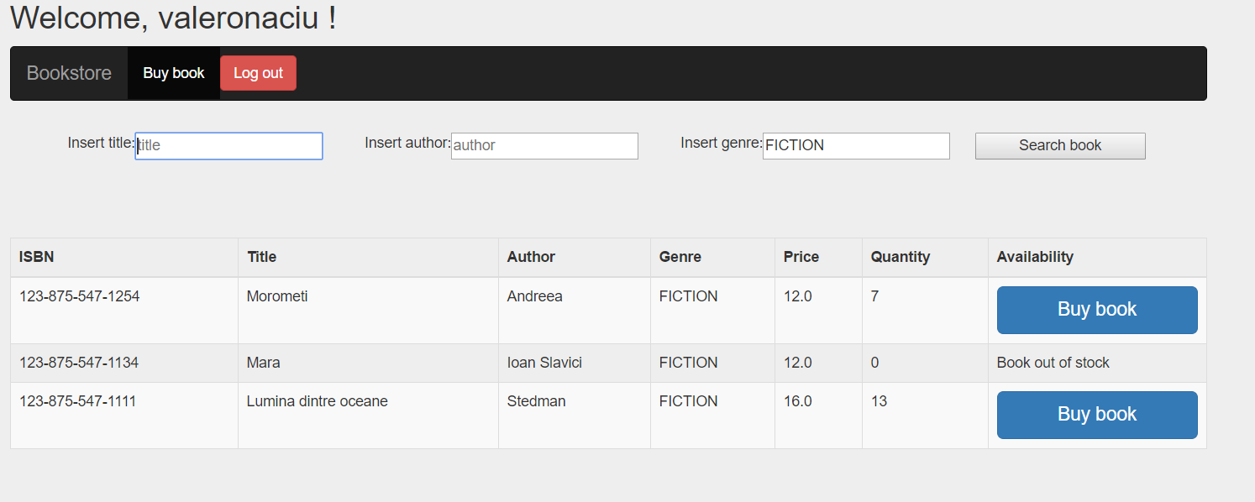

Searching by title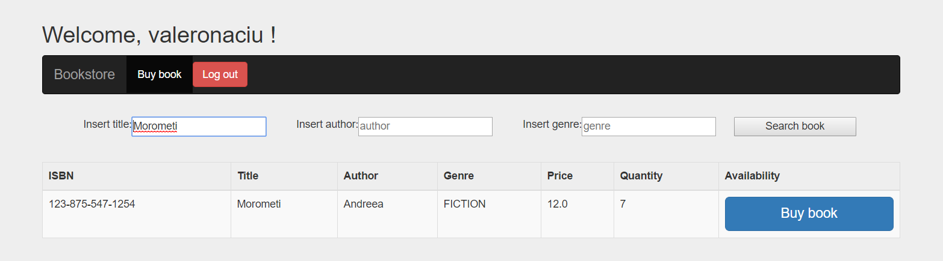

Searching by author

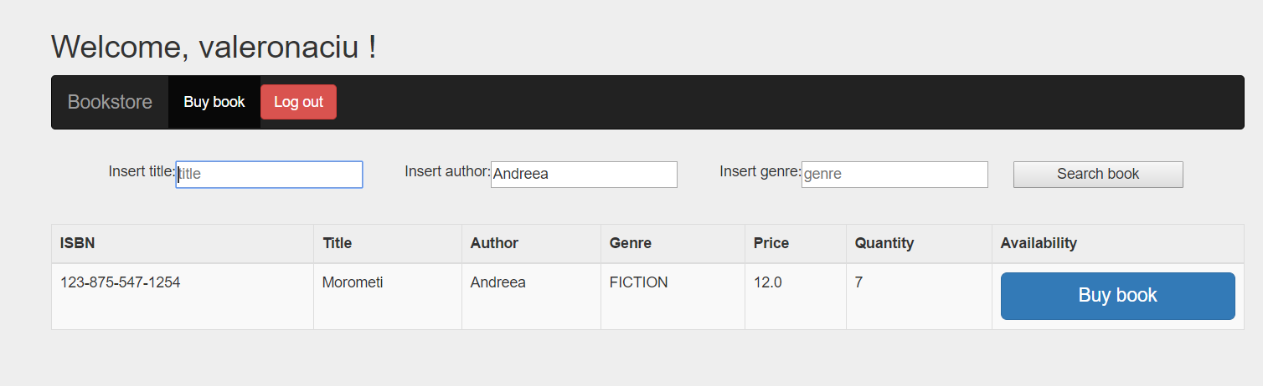

Search with by title and genre:

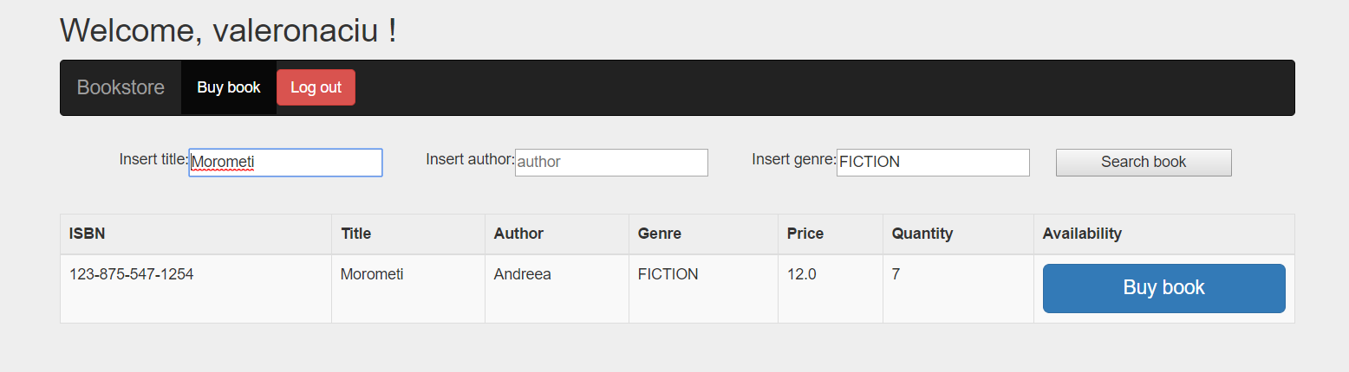

Search by title, author and genre:

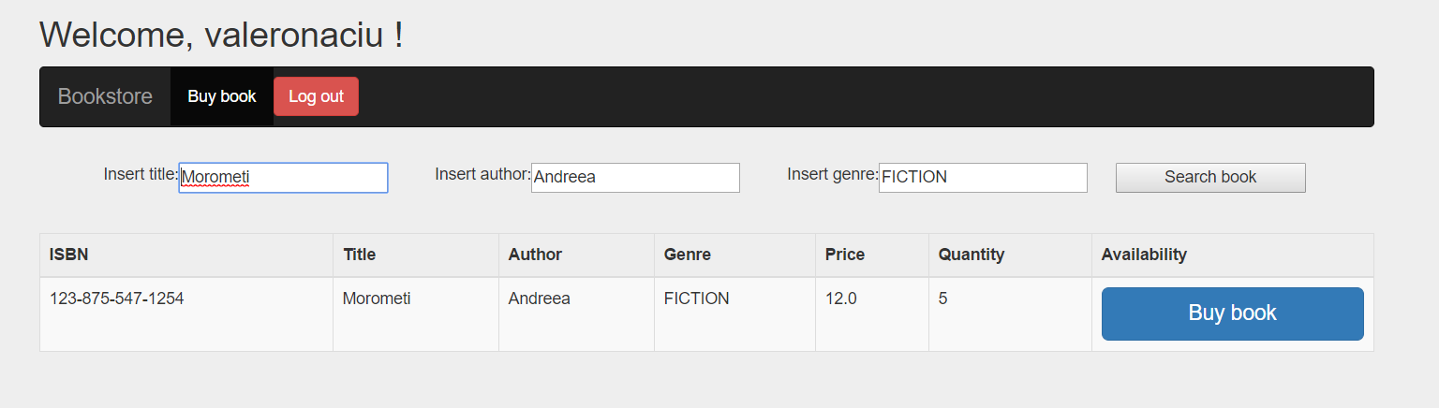

* + 1. *How to: Buy book*

To buy a book press the buy book button from the table in the row with the book you want to buy, books that cannot be bought will not have a button (in the availability column they have written “Book out of stock”). After pressing the button the following message will be shown:

