|  |
| --- |
| Tehnical university of cluj-napoca |
| MedicalSoft - WEB APPLICATION |
| *-READ ME FILE-* |
|  |
| **Andreea Onaciu** |
| **5/15/2017** |

|  |
| --- |
|  |

Contents

*1. Prerequisites…………………………………………………………………………2*

*2. Installation Process…………………………………………………………………3*

*3. How to use the application*

*3.1 Administrator*

*3.1.1 Login…………………….……………………………………….……….3*

*3.1.2 Log out…………………………………………………………….……..5*

*3.1.3 Add user…………………………………………………………….….. 5*

*3.1.4 Delete user………………………………………………………. .…….7*

*3.1.5 Update user……………………………………………………………..8*

*3.1.6 See users………………………………………………………………10*

*3.2 Secretary …….………………………………………………………………..10*

*3.2.1 Login ……………………………………………………………………10*

*3.2.2 Log out………………………………………………………………….11*

*3.2.3 Add patient ……………………………………………………………..12*

*3.2.4 Update patient info…………………………………………………….13*

*3.2.5 Add consultation………………………………………………………..15*

*3.2.6 Edit consultation………………………………………………………...17*

*3.2.7 Delete consultation………………………………………………….….19*

*3.2.8 See consultations………………………………………………………20*

*3.2.9 Notify doctor…………………………………………………………….20*

*3.3 Doctor*

*3.3.1 Login……………………………………………………………………..21*

*3.3.2 Log out………………………………………………………………...…21*

*3.3.3 Add patient consultation………………………………………………..21 3.3.4 View patient consultation……………………………………………….22*

1. Prerequisites

For using the application the following programs need to be available on your computer : Java Development Kit, MySql Workbench and Tomcat server.

* 1. Installing Java Development Kit

You can download the JDK from this link: <http://www.oracle.com/technetwork/java/javase/downloads/jdk8-downloads-2133151.html>

Select the appropriate version according to your operating system and click on “Accept licence agreement”.Then simply run the executable you downloaded and follow the installation steps.

* 1. Installing MySql Workbench

You can download MySql Workbench from this link:

<https://dev.mysql.com/downloads/workbench/>

Pay attention to select the version appropriate to you operating system and follow the installation steps described here:

<https://dev.mysql.com/doc/refman/5.7/en/installing.html>

After the finishing the installation process, open the workbench and add a new connection by clicking on the “+” button near MySql Connections give a new connection name of your choice and set the username: “root” and the password “bankAssignment”.

* 1. Installing TomCat Server

To install Tom Cat server first you have to install the JDK. For downloading the server you can access the following link:

<https://tomcat.apache.org/download-70.cgi>

Download the appropriate archive according to your operating system, after that unzip it and to be able to start the server you have to set the environment variables:

-right click MyComputer

->Properties ->Advanced system settings ->Advanced Menu -> Environement Variables->New-> Variable name: JAVA_HOME Variable value: here you have to enter the path of the jdk file that you installed in the step 1.1-> Ok.

To start the server enter in the bin folder of the archive and double click the startup.bat file. A terminal should appear showing that the server has started. To close the server double click on the shoutDown.bat file also found in the bin folder.

1. Installation process

* To actually start the application, first enter in the config folder of the tomcat server, open tomcat-users.xml file and copy the username and password.
* Start the server and access on your browser the address: <http://localhost:8181/> , a web page of the apache tomcat server should appear;
* Click on the Manager App button in the right part of the screen and an authentication window should appear asking for the username and password you copied from the tomcat-users.xml file, click log in.
* A tomcat application manager should appear, go to the deploy section and press Choose file, select the .war file of the application, which you can find in the target folder. Then click deploy.

1. How to use the application
   1. Administrator
      1. *How to: Login*

The login page is the first page of the application. For the administrator to login, he should enter his credentials in the login fields:

Username: andreeaonaciu

Password: andreeaonaciu

Login page:

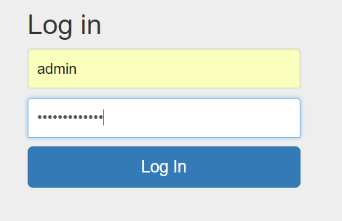

If the credentials are correctly introduced the following menu should appear:

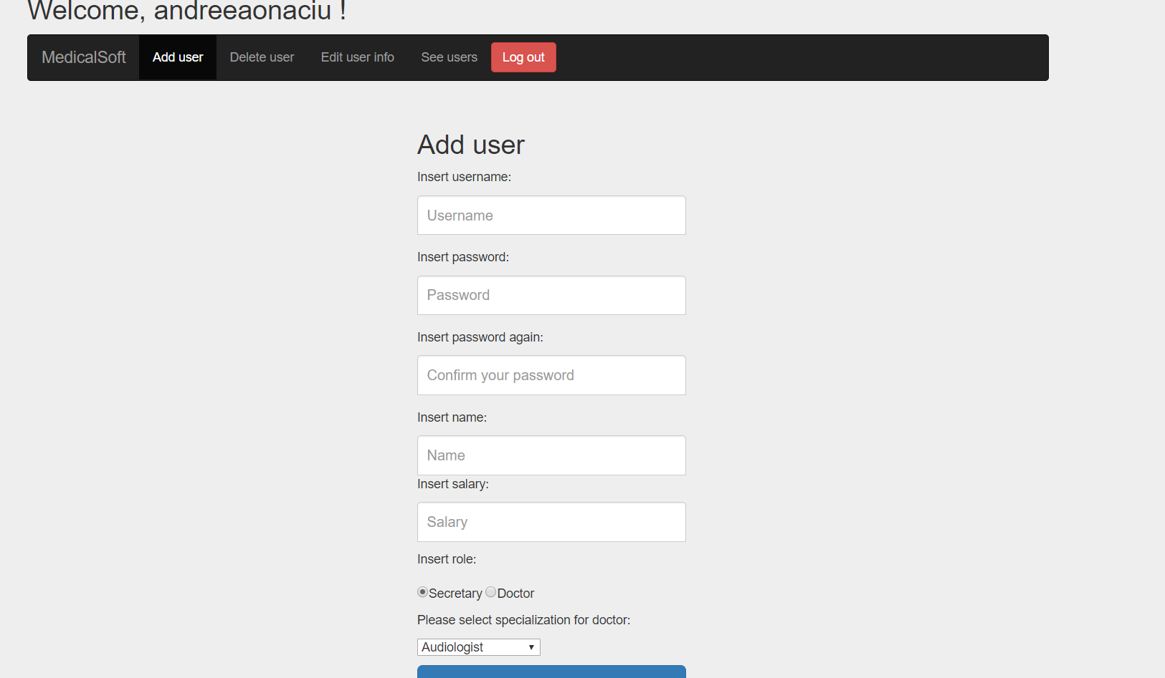

If the credentials are incorrectly introduced the following message will appear:

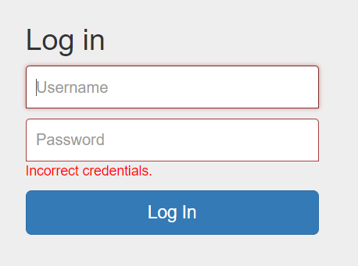

Try to introduce again the credentials, with more attention.

* + 1. *How to: Log out*

To log out from the application press the logout button in the right of the menu. It will bring you back to the login page.

* + 1. *How to: Add user*

To add an user press the “Add user” button from the menu. This form will appear:

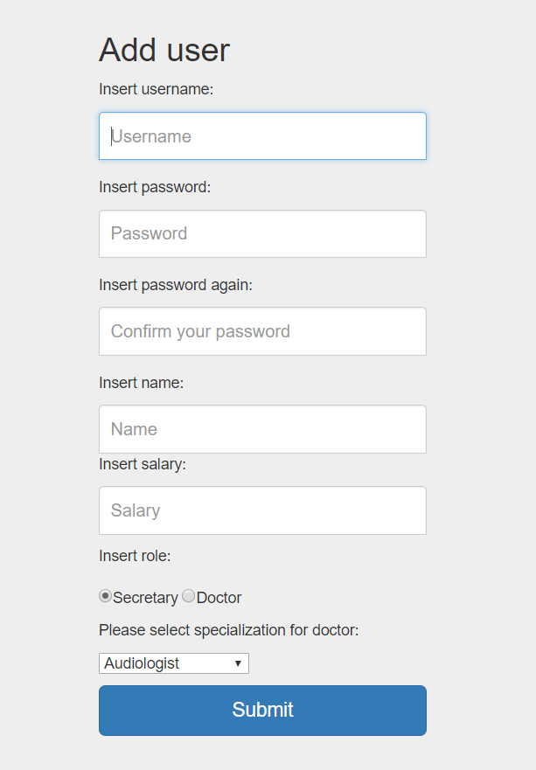

To add an user all the fields must be completed respecting the following constraints:

-username length greater than 3;

-password length greater than 3;

-name length greater than 3 and unique;

-positive salary value;

The admin can add either a secretary or a doctor, for doctor, you can select the specialization of the doctor from the drop down menu.

If the user is added successfully the following message will appear:

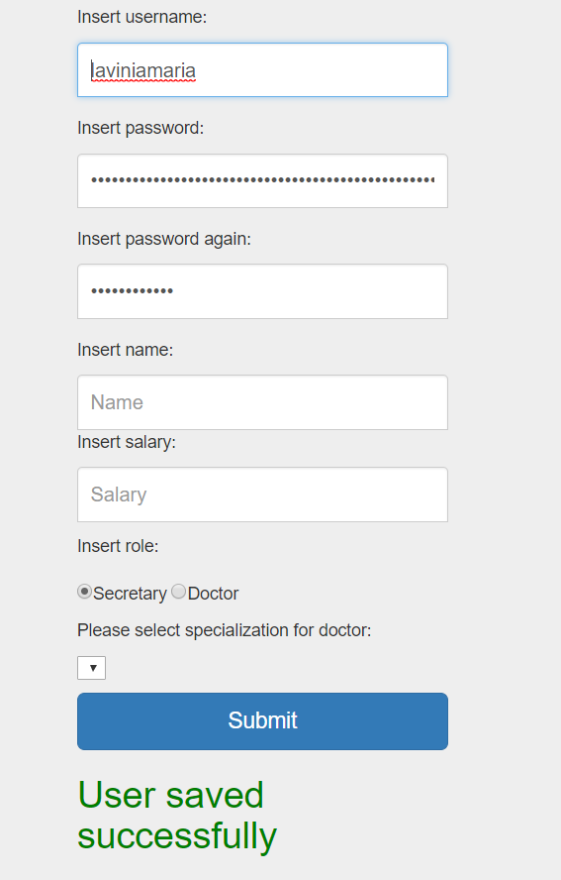

If the data you entered for the new user is incorrect a message saying what you did wrong will appear:

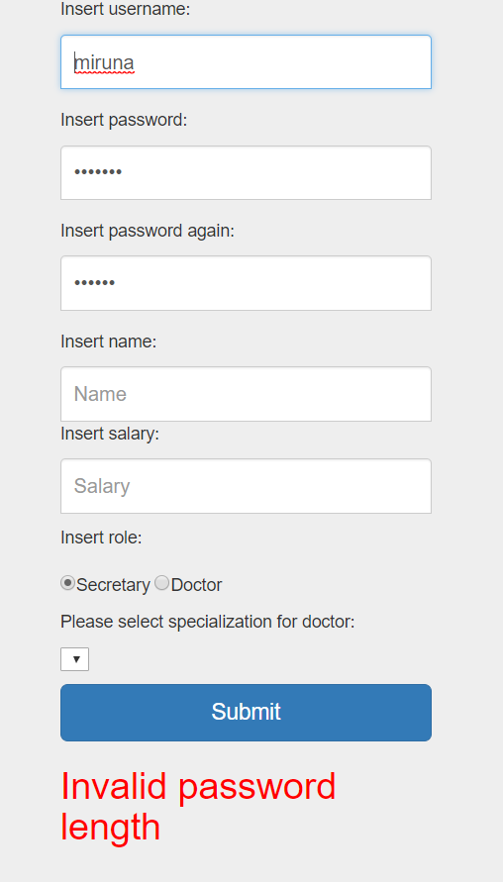

* + 1. *How to: Delete user*

To delete an user enter in the delete user menu and write the user username:

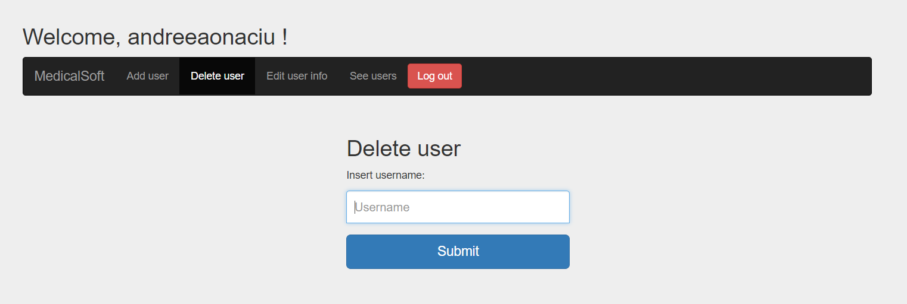

If there is no user with this username the following message will appear:

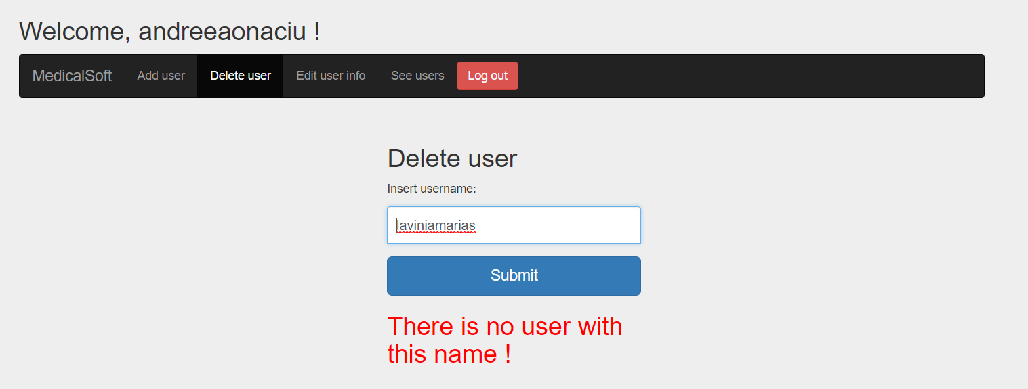

To delete the user press the delete button, the following message will appear:

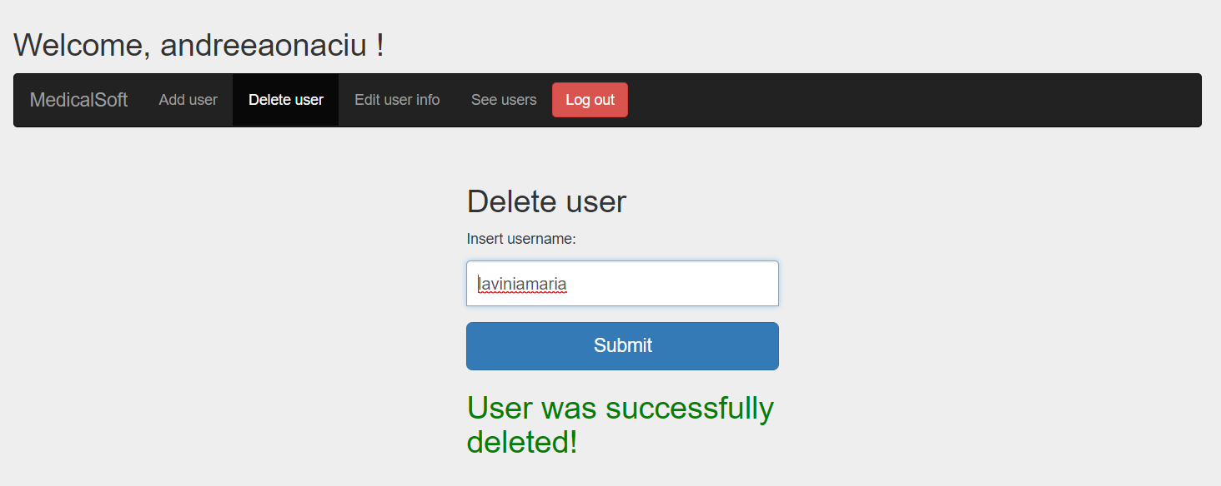

* + 1. *How to: Update user*

To edit user information enter the update user menu.

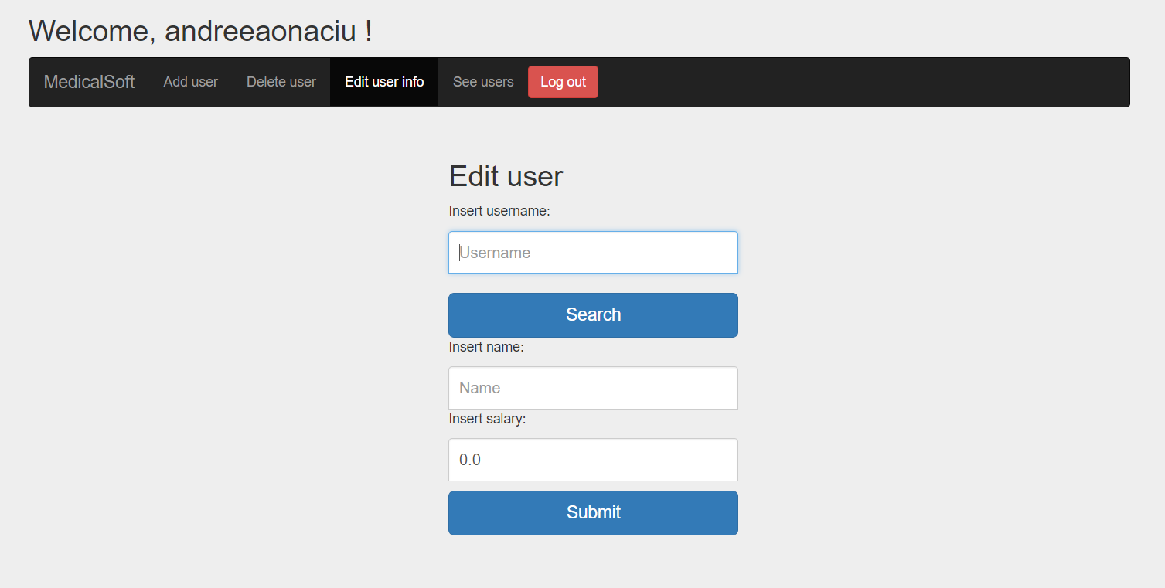

Search the employee by writing correctly its username in the first field and then press the search button. The fields should be filled with the employee information.

If the username is not correctly an error message will be shown.

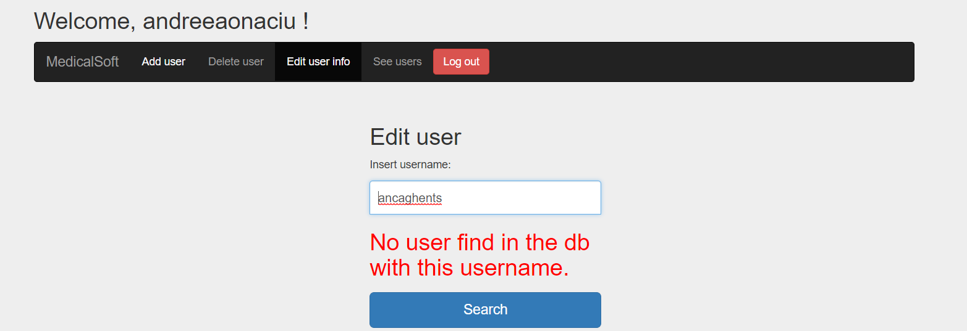

You can update username, password and salary fields. Respecting the constraints mentioned at the Add employee use case (3.1.3). If updated was done correctly this message will appear:

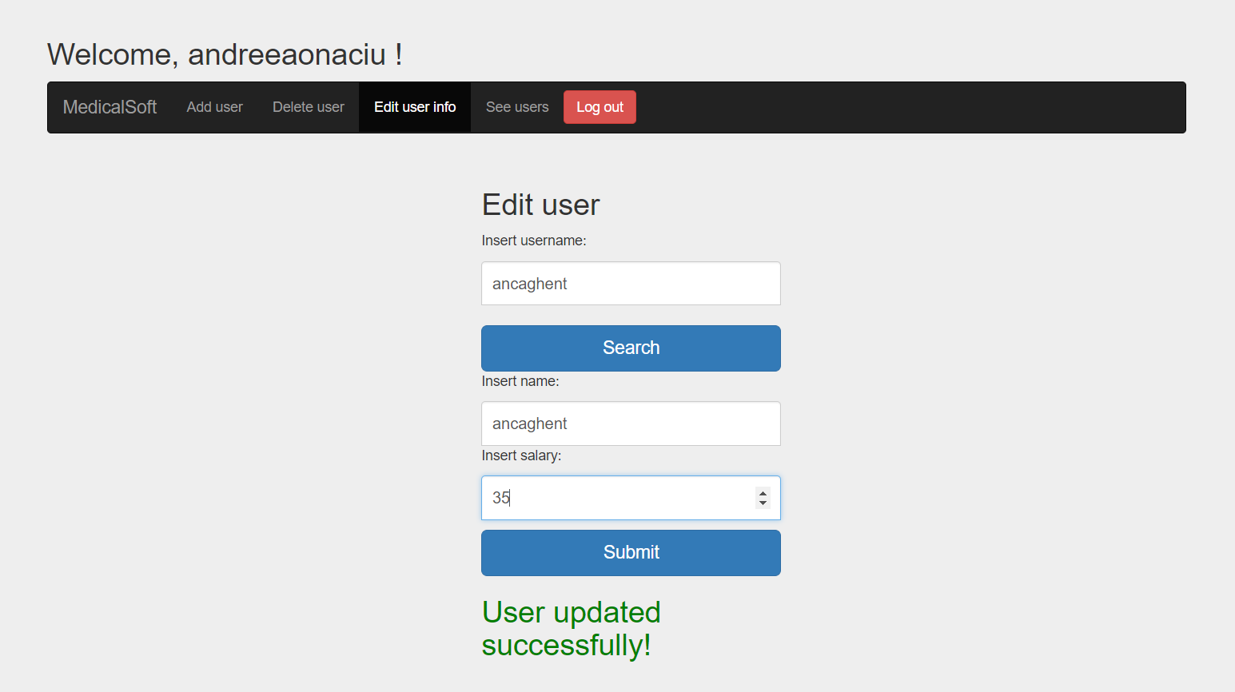

If incorrect information is placed:

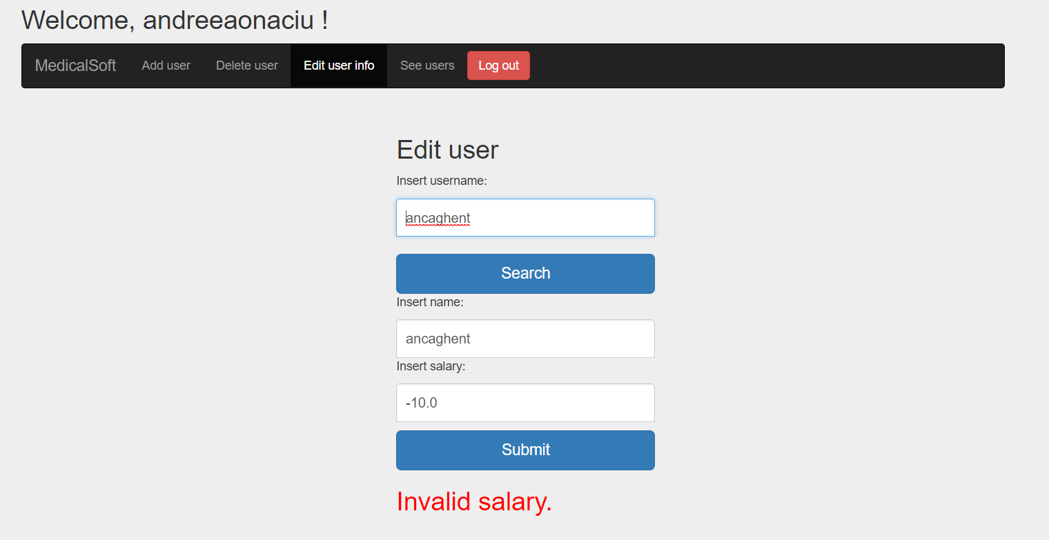

* + 1. *How to: See users*

Too see all the users enter in the “See users” menu:

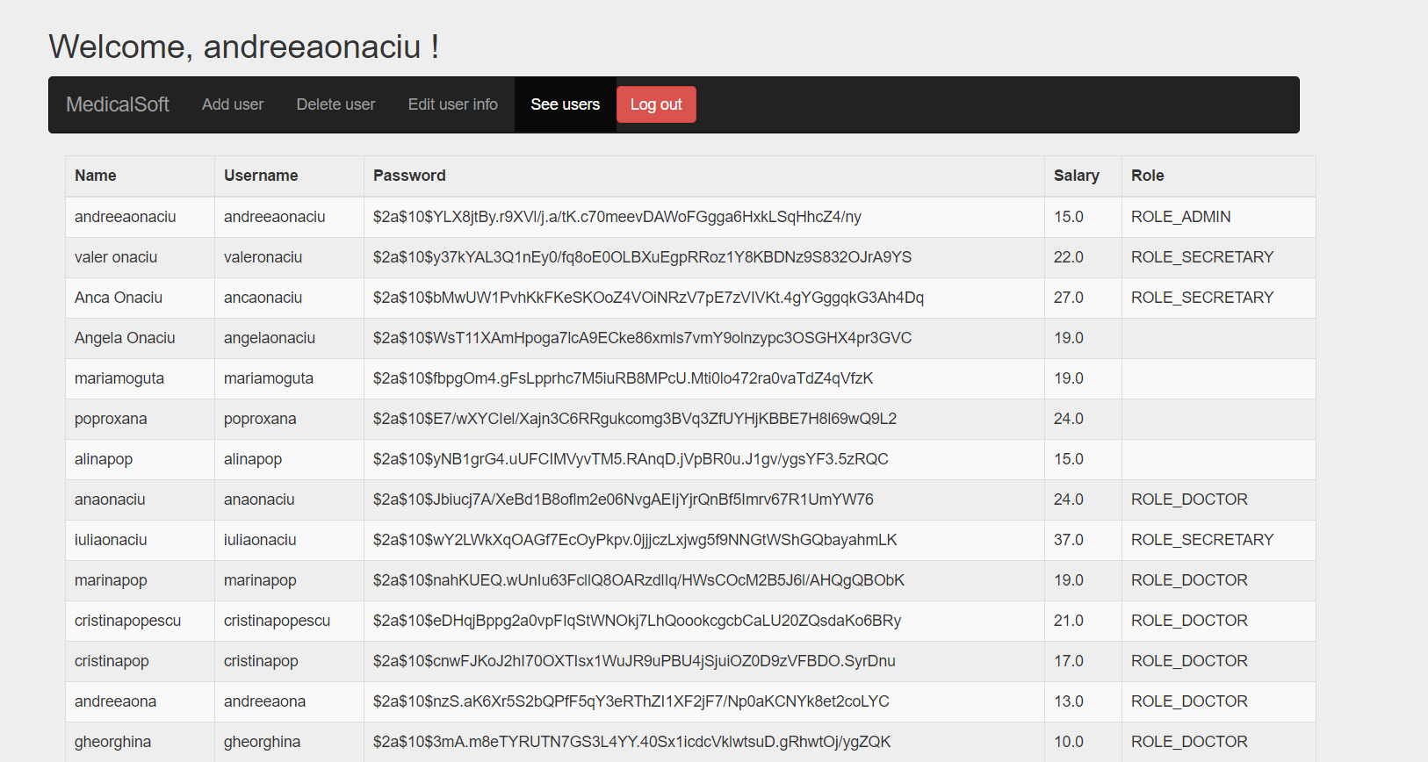

* 1. Secretary
     1. *How to: Login*

The login credentials for an employee are its username and password provided by the administrator. Write the username and password in the fields:

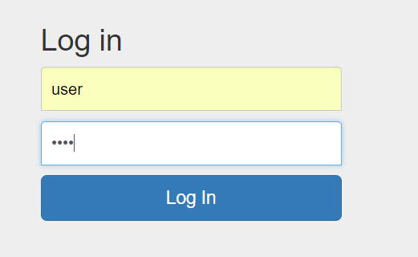

If the credentials are correct the following menu should appear:

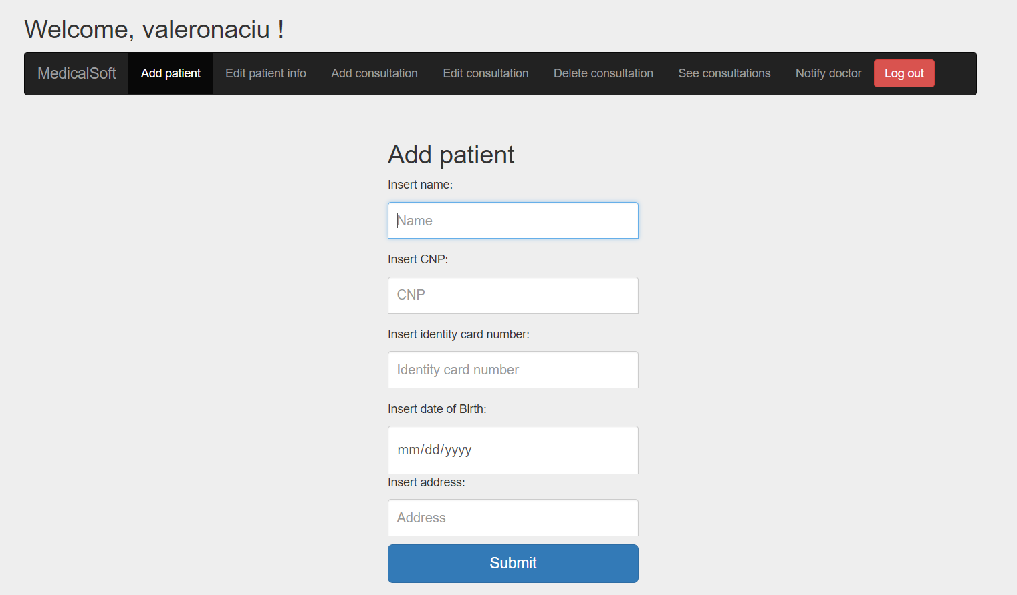

If the login is made incorrectly the following message should appear:

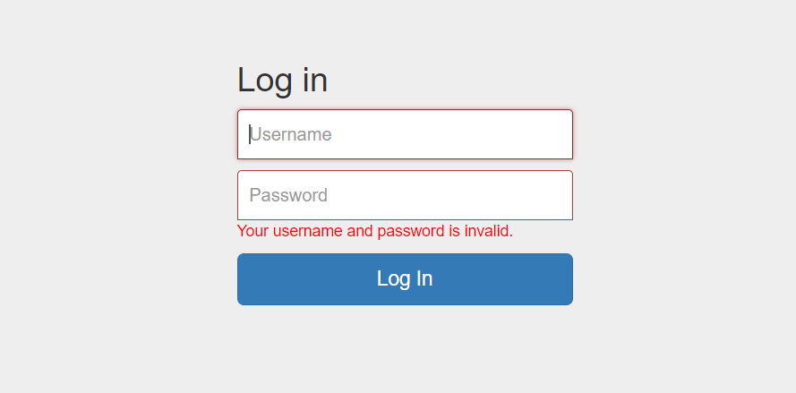

Try again with more attention.

* + 1. *How to: Logout*

To log out from the application press the logout button in the right of the menu. It will bring you back to the login page.

* + 1. *How to: Add patient*

Select “add patient” from the client operations menu.



Enter client information respecting the following constraints:

-> name length greater than 3 and only letters;

-> identity card number form only by numbers and having the length equal with 6;

-> valid CNP;

-> all the fields are mandatory;

Click add client, a success message should be shown if the constraints are met:

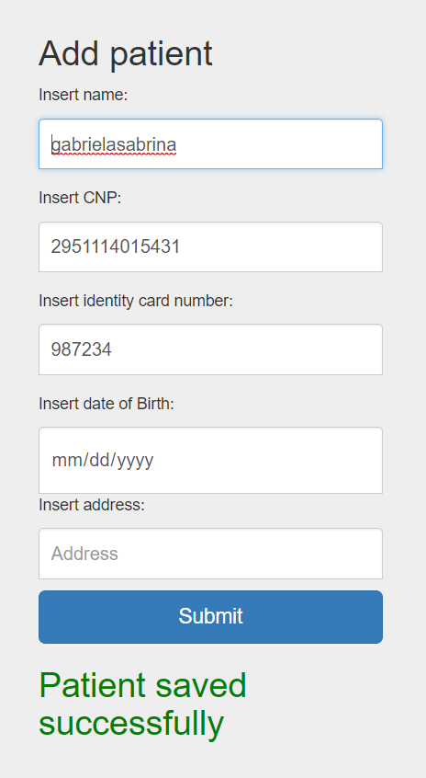

Otherwise an error message showing which is the error is shown.

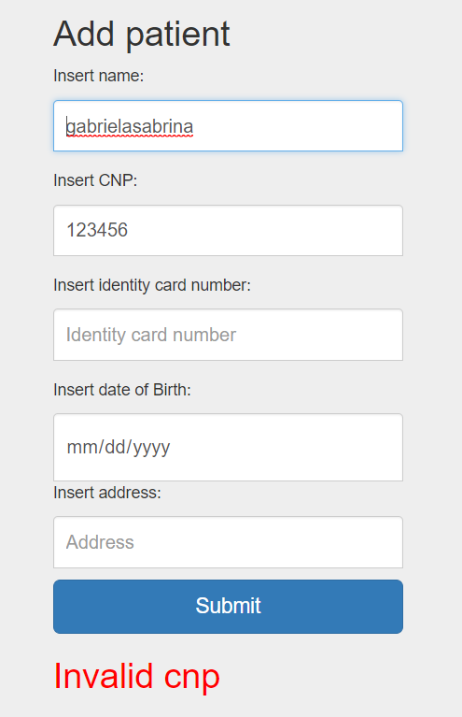

* + 1. *How to: Update patient information*

Select the “Edit patient info” menu.

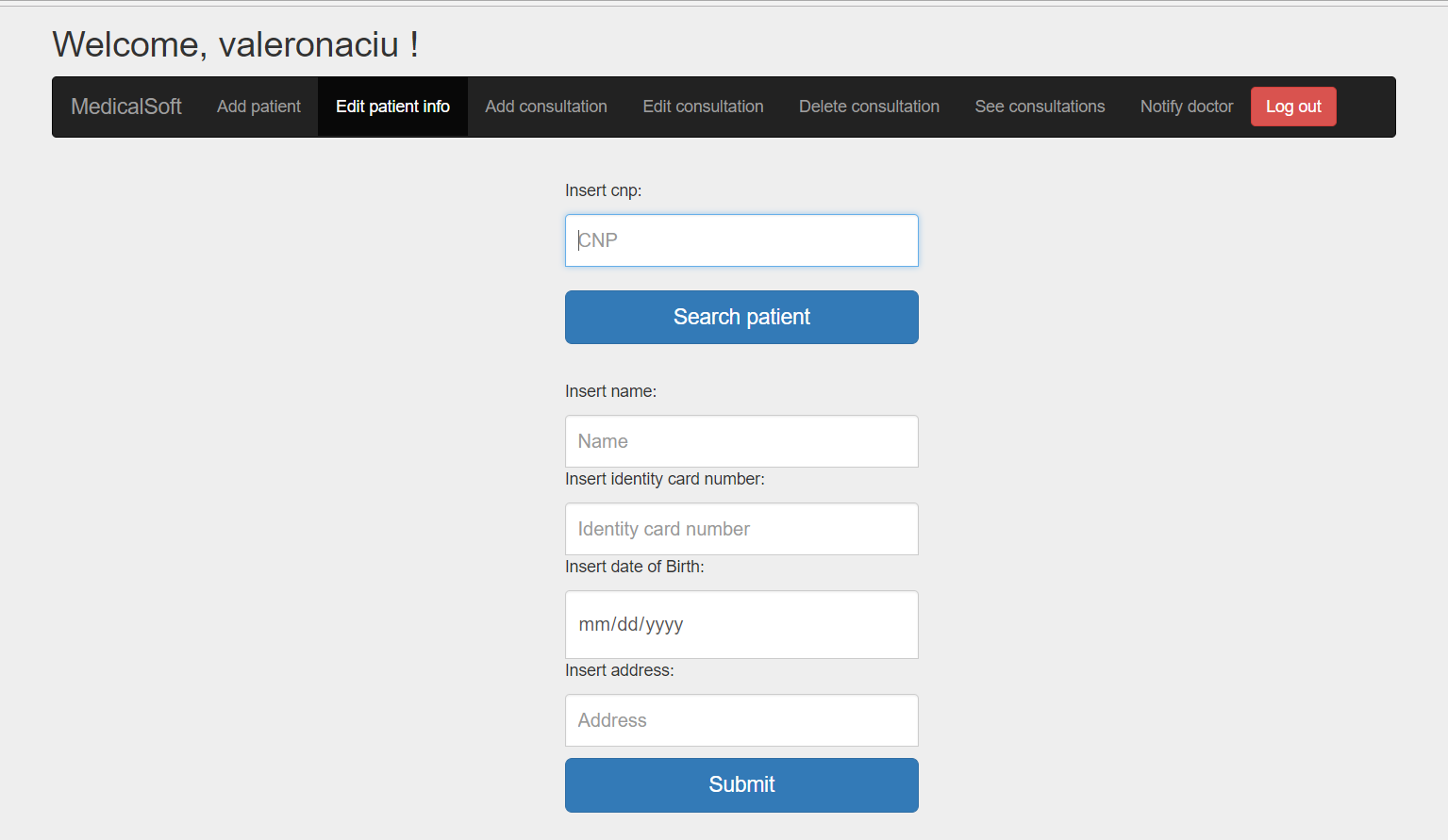

Search client by entering his CNP. If the CNP exists the fields will be filled with patient info:

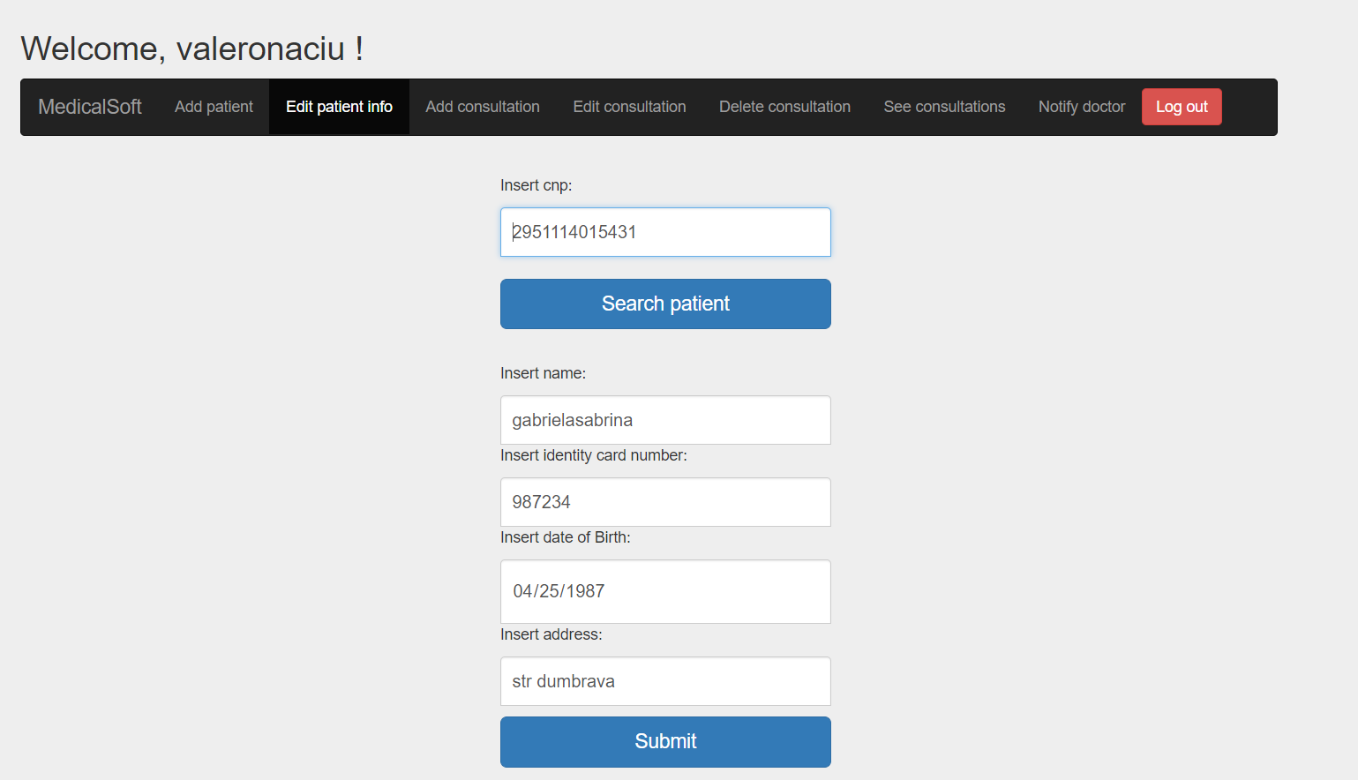

If cnp incorrect the following message will appear:

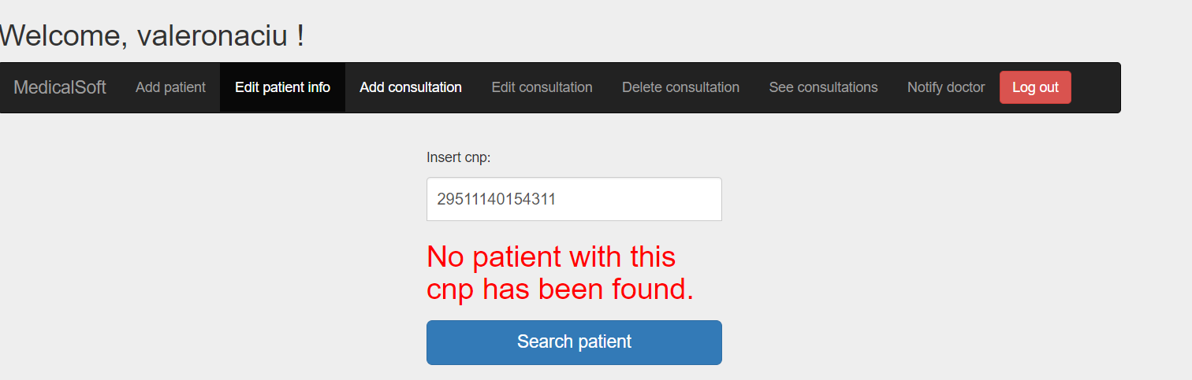

You can update his name, identity number and address and birth date. Press update to save the new information. The new data must respect the constraints written at the point 3.2.2.

Valid message:

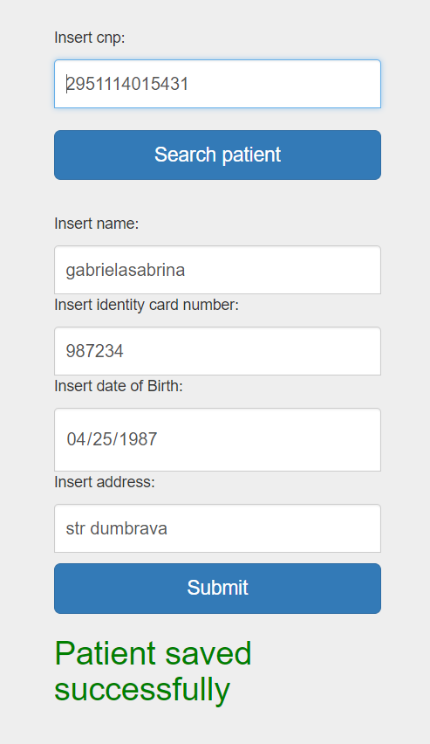

* + 1. *How to: Add consultation*

To add consultations select the “Add consultation” menu.

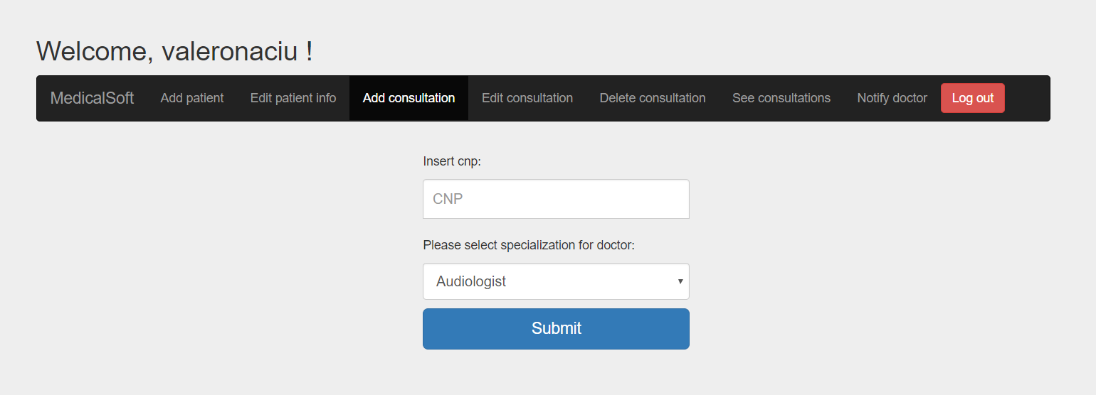

Enter the cnp of the patient and select the type of the doctor the patient wants to visit. If invalid cnp the following message will appear:

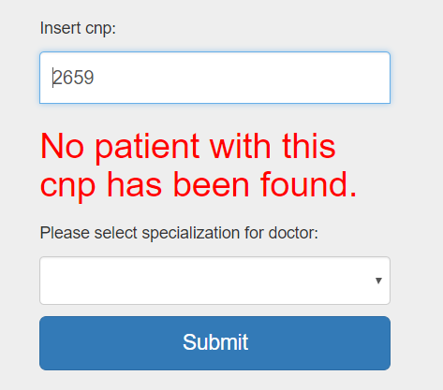

If valid cnp the following page will appear:

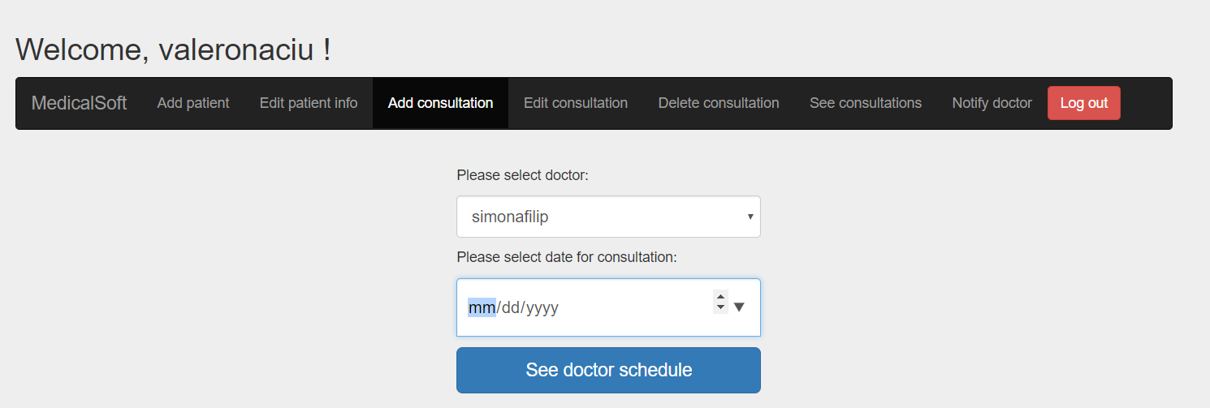

Select the doctor (the doctor list will be according to the specialization you have chosen) and the day in which the consultation has to take place.

In the next step the following window will appear:

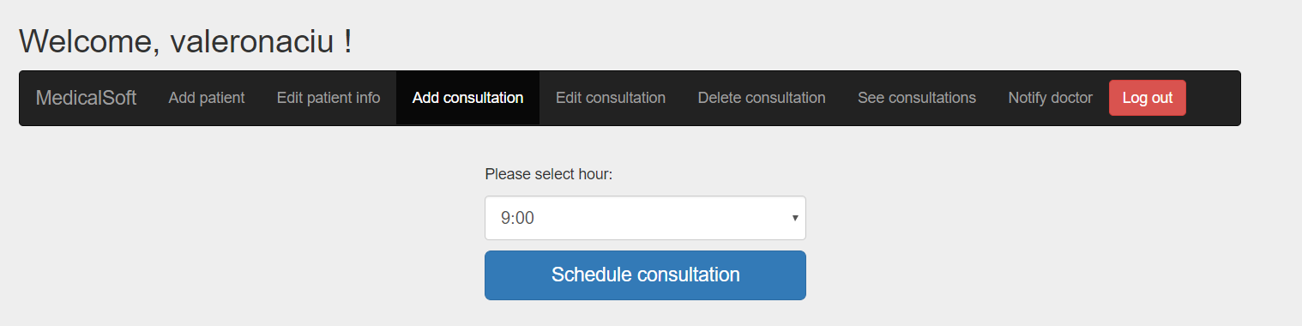

You have to select the hour at which the consultation will be made (only valid hours will appear). Press schedule consultation and the consultation will be made:

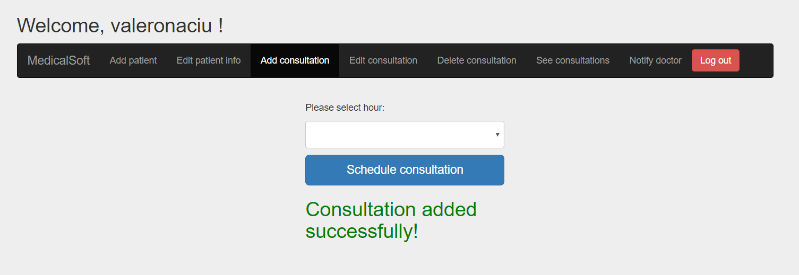

* + 1. *How to: Edit consultation*

To edit a consultation enter the “Edit consultation” menu:

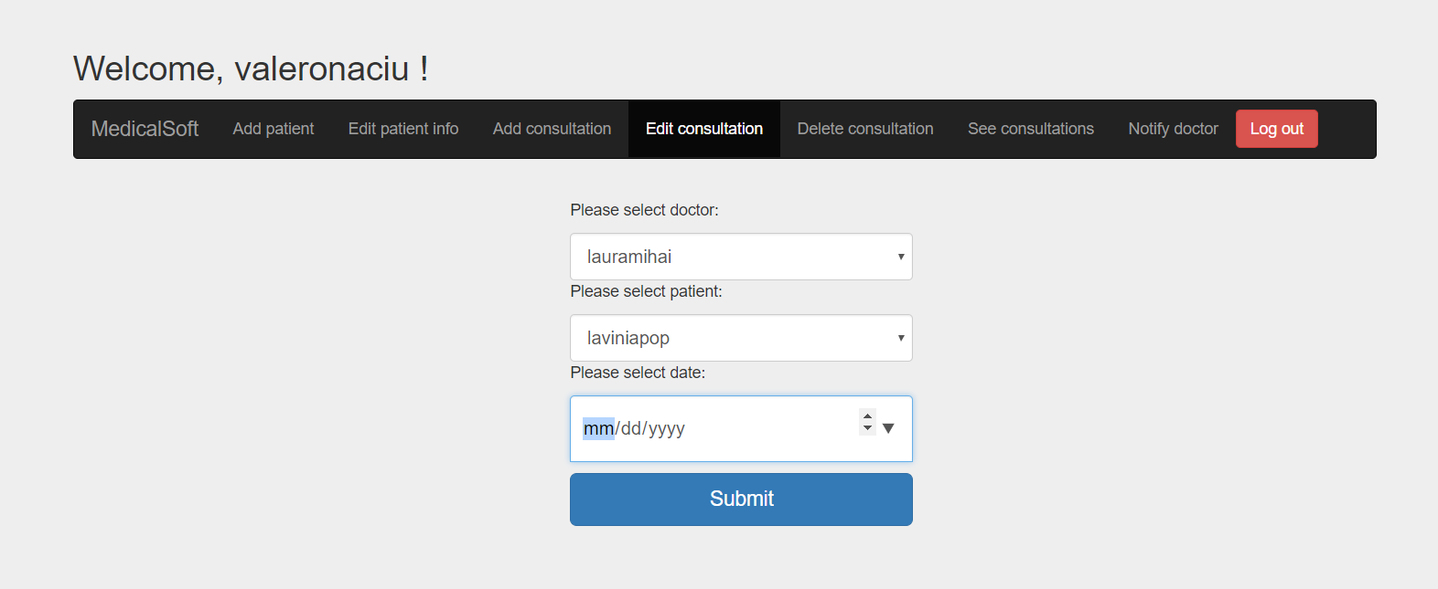

Select the doctor, patient and the date of the consultation, if the consultation is found in the database the following window will appear:

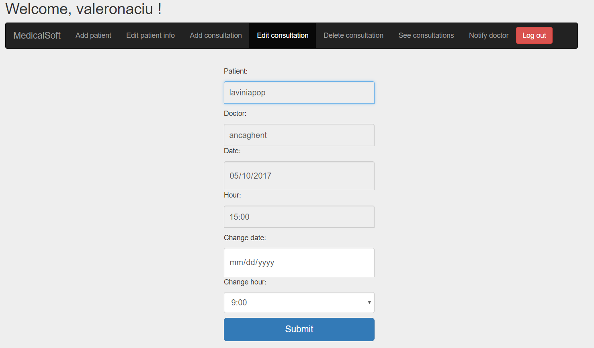

Otherwise the following message will appear:

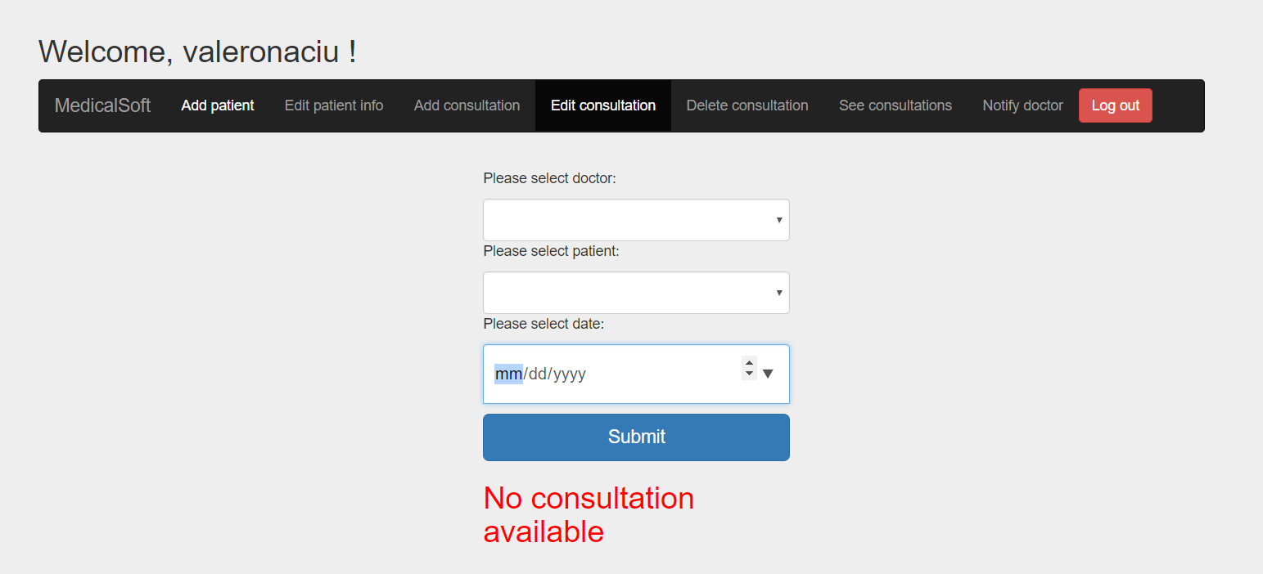

You can change the date and the hour of the consultation press submit and the consultation will be edited:

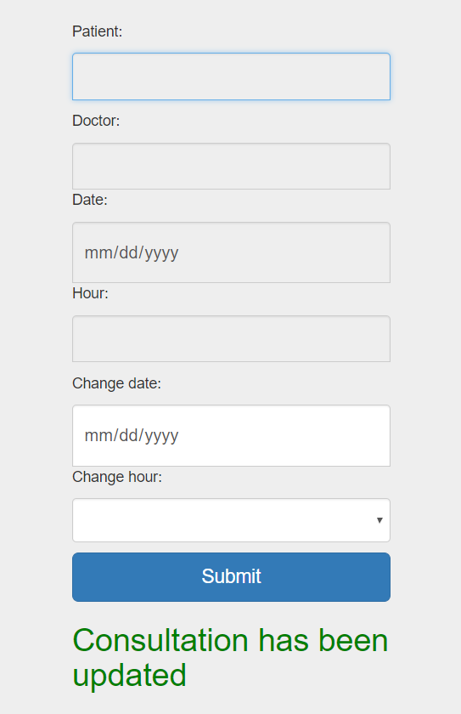

* + 1. *How to: Delete consultation*

To delete a consultation enter the “Delete consultation” menu:

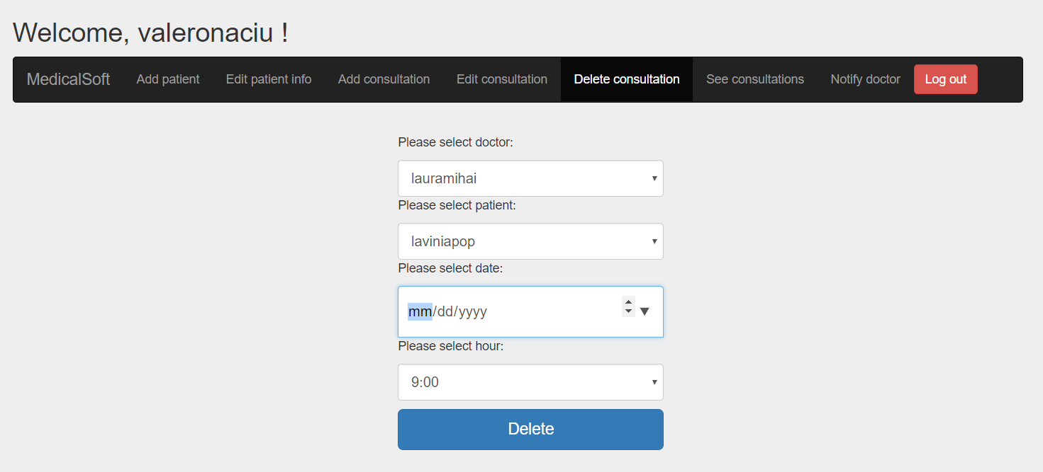

Enter the information regarding the consultation. If invalid information is provided the following message will appear:

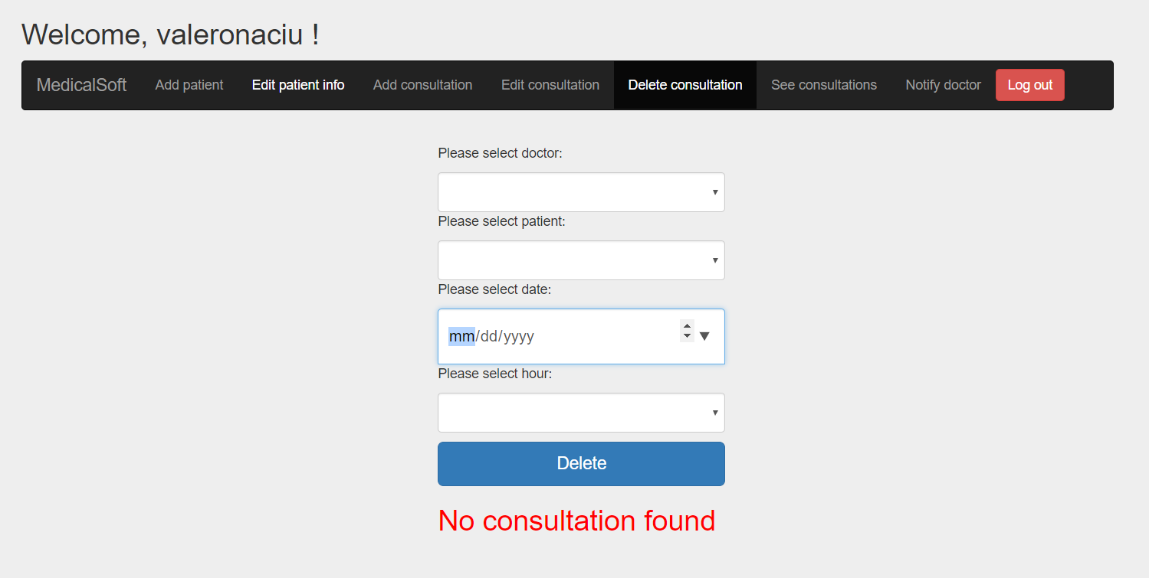

*If valid information is provided the consultation will be deleted when the “Delete” button is pressed and the following message will appear:*

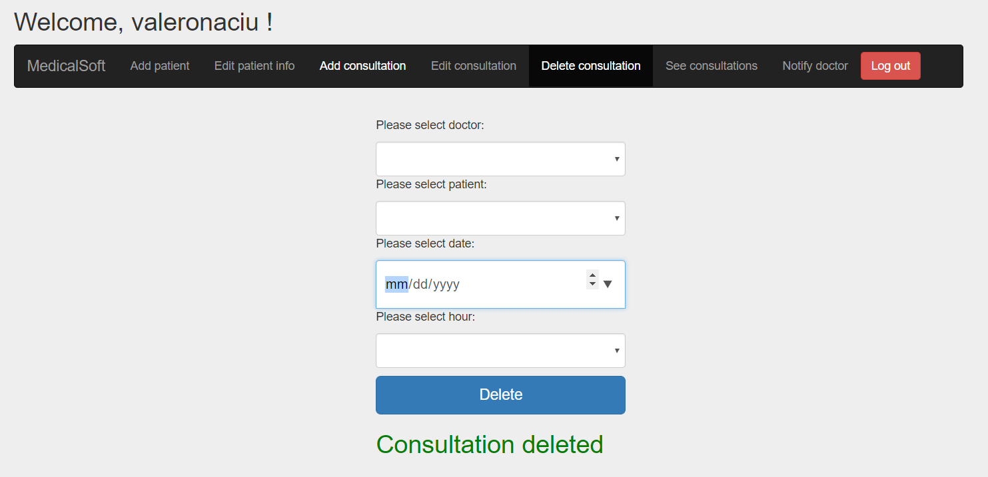

* + 1. *How to: See consultations*

To see consultations enter the consultation menu:

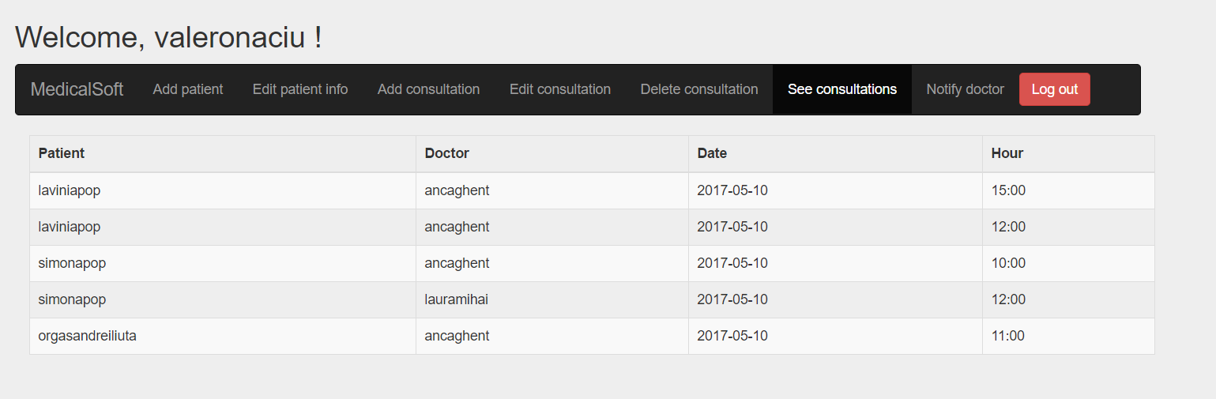

* + 1. *How to: Notify doctor*

Enter in the notify menu, which will look like this:

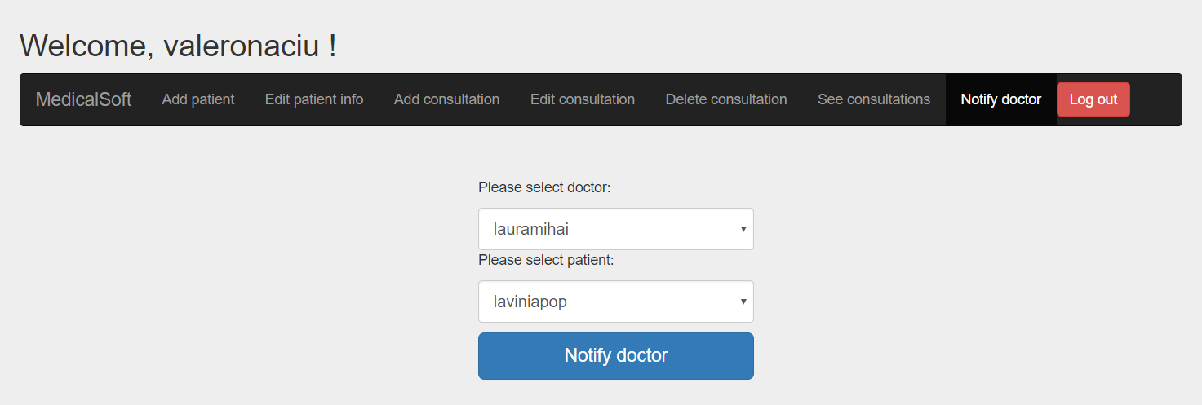

Select the doctor who you want to notify and the patient that has arrived and press the button “Notify doctor”. A notification will be send to the doctor which you have selected.

The notification will appear like this and will appear in the doctor browser:

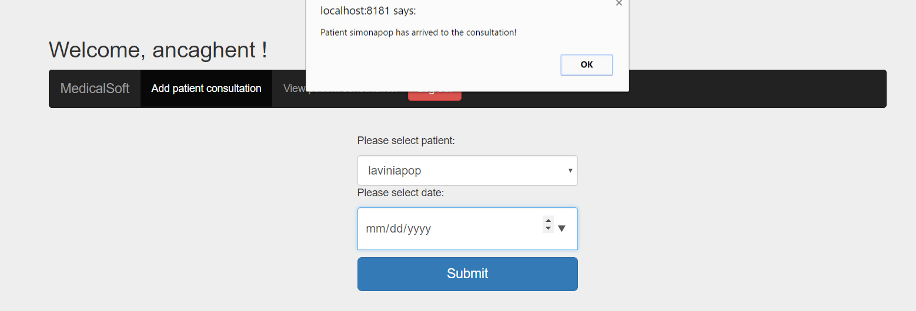

* 1. Doctor
     1. *How to: Login*

*See chapter: 3.2.1.*

* + 1. *How to: Logout*

*See chapter: 3.2.2.*

* + 1. *How to: Add patient consultation*

To add patient consultation enter the “Add patient consultation” menu:

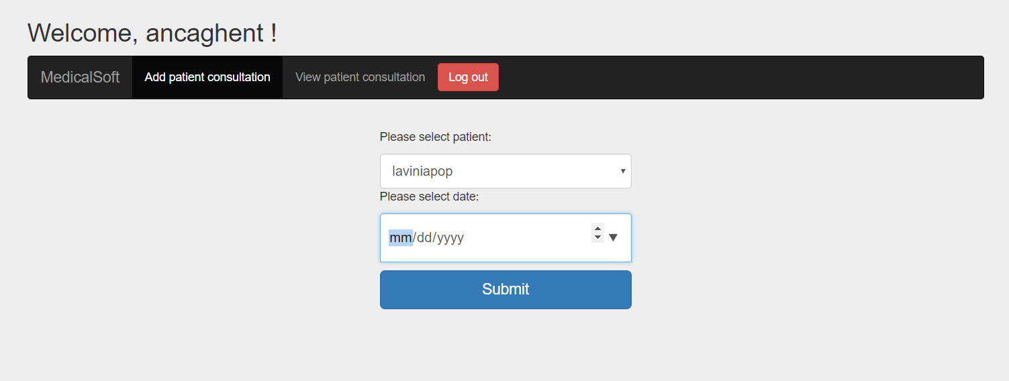

Select a patient and a date for the consultation. Then press submit, the following page will appear:

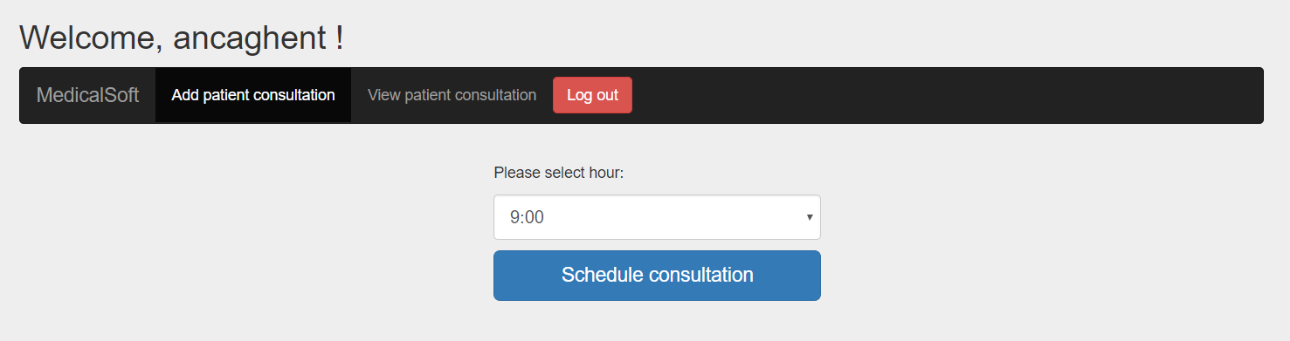

Select an hour(only valid hours for that day will appear).

Press “Schedule consultation” and the following message will appear:

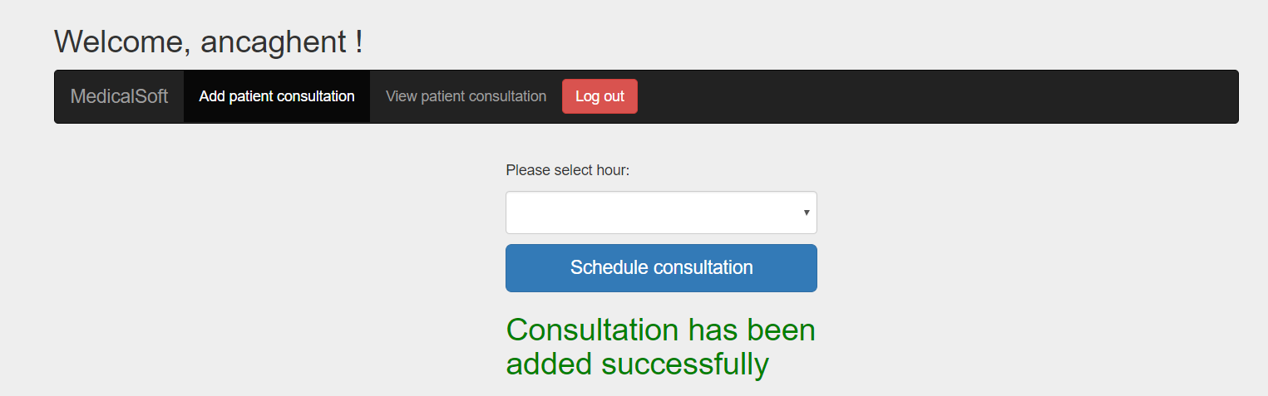

* + 1. *How to: View patient consultation*

To see consultation enter the view patient consultation menu:

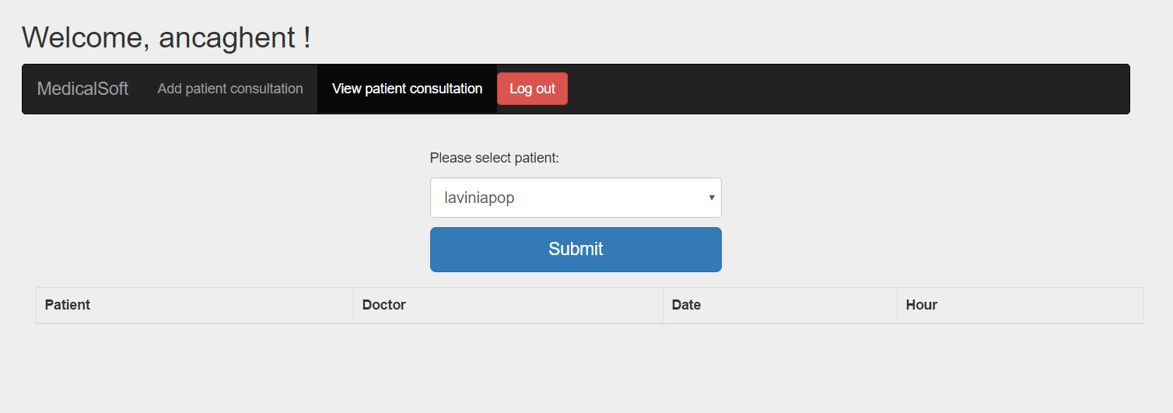

Select the patient’s consultation you want to see:

