- Team Info:
No | Name | ID | Level | Department
1 | احمد محمد عمر محمد | 20225120 | 4 | Software Eng.
2 | إسماعيل اشرف إسماعيل حسن | 20225127 | 4 | Software Eng.
3 | الامير خالد الأمير محمد | 20225129 | 4 | Software Eng.
4 | إيمان احمد سعيد محمد | 20225131 | 4 | Software Eng.
5 | حبيبة محمود مصطفي زكي | 20225138 | 4 | Software Eng.
6 | رولا عصام الدين حسن | 20225155 | 4 | Software Eng.

- Project Overview:
  - Introduction
    - This project aims to demonstrate the solution of N-Queen Puzzle With 4 Different Algorithms
    - Also Generate Plotted Report To help Compare Result between the 4 algorithms
  - Application Type
    - Desktop application
  - Literature Review
    - Backtracking
    - Best first
    - Hill climb
    - Cultural
    - Additional Link
- Solution:
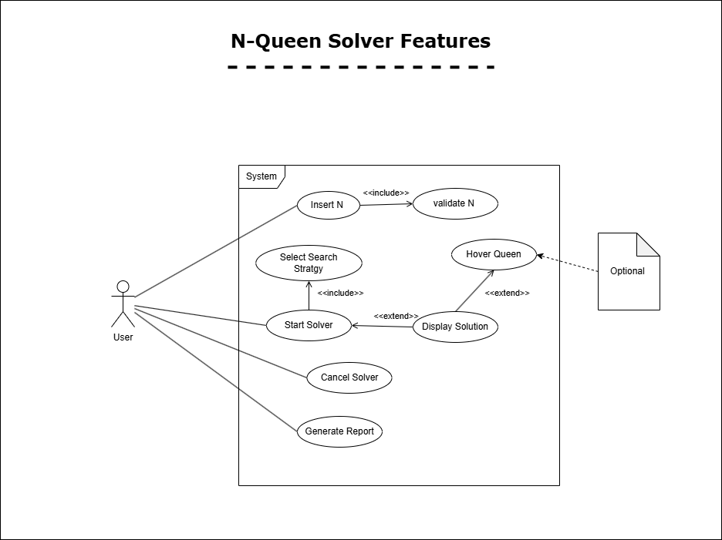

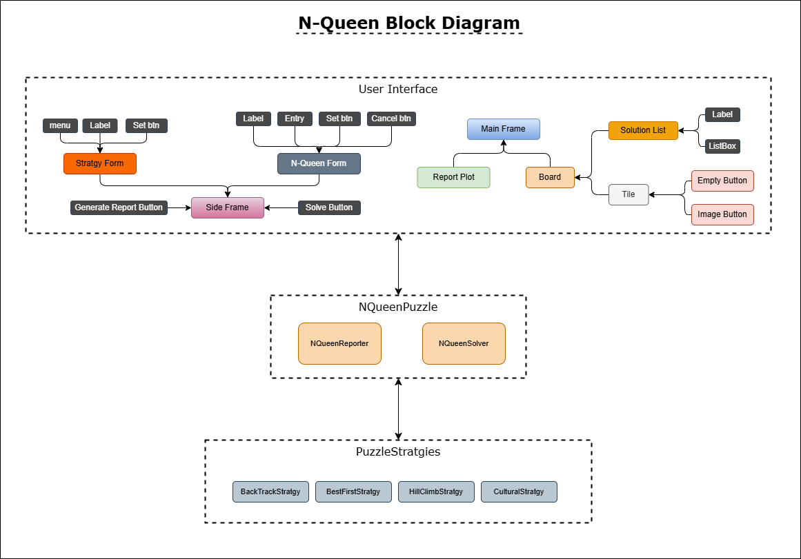
- Applied Algorithms:

