` MINI PROJECT REPORT ON
“NutriAI: An AI-Powered Nutrition Assistant
for College Students”

Submitted to

KIIT Deemed to be University

In Partial Fulfilment of the Requirement for the Award of

BACHELOR’S DEGREE IN

COMPUTER SCIENCE AND SYSTEM ENGINEERING

Submitted by
Yashraj Singh (2328058) Sagar Dutta (2328115)
Subhang Raj (2328131) Uddipt Shankar (2328136)
Sanjam Das (2328196) Samanway Dutta Roy (2328224)

Under the Guidance of
Ms. Indu

Assistant Professor, School of Computer Engineering

SCHOOL OF COMPUTER ENGINEERING
KALINGA INSTITUTE OF INDUSTRIAL TECHNOLOGY
(Deemed to be University)
Bhubaneswar, Odisha – 751024
Academic Year: 2025–26 (Spring Semester)
SCHOOL OF COMPUTER ENGINEERING
KALINGA INSTITUTE OF INDUSTRIAL TECHNOLOGY

(Deemed to be University), Bhubaneswar – 751024

CERTIFICATE

This is to certify that the Mini Project Report entitled

“NutriAI: An AI-Powered Nutrition Assistant for College Students”

has been carried out by the following students of B.Tech (Computer Science and Engineering), School of Computer Engineering, KIIT University, Bhubaneswar, in partial fulfilment of the requirements for the award of the degree of Bachelor of Technology in Computer Science and Engineering during the Academic Year 2025–26 (Spring Semester).

Yashraj Singh (2328058) Sagar Dutta (2328115)
Subhang Raj (2328131) Uddipt Shankar (2328136)
Sanjam Das (2328196) Samanway Dutta Roy (2328224)

This project work is their original work and has not been submitted elsewhere for the award of any other degree or diploma.

Project Guide  Ms. Indu  Assistant Professor  School of Computer Engineering | Head of Department  Prof. / Dr. _______________  School of Computer Engineering

ACKNOWLEDGEMENT

We would like to express our sincere gratitude to all those who contributed to the successful completion of this mini project. First and foremost, we extend our heartfelt thanks to our project guide, Ms. Indu, Assistant Professor, School of Computer Engineering, KIIT University, for her invaluable guidance, continuous support, and constructive feedback throughout the development of this project. Her insights and suggestions were instrumental in shaping the direction and quality of our work.

We are grateful to the School of Computer Engineering, KIIT University, for providing us with the necessary infrastructure and resources to carry out this project. We also thank our faculty members for their encouragement and for sharing their knowledge during our academic journey.

We would like to acknowledge the open-source community and the developers of the tools and frameworks used in this project, including FastAPI, LangGraph, PostgreSQL, Hugging Face, and Google Vision API, whose contributions made the implementation of NutriAI possible.

Finally, we express our gratitude to our families and friends for their constant encouragement and moral support throughout this endeavour.

Yashraj Singh (2328058)  Sagar Dutta (2328115)  Subhang Raj (2328131) | Uddipt Shankar (2328136)  Sanjam Das (2328196)  Samanway Dutta Roy (2328224)

ABSTRACT

NutriAI is an intelligent nutrition assistant designed specifically for college students residing in hostel environments, where meals are served through a fixed mess system without any nutritional information. The primary objective of the system is to enable students to monitor their daily calorie and protein intake without requiring prior knowledge of nutritional science or manual calorie calculation.

The system integrates multiple artificial intelligence and software technologies to provide a comprehensive nutrition tracking solution. Optical Character Recognition (OCR) is used to automatically extract dish names from mess menu boards, while a deep learning model based on EfficientNet-B2 allows food identification from uploaded images. Nutrition values are estimated through a five-layer inference pipeline that combines local caching, database matching, fuzzy search, and dual large language model inference with fallback support.

A multi-agent workflow powered by LangGraph performs weekly gap analysis by comparing user intake against personalized nutritional targets derived from standard metabolic calculations. A context-aware chatbot, built with memory layers and tool-calling capabilities, provides users with personalized dietary guidance based on their actual meal history and intake patterns. All data is persisted in a PostgreSQL database for reliable storage and retrieval.

The system is developed using a modular FastAPI backend, enabling scalable and efficient handling of multiple user requests. The project demonstrates the practical application of artificial intelligence in solving real-world nutritional challenges faced by hostel students, and is designed to support future enhancements such as micronutrient tracking, wearable device integration, and mobile application development.
Keywords: Nutrition Tracking, Artificial Intelligence, OCR, Multi-Agent System, Chatbot, LangGraph, FastAPI, College Mess, Calorie Estimation, Deep Learning.
TABLE OF CONTENTS
1 | Introduction | 1
2 | Basic Concepts / Literature Review | 2
 | 2.1 System Background and Supporting Technologies | 2
3 | Problem Statement / Requirement Specifications | 3
 | 3.1 Problem Statement | 3
 | 3.2 Objectives of the Project | 3
 | 3.3 Functional Requirements | 3
 | 3.4 Non-Functional Requirements | 3
 | 3.5 Project Planning | 3
 | 3.6 Project Analysis (SRS) | 3
 | 3.7 System Design | 3
 | 3.7.1 Design Constraints | 3
 | 3.7.2 System Architecture (UML) / Block Diagram | 3
4 | Implementation | 4
 | 4.1 Methodology / Proposal | 4
 | 4.2 Testing / Verification Plan | 4
 | 4.3 Result Analysis / Screenshots | 4
 | 4.4 Quality Assurance | 4
 | 4.5 Testing | 4
5 | Standard Adopted | 5
 | 5.1 Design Standards | 5
 | 5.2 Coding Standards | 5
 | 5.3 Testing Standards | 5
6 | Conclusion and Future Scope | 6
 | 6.1 Conclusion | 6
 | 6.2 Future Scope | 6
 | References and Individual Contribution | 7,8

1. Introduction
In recent years, there has been a significant increase in awareness of individual health and nutrition, especially among young adults who try to balance their academic lives while making lifestyle changes. However, it is difficult for college students who are largely dependent on college meals served at in-house dining facilities to maintain a healthy diet. Students who live in hostels are largely forced to eat meals served at the college, where the meals are served according to a weekly menu, without specific information about the calories or proteins contained in the meals served. As a result, it becomes difficult for students to evaluate whether they are meeting the required standards or not.
The second significant problem associated with student health is the lack of personalized advice regarding diet, as it varies according to individual requirements, including body types, physical activities, and eating habits. Although there are many applications designed to track nutritional values, it becomes difficult for individuals who are largely dependent on pre-set meals served at the college or restaurant meals, as the values are largely based on the ingredients added or the restaurant values provided in the app. As a result, it becomes difficult for students to estimate the nutritional values of the meals consumed, leading to irregular eating patterns.
In order to mitigate this, a NutriAI system has been developed, which is an intelligent nutrition assistant specifically designed for college students living in a hostel environment. The system focuses on structured nutritional awareness without the need to calculate nutritional values for individual meals. Instead, the system uses a combination of artificial intelligence and database-supported nutritional value look-up to estimate the nutritional value obtained from meals consumed from the mess facilities.
The proposed system presents a realistic and contextual approach to nutritional monitoring through the integration of various intelligent components, which can be broadly classified as menu identification through optical character recognition, food classification through deep learning, a context-aware chatbot, and personalized recommendation through multi-agent workflows.
Another unique feature of the NutriAI system is that it can provide personalized recommendations to users. The system requires users to provide their essential physical and lifestyle characteristics, which includes age, height, weight, and level of activity. The system uses this information to calculate the daily nutritional requirements through metabolic calculations. The nutritional requirements provide a baseline measure for tracking the nutritional improvements over a period of a week.
In addition, the system provides the facility of interactive communication between the user and the assistant through the chatbot. This feature allows the user to pose questions related to real-life problems, like how to modify the diet plan if breakfast is skipped, how to compensate for the reduction of protein intake during the day, or how to maintain consistency in the pattern of weekly intake. By storing the history of user interaction, the chatbot provides answers that are relevant to the user's actual intake patterns instead of general advice on healthy eating habits.
The system becomes more efficient through the provision of weekly summaries of the user's nutritional performance. This provides the user with a detailed insight into the patterns of eating habits. Additionally, the user is also provided with simple guidelines that help improve the consistency of the pattern. This feature plays a vital role in promoting healthy habits among the user population, because the user is provided with the facility of transforming the raw data of intake into easily understandable feedback.
The project of developing the NutriAI system shows the application of modern software development methodologies in the development of intelligent systems. The project provides the facility of a module-based architecture, API-based communication, data storage, integration of the ML library, and agent-based coordination. Moreover, the flexibility of the system also provides the facility of adding future enhancements like the tracking of micronutrients, wearable device integration, and mobile-based development.
The project of developing the NutriAI system provides a comprehensive solution for the gap between the theoretical aspects of nutrition awareness and practical application in the context of college life. By providing the facility of personalized assistance to the hostel population, the project provides a comprehensive solution for the promotion of the concept of nutrition tracking in a constrained living environment.

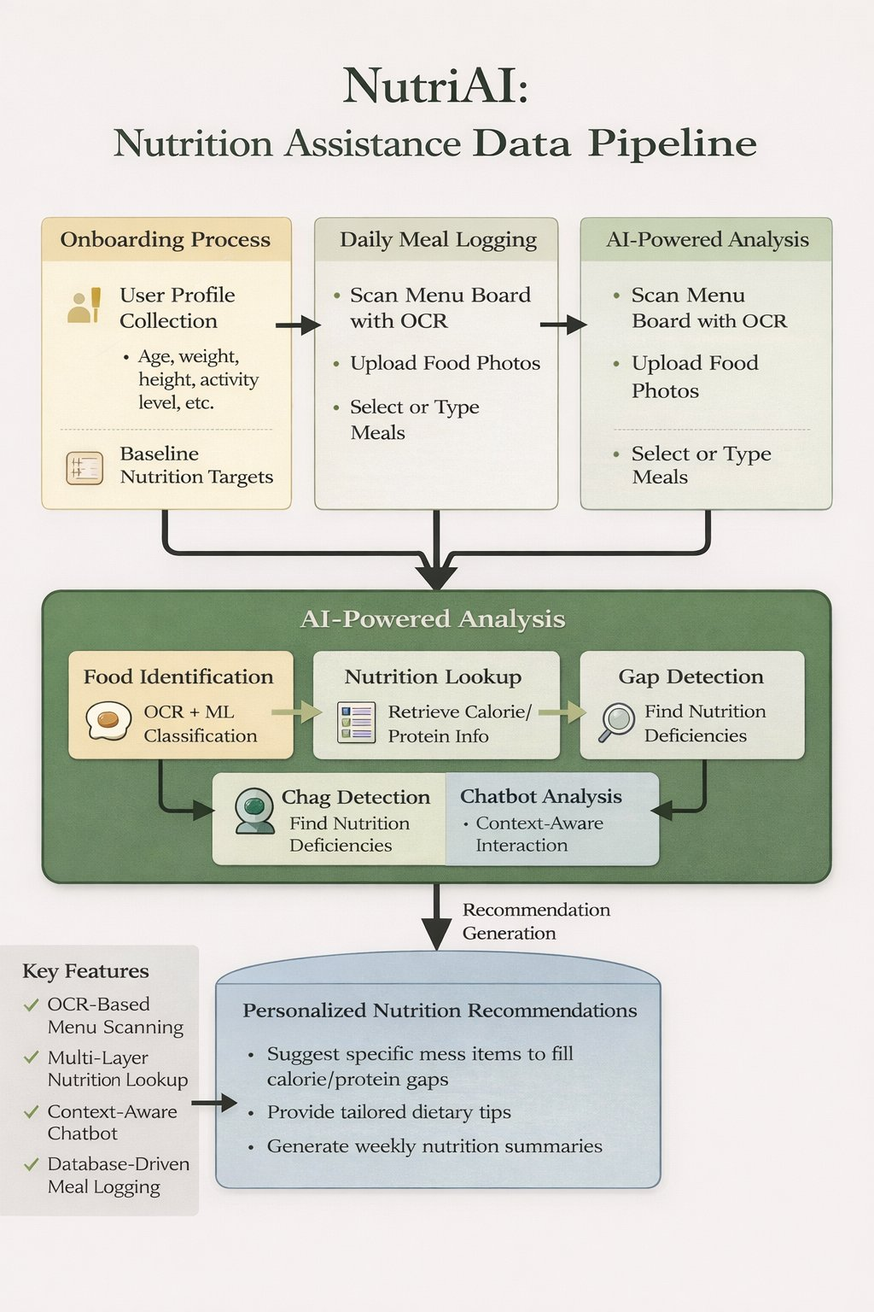
Figure 1: NutriAI – Nutrition Assistance Data Pipeline Flowchart
1.2 Scope
The NutriAI system aims to provide an intelligent and effective solution for the monitoring of nutritional requirements, especially for college students who use the mess facilities for their regular meals. The system focuses on assisting the user in comprehending the nutritional requirements for calorie and protein intake without the need for manual tracking and prior knowledge of nutritional science.
The NutriAI application allows for a systematic process for user onboarding, during which users input their personal data, such as age, height, weight, and activity level. The system then calculates the user's nutritional requirements and establishes their nutritional intake targets. After the user has been registered, they may enter their meals by choosing the food items from the mess menu, inputting the names of the foods they eat, and uploading images of the foods for the system to identify.
Another notable feature is the identification of nutritional gaps within the user's daily/weekly intake by comparing actual intake to nutritional requirements. Once the nutritional gaps have been identified, the NutriAI system suggests foods based on the user's actual intake and the items provided by the mess. The chatbot within the NutriAI system allows users to ask about their nutritional requirements and obtain answers based on their nutritional history and requirements.
1.3 Overview of the System
The NutriAI system can be described as an intelligent nutrition support system designed to assist university students in tracking their nutritional intake and making informed decisions regarding their food choices, considering the limitations of hostel mess facilities. The system combines the use of artificial intelligence technologies and a database-supported nutrition tracking system to provide a structured environment through which a user can evaluate their nutritional requirements without having to calculate them manually.
The process begins with a personalized process, wherein users provide the system with essential information regarding their age, height, weight, gender, and activity level. Once the profile is set up, users can log their daily meals by selecting from the menu database, entering the name of the meal, or uploading the image of the meal. The nutrients consumed can then be compared with the recommended amount, and nutritional deficiencies can be identified.
In addition to the meal tracking feature, the NutriAI application includes a context-aware conversational interface that can assist users with making more informed nutritional choices. The application can provide users with a weekly summary that explains their nutritional intake and provides suggestions for improvement.
1.4 Users of the System
The NutriAI system is basically designed to cater to university students who depend on hostel mess facilities to obtain their daily meals and need an easy way to track their daily calorie and protein consumption. Since mess food does not provide information on nutritional values, students often face difficulties in judging whether their eating habits meet their health or fitness objectives.
The system will help them track their meals and provide personalized advice according to their dietary needs. Additionally, it will cater to fitness-conscious students who want to track their fitness along with their gym schedules. Lastly, it will also be helpful to system developers or administrators responsible for maintaining the system and improving its performance. In all cases, NutriAI will be designed to be easy to use and accessible to students with little technical knowledge.

2. Basic Concepts / Literature Review
It is important to note that proper nutrition demands proper knowledge of calories and proteins consumed by the individual, but college students in hostels are not provided with proper dietary information regarding meals provided by the mess facility. Conventional nutrition tracking applications are designed for individuals who either eat at home or at restaurants where proper information regarding the food consumed is provided. Thus, they are not fully applicable to college students who are provided with fixed meals every week at the hostels without much choice in the food consumed.
Currently, nutrition tracking systems are based on manually entered foods, international food databases, or barcode scanning technologies. Although these technologies are effective in controlled environments, they are not able to properly track food served at the mess facility of the college, making it difficult to estimate the nutritional values of the food consumed by the individual.
With advancements in artificial intelligence technologies, it is possible to enhance the effectiveness of nutrition tracking systems by employing technologies such as image recognition, chatbot technologies, and recommendation systems. NutriAI is based on the concept of scanning the menus of the meals consumed by the individual, searching the nutrition values of the food consumed, interacting with the chatbot, and performing personalized gap analysis.
2.1 System Background and Supporting Technologies
The development of NutriAI technology is informed by a number of modern software and artificial intelligence technologies that can be integrated to provide an effective platform for tracking and monitoring nutrition and dietary information. This allows for effective operation in environments where structured information may not be readily available, particularly useful in environments like college mess facilities.
One of the technologies integrated in this system is Optical Character Recognition technology. This technology allows for scanning of mess menu boards and can automatically extract information from images to provide a list of available dishes in the mess. The system also uses a machine learning-based technology to classify foods and can automatically identify food items from images uploaded to the system.
Another technology integrated in this system is a pipeline for performing a nutrition lookup. This allows for a more accurate estimation of calories and proteins by validating information through a number of validation levels. Finally, the system also uses a conversational chatbot technology to provide more personalized interaction with users and more informed responses to user queries. Collectively, these technologies provide a foundation for the NutriAI system.

3. Problem Statement / Requirement Specifications
3.1 Problem Statement
Balanced nutritional intake is crucial for the health, academic, and overall well-being of an individual. In the context of college students living in a hostel environment, the nutritional intake is usually based on the meals provided by the mess cafeterias. The meals provided by the mess cafeterias follow a fixed weekly schedule, and the nutritional content is not provided. In such a case, the students are unaware of whether they are consuming the recommended amount of calories and proteins on a daily basis.
The existing nutritional tracking applications are mostly intended for people whose nutritional intake consists of either home-cooked meals or packaged foods whose nutritional content is provided. This type of nutritional tracking is not applicable to the mess environment. The second challenge faced by the users is the lack of personalization. In order to solve these problems, the NutriAI system has been proposed to help users track their nutritional content easily and provide personalized guidance based on their actual characteristics and habits.
3.2 Objectives of the Project
The primary objective of the NutriAI system is to provide a facility of offering an intelligent and user-friendly environment where college students are enabled to track their daily nutritional intake within the hostel mess environment. The NutriAI system has been designed in a manner that allows the students to avoid the tedious task of calculating the nutritional values of the meals consumed by them.
The second objective of the project is to provide personalized dietary targets based on the specific information provided by individual users, including age, height, weight, and level of activity. The project also seeks to automate the identification of meals based on scanning the menus, and includes a context-aware chatbot facility, thereby allowing the students to address any of their diet-related queries while making the required food choices.
3.3 Functional Requirements
The functional requirements describe the core operations that the NutriAI system must perform to support nutrition tracking and personalized dietary assistance for users.
- User Registration and Profile Setup
The system shall allow users to enter personal information such as age, height, weight, gender, and activity level in order to calculate individualized calorie and protein targets.
- Mess Menu Scanning
The system shall provide a feature to scan hostel mess menus using OCR technology so that dish names can be automatically extracted and stored for future selection.
- Meal Logging Facility
The system shall allow users to record their daily meals by selecting items from the stored menu, entering food names manually, or uploading meal images for identification.
- Nutrition Value Estimation
The system shall automatically estimate calorie and protein content for selected food items using the internal nutrition database and lookup pipeline.
- Gap Detection and Recommendation
The system shall compare consumed nutrients with recommended daily targets and generate suggestions when deficiencies are detected.
- Chatbot Assistance
The system shall provide a conversational interface that allows users to ask nutrition-related questions and receive personalized responses based on their dietary history.
- Weekly Nutrition Summary
The system shall generate periodic reports summarizing user intake patterns and highlighting areas for improvement.
- Data Storage and Retrieval
The system shall securely store user profiles, meal logs, and nutrition history in a database and allow retrieval when required.

3.4 Non-Functional Requirements
Non-functional requirements describe the quality attributes and performance expectations of the NutriAI system that ensure reliable and efficient operation.
- Performance Requirements
The system should process user inputs such as meal logging, nutrition lookup, and chatbot responses within a reasonable time to ensure smooth interaction.

- Usability Requirements
The interface should be simple and user-friendly so that college students with minimal technical knowledge can easily interact with the system without difficulty.
- Reliability Requirements
The system should provide accurate nutrition estimates and maintain consistent performance during regular usage without unexpected failures.
- Security Requirements
User information such as personal details, dietary records, and nutrition targets should be stored securely to prevent unauthorized access or misuse.
- Scalability Requirements
The system should be capable of handling multiple users and increasing data volume without affecting performance significantly.
- Maintainability Requirements
The system should be designed in a modular manner so that future improvements, feature additions, or updates can be implemented easily.
- Compatibility Requirements
The system should function properly across standard computing environments and web-based platforms without requiring specialized hardware.

3.5 Project Planning
The development of NutriAI was carried out through a structured and phased approach to facilitate clarity and effective execution. The development process was initiated by conducting a thorough requirements elicitation phase, focusing on the challenges experienced by students using mess food, including a lack of nutritional knowledge and a lack of calorie counting mechanisms.
A timeline was established to effectively divide the development process into specific phases, including requirements analysis, system architecture development, backend development, integration of AI components, testing, and documentation. The development milestones included the completion of the multi-agent system, successful integration of the nutrition lookup pipeline, development of the chatbot memory layers, and deployment of API endpoints. By monitoring these milestones, effective and consistent development was achieved, including completion of OCR, the RAG pipeline, and database integration.
3.6 Project Analysis (SRS)
The analysis phase focused on understanding the limitations of existing nutrition tracking systems, in addition to understanding the specific needs of college students who partake in fixed-mess meals. Requirements were identified through an understanding of general student habits, in addition to understanding specific pain points such as the inability to calculate nutritional intake, the lack of personalized guidance, and the inability to maintain a healthy diet.
A feasibility study was carried out to determine the viability of the proposed system, considering the use of contemporary technologies such as FastAPI, LangGraph, and popular machine learning models. User requirements were identified to include precise nutrition estimation, real-time tracking of caloric and protein intake, personalized guidance, and an intelligent chatbot that can understand user context. The proposed system satisfies these requirements through AI-based inference, data storage, and interactive communication.
3.7 System Design
The system architecture of NutriAI is designed with a modular and layered approach, where different components are designed for specific functionalities with a high degree of connectivity. The overall workflow of the system starts with user engagement through APIs, where different inputs are provided in the form of meals, images, or queries. After processing through various components including a nutrition pipeline, a chatbot system, and an OCR system, the processed information is stored in a PostgreSQL database or used for generating outputs.
3.7.1 Design Constraints
NutriAI operates within a set of constraints that affect its operation and execution. The hardware constraints include machine learning model and memory usage, which are taken into account especially in model execution and parallel computations for nutrition estimation. Software constraints include compatibility with Python-based frameworks and the usage of external APIs, including Google Vision for OCR and Hugging Face for NLP. The availability of API keys and internet connection is assumed for the system to be fully functional.

3.7.2 System Architecture (UML) / Block Diagram
The NutriAI architecture is described as a multi-component system, primarily built around a FastAPI backend. The major application layer is responsible for processing incoming requests, which are forwarded to different modules such as agent processing, chatbot interaction, the RAG pipeline, and classification systems. LangGraph-based agents handle onboarding, gap analysis, and weekly reviews. All modules are connected to an asynchronous PostgreSQL database, which stores user profiles, meal logs, and checkpoints.

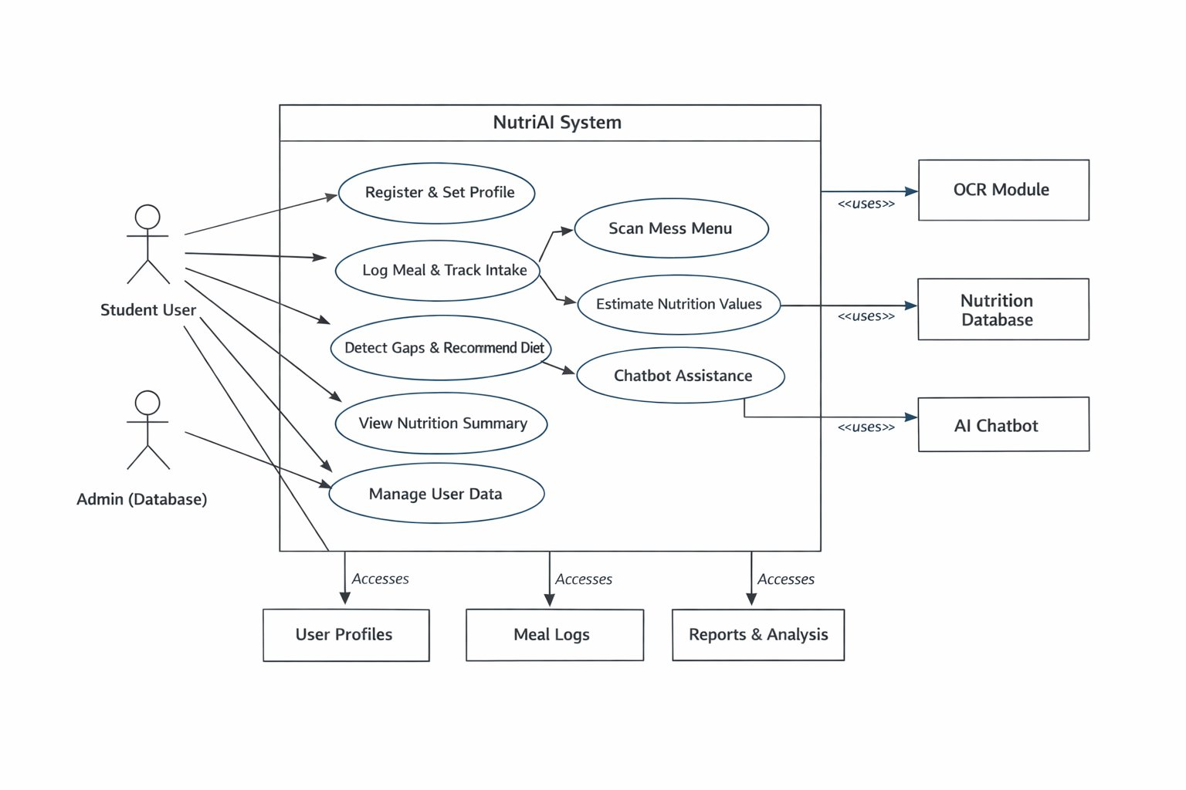
Figure 2: NutriAI System – UML Use Case Diagram

4. Implementation
4.1 Methodology / Proposal
The implementation of NutriAI is based on a systematic multi-algorithm approach designed to handle nutrition estimation, meal tracking, gap analysis, and chatbot interaction in an integrated manner. Each algorithm targets a specific module and contributes to the overall intelligent functionality of the platform.
Algorithm 1: Nutrition Lookup Pipeline (5-Layer Inference)
Input: Dish name (user input)
Output: Estimated nutrition values (calories, protein, carbohydrates, fats)
1. Receive the dish name from the user.
2. Query local cache. If found, return nutrition values.
3. Exact search in nutrition data. Return if found.
4. Fuzzy search: compare dish name to nutrition data.
Return values if similarity > threshold.
5. Dual model inference:
Send dish name to Model 1 (Qwen 72B) and Model 2 (Mixtral 8x7B) concurrently.
6. Aggregate results and calculate average for each nutrient.
7. If model failure: use fallback model (Gemini).
8. Store final result in cache. Return final nutrition values.

Algorithm 2: Multi-Agent Workflow (Gap Analysis)
Input: Weekly meal plan
Output: Nutrition gap detection and recommendations
1. Get the user's meal data for seven days.
2. Calculate daily nutrition totals in parallel.
3. For each day: compare intake values against target values.
Identify gaps in calories or protein >= 10%.
4. For each gap identified: generate a recommendation using an LLM.
5. Await user response: accept to save, skip to continue.
6. Continue until all days processed.
7. Save results in database. Return the final gap analysis.

Algorithm 3: Chatbot Response Generation (Tool-Based Loop)
Input: User query
Output: Contextual chatbot response
1. Receive the user query and initialize conversation state.
2. Load user context: profile, daily targets, meal history.
3. Load prior conversation messages and retrieve relevant information.
4. Combine query, context, and information. Generate initial LLM response.
5. Check for tool calls: get_nutrition, get_daily_totals, get_weekly_summary.
6. Execute tool calls, update context and response.
7. Stream response to user. Save conversation in database.

Algorithm 4: OCR-Informed Menu Scanning
Input: Menu Image
Output: Catalog of dishes extracted
1. Accept the image from the user.
2. Apply OCR: Google Vision API (Primary), Tesseract (Secondary).
3. Extract, clean and preprocess the text.
4. Apply fuzzy matching to the nutrition database.
5. Apply serving unit conversion. Return the list of dishes.

Algorithm 5: Food Image Classification
Input: Food Image
Output: Predicted Dish and Confidence
1. Accept the food image, resize and preprocess it.
2. Apply the EfficientNet-B2 Model to the preprocessed image.
3. Return the top three prediction results.
4. If confidence < 40%, mark as uncertain. Return the prediction result.

Algorithm 6: Retrieval-Augmented Generation (RAG) – Nutrition Query Processing
Input: User Query
Output: Context-Informed Response
1. Accept and preprocess the user query.
2. Generate a vector representing the user query.
3. Perform similarity search: Nutrition DB, User meal logs, Mess Menu DB.
4. Retrieve most relevant documents and format into contextual format.
5. Integrate query, context, and user objective. Send to LLM.
6. Apply post-processing. Return the final result.
4.2 Testing / Verification Plan
Various tests were performed at different levels to ensure the accuracy and reliability of the system. Unit testing was performed for individual modules, including nutritional information lookup, OCR, and chatbot response generation. Similarly, integration testing was performed for different components, such as agents, databases, and APIs. Test cases were created for testing different scenarios, including valid input, invalid input, missing information, and edge cases.
4.3 Result Analysis / Screenshots
The system was evaluated on its ability to make an accurate estimation of nutrient intake, provide significant recommendations, and respond to user queries intelligently. The results have shown that NutriAI is able to accurately monitor calorie and protein intake, detect nutrient deficiencies, and provide appropriate dietary interventions. The chatbot is able to effectively utilize user context and history to provide relevant information. The OCR part is able to correctly extract information from menus, and the classifier provides accurate predictions for food image classifications.
4.4 Quality Assurance
Quality assurance was ensured through the continuous testing and validation of the system's parts. Accuracy was ensured through the use of a multi-layered nutrition inference pipeline that helps prevent inaccuracies through model averaging and fallbacks. Reliability was ensured through the use of graceful failure techniques such as the use of fallback OCR or rule-based recommendations in the absence of AI models. Performance optimization techniques were used to ensure a responsive system.
4.5 Testing
A comprehensive testing program was undertaken to ensure that the NutriAI system works appropriately, effectively, and efficiently in relation to its constituent parts. As a first step, the system underwent unit testing, whereby individual components including the nutrition lookup pipeline, OCR scanner, chatbot, and food image classifier were individually tested for functionality.
Next, integration testing was performed to verify the seamless interaction of system components, including API responses, chatbot-tool communication, and PostgreSQL database communication. Functional testing was then conducted to verify main features such as onboarding, logging meals, gap analysis, OCR-based menu scanning, and chatbot responses. Additionally, performance testing and validation testing were conducted to confirm system stability and accuracy under real-world conditions.

5. Standard Adopted
5.1 Design Standards
The development of the NutriAI system is carried out in accordance with a structured framework of software engineering principles ensuring the system's readability, modularity, and scalability. The system's architecture is built upon a layered framework that ensures the logical separation of different components, including user interaction, data processing, artificial intelligence, and database management.
The system's architecture is also built upon a modular design strategy where different components, including menu scanning, nutrition lookup, chatbot interaction, and recommendation generation, operate independently. The design also incorporates structured workflow modeling that ensures the efficient handling of multiple agents, including sequential, conditional, and concurrent processing.
5.2 Coding Standards
The development process of the NutriAI system follows a set of structured coding standards, which helps in making the code more readable. The use of appropriate naming conventions for variables, functions, and modules ensures that the program's structure is transparent and easy to understand for any programmer interested in working with the code.
The NutriAI system is developed using a modular programming approach, which helps organize different program functionalities into separate files. These functionalities include user profile handling, nutrition information, chatbot, OCR, and database handling. The use of this approach helps simplify the program's complexity, making debugging easier. The development process includes the use of standard software development approaches, which ensures error handling, efficient input validation, and effective data processing. The development process ensures that there is minimal use of redundant code through the encouragement of function reuse. The project development process ensures adherence to standard backend development approaches, which helps in effective communication with API and database connectivity. The use of coding standards helps build a stable application that can be extended with more features in the next versions.
5.3 Testing Standards
System verification was carried out to ensure the functioning of all the modules of the NutriAI system to produce accurate results under different usage conditions. The verification was conducted at different stages of the system's development to ensure the identification of any errors or defects.

For instance, unit testing was conducted on the different modules of the system, such as user profile setting, meal recording, nutrition information search, OCR-based menu scanning, and interaction with the chatbot, to ensure the functionality of the system modules individually. However, once the unit validation of the system modules was complete, integration testing was conducted to ensure the coherence of the system's components, such as the database, the AI modules, and the API services.

Functional testing was also conducted to ensure the accuracy of the system's functions, such as the determination of the user's nutritional targets, recording of the user's meal intake, detection of the user's meal intake gaps, and the provision of appropriate recommendations to the users. The system was also subjected to particular emphasis to ensure the accuracy of the user inputs to the system to prevent the deterioration of the system's functionality.

Furthermore, the system was subjected to a preliminary performance test to ensure the efficiency of the system's response to user interactions with the system, such as when the user is recording their meal intake information or when the user is seeking information on the nutrients contained in the meal or when the user is interacting with the chatbot. These different types of system testing ensure the accuracy, reliability, and consistency of the system when deployed to the college environment.
6. Conclusion and Future Scope
6.1 Conclusion
The NutriAI system is developed as an intelligent and pragmatic system to help university students effectively monitor their daily nutritional intake within the hostel mess environment. The project is designed to overcome the common problem of estimating the intake of calories and protein faced by students due to the unavailability of structured information on the mess menu. The application of different technologies such as menu scanning, nutrition data processing, image-based food identification, and a context-aware chatbot helps the system to deliver personalized information to the users in a simple manner.
The system helps users to efficiently track their meals while providing information on the gaps in their diet and realistic information as per their requirements and the availability of food items. The system is designed to be modular to allow the incorporation of different features in the future. The project demonstrates the application of artificial intelligence to overcome different issues faced by students concerning their health and nutrition awareness.
6.2 Future Scope
The NutriAI system has been designed with scalability in mind, and several enhancements can be incorporated in future versions. The system may be extended to track micronutrients such as vitamins and minerals in addition to the current calorie and protein tracking capabilities. Integration with wearable fitness devices would allow the system to incorporate real-time physical activity data into personalized dietary recommendations.
A mobile application version of NutriAI could significantly improve accessibility for students, allowing them to log meals and receive recommendations on the go. Additionally, the nutrition database could be expanded to include a broader range of Indian mess dishes and regional food items. The chatbot could also be enhanced with multilingual support to cater to students from diverse linguistic backgrounds across India.

Individual Contribution

S.No | Name | Roll No. | Domain | Contribution
1. | Samanway Dutta Roy | 2328224 | Frontend | UI design, user onboarding screens, meal logging interface
2. | Sagar Dutta | 2328115 | Frontend | Dashboard, nutrition summary screens, chatbot interface, Dark/Light theme toggle.
3. | Yashraj Singh | 2328058 | Backend | REST API backend — JWT authentication, email verification, meal logging, nutrition search, progress sharing with crypto tokens, OCR proxy, all 8 controllers, route files, security middleware, and Express server configuration
4. | Subhang Raj | 2328131 | Backend | Database schema design (users, food_logs, shared_links tables), PostgreSQL model files (FoodLog and User with parameterized queries), Neon DB connection pooling setup
5. | Sanjam Das | 2328196 | DL | Food image classification, EfficientNet-B2 model training and inference
6. | Uddipt Shankar | 2328136 | ML | Nutrition lookup pipeline, dual-LLM ensemble inference, LangGraph agents, chatbot, RAG pipeline, OCR module, FastAPI backend

Plagrism Report
