Print your name: **Spandan Das**

Today's date: **9/9/2019**

Class period: **3**

-----------------------------------------------------

1. Plot the average step counts for inputs 0 < P < 100.

2. Report the random number seed, M, N, T, and delta P.

**M = 30, N = 40**

3. Change M and N.

4. For example, scale each value up by a factor of two.

5. Plot the average step counts for inputs 0 < P < 100.

6. Report the change in M and N.

**M = 60, N = 80**

7. Show the two plots together, in an overlay.

8. Scale up yet again.

9. Show all three plots together, in an overlay.

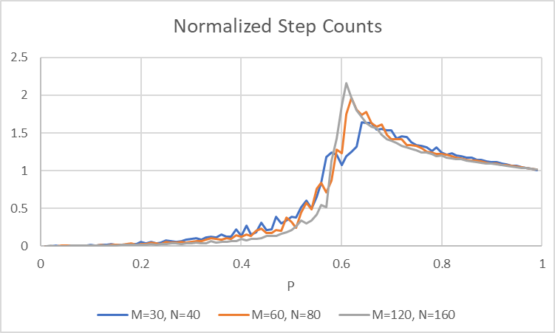

10. Report the three different values for M and N.

**M = 30, N = 40**

**M = 60, N = 80**

**M = 120, N = 160**

-----------------------------------------------------

END