Print your name:

**Spandan Das**

Today's date:

**10/10/2019**

Class period:

**3**

-----------------------------------------------------

1. Initialize a grid M rows -by- N columns.

2. Each slot has a P% chance to be turned ON.

3. At time zero IGNITE the on-slots in the left column.

4. Then count the number of steps it takes to BURNOUT.

5. At each timestep spread to the four nearest neighbors.

6. Normalize the final count by dividing by the width.

7. Average the normalized burnout time over T trials.

8. Connect to infosphere and run on the cluster.

9. Report M, N, T that runs for 30+ seconds for np = 8.

**300, 400, 500**

10. Plot the runtime for np = 8, 16, 32, 64, 128.

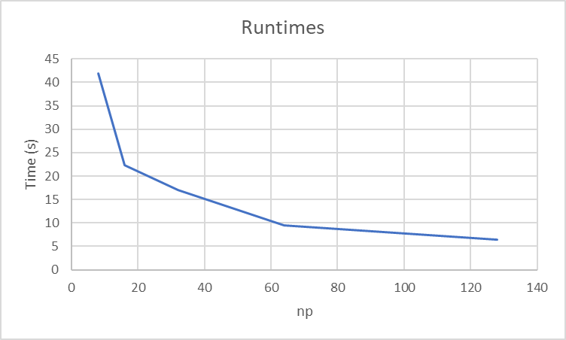

-----------------------------------------------------

END