Print your name: **Spandan Das**

Today's date: **10/21/2019**

Class period: **3**

-----------------------------------------------------

1. Earth and a satellite in orbit.

2. Assume a point mass at the origin not moving.

3. Circular orbit. Duration is 90 minutes.

4. Initialize y = R + 400 km, and vx = sqrt( G*M / y ).

5. Loop, update position and velocity each DT timestep.

6. Plot trajectory, and speed and distance over time.

7. Can include surface of Earth in trajectory plot too.

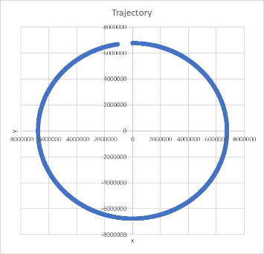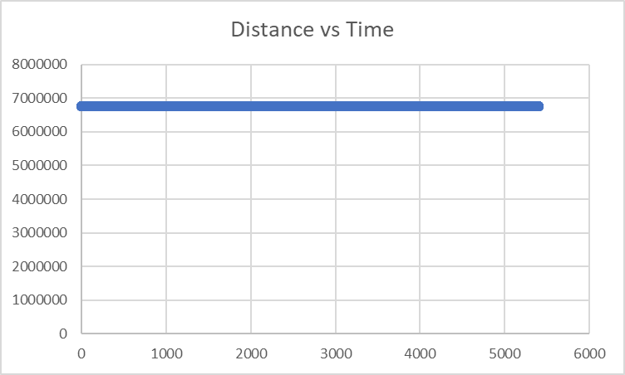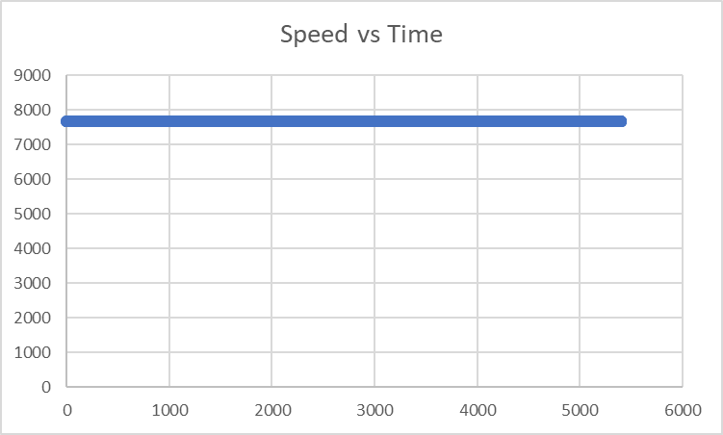

8. Elliptical orbit, vx + 20%, duration 4 or 5 hours.

9. Same plots, but include vx and vy over time as well.

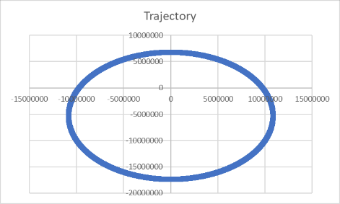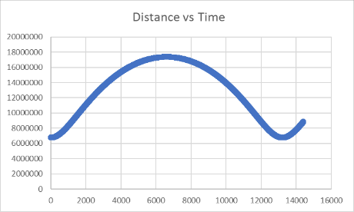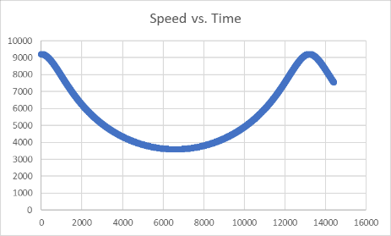

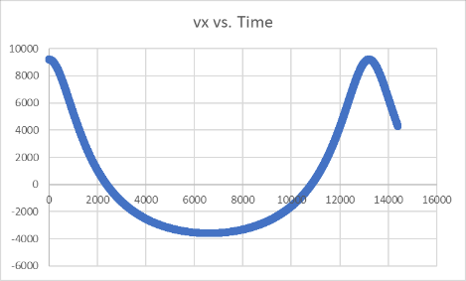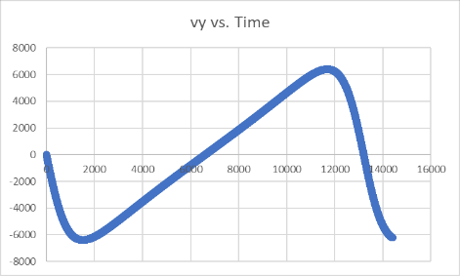

10. Hyperbolic orbit, vx + 50%, x and y farther away.

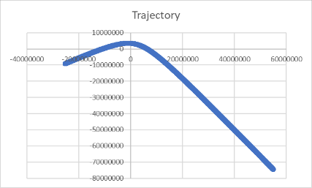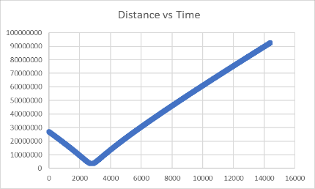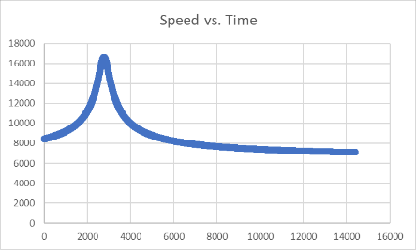

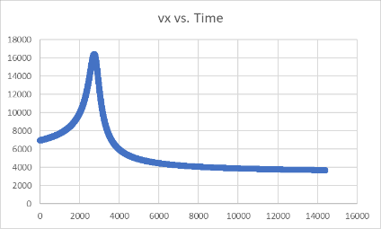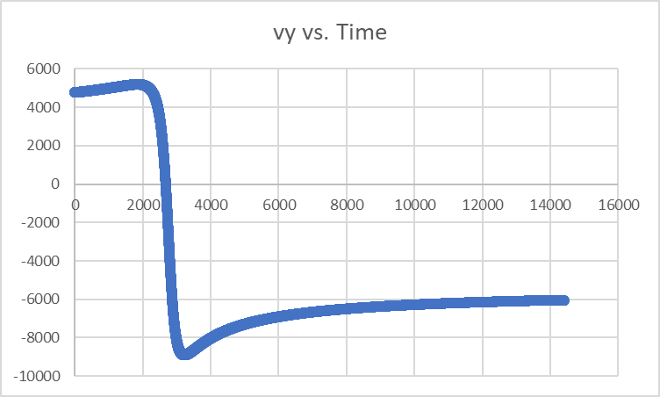

-----------------------------------------------------

END