Print your name: **Spandan Das**

Today's date: **11/6/2019**

Class period: **3**

-----------------------------------------------------

1. Earth and Moon in orbit.

2. Moon

#define M 7.349e+22 // kg

#define R 1.7374e+6 // m

#define V 1023.157 // m/s

double r = 3.844e8 ; // distance from Earth

3. Speed, okay to use uniform circular motion formula.

4. Mass does not matter until including spaceship too.

5. Radius to visualize and later if spaceship crashes.

6. Initialize x = r and vy = V, first quadrant.

7. Check it is correct.

8. Only then, add vehicle, must change loop code now.

9. Apollo

t[0] = 96302.0 ; // 26 h, 45 m, 2 s

r = RE + 202751774.4 ;

vmag = 1527.048 ;

10. Find THETA for a free return trajectory. Plot the

Earth, the Moon, and the Apollo spacecraft free return.

Plot the speed of Apollo over time. Indicate when the

interaction with the moon takes place, by hand is fine.

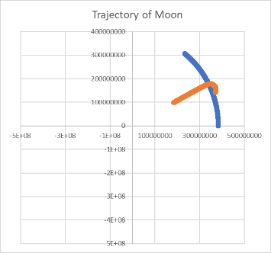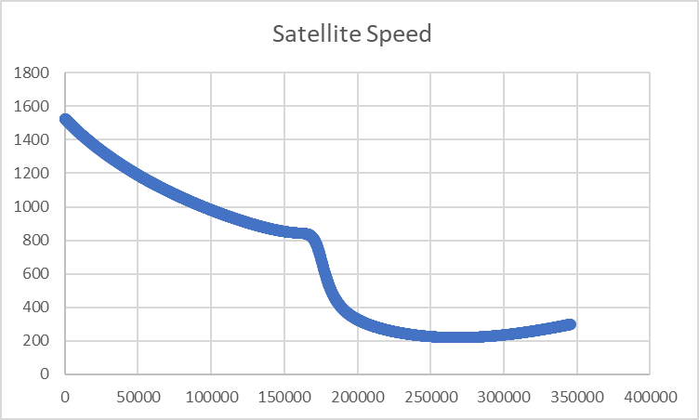

-----------------------------------------------------

END