**Assignment**

**Module – 1**

**1. What is software? What is software engineering?**

**=>** Software :

- Software is a set of information, instructions, and data.

- We can use it virtually, we can use it but we can’t feel it.

- It’s also a collections of functionalities or tasks.

**=>** Software Engineering :

- Software Engineering is a term of create or building program that perform specific task on system.

**2) Explain types of software**

**=>** There are 5 types of software :

I) System Software:

- System software is a program that helps to run computer’s hardware and applications.

- One of the best example of System software is Operating System.

- Example of O/S. Windows, Mac, Linux, Debian etc…

II) Application Software :

- Application Software used to handle specific tasks for users.

- There are 3 types of Application Software:

a) Desktop Application :

- Desktop Application is a program design to run on computers and use system resources to perform their function.

- For ex. Visual Studio Code, Notepad, Photoshop etc…

b) Mobile Application :

- Mobile Application is a program design to run on Mobile, Tablets, and Smart Watches.

- For ex. Instagram, Telegram,VLC Media Player etc…

c) Web Application :

- Web application is application software that is accessed using a web browser.

- For ex. Google Chrome, Opera, Mozilla Firefox etc…

III) Programming Software :

- Programming software are helps to programmers to developing other software.

- For ex. Compiler, Interpreter etc…

IV) Driver Software :

- Driver is a program that provides programming interface to control and handle specific tasks that are connected through the hardware or other services.

- Ex. BIOS, Motherboard driver, etc…

V) Middleware :

- Middleware software is used to communicate with other software.

- It’s acts as a bridge between tools, databases or other software so we can interact easily in our system.

**3) What is SDLC? Explain each phase of SDLC**

**=>** SDLC stands for Software Development Life Cycle.

**=>** SDLC used for creating or building high quality software.

**=>** SDLC process have 6 phases:

I) Planning

II) Analysis

III) Designing

IV) Implementation

V) Testing

VI) Maintenance

I) Planning :

- First of all we have to get requirement of software from the client.

- For example, if we are going to build online shopping software, so we’ve to get the basic need of software like which type of products, user management, admin power, and other features.

II) Analysis :

- Once planning ends, we have to create document for the software like which type of features can access by user, tables for database, validations of software, and many more things.

III) Designing :

- After Analysis, we’ve to create a design for software.

- How software looks like, create UI (User Interface), product design, user Login / Sign Up, etc…

IV) Implementation :

- Once Designing phase over then we’re going to start development of the software.

- There are two teams work on the software at a time.

- First, Front end developer team, this team develop design

attractive design of the software.

- Second, Back end developer team, this team develop database or other functionality of the software.

V) Testing :

- After complete the development phase, software going for the test, or testing team will find the bugs or any other issue of software.

- Software is well designed or not as per software document or blueprint that also check by testing team.

VI) Maintenance :

- After testing, if there is no problem with software then software is ready to deploy or if any issue occurs then software team send that issue to the development team.

- After deployment, software need maintenance.

- In future client have to change some feature, remove some features, add some authorities, add any new validation that all type of process called maintenance of software.

**4) What is DFD? Create a DFD diagram on Flipkart**

**=>** DFD stands for Data Flow Diagram.

**=>** It shows how software will work or how data will traverse in software.

**=>** It’s contains all the features all the database and many more things of the software.

**=>** DFD have 4 elements :

I) External Entity - It contains a user, admin or group of person.

II) Process - It contains the process that happen by admin or user.

III) Data Flow - It shows the flow of data.

IV) Data Store - It’s use to show tables of database.

* Zero Level DFD of Flipkart :

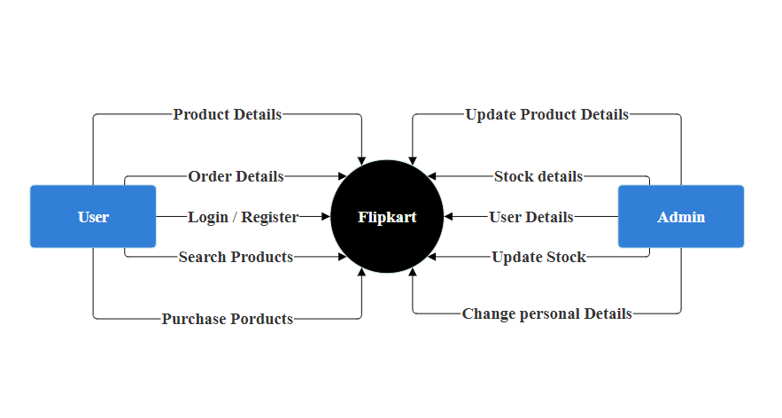

* 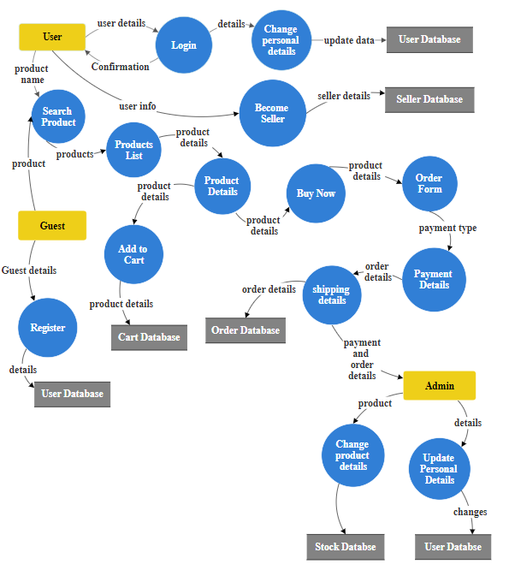One Level DFD of Flipkart :

**5) What is Flow Chart? Create a Flow chart to make addition of two numbers.**

**=>** Flow chart shows algorithms of software.

**=>** It’s shows how software’s functionalities and features works.

**=>** It’s describe the flow of logics.

**=>** Flow chart is very useful when some logics are complex.

**=>** When flow chart drown, we can create functionality more easily.

**=>** Flow chart uses 5 shapes :

I) Start or End : It is use to describe chart’s stating point or ending point.

II) Process : Process always describe in square and used to show the process like addition, subtraction, multiplication, division, etc…

III) Input / Output : It’s describe Input or Output. It’s always describe in parallelogram.

IV) Decision Making : Decisions always describe in diamond shape.

V) Flow Line : It’s shows the flow of instructions.

**=>** Flow charts can be in three format :

A) Linear or sequence

B) Branching

C) Looping

* Flow Chart of Addition :

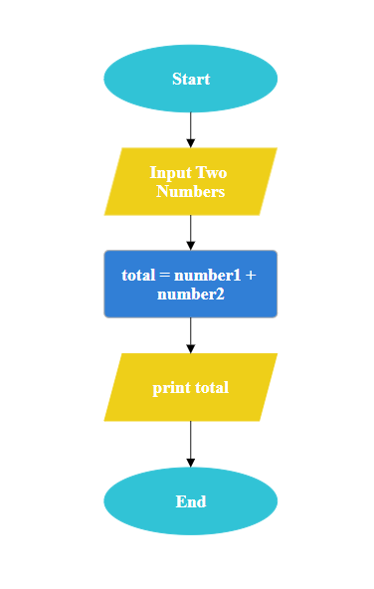

**6) What is Use Case Diagram? Create a Use Case on bill payment on Paytm.**

**=>** A Use Case Diagram helps to summarize the details of software’s user and their interactions with the software.

**=>** A proper Use Case Diagram helps to discuss :

- Features or Functionalities of software that helps to user / admin.

- Scope of Software.

* Use Case Diagram of Bill Payment of Paytm :

