**SDA6 LUND**

**GROUP3 FINAL PROJECT**

**ONLINE GROCERY SYSTEM**

**Installation Guide**

|  |  |
| --- | --- |
| **Author:** | Veena Ramappa |
| **Date:** | 20191214 |
| **Version:** | V1.0 |
| **Name:** | Installation Guide |

**TABLE OF CONTENTS**

**1- Download of .WAR and .EAR file:** 3

**2 - Confirmation on JDBC and JBoss Drivers:** 5

**3. Database tables:** 8

**3.1 - Customer:** 9

**3.2 - Categories:** 9

**3.3 - Products:** 9

**3.4.1 - Order table:** 10

**3.4.2 - OrderInfo table:** 10

**4. Run/launch the application:** 11

# **1- Download of .WAR and .EAR file:**

Download the .war and .ear file of Online Grocery System and save into your system.

In Eclipse IDE go to

—>File

—>Click on Import

—>Select WEB —> WAR file

—> click on Next and browse to your .war and .ear file

—> click on Finish.

# **2 - Confirmation on JDBC and JBoss Drivers:**

* Make sure that JDBC drivers (.jar) file is present in lib folder under web content

* If there is an error as: “WebServlet cannot be resolved to a type” as below in servlet class:

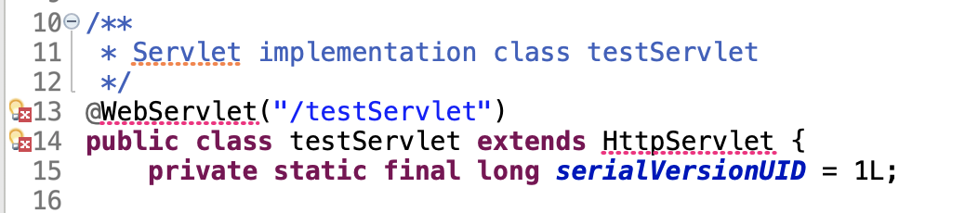

Resolve the above said error by setting the JBoss servlet API to project build path as below:

* Right click on the project
* Select properties
* Then click on Java Build Path
* Select Libraries
* Click on Add External JARs

* Select boss-servlet-api .jar file and click on Open

* Then click on “Apply”.
* Click on “Apply and close button”.

# 

# **3. Database tables:**

* Make sure that below tables are created and required data is entered in the table.

# **3.1 - Customer:**

# **3.2 - Categories:**

# 

# **3.3 - Products:**

3.4 - Orders and OrderInfo tables will be updated once user does uses “Pay” option on Online Grocery System application.

# **3.4.1 - Order table:**

# 

# **3.4.2 - OrderInfo table:**

1. Make sure that database is connected with valid username, password and schema name.

# 

# **4. Run/launch the application:**

If there are no errors (deployment of the project in server is successful) or rectified errors are resolved, then start the server and Online Grocery System application’s index.html will be launched.

Now User can start using the application.