**SDA6 LUND**

**GROUP3 FINAL PROJECT**

**ONLINE GROCERY SYSTEM**

**User Guide**

|  |  |
| --- | --- |
| **Author:** | **Patrick Chimezie** |
| **Date:** | **20191212** |
| **Version:** | **V1.0** |
| **Status:** | **Initial Draft** |

**INTRODUCTION:** 3

**Application Home page:** 4

**Login:** 5

**Successful Login Dashboard:** 6

**Unsuccessful Login & Sign Up Notification:** 7

**Registration & Sign Up:** 7

**Grocery Categories:** 8

**List of Products:** 9

**List of Vegetables:** 9

**List of Fruits:** 10

**Making an Order:** 11

**Updating the Cart:** 12

**Viewing Cart & Checking Out:** 13

**Make Payment:** 14

**Payment Confirmation & Thank You Message:** 15

**AMENDMENT HISTORY:**

|  |  |  |  |  |
| --- | --- | --- | --- | --- |
| **Version** | **Date** | **Author/Changed by** | **Status** | **Change Description** |
| V1.0 | 20191212 | Patrick Chimezie | Draft | Update table of contents |
| V2.0 | 20191213 | Patrick Chimezie/Veena Ramappa | Final | Updated the font and table of contents |

# **INTRODUCTION:**

The web application provides an interface for the online grocery store and enables the end users to register to the system online, select the grocery items of their choice from the menu list, and order grocery items online.

This User Guide document explains the step-by-step procedures on how the end users can use the online application. It explains how he/she can register, login, navigate through the webpages, and make orders from the menu list.

# **Application Home page:**

The front page of the Online Grocery System is shown below:

# **Login:**

Go to Login, type in your email address and password, and click on **“Login”** button.

# **Successful Login Dashboard:**

Successful login will lead to the page where user can see his/her name on the web page.

# **Unsuccessful Login & Sign Up Notification:**

Unsuccessful login will lead you to web page where the user will be shown a message to signup and the login as below.

# **Registration & Sign Up:**

User can signup through signup tab on the main page, and then login.

# **Grocery Categories:**

Successful login of the user will be seen in below webpage with logged in username at the top right corner.

The two categories of the groceries (“**Vegetables**” and “**Fruits**”) will be displayed on the screen to the user. The customer can navigate to the page of his/her choice by making selection according to the items he/she wants to buy.

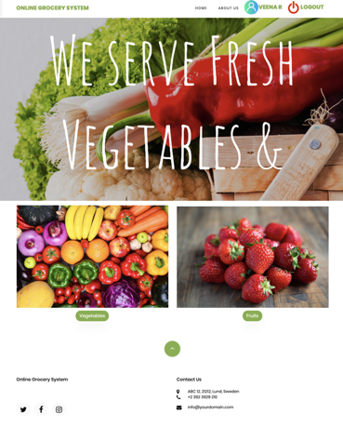

# **List of Products:**

The page below is displayed when a user clicks on “**Vegetables”**. The customer can select they needed items from the list of vegetables.

## **List of Vegetables:**

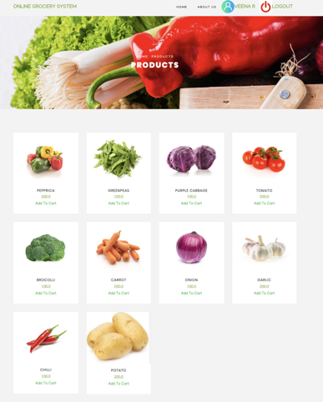

The page below is displayed when a user clicks on **“Fruits”**. The customer can select they needed items from the list of fruits.

## **List of Fruits:**

# **Making an Order:**

User can click on “**Add to Cart”** link to add item into his/her cart, and also select the quantity he/she needs.

# **Updating the Cart:**

User can also go to other categories and add items and cart will be updated accordingly.

# **Viewing Cart & Checking Out:**

By clicking on **View Cart & Checkout** button, user will be led to the order cart page where he/she can view the details of the order.

On this screen, user can see selected items, price, quantity and total amount and he/she can make payment by clicking on **Go to Payment** button.

# **Make Payment:**

In payment screen, user can enter his/her contact name, address, credit/debit card details and click on **Pay** button.

# **Payment Confirmation & Thank You Message:**

On successful payment, a “Thank You for Your Order” message will be displayed on the screen.

