SDAINT AI — Solution Architecture Document (SAD)

AI-Powered SAP Integration Migration Platform
Document Type: Solution Architecture Document (Arc42-aligned, 4+1 view model where applicable) Classification: SDA Proprietary | Client-Ready upon SDA review Version: 2.1 — July 2026 (complete redesign; supersedes SAD v1.1; adds sourced references §20) Author: Ayman Kaabi Kabalan — Lead BAIP SAP Architect, SDA · SDA Enterprise Architecture Practice Diagram legend: ⬜ grey = legacy sources · 🟥 red = AI brain · 🟦 blue = deterministic logic · 🟨 yellow = human decisions · 🟩 green = SAP output · 🟪 purple = knowledge/learning. All flows read left → right. Audience: Solution architects, SAP executives, implementation partners, project managers Terminology: BAIP = SAP Business AI Platform — SAP's current naming for the platform formerly known as SAP Business Technology Platform (BTP). Program numbers: locked task-level estimates and dates now live in ONE-PAGER-Master-Task-Plan-Final.md and PLAN-05-Two-Golives-Simple.md, not in this document.

1. Introduction
This document describes the solution architecture of SDAINT AI, SDA's AI-powered platform for migrating legacy integration estates — SAP PI/PO, MuleSoft, Dell Boomi, and Informatica — to the SAP-native target landscape: S/4HANA, SAP Integration Suite, and CAP services on BAIP.
It is written to be understood by both technical and non-technical readers. Every diagram reads left to right: source on the left, intelligence in the middle, SAP target on the right. Deep engineering detail lives in the TDD v2.1; commercial and financial detail lives in the Unified Blueprint v2.2.
If you read nothing else: legacy interfaces go in on the left; an AI brain classifies each one, picks the right SAP target, estimates the hours, and generates the deployable artifact; humans review and approve; financial flows pass an AI firewall (Pattern C) before touching the books; and everything the platform learns makes the next migration faster. In SDA's lab, 10 real PI/PO interfaces took 60 hours by hand — the platform does the same work in 18 (Blueprint v2.2 §8).

2. Business Goals
# | Goal | Owner
G1 | Win PI/PO → Integration Suite engagements against tool vendors and capacity SIs on AI-powered speed and quality | SDA Sales / Practice Lead
G2 | Compress the assessment phase from 6–10 weeks to 2–5 days per client landscape [1] | SDA Delivery
G3 | Build a compounding, proprietary knowledge asset from every delivery (the AI brain) | SDA Enterprise Architecture
G4 | Eliminate financial data migration risk via AI validation (Pattern C) | SDA Delivery / Client Finance
G5 | Cover four strategic legacy platforms — PI/PO, MuleSoft, Boomi, Informatica — with one conversion pipeline | SDA Practice Lead
G6 | Deliver converted, deployable packages (RAP/BDEF + BAPI, CAP services, IS artifacts) — not just recommendations | SDA Engineering

3. Success Metrics
Metric | Target | How measured
Assessment turnaround (inventory in → scored wave plan out) | ≤ 5 business days | Per engagement
Recommendation acceptance (architect accepts AI tier/tool) | ≥ 80% | Brain telemetry
Pattern C auto-post rate | ≥ 85% of records, zero bad postings | Per FI batch
Estimate accuracy (predicted vs actual hours) | ±20%, converging | actualHours feedback loop
Knowledge growth | Vector store grows every engagement; coherence trending up | getBrainStatus
Commercial | Package 1 → Package 3 conversion ≥ 50% | CRM

4. Stakeholders
Stakeholder | Needs from the system
CIO / Integration Lead (client) | Classified inventory, defensible wave plan, tool per object, risk register
CFO / Business Sponsor (client) | Budgetable cost model, ROI framing, license-retirement path
Finance Manager (client) | Pattern C review queue, side-by-side validation UI, audit trail, zero unvalidated postings
SDA Architect (operator) | Migration Advisor API, batch analysis, override capability, transparent rationale
SDA Delivery Lead (operator) | Multi-project dashboard, wave progress, high-risk alerts
SDA Practice / Sales | Branded executive PDF, engagement packages, competitive proof points
SAP (ecosystem) | SDA amplifies — never replaces — SAP tooling (MAT, Migration Wizard, Integration Advisor, Joule)

5. Functional Scope
In scope
- Intake and normalization of legacy inventories: PI/PO (MAT JSON export), MuleSoft (Anypoint catalog), Boomi (process export), Informatica (mapping/workflow export)
- AI classification (Simple / Medium / Complex), complexity scoring, tool recommendation, effort estimation, wave planning
- Convert & package: generation of tier-specific deployable output — RAP/BDEF + BAPI packages, CAP integration services, IS iFlow bundles (incl. Integration Advisor MIG/MAG for EDI)
- Pattern C financial validation: validation API, ≥85% confidence routing, Fiori review queue, BAPI posting incl. tax handling
- Knowledge/vector store, event capture, insight generation, brain export/import
- Assessment deliverables: scored inventory, wave plan, risk register, branded executive PDF
- Migration Cockpit: portfolio, buckets, waves, approvals, execution tracking, metrics
Out of scope
- S/4HANA core configuration and client ABAP development
- Client network design; operation of the legacy runtimes
- Runtime execution of migrated iFlows (they run in the client's IS tenant; SDAINT AI advises, generates, and validates)
- HR record content processing (metadata only, by policy)

6. Architecture Principles
# | Principle | Consequence
P1 | SAP-first | Every component is SAP-native unless SAP has no equivalent; the only external dependency is the Claude API (routed via SAP AI Core Generative AI Hub in target state)
P2 | Deterministic floor, AI overlay | Rules always compute a complete result; the LLM improves it but can never block it
P3 | AI advises, humans decide | Every material action (especially financial) has a human approval path and stored rationale
P4 | Learn from every asset | Every classification, conversion, and outcome is vectorized; the platform must get smarter per engagement
P5 | Simple before clever | Local JSON vectors before HANA Vector Engine; Event Mesh before AEM; scale infrastructure only when metrics demand it
P6 | Deployable output | Every assessment ends in artifacts a client can deploy, not only documents
P7 | Everything explainable | Tier, score, tool, and estimate each carry a stored, human-readable rationale

7. System Context
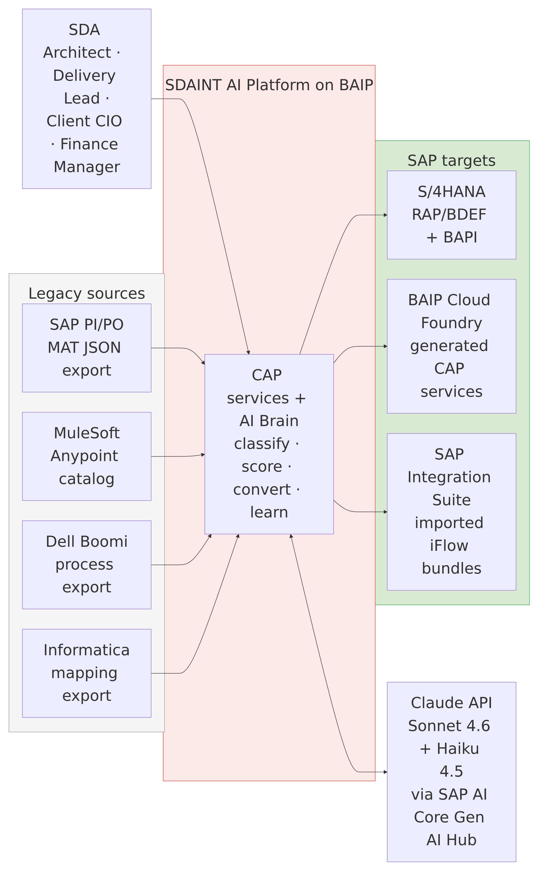
Users interact through the Fiori console (and, in target state, SAP Joule); legacy inventories flow in from the left; deployable SAP artifacts flow out to the right; the Claude LLM is consulted for classification and plan narrative only.

8. High-Level Component Architecture
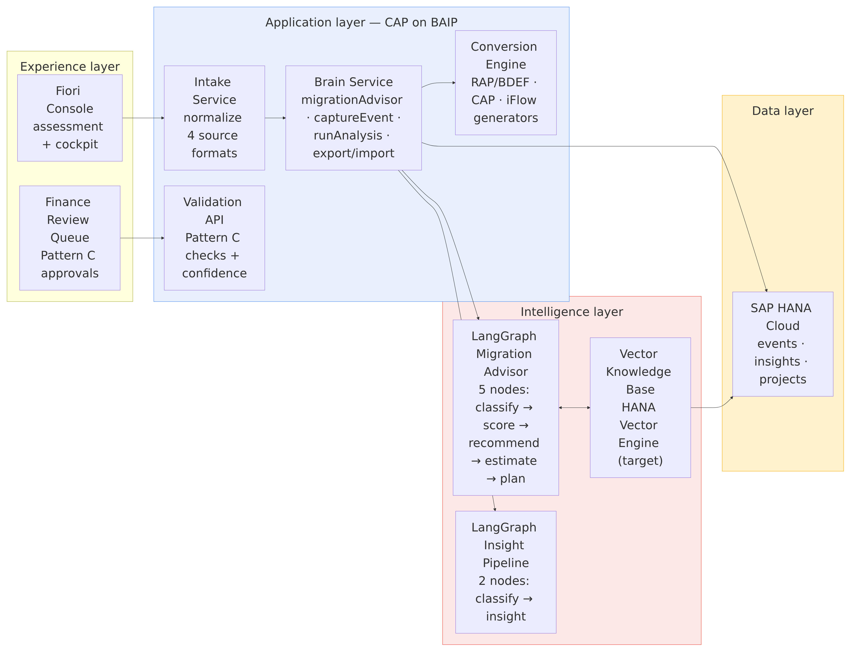
Component | Responsibility | Key fact
Intake Service | Normalize the four source formats into one inventory model | Gap report produced on day 1
Brain Service (CAP) | Exposes all AI actions as OData v4: migrationAdvisor, captureEvent, runAnalysis, getBrainStatus, exportBrain/importBrain, seedMigrationKnowledge | The rule-based advisor always computes a floor result first
LangGraph Migration Advisor | 5-node graph — classify (Claude Sonnet 4.6) → score (deterministic 8-factor) → recommend tool → estimate effort → build plan (Sonnet 4.6) | Graph output overlays the rule floor field-by-field
LangGraph Insight Pipeline | 2-node graph (classify → insight) on Claude Haiku 4.5 | Low-cost telemetry-to-insight conversion
Vector Knowledge Base | RAG store of every assessed object + outcome | Local JSON as-built; HANA Vector Engine at scale (AD-008)
Conversion Engine | Generates tier-specific artifacts per §9 of the TDD | Simple → RAP/BDEF+BAPI; Medium → CAP; Complex → iFlow bundle
Validation API (Pattern C) | Deterministic FI checks + confidence score + routing | ≥0.85 auto-post, else Fiori review queue
Pattern C in plain words: every financial record is checked (account exists, period open, debits = credits), the system scores its own confidence, records at ≥85% post automatically, everything else goes to a human reviewer — and no unvalidated record ever reaches S/4HANA. Full layman explanation: Blueprint v2.2 §7.

9. Deployment Architecture
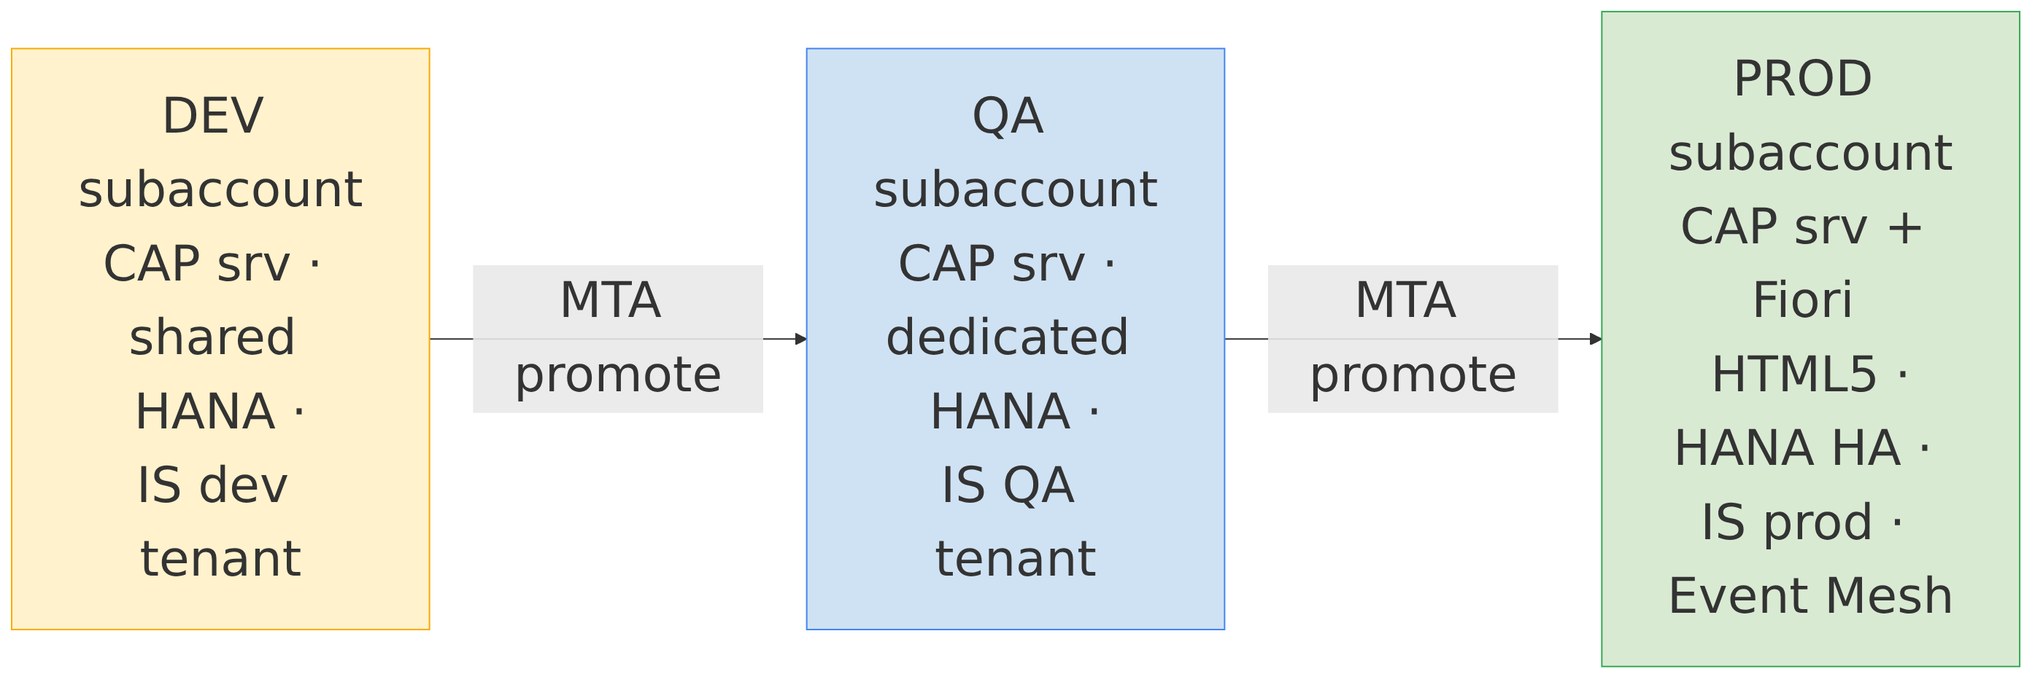
Artifact | Technology | Deployment unit
SDAINT AI Brain platform (CAP, Node.js 20) | mta.yaml (ID SDAINTAI) | BAIP Cloud Foundry, MTA (MBT)
Static web console (SDAINT-AI BTP cockpit) | mta-sdaintai.yaml (staticfile buildpack, 64M) | CF route sdaintai.cfapps.us10.hana.ondemand.com
HANA schema (CDS/HDI) | db/*.cds | HDI container via MTA
iFlow templates (Patterns A/B/C) | IS artifacts | IS Content API / Figaf CI-CD
Security descriptor | xs-security.json | XSUAA service instance
CI/CD | Jenkinsfile; Kyma/Helm option (chart/, containerize.yaml) | CF primary; K8s ready

10. Infrastructure Architecture
All infrastructure is SAP-managed PaaS — no customer-managed VMs anywhere.
Concern | Choice | Notes
Region | BAIP Canada East (data residency: Canada/North America) | Client-selectable per engagement
Runtime | Cloud Foundry (primary); Kyma/K8s prepared | CF instances: brain 2×512M target, console 64M staticfile
Database | HANA Cloud — shared (DEV) → dedicated (QA) → dedicated HA (PROD) | SQLite locally, PostgreSQL optional
Cache/state | Redis (BAIP hyperscaler option) | Session/state scaling option
Messaging | SAP Event Mesh → Advanced Event Mesh at multi-project scale | AMQP topics sda/migration/…, sda/brain/…
Egress | Single external endpoint: Claude API over HTTPS | Via AI Core Gen AI Hub (target); key in Credential Store
Private landscapes | Edge Integration Cell supported as advisory target | Advisory output is deployment-target-aware

11. Security Architecture
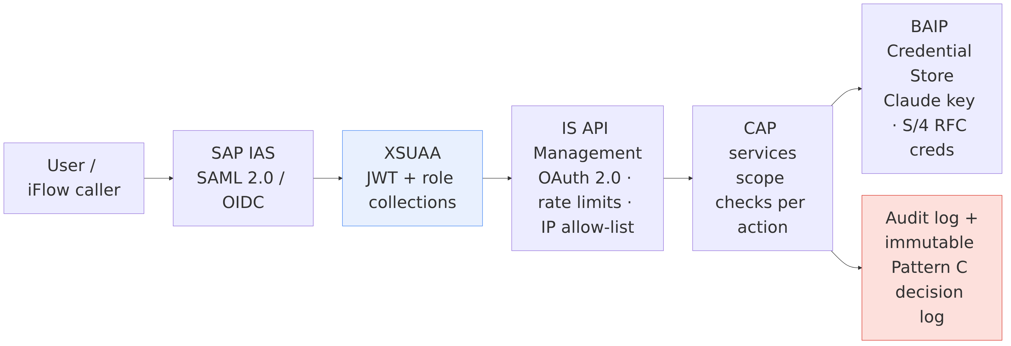
Layer | As-built (today) | Target
Platform identity | BAIP subaccount + IAS | IAS federated to client IdP where required
Service authorization | Shared master key on brain actions (DEV-grade only) | XSUAA JWT scopes: MigrationAdvisor, BrainAdmin, FinanceReviewer
API exposure | CAP OData over HTTPS | IS API Management front door
Secrets | Environment variables | BAIP Credential Store + Destination Service
Data isolation | Single project per deployment; brain export/import between projects | Row-level projectId predicate on every query

Data handling policy
Data class | Policy
Interface metadata (names, adapters, volumes) | Stored in brain; sent to Claude for classification — never message payloads
Financial records (Pattern C) | Validated in-memory only; brain stores GL account, amount range, confidence, outcome — never full documents
HR master data | Metadata only, always Complex tier; employee records never enter the platform
Brain exports (.sdab) | SDA Confidential; encrypted at rest; contractual right-to-delete per client
LLM governance | Prompts + model versions pinned; rationale stored per decision; human approval for all material financial actions

12. Identity & Access
Persona | Role collection | Can do
SDA Architect | MigrationAdvisor | Run assessments, review/override recommendations
SDA Delivery Lead | MigrationAdvisor + dashboard | Multi-project view, wave management
Finance Reviewer (client) | FinanceReviewer | Approve/reject Pattern C exceptions only
Brain Administrator | BrainAdmin | Toggle brain, seed knowledge, export/import
iFlow (system) | OAuth client credentials | Call validation API only, IP allow-listed

13. High Availability & Disaster Recovery
Aspect | Design
Platform availability | 99.5% (BAIP CF SLA); stateless CAP instances scale horizontally
Database HA | HANA Cloud HA in PROD (SAP-managed replicas)
LLM outage | Zero assessment downtime — rule-based advisor is always computed first and stands alone if the graph/Claude is unavailable (verified in code)
Brain state DR | exportBrain produces a portable .sdab archive (events, insights, sessions, vectors); scheduled exports = point-in-time recovery
Deployment rollback | Blue-green via MTA; cds-mtx upgrade hooks
RPO / RTO (target) | RPO ≤ 24h (daily brain export + HANA backups), RTO ≤ 4h (redeploy MTA + import)

14. Performance & Scalability
Scenario | Target | Mechanism
Single-object assessment | < 30 s (LLM path); < 2 s (rule path) | One Sonnet call for classify+plan; everything else deterministic
Batch (127-ICO MAT export) | < 5 min | Chunked parallel Claude calls (10-item chunks, Promise.allSettled)
RAG similarity query | < 500 ms | In-memory cosine (as-built); HANA COSINE_SIMILARITY (target)
Pattern C per-record validation | < 10 s | Deterministic checks first; LLM only for ambiguous cases
Objects per batch | 1,000+ | Stateless graph invocations, async CAP handlers
Concurrent client projects | 10+ (target) | projectId row isolation; per-project export/import interim
Scale triggers (act only when hit — Principle P5): >10K vectors or first multi-client PROD → HANA Vector Engine; sustained event fan-out across projects → Advanced Event Mesh; >3 concurrent projects → mtx multi-tenant activation.

15. Monitoring, Logging & Audit
Concern | Mechanism
Application logs | SAP Application Logging service (bound in MTA)
Platform health | getBrainStatus — events count, insights count, vector count, coherence score, enabled-since
AI decision audit | One BrainEvent per advisory/decision with payload, summary, and embedding reference
Financial audit | Immutable Pattern C decision log: record, confidence, verdict, approver identity, S/4 document number; AEM audit topic sda/migration/fi/posted
Alerting | sda/brain/alert/high-risk-object events; BAIP Alert Notification (target)
Cost observability | Claude token usage logged per action; monthly LLM budget report

16. AI Components
The AI explanation, simplified: the AI observes migration assets → the vector database recognizes patterns → the orchestration engine selects the best migration strategy → the migration engine generates the recommended SAP artifact.
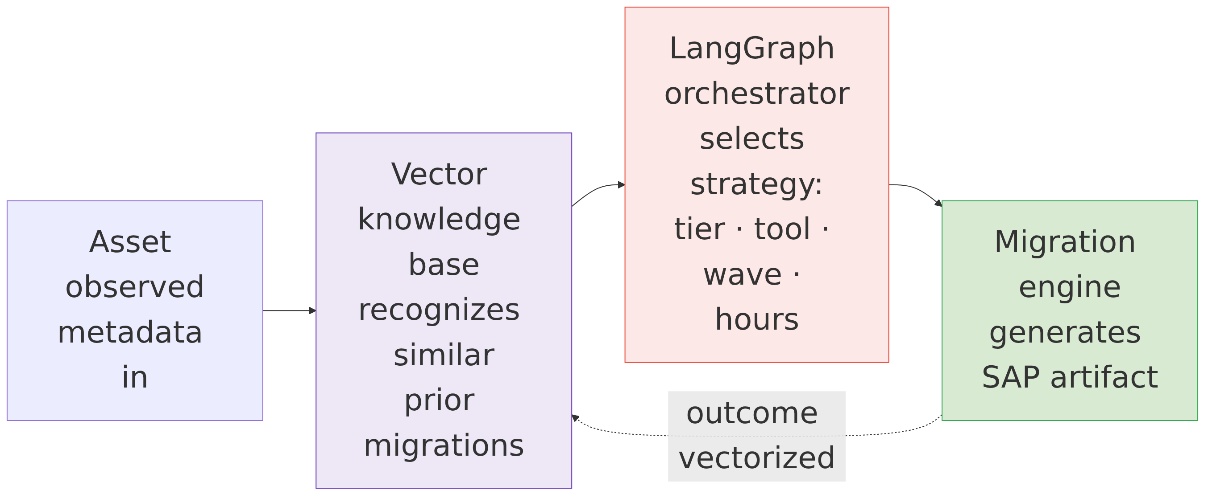

LangGraph Brain
Two compiled graphs orchestrate all AI work. The Migration Advisor (5 nodes) drives assessment; the Insight Pipeline (2 nodes, Claude Haiku 4.5) turns captured platform events into prioritized insights. Graphs are deterministic state machines: every LLM node has a rule-based fallback, and outputs merge over the always-computed rule floor.

LangChain
Provides the model bindings (@langchain/anthropic), prompt templating, and JSON-mode output parsing beneath LangGraph. License cost: $0 (MIT open source).

HANA Vector Database
Target-state RAG store: VectorEntry (1536-dim real embeddings) in HANA Cloud Vector Engine, queried with COSINE_SIMILARITY(). One database engine for business data and vectors — no separate vector-DB license, no data movement, row-level projectId security applies to vectors identically. As-built interim: local JSON store with 128-dim deterministic embeddings behind the same add/search/getAll/replaceAll interface — swap-ready.

SAP AI Core
Target-state LLM gateway: Claude models consumed through the Generative AI Hub in SAP AI Core, giving SAP-native procurement, metering, prompt logging, and model governance. Also the future host for embedding generation. Until then, direct Anthropic API access with the key in the Credential Store.

Joule
SAP's copilot is treated as a client-side surface, not a dependency: SDAINT AI exposes clean OData v4 actions that Joule (or any assistant) can call — "Joule, what's the migration recommendation for MATMAS?" resolves to migrationAdvisor. This keeps SDAINT AI complementary to SAP's AI roadmap rather than competitive with it.

17. Data Storage
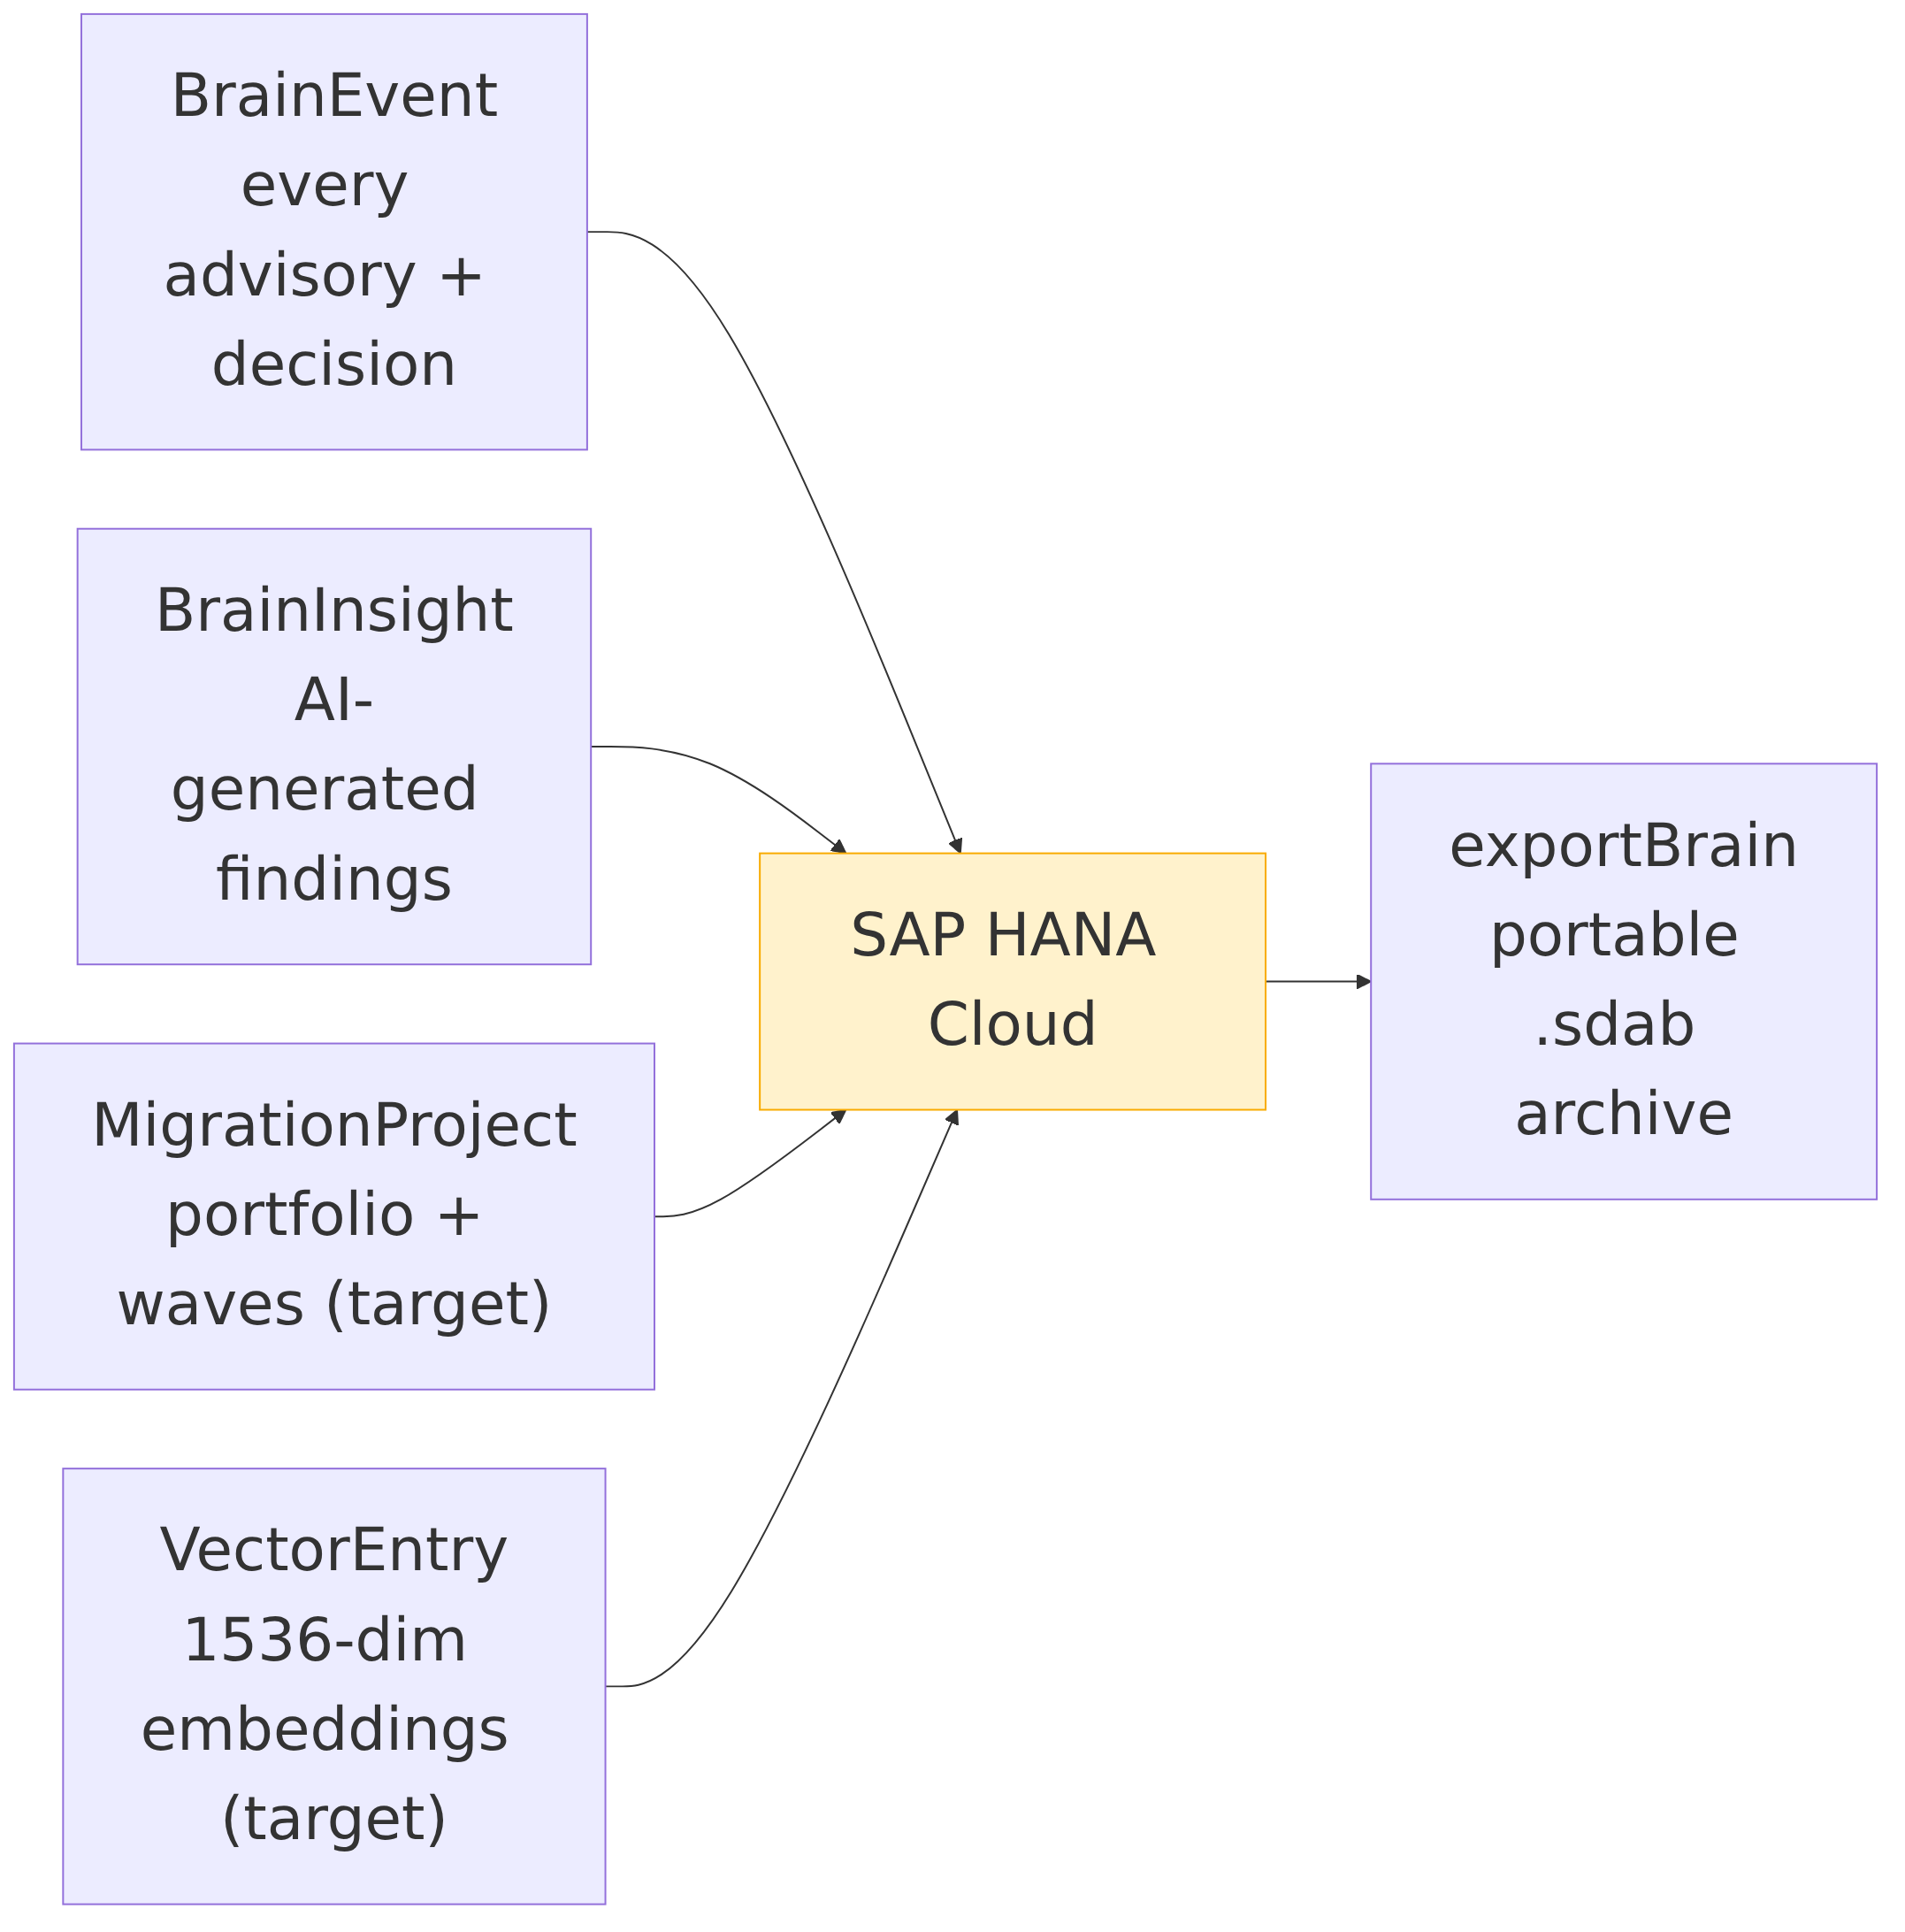
Entity | Purpose | Store
BrainEvent | Every advisory, capture, decision — type, source, payload, summary, embedding ref | HANA (SQLite dev)
BrainInsight | Prioritized insights from the Haiku pipeline | HANA
BrainSession / BrainConfig | Session telemetry, config keys | HANA
VectorEntry (target) | Embedding + content + tier + outcome + projectId | HANA Vector Engine
MigrationProject (target) | Client, source system, phase, wave, coherence | HANA
Brain archive | Full-state export/import (base64 .sdab) | File — interim isolation + DR

18. SAP Landscape Alignment
SAP element | Role in SDAINT AI
SAP Integration Suite | Target runtime for Complex tier; MAT feeds intake; Migration Wizard and Integration Advisor (MIG/MAG) are leveraged, not replaced; API Management fronts the platform APIs
BAIP services | CF runtime, HANA Cloud, XSUAA, IAS, Destination + Connectivity, Credential Store, Event Mesh/AEM, Application Logging, Audit Log, HTML5 repo, Portal
ABAP Cloud | The clean-core programming model our Simple-tier output targets; generated RAP artifacts are ABAP-Cloud-compliant (released APIs only)
S/4HANA | Simple-tier destination; Pattern C posts via BAPI_ACC_DOCUMENT_POST with full tax handling (ACCOUNTTAX, OB40/FTXP keys) and commit/rollback discipline
RAP | Generated behavior definitions (BDEF) give validated, transactional CRUD on the digital core — the modern replacement for point-to-point interface code
CAP | Both the platform's own runtime and the Medium-tier output format — SDAINT AI generates what it is built from, so every generated service inherits the platform's own patterns

19. Architecture Decisions (summary)
AD | Decision | Rationale
AD-001 | CAP on BAIP CF (not Kyma-first) | Fastest SAP-native path; Kyma kept as option via Helm chart
AD-002 | LangGraph for orchestration (not custom code / SAP Build) | Deterministic graphs, OSS, testable nodes, model-agnostic
AD-003 | Claude Sonnet 4.6 + Haiku 4.5 split | Advisory quality where it matters; 3–5× cheaper insight path
AD-004 | Rule floor beneath every LLM call | Availability + explainability + cost control
AD-005 | Three-tier output model (RAP / CAP / iFlow) | Right-sized target per asset; avoids "everything becomes an iFlow" cost trap
AD-006 | 85% Pattern C confidence threshold | Conservative by design; threshold recalibrated per record family from review outcomes
AD-007 | Event Mesh now, AEM at scale | Defer ~$1–2K/month broker cost until event volume justifies
AD-008 | Local JSON vectors → HANA Vector Engine at >10K vectors or first multi-client PROD | Ship-fast pragmatism with an explicit, metric-gated migration trigger
AD-009 | LLM via AI Core Gen AI Hub (target) | SAP procurement, governance, and metering for the single external dependency

20. References & Sources
This document is architecture-focused and doesn't itself make the competitor cost/timeline claims that most need sourcing (Crave InfoTech, Bluethink) — those live in SDAINTAI-Blueprint.md §14 and SDAINTAI-Unified-Architecture.md Appendix C, including an open sourcing gap on the Bluethink figures that should be resolved before external distribution. The one figure cited directly in this document:
- SAP Migration Assessment Tool documentation — https://help.sap.com/docs/integration-suite/sap-integration-suite/migration-assessment. Describes SAP's own free scoring/ICO-assessment tool. The "6–10 week manual assessment" baseline this document compresses against is SDA's own delivery-pattern estimate for the human assessment phase this tool doesn't automate, not a SAP-published figure. Full detail: Blueprint §14 item 2.

SDAINT AI Solution Architecture Document v2.1 — July 2026 (References added §20) Ayman Kaabi Kabalan — Lead BAIP SAP Architect, SDA SDA — SAP Integration Suite Migration Factory Partner (North America)

