SDAINT AI — Technical Design Document (TDD)

The Engineering Blueprint for Migration Execution
Document Type: Technical Design Document Classification: SDA Internal | Engineering Reference (client-shareable extracts) Version: 2.1 — July 2026 (complete redesign; supersedes TDD v1.1; adds sourced references §11) Author: Ayman Kaabi Kabalan — Lead BAIP SAP Architect, SDA · SDA Engineering Practice Diagram legend: ⬜ grey = legacy sources · 🟥 red = AI brain · 🟦 blue = deterministic logic · 🟨 yellow = human decisions · 🟩 green = SAP output · 🟪 purple = knowledge/learning. All flows read left → right. Audience: Engineers, integration consultants, solution architects, project managers Design goal of this document: every engineer should understand the migration process within minutes. Every flow reads left to right. Simplified SAP terminology throughout. Terminology: BAIP = SAP Business AI Platform (formerly SAP BTP). Program numbers: locked task-level estimates and dates now live in ONE-PAGER-Master-Task-Plan-Final.md and PLAN-05-Two-Golives-Simple.md, not in this document.

1. The Migration Process in One Picture
Every migration — regardless of source platform — follows the same conveyor. Only the intake adapter (step 1) differs per source.
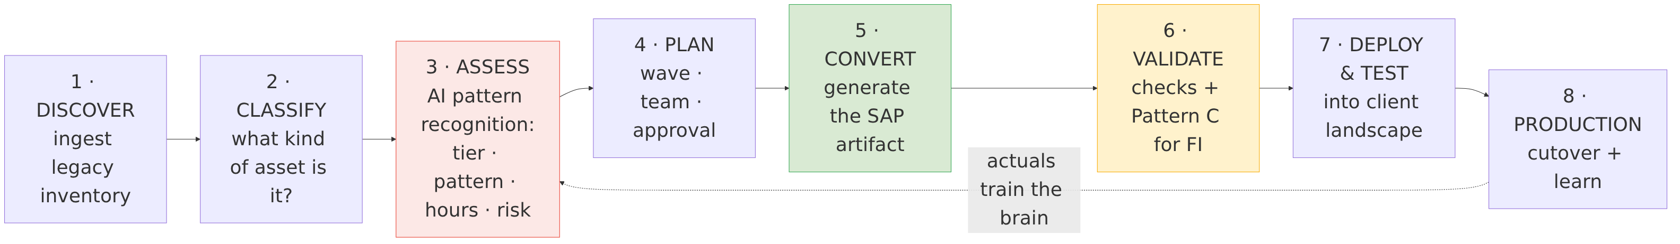
Why each stage exists:
Stage | What happens | Why it happens
Discover | Legacy export is parsed and normalized | You cannot migrate what you have not inventoried; gaps surface on day 1, not month 4
Classify | Asset typed as Master Data / Transactional / Technical / Custom | The asset type predicts the migration pattern better than any other single fact
Assess | AI brain scores complexity, picks the pattern, estimates hours/days, assigns risk | Consistent, explainable judgment — the step where projects traditionally go wrong
Plan | Wave assignment, team assignment, human approval | Sequencing controls risk; simple assets first builds confidence and trains the brain
Convert | The tier-specific SAP artifact is generated | Deployable output is the deliverable — not a recommendation document
Validate | Automated checks; financial flows pass the Pattern C firewall | One bad FI posting costs more than the whole migration; zero-unvalidated-postings rule
Deploy & Test | Artifact deployed to DEV → QA; Int4-style regression against legacy behavior | Prove equivalence before cutover
Production | Cutover per runbook; actual hours captured | The actuals feed back and make the next estimate better

2. Migration Flows per Source Platform

2.1 SAP PI/PO → SAP targets
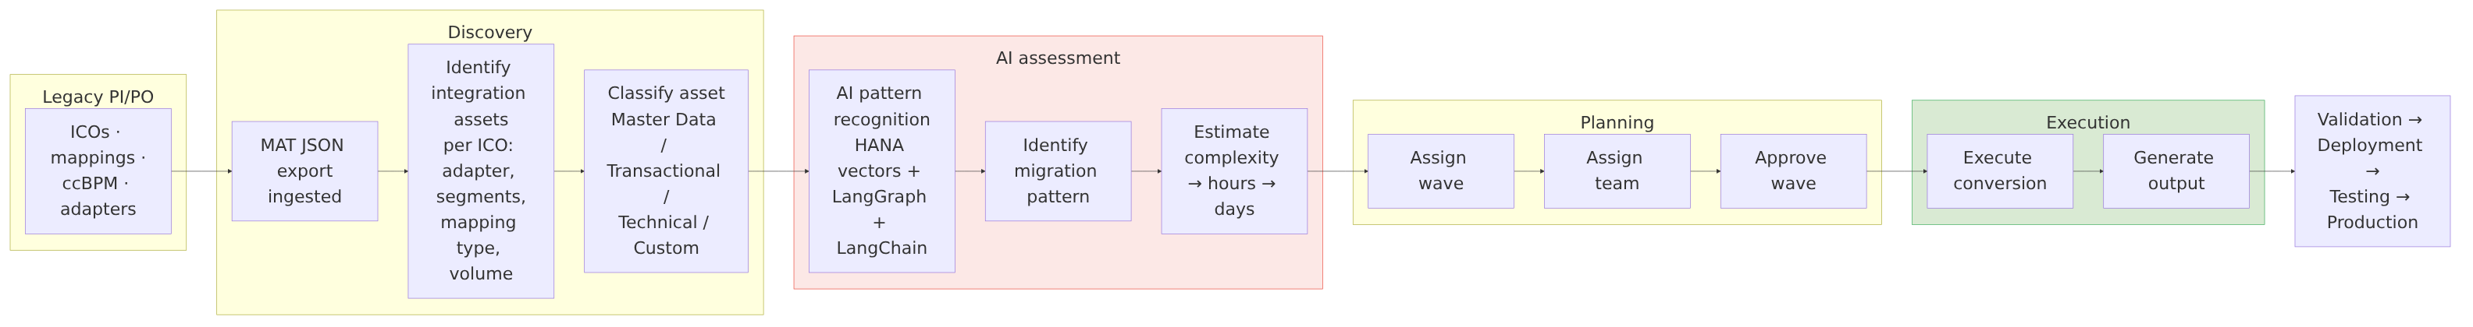
Possible PI/PO outputs (chosen by the AI, confirmed by the architect):
Output | When
SAP Integration Suite iFlow | Stateful, multi-partner, high-volume, or ccBPM-derived scenarios
S/4HANA BAdI | Logic that belongs inside the application core
ABAP / RAP service (BDEF) | Simple master-data or transactional posting — no middleware hop needed
API (API Management) | Interface consumers need a managed, governed endpoint
CAP service wrapper | Transformation/orchestration logic best expressed cloud-natively
Manual conversion | Genuinely bespoke assets — routed to a senior architect with an AI-generated plan
PI/PO-specific classification inputs: IDoc type (MATMAS, DEBMAS, ORDERS05, …), segment count, Z-fields, mapping technology (graphical / XSLT / Java / ABAP), adapter type (IDoc / SOAP / RFC / SFTP / JDBC / AS2 / JMS), daily volume, ccBPM flag, EDI flag.

Lab-verified PI/PO baseline (July 2026)
SDA manually migrated 10 real PI/PO interfaces to Integration Suite (tenant lab-sda.it-cpi019, package PJ1_2_IS_MIGRATION) and timed each one: 4 h migrate + configure, 2 h test — 6 h per interface, 60 h total. These are the engineering reference numbers behind every estimate in the commercial documents.
# | Asset | IDoc / BAPI | Sender → Receiver | iFlow ID | Manual (hrs) | SDAINT AI target (hrs)
1 | Material Master | MATMAS07 | IDoc → HTTP | MAS_Material_Master | 4 + 2 | 1.8
2 | Customer Master | DEBMAS08 | IDoc → SFTP | MAS_Customer_Master | 4 + 2 | 1.8
3 | Vendor Master | CREMAS07 | IDoc → SFTP | MAS_Vendor_Master | 4 + 2 | 1.8
4 | Sales Orders | BAPI_SALESORDER_CREATEFROMDAT2 (Z-wrapper) | SOAP → RFC | O2C_Sales_Order | 4 + 2 | 1.8
5 | Delivery | DELVRY03 (DESADV) | IDoc → SFTP | O2C_Delivery | 4 + 2 | 1.8
6 | Invoice (Billing) | INVOIC02 | IDoc → SFTP | O2C_Invoice | 4 + 2 | 1.8
7 | Shipment | SHPMNT05 | IDoc → SFTP | O2C_Shipment | 4 + 2 | 1.8
8 | Purchase Order | ORDERS05 | HTTPS → IDoc | P2P_Purchase_Order | 4 + 2 | 1.8
9 | Goods Receipt | MBGMCR03 | HTTPS → IDoc | P2P_Goods_Receipt | 4 + 2 | 1.8
10 | FI Document | BAPI_ACC_DOCUMENT_POST (Z-wrapper) | HTTPS → RFC | FIN_Document | 4 + 2 | 1.8 + Pattern C
 |  |  |  | Total | 60 h | 18 h (−70%)
The SDAINT AI target splits per interface as ~1.2 h human configuration/review + ~0.6 h assisted testing; classification, pattern match, and artifact generation are automated (all 10 objects are seeded patterns). Timeline diagrams and the full cost math: Blueprint v2.2 §8.

2.2 MuleSoft → SAP targets
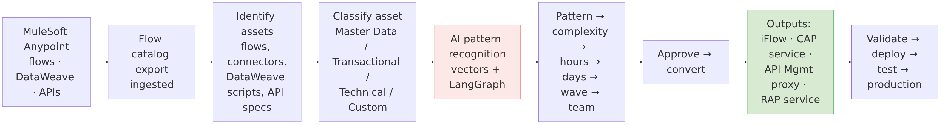
MuleSoft-specific notes: DataWeave transformations map to message-mapping/Groovy in iFlows or JavaScript in CAP; API specifications (RAML/OAS) migrate near-1:1 into SAP API Management; the commercial driver is license retirement ($400K–$600K/yr) [1].

2.3 Dell Boomi → SAP targets
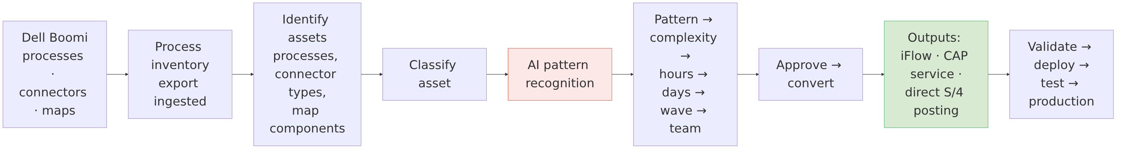
Boomi-specific notes: Boomi processes are typically fine-grained — many collapse into fewer, better-factored iFlows or one CAP service; connector inventory maps to IS adapter availability first, gaps flagged as Complex.

2.4 Informatica → SAP targets
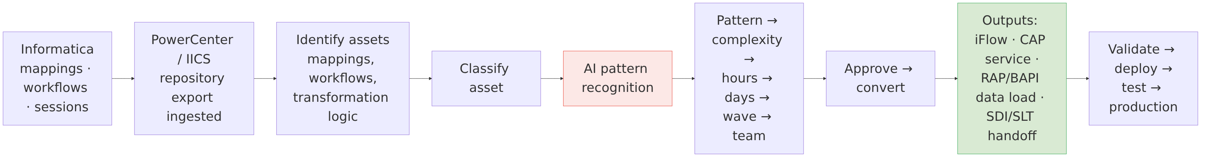
Informatica-specific notes: pure data-movement mappings often belong in SAP data-integration tooling (SDI/SLT/Datasphere) rather than Integration Suite — the AI flags these as a distinct pattern; heavy transformation workflows become CAP services or iFlows with script steps.

3. Asset Classification Model
Every asset, from every source, lands in one of four classes — because the class predicts the pattern:
Class | Examples | Typical tier | Typical output
Master Data | MATMAS, DEBMAS, CREMAS, GLMAST, product/customer syncs | Simple–Medium | RAP/BDEF + BAPI direct to S/4
Transactional | ORDERS05, INVOIC02, DESADV, payment runs | Medium–Complex | iFlow or CAP service; Pattern C if financial
Technical | File transfers, pollers, routers, pub/sub | Simple–Medium | iFlow (Pattern A) or CAP service
Custom | ccBPM, custom Java/DataWeave logic, EDI trading partners | Complex | Redesign: Build Process Automation, Integration Advisor MIG/MAG, custom iFlow

4. The AI Brain — Simple Explanation
The AI observes migration assets. The vector database recognizes patterns. The orchestration engine selects the best migration strategy. The migration engine generates the recommended SAP artifact. That is the whole concept — everything below is implementation detail.
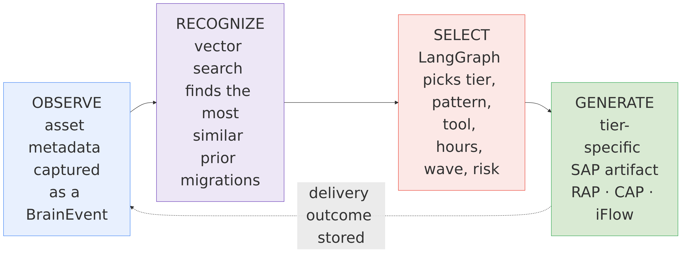
Three engineering guarantees behind the simple story:
- The rules always answer first. A deterministic advisor computes a complete result (tier, tool, hours, wave) for every request. The LangGraph/Claude result overlays it field-by-field. If the LLM is down, slow, or wrong-shaped, the assessment still completes in under 2 seconds.
- Known patterns skip the LLM. 19 seeded SAP object patterns (GLMAST, MATMAS, DEBMAS, ORDERS05, INVOIC02, …) carry curated tier/tool/hours — the fast path costs zero tokens.
- Every answer is explainable. Tier, score, tool, and estimate each store a human-readable rationale; the architect can override any field, and the override is captured as training signal.

4.1 Migration Advisor graph (engineering view)
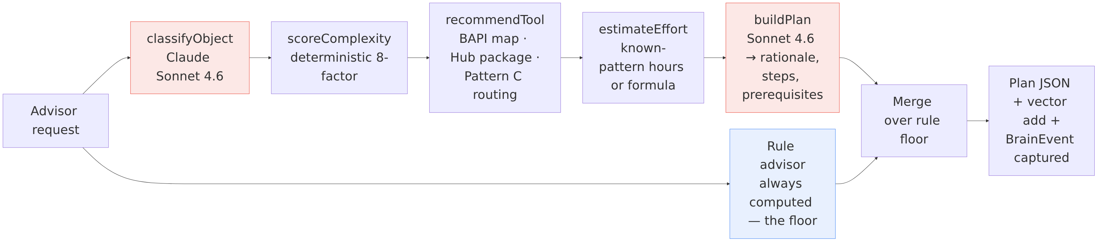
Complexity scoring (node 2, deterministic): segments (>15 → +6, >5 → +3, else +1) · Z-fields (+4) · mapping type (Java/ABAP +6, XSLT +3) · volume (>100K/day +6, >10K +3) · adapter (AS2/JMS/custom +6, JDBC/RFC +3) · EDI (+4) · BPM (+10) · FI/HR elevation (+3). Tier: ≤8 Simple, ≤18 Medium, else Complex. complexityScore = min(100, round(score/30·100)).
Effort formulas (node 4): known-pattern hours take precedence; otherwise Simple 4 + 0.3·segments · Medium 16 + 0.5·segments + 8·zFields · Complex 60 + 0.8·segments + 20·EDI + 40·BPM. Days = hours ÷ 6 productive hours; both are surfaced.
In plain words: if the brain has seen this object before, it quotes the hours it actually took. If not, it starts from a base price per tier (like a garage's standard job rate) and adds a surcharge for each thing that makes the job harder — more data segments, custom Z-fields, EDI partners, embedded BPM workflows. Every delivered wave feeds actualHours back in, so the quotes tighten toward ±20% over time.
Tool routing (node 3): Simple → BAPI package (from BAPI_MAP, fallback BAPI_{ID}_SAVE) · Medium → iFlow_SemiAuto with SAP Business Accelerator Hub package match, else iFlow_Custom · Complex FI/HR → LangChain_Pattern_C (AI-guarded iFlow) · other Complex → full iFlow rebuild / redesign path.

4.2 API contract — migrationAdvisor (OData v4 action)
Request:
{
"objectId": "MATMAS",
"objectDesc": "Material master replication to 3 plants with Z-fields",
"segmentCount": 38,
"hasZFields": true,
"mappingType": "graphical | xslt | java | abap",
"adapterType": "idoc | soap | rfc | sftp | jdbc | as2 | jms | rest | custom",
"volumePerDay": 12000,
"isBpmProcess": false,
"isEdiBased": false,
"sourceSystem": "PI_PO | MULESOFT | BOOMI | INFORMATICA"
}
Response:
{
"objectId": "MATMAS",
"objectType": "MASTER_DATA_MATMAS",
"tier": "medium",
"complexityScore": 55,
"recommendedTool": "iFlow_SemiAuto",
"specificTool": "SAP S/4HANA Material Replication",
"estimatedHours": 20,
"riskLevel": "medium",
"waveAssignment": 2,
"rationale": "2-3 sentence AI-generated explanation",
"steps": "[\"…\"]",
"prereqs": "[\"IS tenant configured\", \"RFC destination to S/4\"]"
}
Other exposed actions: captureEvent, runAnalysis, getBrainStatus, seedMigrationKnowledge, exportBrain / importBrain (base64 .sdab archives), toggleBrain. Auth: master key as-built → XSUAA scopes (MigrationAdvisor, BrainAdmin, FinanceReviewer) per hardening stage H1.

5. Migration Cockpit
The cockpit is the delivery lead's single pane of glass — portfolio in, completion out:
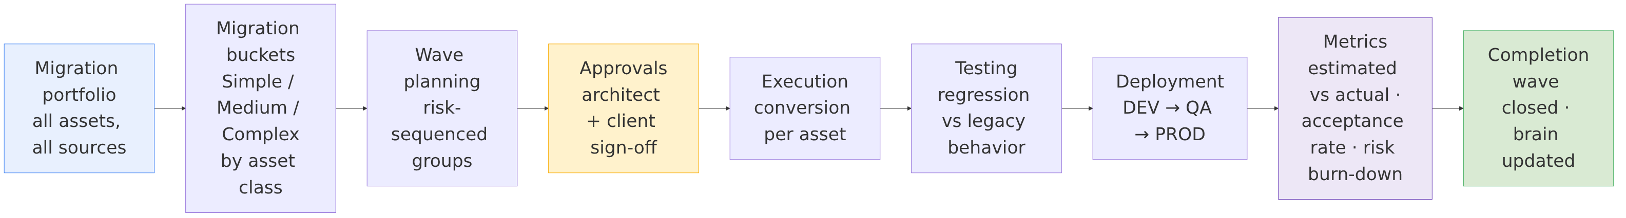
Wave sequencing rules (why, not just what): Wave 1 = high-count, low-risk Simple assets (builds momentum, trains the brain on this client's landscape); middle waves = Medium tier grouped by business domain (bounded blast radius per cutover); final waves = Complex + financial assets (maximum accumulated knowledge and test coverage when it matters most).
Cockpit metrics surfaced: objects per tier and wave, estimated vs actual hours per wave, recommendation acceptance rate, Pattern C auto-post rate, high-risk alerts (sda/brain/alert/high-risk-object), coherence score.

6. Pattern C — The Financial Firewall
In plain words: Pattern C is a checkpoint that every financial record must pass before it may touch the client's books — like an experienced accounts clerk who never gets tired. Records the system is ≥85% confident about post automatically; everything else waits for a human. Nothing unvalidated ever reaches S/4HANA. (Layman walk-through: Blueprint v2.2 §7.)
Financial flows get one extra, non-negotiable stage between conversion and posting:
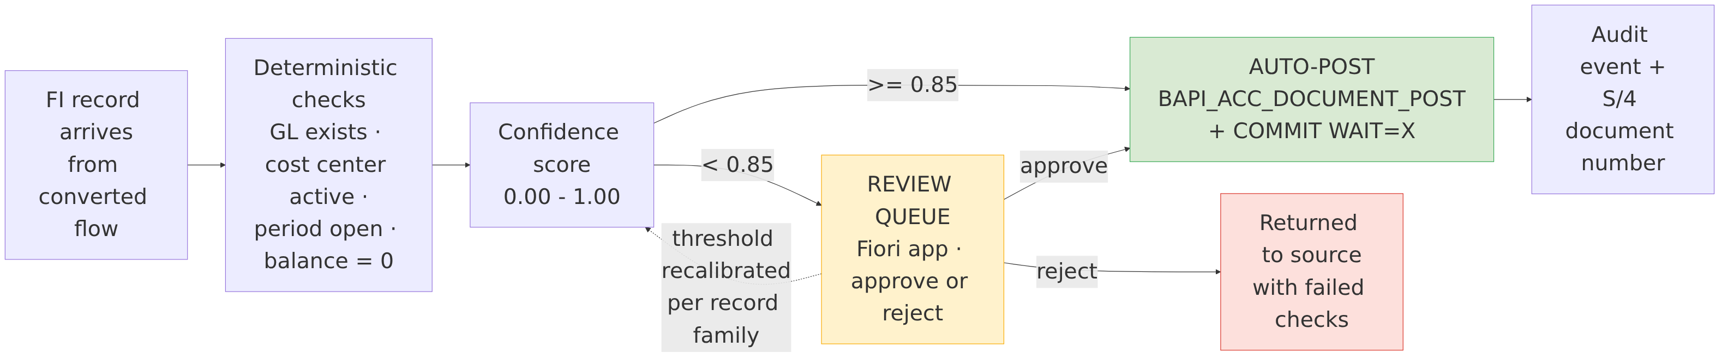
Posting discipline (verified reference implementation): gross AR debit (ACCOUNTRECEIVABLE), net revenue credit with TAX_CODE (ACCOUNTGL), one ACCOUNTTAX row per tax component (GST MWS / QST MW1 account keys, condition keys per FTXP), AMT_BASE on tax rows, BAPI_TRANSACTION_COMMIT (WAIT='X') on success, rollback on any RETURN type E/A. Full walk-through: docs/howtocallbapiandaddtaxtonetamount.md.
Rules: no unvalidated record ever reaches S/4; every decision writes an immutable audit event with confidence, verdict, and approver; rejected/approved outcomes recalibrate the threshold per record family (the firewall also learns).

7. Conversion Output Specifications
Tier | Generated artifact | Contents | Deployment
Simple | RAP/BDEF + BAPI package | Behavior definition, mapping sheet, BAPI call module (e.g. BAPI_MATERIAL_SAVEDATA, BAPI_ACC_DOCUMENT_POST), unit test stubs | Transport to S/4HANA
Medium | CAP integration service | CDS model, Node.js handlers, OData v4 API, mta.yaml, destination config | MTA deploy to BAIP CF
Complex | IS artifact bundle | iFlow(s), value mappings, externalized parameters, Integration Advisor MIG/MAG (EDI), Int4-style test plan | Import via IS Content API
Per wave | Migration Package | All tier artifacts + cutover runbook with rollback points | Client hand-off

8. Eventing & Integration Matrix
# | Interface | Direction | Protocol
I1 | MAT assessment import | IS → SDAINT AI | REST/JSON
I2 | migrationAdvisor | client / iFlow → SDAINT AI | OData v4 action
I3 | Batch runAnalysis | operator → SDAINT AI | OData v4 action
I4 | Pattern C validation | IS iFlow → SDAINT AI | REST (HTTPS)
I5 | Simple-tier posting | generated package → S/4 | RAP OData / RFC-BAPI
I6 | Medium-tier deploy | SDAINT AI → BAIP CF | MTA
I7 | Complex-tier import | SDAINT AI → IS tenant | IS Content API
I8 | Brain/migration events | SDAINT AI ↔ Event Mesh/AEM | AMQP — sda/migration/fi/posted, sda/migration/batch/{wave}/complete, sda/brain/alert/high-risk-object
I9 | LLM | SDAINT AI → Claude (via AI Core Gen AI Hub, target) | HTTPS

9. Technology Stack (engineering reference)
Layer | Technology | Version
Runtime | SAP CAP Node.js, @sap/cds 9.x, Node 20 LTS, cds-mtxs sidecar | as-built
AI orchestration | @langchain/langgraph 1.4.x, langchain 1.5.x, @langchain/anthropic | as-built
LLM | claude-sonnet-4-6 (advisory, maxTokens 1024) · claude-haiku-4-5 (insights, maxTokens 512) | pinned
Vector store | Local JSON (128-dim, cosine) → HANA Cloud Vector Engine (1536-dim) | AD-008
DB | HANA Cloud (@cap-js/hana) / SQLite dev / PostgreSQL option | as-built
Eventing | Event Mesh (enterprise-messaging) · kafkajs present | as-built
Cache | Redis 5.x client | option
UI | SAPUI5 / Fiori + static console (Staticfile buildpack) | as-built
Deploy | MTA (MBT 1.2.x) → CF us10; Jenkinsfile; Helm chart for Kyma | as-built
iFlow lifecycle | Figaf Migration Edition (CI/CD) [3], Int4 Shield Lite (regression) [2] — both free 12 months via SAP promotion | engagement

10. Production Hardening Roadmap (engineering backlog)
Stage | Item | Exit criterion
H1 | XSUAA on all brain actions; retire master key | Pen-test pass; no shared secrets
H2 | projectId multi-tenancy on BrainEvent + vectors | Two concurrent projects, verified isolation
H3 | HANA Vector Engine + real embeddings (AI Core) | RAG A/B vs local store; >10K vector scale test
H4 | Pattern C validation API + Fiori review queue productionized | First FI batch ≥85% auto-post, zero bad postings
H5 | MigrationProject entity + multi-project cockpit | Delivery lead runs 3 projects from one screen
H6 | Event Mesh topic wiring + high-risk alerting | Event-driven wave dashboard live

11. References & Sources
This is an engineering document; it doesn't make the competitor cost/timeline claims that need sourcing (Crave InfoTech, Bluethink) — those live in SDAINTAI-Blueprint.md §14 and SDAINTAI-Unified-Architecture.md Appendix C, which readers should consult for the full analysis including an open sourcing gap on the Bluethink figures. The two figures cited directly in this document:
- MuleSoft Anypoint Platform pricing — no public list price (mulesoft.com/anypoint-pricing is sales-negotiated). The $400K–$600K/yr enterprise range is an order-of-magnitude estimate from third-party pricing analyses (integrate.io, cloudconsultings.com), not a MuleSoft-published figure. Full detail: Blueprint §14 item 6.
- Int4 Shield (Lite edition) — free 12 months via SAP promotion: https://int4.com/shield.
- Figaf Migration Edition — free 12 months via SAP promotion: https://figaf.com.

SDAINT AI Technical Design Document v2.1 — July 2026 (References added §11) Ayman Kaabi Kabalan — Lead BAIP SAP Architect, SDA SDA — SAP Integration Suite Migration Factory Partner (North America)

