- Use Case
Recommendation systems use historic ratings of products/services by users to make specific recommendations. They are based on ratings' predictions. Previous ratings from a given user are used to predict what rating he/she would give to a specific item and items for which a high rating is predicted are then recommended to that user.
- Data Set
The MovieLens dataset that we are using for this project is provided by GroupLens, a research lab in the Department of Computer Science and Engineering at the University of Minnesota.
GroupLens has collected and made available rating datasets from their website. The datasets were collected over various periods of time, depending on the size of the set.
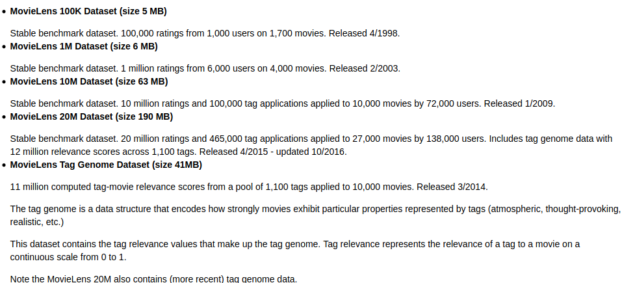
For this project, we are using the MovieLens 1M dataset.
- Data Quality Assessment
The data is actually already curated, ready to use. No missing values, no wrong formatting,no much data engineering is required.
- We just need to merge the movies.dat and ratings.dat files into a Pandas dataframe for our whole project.
- In the course of Exploratory Data Analysis, year-month features are temporarily added, based on the timestamp information.
- Data Exploration (e.g. correlation between columns)
Cause we just use the column: userId movieId rating genres,So we cant check the correlation between columns

But we can check the data below
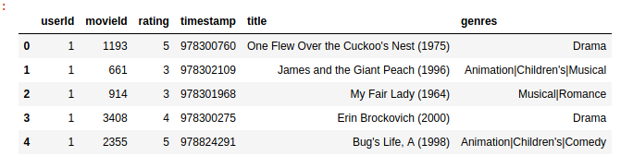
- Data Visualization (e.g. value distribution of columns)
Here is the value distribution of columns
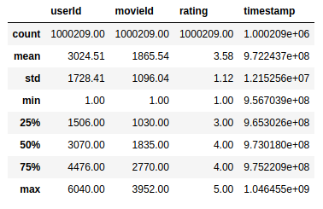

- At least one Feature Engineering (e.g. imputing missing values) applied
The data is actually already curated, ready to use. No missing values, no wrong formatting,no much data engineering is required.
- We just need to merge the movies.dat and ratings.dat files into a Pandas dataframe for our whole project.
In the course of Exploratory Data Analysis, year-month features are temporarily added, based on the timestamp information.
- Selection and justification of Model Performance Indicator (e.g. F1 score)
We use RMSE to evaluate

- At least one traditional Machine Learning Algorithm and one DeepLearning Algorithm applied and demonstrated
We use MF-MLP neural network and User and movie effects with regularization to predict
- Model performance between different feature engineerings and models compared and documented
