**GitHub Projects 2**

**Navigation menu**

**Our team …………**

**Used technologies ……………**

**---For technical purpose---**

**---For communication purpose---**

**How it all works**

**Future ideas**

**Our team:**

1. Kristian Lalev, 9g, [KALalev18@codingburgas.bg](mailto:KALalev18@codingburgas.bg)
2. Stoicho Dimitrov, 9a, [SDDimitrov18@codingburgas.bg](mailto:SDDimitrov18@codingburgas.bg)
3. Georgi Kalchev, 9b, [GSKalchev18@codingburgas.bg](mailto:GSKalchev18@codingburgas.bg)

**Who has what part in the team**

1. Kristian Lalev – Lead researcher

2. Stoicho Dimitrov – Manager, Lead developer

3.Georgi Kalchev – Developer , Researcher

**Used technologies**

---For technical purposes we have used c++ in microsoft visual studio environment---

---For communicational purposes we have used Discord---

**How it all work**

You need to input the letter and the letter must be in the word, or else you lose the game.

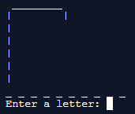

If you guess the word, you will get that on screen:

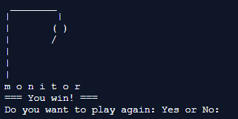

If your letter isn't in your word six times, you will get that on your screen:

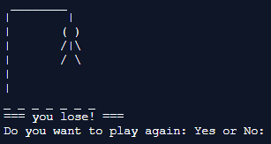

When you answer “Yes”, it is going to start a new game, but if you answer no, the game is ending.

**Future ideas**

**1.** We want toadd more features to the game.

**2**. We would like to add different game modes to the game and improve the algorithm

In the future, we would like to add more options on the game and something like new game modes.