SDG Metadata Authoring Tool Template
  - Word Version 3.4 (DRAFT)
Main and Detailed Concept Collection Form
Contents
Metadata Attachment 2
Metadata Submission Form 2
0. Indicator information 2
1. Data reporter 2
2. Definition, concepts, and classifications 3
3. Data source type and data collection method 3
4. Other methodological considerations 3
5. Data availability and disaggregation 4
6. Comparability/deviation from international standards 4
7. References and documentation 4
Appendices 4
A. Definitions of Metadata Concepts 4
B. Mapping of SDMX Detailed Concepts to IAEG-SDG File Format 7
C. Mapping of IAEG-SDG File Format to SDMX Detailed Concepts 8
Instructions
This is a template for providing metadata for SDG indicators. The tables listed below use the SDMX Metadata Concepts prepared by the SDG SDMX Working Group of the IAEG-SDGs to provide a standard format for your metadata. This enables more efficient and accurate processing.
Both national and global metadata can be submitted using this tool. Headers, text, bullets, tables, formulas, and images can be cut and pasted into their corresponding cell without additional formatting. A mapping of the IAEG-SDG metadata file format to SDMX metadata concepts is also provided.
Use only the metadata concepts provided. Do not add additional metadata concepts. Only the SDMX Metadata Concepts will be read by our automation tool. Use the detailed metadata concepts (preceded by a number and a letter e.g. “0.a”) where available and as feasible; otherwise use the main concepts (preceded by a number e.g. “0”). If you are not sure where to put metadata within the existing SDMX Metadata Concepts, see the descriptions provided.
Submit one set of tables for each SDG indicator metadata file.

Metadata Attachment
Reporting type
National (N)
SDG series
17.1.1 Total government revenue as a proportion of GDP [17.1.1] (GR_G14_GDP)

Reference area
Kenya (404)
Metadata language
en
Please use a 2-letter ISO 639-1 language code. Full list is available at the ISO web page.

Import Data Structure Definition
To update the options in the dropdowns according to an SDMX DSD, click one of the buttons below:

Metadata Submission Form

0. Indicator information
Concept name | Insert text, lists, tables, and images.
0. Indicator information | PROPORTION OF POPULATION WITH ACCESS TO ELECTRICITY
0.a. Goal | Goal 17: Strengthen the means of implementation and revitalize the Global Partnership for Sustainable Development
0.b. Target | 17.1: Strengthen domestic resource mobilization, including through international support to developing countries, to improve domestic capacity for tax and other revenue collection
0.c. Indicator | 17.1.1: Total government revenue as a proportion of GDP, by source
0.d. Series
0.e. Metadata update | 2024
0.f. Related indicators | 17.1.2
0.g. International organisations(s) responsible for global monitoring | World Bank

1. Data reporter
Concept name | Insert text, lists, tables, and images.
1. Data reporter
1.a. Organisation | Kenya National Bureau of Statistics
1.b. Contact person(s) | Director Macroeconomics Statistics
1.c. Contact organisation unit | Senior Manager: Fiscal and Financial Statistics and External Statistics
1.d. Contact person function | Production and Dissemination of Macroeconomics Statistics
1.e. Contact phone | +254-202-911-000
1.f. Contact mail | 30266-00100, Nairobi- Kenya
1.g. Contact email | macro@knbs.or.ke

2. Definition, concepts, and classifications
Concept name | Insert text, lists, tables, and images.
2. Definition, concepts, and classifications | DEFINITION, CONCEPTS, AND CLASSIFICATIONS
2.a. Definition and concepts | Definition:  Revenue is defined in Chapter 4 (paragraph 4.23) of Government Finance Statistics Manual (GFSM) 2014 as an increase in net worth resulting from a transaction. It is a fiscal indicator for assessing the sustainability of fiscal activities. General government units have four types of revenue. The major types of revenue are taxes (GFS code 11), social contributions (GFS code 12), grants (GFS code 13), and other revenue (GFS code 14). Of these, compulsory levies and transfers are the main sources of revenue for most general government units. In particular, taxes are compulsory, unrequited amounts receivable by government units from institutional units. Social contributions are actual or imputed revenue receivable by social insurance schemes to make provision for social insurance benefits payable. Grants are transfers receivable by government units from other resident or non-resident government units or international organizations, and that do not meet the definition of a tax, subsidy, or social contribution. Other revenue is all revenue receivable excluding taxes, social contributions, and grants. Other revenue comprises: (i) property income; (ii) sales of goods and services; (iii) fines, penalties, and forfeits; (iv) transfers not elsewhere classified; and (v) premiums, fees, and claims related to non-life insurance and standardized guarantee schemes.  Concepts:  The transactions and the associated classifications are detailed in Chapter 5 of GFSM 2014 and are structured to demonstrate how general government (and public sector) units raise revenue. Only those taxes and social insurance contributions that are evidenced by tax assessments and declarations, customs declarations, and similar documents are considered to create revenue for government units. Thus, the difference between assessments and expected collections represents a claim that has no real value and should not be recorded as revenue (see GFSM 2014 paragraph 5.20). The analytic framework of GFSM 2014 (like that of the GFSM 2001) builds on the GFSM 1986 framework, and extends it by incorporating additional elements that are useful in assessing fiscal policy. An important example is the treatment of non-financial assets, where the sale of such assets is no longer included in revenue. The disposal of a non-financial asset by sale or barter is not revenue because it has no effect on net worth. Rather, it changes the composition of the balance sheet by exchanging one asset (the non-financial asset) for another (the proceeds of the sale).  Similarly, amounts receivable from loan repayments and loan disbursements are not revenue. In general, transactions that increase net worth result from current operations. Capital transfers are an exception. In GFSM 2014, capital transfers receivables are classified as revenue because they increase the recipient’s net worth and they are often indistinguishable from current transfers in their effect on government operations. In recording cash-based accounting revenue transactions, data representing the tax payments received by government, net of refunds paid out during the period covered should be reported. These data will include taxes paid after the original assessment, taxes paid or refunds deducted from taxes after subsequent assessments, and taxes paid or refunds deducted after any subsequent reopening of the accounts. Therefore, total tax revenue could be presented on a gross basis as the total amount of all taxes accrued, or on a net basis as the gross amount minus tax refunds. Revenue categories are presented as gross of expense categories for the same or related category. In particular, interest revenue is presented as gross rather than as net interest expense or net interest revenue.  Similarly, social benefits and social contributions, grant revenue and expense, and rent revenue and expense are presented gross. Also, sales of goods and services are presented gross of the expenses incurred in their production. In cases of erroneous or unauthorized transactions, revenue categories are presented net of refunds of the relevant revenue, and expense categories are presented net of inflows from the recovery of the expense. For example, refunds of income taxes may be paid when the amount of taxes withheld or otherwise paid in advance of the final determination exceeds the actual tax due. Such refunds are recorded as a reduction in tax revenue. For this reason, tax revenue is presented as net of non-payable tax credits (see GFSM 2014 paragraphs 5.29–5.32).
2.b. Unit of measure | Percent
2.c. Classifications | Classification of economic items defined according to the breakdown proposed in the International Monetary Fund (IMF) Manual Government Finance Statistics (GFS), available at:  http://www.imf.org/external/Pubs/FT/GFS/Manual/2014/gfsfinal.pdf.  , 2014, ISIC Rev. 4, Systems of National Accounts

3. Data source type and data collection method
Concept name | Insert text, lists, tables, and images.
3. Data source type and collection method | DATA SOURCE, TYPE AND DATA COLLECTION METHOD
3.a. Data sources | Economic Survey and Administrative Data
3.b. Data collection method | Administrative Data
3.c. Data collection calendar | Annual Economic Survey
3.d. Data release calendar | End of April of every year
3.e. Data providers | Stakeholders (Administrative Data)
3.f. Data compilers | Kenya National Bureau of Statistics
3.g. Institutional mandate | According to the Statistics Act of 2006, Kenya National Bureau of Statistics is mandated to collect, compile, analyze, publish and disseminate official statistics for public use

4. Other methodological considerations
Concept name | Insert text, lists, tables, and images.
4. Other methodological considerations
4.a. Rationale | Fiscal policy is the use of the level and composition of the general government and public sectors’ spending and revenue—and the related accumulation of government assets and liabilities—to achieve such goals as the stabilization of the economy, the reallocation of resources, and the redistribution of income. In addition to revenue mobilization, government units may also finance a portion of their activities in a specific period by borrowing or by acquiring funds from sources other than compulsory transfers—for example, interest revenue, incidental sales of goods and services, or the rent of subsoil assets. Indicator 17.1.1 Total government revenue as a proportion of GDP, by source supports understanding countries’ domestic revenue mobilization in the form of tax and non-tax sources. The indicator will provide analysts with a cross-country comparable dataset that highlights the relationship between the four main types of revenue as well as the relative "tax burden" (revenue in the form of taxes) and “fiscal burden” (revenue in the form of taxes plus social contributions).
4.b. Comment and limitations | In principle, GFS should cover all entities that materially affect fiscal policies. Cross-country comparisons are ideally made with reference to the consolidated general government sector. However, for most developing and many emerging market economies, compiling data for the consolidated general government and its sub-sectors is problematic owing to limitations in the availability and/or timeliness of source data. For example, a country may have one central government; several state, provincial, or regional governments; and many local governments. Countries may also have social security funds. The GFSM 2014 recommends that statistics should be compiled for all such general government units. This reporting structure is illustrated below: 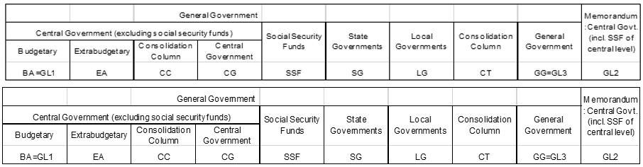  Some countries report data for the consolidated general government with one or more sub-sectors not separately reported. Similarly, there are some countries that report “consolidated central government” without necessarily providing the budgetary central government sub-sector separately. To address this, and allow the derivation of regional and world aggregates, the country data are presented for the budgetary central government, the consolidated central government (with and without social security funds), and for consolidated general government, as reported by the national authorities.  For many emerging market and low-income countries with limited statistical capacity, budgetary central government is considered the most appropriate level of institutional coverage for comparison purposes. Budgetary central government, as described in GFSM 2014 (paragraph 2.81), is an institutional unit of the general government sector particularly important in terms of size and power, particularly the power to exercise control over many other units and entities. This component of general government is usually covered by the main (or general) budget. The budgetary central government’s revenue (and expense) are normally regulated and controlled by a ministry of finance, or its functional equivalent, by means of a budget approved by the legislature.
4.c. Method of computation | Indicator 17.1.1 will be derived using series that are basic to the GFS reporting framework. GFS revenue series maintained by the IMF Statistics Department are collected in Table 1 of the standard annual data questionnaire. Each revenue transaction is classified according to whether it is a tax or another type of revenue. GFS revenue aggregates are summations of individual entries and elements in this particular class of flows and allow for these data to be arranged in a manageable and analytically useful way. For example, tax revenue is the sum of all flows that are classified as taxes. Conceptually, the value for each main revenue aggregate is the sum of the values for all items in the relevant category. The annual GFS series for monitoring Indicator 17.1.1 will be derived from the data reported by the national authorities (in national currency) expressed as a percent of Gross Domestic Product (GDP), where GDP is derived from the IMF World Economic Outlook database (no adjustments and/or weighting techniques will be applied). Mixed sources are not being used nor will the calculation change over time (i.e., there are no discontinuities in the underlying series as these are key aggregates/ components in all country reported GFS series). The presentation will closely align with that currently contained in World Table 4 from the hard-copy GFS Yearbook:  Revenue categories  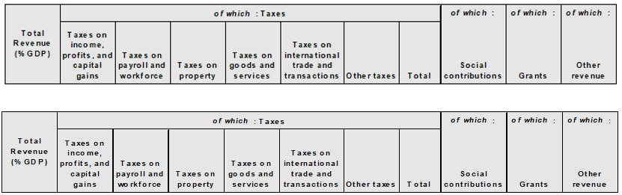 Historic series have been aligned with GFSM 2014 classifications. This enhances the comparability of data across countries and ensures establishing robust analytical findings to support SDG monitoring using fiscal data.
4.d. Validation | Statistics produced undergoes a rigorous process of peer review from stakeholders through set Technical Working Groups(TWG)
4.e. Adjustments | Not applicable
4.f. Treatment of missing values (i) at country level and (ii) at regional level | The IMF plans to rely exclusively on officially reported data provided by the national authorities using the standard GFS questionnaire based on GFSM 2014 methodology. No country data estimates for missing values will be calculated by the IMF Statistics Department. Where country data are not available due to a lack of reporting to the IMF Statistics Department, we plan to engage in outreach to the national authorities, in consultation with the respective IMF Area Departments and Offices of the Executive Director, as needed, to ensure that the key GFS series are reported.
4.g. Regional aggregations | The IMF Statistics Department will leverage the existing GFS database to provide cross-country comparable series in a standardized presentation format.
4.h. Methods and guidance available to countries for the compilation of the data at the national level | See 4.c.
4.i. Quality management | The Bureau is ISO certified and also carries out its own internal audit that ensures that high quality statistics are produced
4.j. Quality assurance | The Bureau adheres to KeSQAF that ensures that statistics produced meets the needs of the users
4.k. Quality assessment | The Bureau has a quality management system in place that ensures that data produced meets the set standards

5. Data availability and disaggregation
Concept name | Insert text, lists, tables, and images.
5. Data availability and disaggregation | Data availability:  Classification of the indicator into one of the three tiers: We recommend that 17.1.1 (like 17.1.2) remain classified as Tier 1: The indicator is conceptually clear and internationally agreed standards for compiling components and aggregates are available. The underlying data are regularly produced by countries, and there is current data available. From the IAEG-SDGs Tier Classification description at https://unstats.un.org/sdgs/iaeg-sdgs/tier-classification/, a key criterion is that “data are regularly produced by countries for at least 50 percent of countries”. The IMF GFS database, with 130+ regular annual reporting countries using the same reporting format meets this key criterion. Apart from conflict countries, all IMF member countries produce revenue (and expenditure) data for surveillance purposes. In recent rounds of soliciting annual GFS series from countries, we have specifically encouraged those countries that were non-reporters over the past few years to (at a minimum) provide the key revenue and expenditure series needed to monitor 17.1.  Disaggregation:  The detailed GFS revenue classification structure in the annual questionnaire that is used by countries to report data allows for compiling 17.1.1. The four types of revenue: Taxes, Social contributions, Grants and Other revenue are further disaggregated in the annual GFS questionnaire in order to encompass all possible forms of revenue administrations. Taxes are disaggregated as follows:  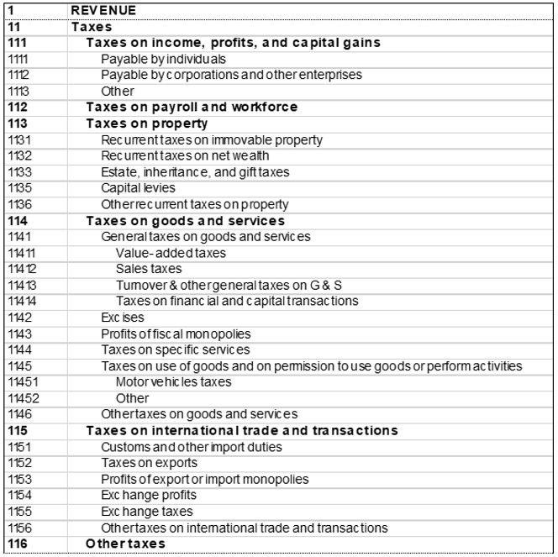  Social contributions differentiate between social security and other social contributions, as follows:  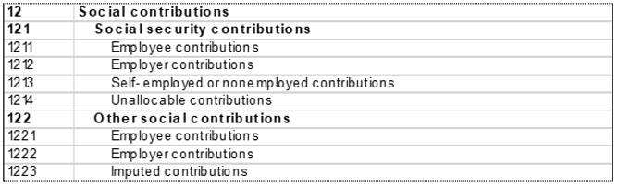  Grants can be disaggregated by source as follows:  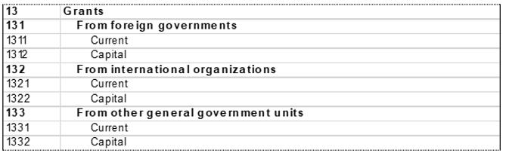  And Other revenue is disaggregated into five main types, with additional component detail as follows:  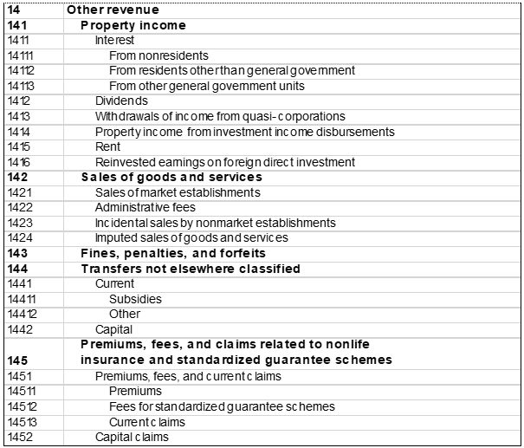

6. Comparability/deviation from international standards
Concept name | Insert text, lists, tables, and images.
6. Comparability/deviation from international standards | Sources of discrepancies:  Where the relevant aggregates and component detail in series disseminated by the national authorities are found to differ from GFS due to unreported revisions, the IMF Statistics Department will solicit revised time series in GFS format from the national authorities.

7. References and Documentation
Concept name | Insert text, lists, tables, and images.
7. References and Documentation | The GFSM 2014 is available at http://www.imf.org/external/np/sta/gfsm/. A series of videos that discuss the GFS analytical framework are available at: IMF Statistics E-Learning Videos - YouTube. Although not foreseen under the reporting of 17.1.1, analysts can also use the detailed IMF GFS Revenue database to supplement this indicator with measures of direct, indirect and capital taxes (see GFSM 2014, Annex to Chapter 4).

Appendices

A. Definitions of Metadata Concepts
0.a. Goal: SDG Goal number and name.
0.b. Target: SDG Target number and name.
0.c. Indicator: SDG Indicator number and name.
0.d. Series: Description of SDG data series.
0.e. Metadata update: The date when this metadata report was last updated.
0.f. Related indicators: Linkages with any other Goals and Targets.
0.g. International organisations(s) responsible for global monitoring: Global reporting: International organizations (departments/offices) responsible for monitoring this indicator at the global level. Country reporting: This concept has no national counterpart.
1.a. Organisation: Organisation unit information of the contact points for the data or metadata.
1.d. Contact person function: Functional title(s) of the contact points for the data or metadata.
1.e. Contact phone: Phone number(s) of the contact points for the data or metadata.
1.f. Contact mail: Mailing address(es) of the contact points for the data or metadata.
1.g. Contact emails: E-mail address(es) of the contact points for the data or metadata.
2.a. Definition and concepts: Precise definition of the indicator preferably relying on internationally agreed definitions. The indicator definition should be unambiguous and be expressed in universally applicable terms. Precise definition of all different concepts and terms associated with the indicator, also including reference to any associated classifications.
2.b. Unit of measure: Description of the unit of measurement (proportion, dollars, number of people, etc.)
2.c. Classifications: Describe references to both national and international standards and classification being used. [Information to be provided where applicable.]
3.a. Data sources: Description of all actual and recommended sources of data. This description should include, when applicable, any changes of the data source over time, details of denominator (if from a different source) and any other relevant information related to the origin of the source or indicator. Similar details should be given for administrative sources.
3.b. Data collection method: Description of all methods used for data collection. This description should include, when applicable, the sample frame used, the questions used to collect the data, the type of interview, the dates/duration of fieldwork, the sample size and the response rate. Some additional information on questionnaire design and testing, interviewer training, methods used to monitor non-response etc. should be provided here. Questionnaires used should be annexed (if very long: via hyperlink).
3.c. Data collection calendar: Dates when source collection is next planned.
3.d. Data release calendar: Expected dates of release of new data for this indicator, including the year (or, ideally, the quarter/month when the next data point associated with the indicator will become available).
3.e. Data providers: Identification of national and/or international data provider(s), specifying the organization(s) responsible for producing the data.
3.f. Data compilers: Organization(s) responsible for compilation of this indicator either at national or global level.
3.g. Institutional mandate: Description of the set of rules or other formal set of instructions assigning responsibility as well as the authority to an organisation for the collection, processing, and dissemination of statistics for this indicator.
4.a. Rationale: Description of the purpose and rationale behind the indicator, as well as examples and guidance on its correct interpretation and meaning.

4.b. Comment and limitations: Comments on the feasibility, suitability, relevance and limitations of the indicator. Also includes data comparability issues, presence of wide confidence intervals (such as for maternal mortality ratios); provides further details on additional non-official indicators commonly used together with the indicator.
4.c. Method of computation: Explanation of how the indicator is calculated, including mathematical formulas and descriptive information of computations made on the source data to produce the indicator (including adjustments and weighting). This explanation should also highlight cases in which mixed sources are used or where the calculation has changed over time (i.e., discontinuities in the series).

4.d. Validation: Description of process of monitoring the results of data compilation and ensuring the quality of the statistical results, including consultation process with countries on the national data submitted to the SDGs Indicators Database. Descriptions and links to all relevant reference materials should be provided.
4.e. Adjustments: Global reporting: Description of any adjustments with respect to use of standard classifications and harmonization of breakdowns for age group and other dimensions, or adjustments made for compliance with specific international or national definitions. National reporting: This concept is typically not applicable for national reporting.
4.f. Treatment of missing values (i) at country level and (ii) at regional level: Global reporting: (National level) Description of the methodology employed for producing estimates for the indicator when country data are not available, including any mathematical formulas and description of additional variables used as input into the estimation process. (Regional level) Description of how missing values for individual countries or areas are imputed or otherwise estimated by international agencies to derive regional or global aggregates of the indicator. National reporting: This concept is not applicable for national reporting.
4.g. Regional aggregations: Global reporting: Description of the methodology, including any mathematical formulas, used for the calculation of the regional/global aggregates from the country values. Description of the weighting structure used for aggregating country indicator values to regional and global levels. Additional methodological details on how the data from countries or areas is assembled by custodian international agencies to provide regional and global aggregates. This is distinct from the method of computation, which looks at how the indicator is compiled at a national level. National reporting: This concept is not applicable for national reporting.
4.h. Methods and guidance available to countries for the compilation of the data at the national level: Global reporting: Description of methodology used by countries for the compilation of data at national level and the relevant international recommendations and guidelines available to countries. Descriptions and links to all relevant reference materials should be provided. National reporting: For national reporting a country may refer to the globally available metadata and explain how it is being used.
4.i. Quality management: Description of systems and frameworks in place within an organisation to manage the quality of statistical products and processes.
4.j Quality assurance: Description of practices and guidelines focusing on quality in general and dealing with quality of statistical programmes at your agency, including measures for ensuring the efficient use of resources.
4.k Quality assessment: Description of overall evaluation of fulfilling quality requirements, based on standard quality criteria.

5. Data availability and disaggregation: Global reporting: Indicate for how many countries the data for this indicator are already currently available on a regular basis. Data availability by regional breakdowns and time periods can also be descibed here. Describe the specification of the dimensions and levels used for disaggregation of the indicator (e.g., income, sex, age group, geographic location, disability status, etc.). National reporting: Data availability by sub-national breakdowns and time periods can be descibed here. Describe the specification of the dimensions and levels used for disaggregation of the indicator (e.g., income, sex, age group, geographic location, disability status, etc.).

6. Comparability / Deviation from international standards: Explanation on the differences between country produced and internationally estimated data on this indicator, highlighting and summarising the main sources of differences.
7. References and Documentation: Descriptions and links to all relevant reference materials related to this indicator.

B. Mapping of SDMX Detailed Concepts to IAEG-SDG File Format
This is an aid to format the SDMX metadata concepts to the metadata submitted in the IAEG-SDG file format. In some cases, these headers and sections of the IAEG-SDG format do not correspond perfectly to the SDMX concepts. Consult the SDMX metadata concept definitions.

Detailed Metadata Concept Name | IAEG-SDG Headers and Subheaders
0.a. Goal | Goal
0.b. Target | Target
0.c. Indicator | Indicator
0.d. Series
0.e. Metadata update | Last updated: [DATE]
0.f. Related indicators | Related indicators
0.g. International organisations(s) responsible for global monitoring | Institutional information  Organization(s)
1.a. Organisation
1.b. Contact person(s)
1.c. Contact organisation unit
1.d. Contact person function
1.e. Contact phone
1.f. Contact mail
1.g. Contact emails
2.a. Definition and concepts | Concepts and definitions  Definition  Concepts
2.b. Unit of measure
2.c. Classifications
3.a. Data sources | Data sources  Description
3.b. Data collection method | Collection process
3.c. Data collection calendar | Calendar  Data collection
3.d. Data release calendar | Data release
3.e. Data providers | Data providers
3.f. Data compilers | Data compilers
3.g. Institutional mandate
4.a. Rationale | Rationale
4.b. Comment and limitations | Comments and limitations
4.c. Method of computation | Methodology  Computation method
4.d. Validation
4.e. Adjustments
4.f. Treatment of missing values (i) at country level and (ii) at regional level. | Treatment of missing values  * At country level:  * At regional or global levels:
4.g. Regional aggregations | Regional aggregates
4.h. Methods and guidance available to countries for the compilation of the data at the national level | Methods and guidance available to countries for the compilation of the data at the national level
4.i Quality management
4.j Quality assurance | Quality assurance
4.k Quality assessment
5. Data availability and disaggregation | Data availability  Disaggregation
6. Comparability / Deviation from international standards | Sources of discrepancies
7. References and Documentation | References  URL  References

C. Mapping of IAEG-SDG File Format to SDMX Detailed Concepts
This is an aid to format metadata previously submitted in the IAEG-SDG file format into the format of the SDMX metadata concepts. In some cases, these headers and sections of the IAEG-SDG format do not correspond perfectly to the SDMX concepts. Consult the SDMX metadata concept definitions.

IAEG-SDG Headers and Subheaders | Detailed Metadata Concept Name
Last updated: [DATE] | 0.e. Metadata update
Goal | 0.a. Goal
Target | 0.b. Target
Indicator | 0.c. Indicator
 | 0.d. Series
Institutional information  Organization(s) | 0.g. International organisations(s) responsible for global monitoring
 | 1.a. Organisation
 | 1.b. Contact person(s)
 | 1.c. Contact organisation unit
 | 1.d. Contact person function
 | 1.e. Contact phone
 | 1.f. Contact mail
 | 1.g. Contact emails
Concepts and definitions  Definition  Concepts | 2.a. Definition and concepts
 | 2.b. Unit of measure
 | 2.c. Classifications
Rationale | 4.a. Rationale
Comments and limitations | 4.b. Comment and limitations
Methodology  Computation method | 4.c. Method of computation
 | 4.d. Validation
 | 4.e. Adjustments
Treatment of missing values  * At country level:  * At regional or global levels: | 4.f. Treatment of missing values (i) at country level and (ii) at regional level.
Regional aggregates | 4.g. Regional aggregations
Sources of discrepancies | 6. Comparability / Deviation from international standards
Methods and guidance available to countries for the compilation of the data at the national level | 4.h. Methods and guidance available to countries for the compilation of the data at the national level
 | 4.i. Quality management
Quality assurance | 4.j. Quality assurance
 | 4.k. Quality assessment
Data sources  Description | 3.a. Data sources
Collection process | 3.b. Data collection method
Data availability  Disaggregation | 5. Data availability and disaggregation
Calendar  Data collection | 3.c. Data collection calendar
Data release | 3.d. Data release calendar
Data providers | 3.e. Data providers
Data compilers | 3.f. Data compilers
 | 3.g. Institutional mandate
References  URL  References | 7. References and Documentation
Related indicators | 0.f. Related indicators

To insert a table within a template cell, copy your table; insert cursor into the template cell; right click, select Paste Options, choose Nested Table (first option). Insert formulas as text or images. Do not use equation editor.

