Task2 : Sequence Diagrams
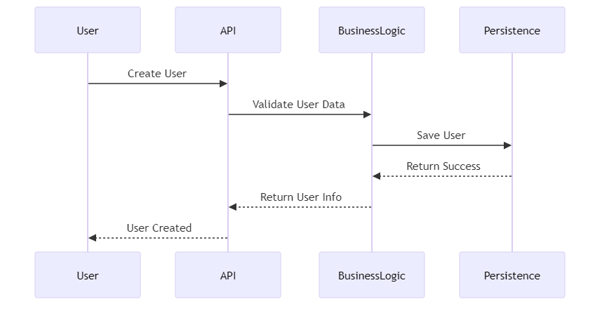
- User Registration Sequence Diagram

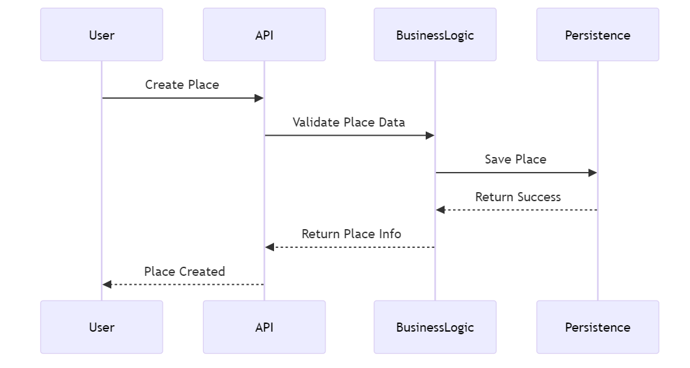
- Place Creation Sequence Diagram

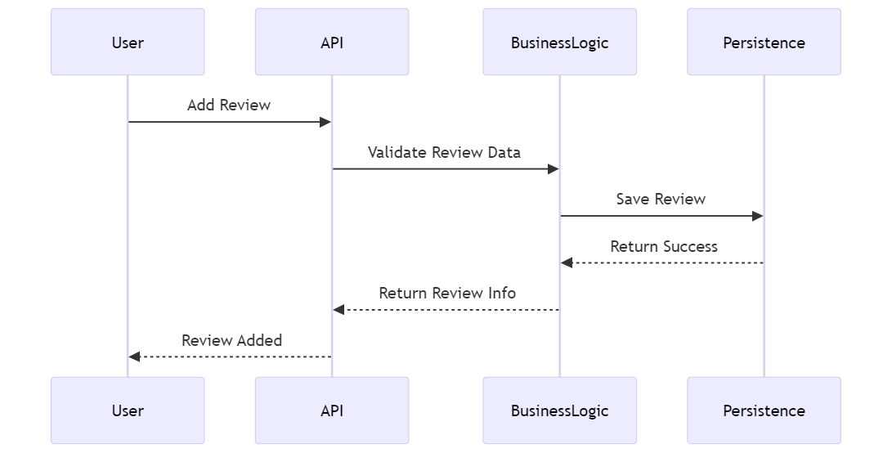
- Review Submission Sequence Diagram

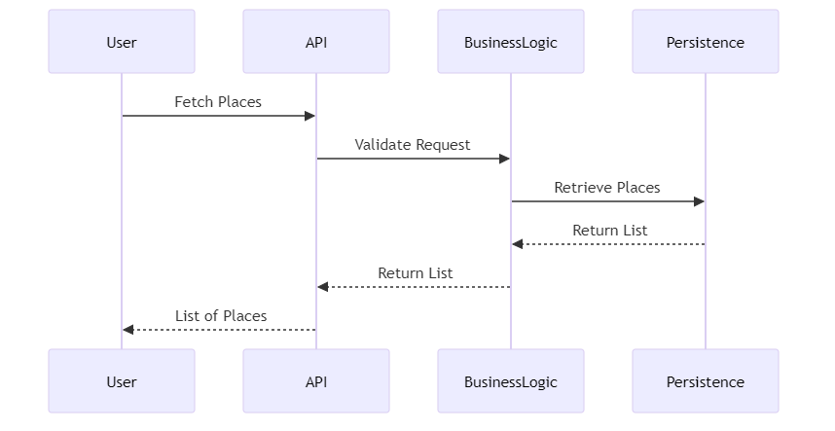
- Fetching a List of Places Sequence Diagram

