NDS-WiDaX
GOT (Goettingen) Repository Importation:

Report of comments and doubts:

- Jasmin (source_metadata_modified): (14/07/26) lastUpdateTime (remove empty string constant) from api call like this: https://data.goettingen-research-online.de/api/datasets/:persistentId/?persistentId=doi:10.25625/AGW0Y9 (in the code you use a different format: https://data.goettingen-research-online.de/api/datasets/export?exporter=schema.org&persistentId=doi%3A10.25625/AGW0Y9)
(22/07/26) Then we don't need setConstant("")

Mauricio: (31/07/26) We need to discuss regarding the importation API.

Status: Need to discuss (Mauricio)

- Jasmin (source_metadata_modified): (14/07/26) You could extract the license[name] from this schema: https://data.goettingen-research-online.de/api/datasets/:persistentId/?persistentId=doi:10.25625/MDWJR3 but you would need to match it to a set of accepted values anyway... So maybe the transformation to the license abbreviation (e.g. CC0 1.0) is easier with the license link only.
Mauricio:
(31/07/26) Working/Developing a way to standardize the values and track missing values during importation process.
Status: Work in progress

- Jasmin (subject_areas): (14/07/26) I didn't find this field in your json. Alternative: Look at this schema for extracting subject areas: https://data.goettingen-research-online.de/api/datasets/:persistentId/?persistentId=doi:10.25625/MDWJR3

metadataBlocks[citation][fields].* iterate over all to search for "typeName": "subject". In that list, select value[0]

Mauricio:
(31/07/26) This is the API call to collect the metadata:
https://data.goettingen-research-online.de/api/search?q=*&type=dataset&per_page=1000&start=1
Open it in a browser, expand “data.items,0” and search for “subjects”.
Status: Answered (Mauricio)

- Jasmin (resource_type): (14/07/26) Not sure what this means – should it be a constant „dataset“?

Mauricio:
(31/07/26) Take a look into https://docs.google.com/spreadsheets/d/1RomQUGBQAGcsr8xJUBNiu-SPlEtRLT3J7lPXhePaYvM/edit?gid=0#gid=0 the “comments” for Goettingen: “Please harvest Type 'Datasets' ONLY (=open licences), DO NOT harvest type 'dataverses' (restricted content)”. This is a requirement. We are filtering “datasets” in the API call and in the code filtering the datasets with open licenses (the API doesn’t allow that kind of filter).
For this reason “@type” is always “dataset”. I choose “@type” and not a constant as a sign or validation: if we have anything there different from “dataset” then the filter is not correct.
Status: Answered (Mauricio)

- Jasmin (related_identifiers): (14/07/26) I didn't find this field in your json. Alternative: Look at this schema for extracting publications (it doesn't necessarily have a doi, only the title): https://data.goettingen-research-online.de/api/datasets/:persistentId/?persistentId=doi:10.25625/MVO08Y

metadataBlocks[citation][fields].* iterate over all to search for "typeName": "publication". In that list, select value[publicationCitation][value]

Mauricio:
(31/07/26) This is the API call to collect the metadata:
https://data.goettingen-research-online.de/api/search?q=*&type=dataset&per_page=1000&start=1
Open it in a browser, expand “data.items,0” and search for “publications”.
Status: Answered (Mauricio)

- Jasmin (authors): (14/07/26) Seems equivalent with "author"?

Alternative, this schema: https://data.goettingen-research-online.de/api/datasets/:persistentId/?persistentId=doi:10.25625/MDWJR3

metadataBlocks[citation][fields].* iterate over all to search for "typeName": "author". In that list, select value. Iterate through that list and select all authorName[value]

Mauricio:
(03/08/26) After analyzing the data I can give you some details. This is the API call to collect the metadata:
https://data.goettingen-research-online.de/api/search?q=*&type=dataset&per_page=1000&start=1
There you can see the “authors” metadata:
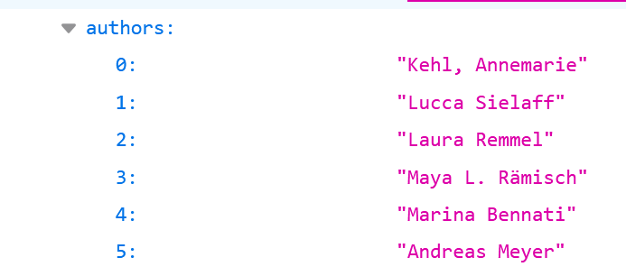
But using the API extending the metadata extracted: https://data.goettingen-research-online.de/api/datasets/export?exporter=schema.org&persistentId=doi%3A10.25625/AGW0Y9
We have for the same dataset:
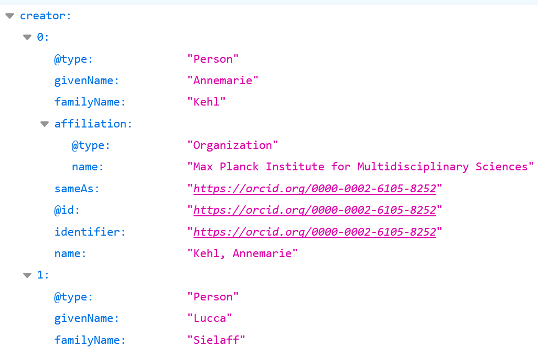
As you can see, here the disambiguation related with “givenName” and “familyName” is solved. This is the reason why I’m taking “creator” and not “authors” for the importation.

Status: Answered (Mauricio)

- Jasmin (authors): (14/07/26) There exist also ORCID infos that we can use.

Mauricio:
(03/08/26) I agree. I will add this field after we discuss point 1.
Status: Need to discuss (Mauricio)

