NDS-WiDaX
LUH (Leibniz University Hannover) Repository Importation:

Report of comments and doubts:

- Jasmin (general): (02/07/26) For all fields: strip whitespace characters at the beginning and end of strings.
Mauricio: (30/07/26) Since we are importing metadata from APIs, we don’t have this kind of issue. I will take in count your comment, but in future integration steps we will see if this is a problem to solve in a more specific way than just adding this “strip” process to all fields by default.
Note 2: I add this issue to be analyzed in “integration issues detected.docx”.

Status: Answered (Mauricio)

- Jasmin (authors): (02/07/26) This seems not correct. There are currently 2 fields: "author" (i.e. first author, only 1 possible) and "extra author" (multiple entries possible).
I would combine both fields anyway to "authors" and have an optional indicator/property for first authorship.

Mauricio:
(30/07/26) LUH repository is a CKAN instance using the regular CKAN’s schema. On this schema “author” is a single field and for adding multiple authors the people of LUH is just writing the names into the field with no standardization regarding: names, surnames, or characters of separation between each author (See an example here).
In WiDaX instance of LDM I changed the schema to just one field called “authors”:
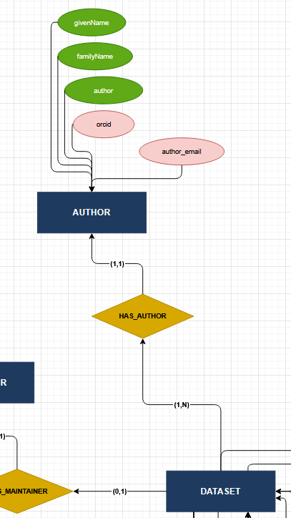
The function transforming the “author” metadata field to WiDaX schema is called “processLUHauthors” and is using a call to OpenAI LLM to disambiguate this string (list of authors). This call to the LLM have a cost in money, and for that I am differing this call to the case on which a new dataset needs to be inserted or updated, and for that reason in the mappings you are just going to see the importation of this sting field without transformation.
This is a very particular case, and we are just following this approach only for LUH repository until now.
Status: Answered (Mauricio)

- Jasmin (doi_date_published): (02/07/26) Need transformation function here. Source field is in ISO 8601 format (YYYY-MM-DDThh:mm:ss.sss) and LDM field has YYYY. We could add property "doi_year_published" and extract the year from the long format. To have it comparable (and filterable) in the KG.
Note: Depends on which API call you execute. Here we have YYYY-MM-DD https://service.tib.eu/ldmservice/api/3/action/package_search?q=%22Yes%22 and here we have YYYY https://service.tib.eu/ldmservice/api/3/action/package_search?q=abdessalem-2026-1-1 so depending on that we need a transformation function or not.

Mauricio:
(30/07/26) The field in source has the format “YYYY-MM-DD”. We are just importing as it is.
CKAN’s APIs are just showing the value as string.
You can check the following calls in WiDaX test instance:
http://ndswidax11.test.service.tib.eu/api/3/action/package_show?id=luh-2022-soups-olab
http://ndswidax11.test.service.tib.eu/api/3/action/package_show?id=luh-2022-oakland-usec-in-sdps-replication
http://ndswidax11.test.service.tib.eu/api/3/action/package_show?id=luh-2022-usenix-dev-sampling
And compare with CKAN’s API calls in source:
https://data.uni-hannover.de/api/3/action/package_show?id=2022-soups-olab
https://data.uni-hannover.de/api/3/action/package_show?id=2022-oakland-usec-in-sdps-replication
https://data.uni-hannover.de/api/3/action/package_show?id=2022-usenix-dev-sampling
Note: Always check imported metadata in our WiDaX instance (http://ndswidax11.test.service.tib.eu/) and origin of the same metadata on the source. In this way we are sure that we are analyzing the same data.
Note 2: I add this field to be analyzed in “integration issues detected.docx”.

Status: Answered (Mauricio)

- Jasmin (doi_status): (02/07/26) Probably need transformation function here. Source field is boolean true/false, LDM field is sometimes string "True"/"False" or "true"/"false" and sometimes true/false. For all datasets I checked.
Also depends on the exact API call for fetching the metadata (see comment above for `doi_date_published`).

Mauricio:
(30/07/26) CKAN’s APIs are just showing the value as string.
I added the function “returnAsBoolValue” transforming the value to boolean.
Note: I add this field to be analyzed in “integration issues detected.docx”.

Status: Answered (Mauricio)

- Jasmin (licenses):
(02/07/26) Need to make sure via transformation function that license_title is the long title (e.g. "Creative Commons Attribution Share-Alike 3.0") of the license_id (e.g. "CC-BY-NC-3.0"). Is currently not correct in all cases.
This is one example for our next step of metadata completion: if the license id or title are given, we can complete the license_url field and vice versa. Currently not all 3 are present in all cases.
E.g. license_url is missing for dataset with id "c24925ab-2e0b-4d75-b0c4-b68f08b7023f".

Mauricio:
(30/07/26) Working/Developing a way to standardize the values and track missing values during importation process.
Status: Work in progress

- Jasmin (source_metadata_created, source_metadata_modified):
(02/07/26) Need transformation function here. Source field is in ISO 8601 format (YYYY-MM-DDThh:mm:ss.sss) and LDM field has only YYYY. For all datasets I checked.
Also here depends on the exact API call which data format we get for this value.

Mauricio:
(30/07/26) Please check the values in WiDaX test instance, and for LUH datasets:
http://ndswidax11.test.service.tib.eu/api/3/action/package_show?id=luh-2022-soups-olab
http://ndswidax11.test.service.tib.eu/api/3/action/package_show?id=luh-2022-oakland-usec-in-sdps-replication
http://ndswidax11.test.service.tib.eu/api/3/action/package_show?id=luh-2022-usenix-dev-sampling
In LUH profile we are using this value for checking the need of update. We need the precision in the date/time for this porpoise.
Note: I add this field to be analyzed in “integration issues detected.docx”.
Status: Answered (Mauricio)

