NDS-WiDaX
OSN (OsnaData) Repository Importation:

Report of comments and doubts:

- Jasmin (source_metadata_created/modified): (24/08/26) There's a "dates" field containing "submitted" and "updated" dates in yyyy-mm-dd format in the source metadata. We could use those for "source_metadata_created" and "source_metadata_modified" instead of "publicationYear"? Or did we agree on using the LDM fields for the creation and modification dates of metadata on our side? I think it still makes sense to use the info from the source repo as a kind of "versioning" so users can compare if WiDaX has the most updated version of a specific dataset or if someone made changes on the dataset in the source repo.

Mauricio: (08/09/26) I agree, those fields are more accurate and I take notes for implementing this in our next round of development of the mappings and the importation profile.

Status: Answered (Mauricio)

- Jasmin (titles): (24/08/26) Most datasets have one title. I saw one with two titles, with titleTypes "null" and "Subtitle". Does the transformation function filter subtitle out? As a sidenote: The language field seems always null, so we would have to infer the language on our side during the integration steps. I saw examples of German and English titles.
Mauricio:
(08/09/26) The function now is just extracting the first title in the list of titles if exists more than one. We need to discuss how to manage multiple titles and more in general if the new schema is going to allow multiple titles (title, subtitle, etc.) and multiple languages for each one.
Status: Answered (Mauricio)

- Jasmin (related_identifiers): (24/08/26) Looks like you switched from using source field "publication" to "relatedIdentifiers"? The first one contains the doi and citation, the latter only doi. Since it would be good to provide a citation (or at least the title), we could create a citation from the doi ourselves in the integration phase.

Mauricio:
(09/09/26) Now in our current schema we have only “Related identifiers” with some fixed metadata fields on it. This is the reason why I added publications as “Related identifiers”. This need to be discussed and the implementation in future depends on the decisions regarding the new and extended metadata schema that we need to define.
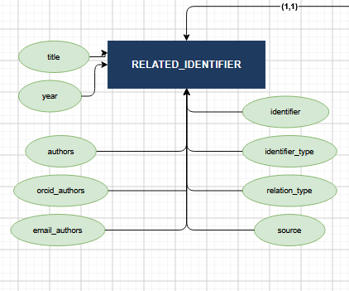
Status: Answered (Mauricio)

- Jasmin (tags): (24/08/26) Since not all datasets provide keywords, we should also create "tags" ourselves, probably from the title + abstract. Another thing for the To-Do list in the integration phase.

Mauricio:
(09/09/26) This is a point to discuss. How to manage and make the tags more useful and cleaner in LDM is a big topic of discussion and development in the SMD group. Let’s keep this point open here for further reference.

Status: Answered (Mauricio)

