BioNexus Clinical Genomics Platform: Standard Operating Procedure
This document describes the secondary bioinformatics analysis, alignment standards, and automated variant filtration criteria used in BioNexus diagnostic assays.

1. High-Throughput Sequencing Pipeline Overview
Raw sequencing data is generated on Illumina NovaSeq 6000 platforms using 2x150 bp paired-end chemistry. The standard diagnostic pipeline workflow from raw reads to clinical interpretation is shown in Figure 1 below:
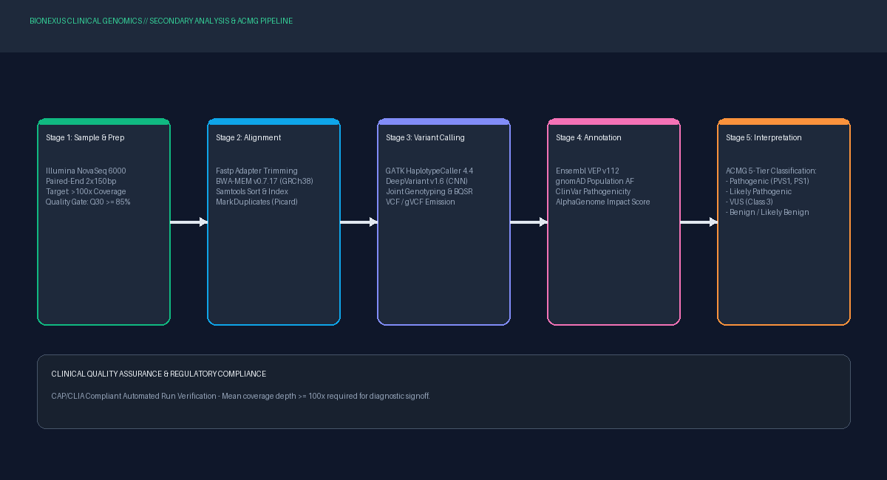
Figure 1: BioNexus Clinical Sequencing & ACMG Variant Interpretation Flowchart.

2. Primary Alignment & Secondary Variant Calling
Raw FASTQ reads undergo adapter trimming and poly-G tail clipping with fastp. Filtered reads are aligned to the GRCh38 human reference genome using BWA-MEM (v0.7.17). Duplicate reads are flagged with Picard MarkDuplicates, followed by Base Quality Score Recalibration (BQSR). Single nucleotide variants (SNVs) and small insertions/deletions (indels) are called using GATK HaplotypeCaller 4.4 in conjunction with DeepVariant v1.6 for orthogonal cross-validation.

3. Quality Control Standards for Diagnostic Release
Quality Metric | Acceptance Threshold | Action on Failure | Clinical Impact
Base Quality (Q30) | >= 85.0% of bases | Re-sequence flowcell lane | Minimizes false positive calls
Mean Target Depth | >= 100x coverage | Top-up library sequencing | Ensures high detection sensitivity
20x Target Coverage | >= 98.5% of target bases | Inspect target capture gaps | Guarantees complete exon view
Transition/Transversion (Ti/Tv) | 2.0 - 2.2 (Exome) | Bioinformatics QC flag | Verifies overall callset purity

