Project Apollo: Autonomous Avionics Platform
Project Apollo defines the reference mission avionics, real-time sensor fusion topologies, and deterministic safety envelopes for heavy-payload autonomous aerial systems.

1. Flight Control & Core Hardware Architecture
The flight control unit is powered by a triple-core Cortex-M7 microcontroller operating at 480 MHz. All critical flight guidance loops run within a deterministic RTOS partition guaranteed at 1000 Hz. Dual isolated power distribution buses supply independent 5V regulated rails to redundant flight sensors.

2. High-Rate Telemetry & Sensor Fusion Architecture
The sensor fusion subsystem combines redundant 3-axis gyroscopes, accelerometers, RTK-GNSS positioning, and downward-facing optical flow. The fusion pipeline is structured as shown in Figure 1 below:
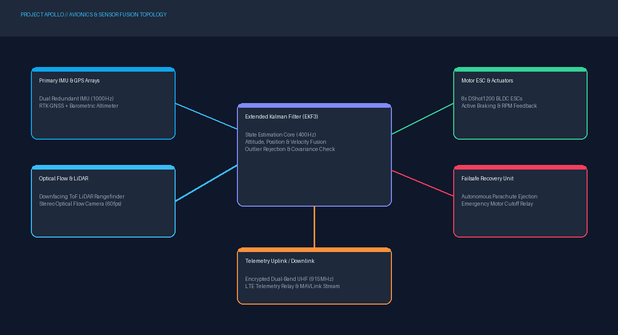
Figure 1: Apollo High-Reliability Avionics & Telemetry Topology Flowchart.
Sensor measurements from the dual IMU array are fed into an Extended Kalman Filter (EKF3) at 400 Hz to generate real-time estimates of attitude, position, and velocity.

3. Redundant CAN Bus Communication Protocol
Message ID | Rate (Hz) | Priority | Payload Description
0x101 | 1000 | Critical | Raw IMU Accelerometer and Gyroscope vectors
0x204 | 400 | High | Fused EKF Attitude & Velocity State Vector
0x308 | 50 | Medium | RTK-GNSS Dilution of Precision & Satellite Fix
0x410 | 10 | Low | Battery Cell Voltages, Current Draw & Pack Temp

