On the fly Test Client

Documentation

|  |  |  |  |  |  |
| --- | --- | --- | --- | --- | --- |
| **Type of Document** | Project documentation | | | | |
| **Reference:** |  | | | | |
| **Issue:** |  | **Revision:** |  | **Status:** | Draft |
| **Created by:** | Gino Mascotti | | | **Date:** | 04/07/2014 |
| **Updated by:** | Gino Mascotti | | |  | 2626/0505/52015 |
| **Approved by:** |  | | | | |

**Software Description**

This software was created to:

1. Test the functionalities of the “On the fly WebService”
2. Create dynamic data queries with Sdmx 2.0 and Sdmx 2.1 standard
3. Test Sdmx Query in “On the fly WebService”

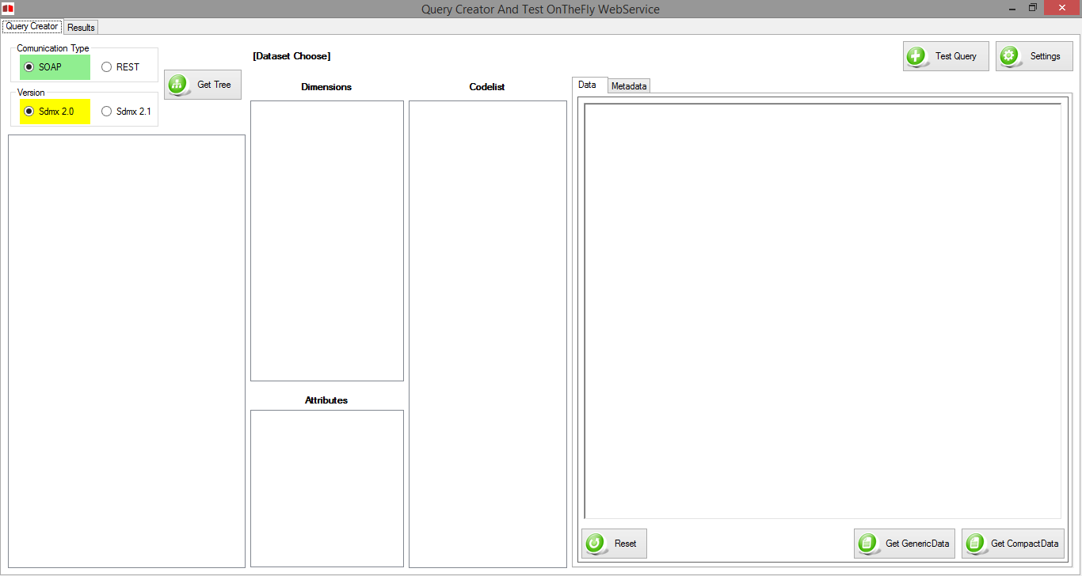

**Configuration**

First of all, we need to set the correct Web service endpoints.

Then click on the button C:\Users\eidos\Desktop\Screeshot Client Documentation\Settings.png

This operation will open the page for editing the configuration

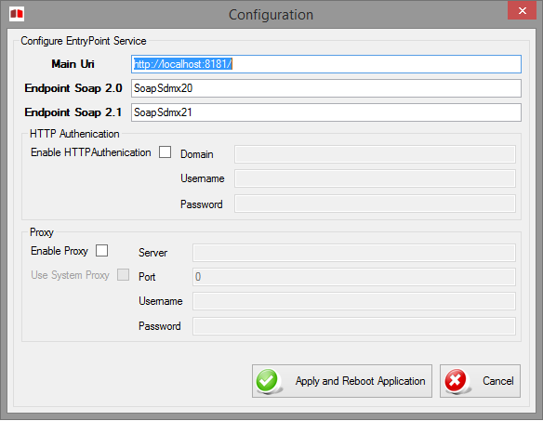

You must indicate a *Main Uri*, (Server uri - that must be ended with a backSlash “/”) and write a Soap 2.0 and Soap 2.1 EndPoint.

For OnTheFly WebServices it will be: *SoapSdmx20* and *SoapSdmx21*

You can also choose to apply an *HttpAutentication* or a *Server Proxy,* filling the appropriate fields.

Click the "*Apply and Reboot Application*" in order to apply the changes.

If you want to exit from the configuration page, you can either press the "*Cancel*" button or close the form clicking the X in the upper right.

**Navigation among Metadata**

First of all, we need to select the preferred *Communication Type*



and version of the SDMX messages



After the selection you will be allowed to create a treeview

C:\Users\eidos\Desktop\Screeshot Client Documentation\GetTree.png

this function will call the related function of the WebService to get the *CategoryScheme* and *CategorisationScheme* to build a tree structure with the linked *Dataflows*

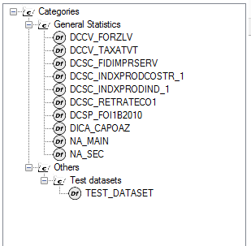

You can select only the dataflow

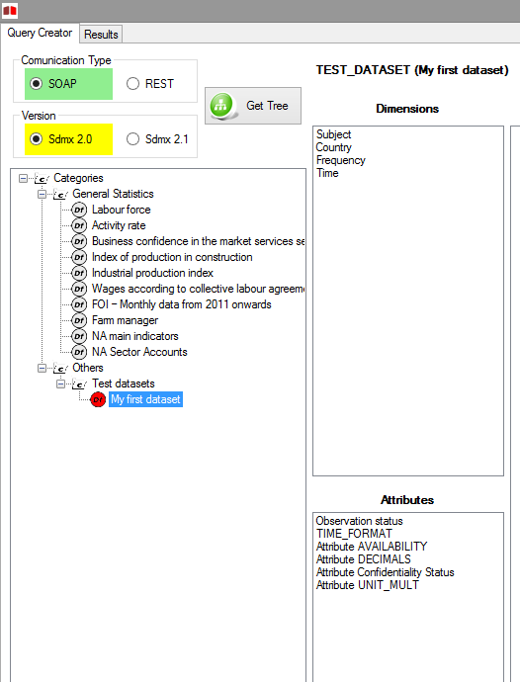

Questo andrà a richiedere tutti i concetti associati al dataflow dividendoli per dimensioni e attributi

Selezionando una dimension o un attributo il sistema andrà a richiedere i CodeItem della codelist associata al concetto selezionato, ma solo i valori presenti nella tabella dei dati per il Dataflow scelto.

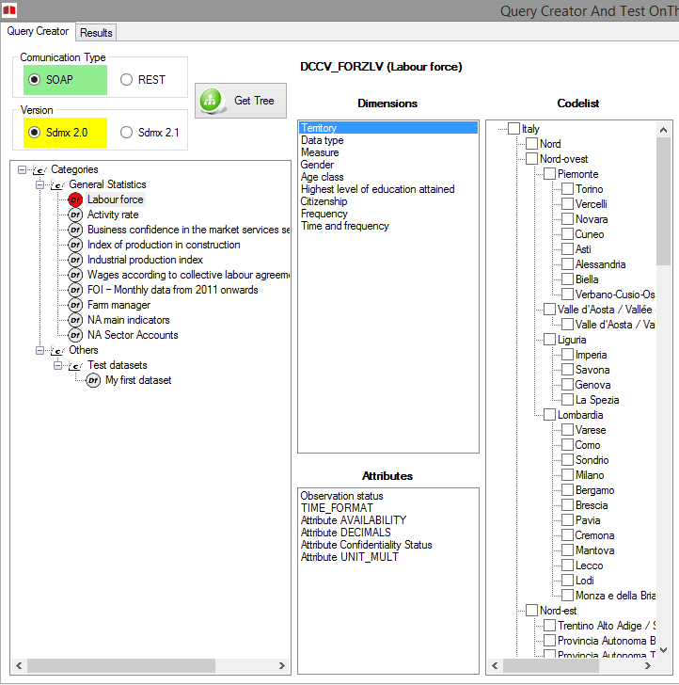

Only for dimension, you can check one or more "Codes" to put it in the "*query creator*"

The set of the selections will create the *Where condition* of the SDMX Query

By selecting the *TimeDimension,* will display a datagrid where you can enter   
(in standard SDMX) the start time and end time that you want to select in your query.

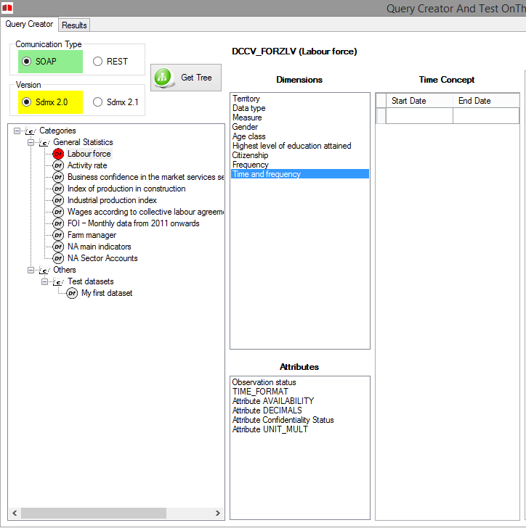

**QueryCreator**

**SOAP Sdmx 2.0**

It is possible to see, during the selection of the different "code” of the dimensions or attributes, the panel of the "*Query Creator*" which builds dynamically the query that has to be sent to the WebService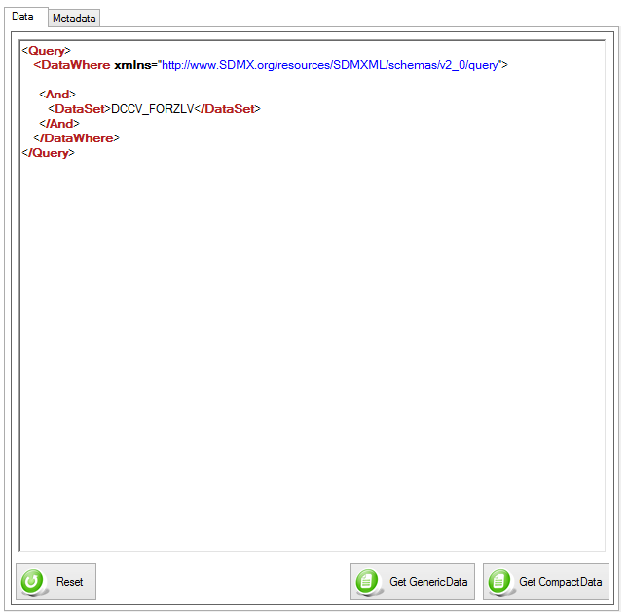

In the sdmx 2.0 version is possible to:

C:\Users\eidos\Desktop\Screeshot Client Documentation\GetGenericData20.png Request data in GenericData format

C:\Users\eidos\Desktop\Screeshot Client Documentation\GetCompactData20.png Request data in CompactData format

C:\Users\eidos\Desktop\Screeshot Client Documentation\Reset.png Remove all the filters applied into the query

If you need to request the metadata, you can switch to tab "Metadata"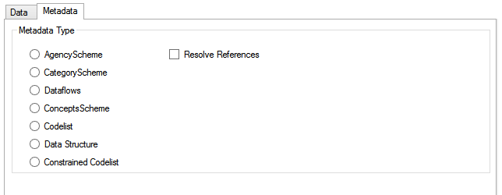

In this Tab you can choose the type of Metadata and get it through the WebService clicking on the button *Get Metadata*

It is possible to choose whether or not the request is *Resolve Reference*

**SOAP Sdmx 2.1**

It is possible to see, during the selection of the different "code” of the dimensions or attributes, the panel of the "Query Creator" which builds dynamically the query that has to be sent to the WebService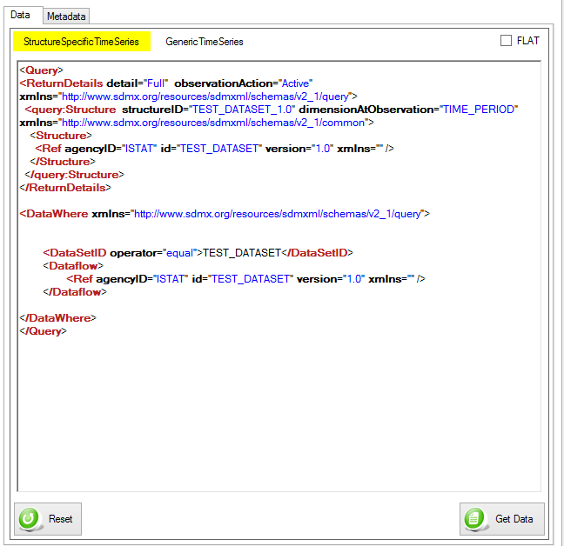

In SDMX 2.1 version you must select the type of the structure that you want to return

C:\Users\eidos\Desktop\Screeshot Client Documentation\ChooseStructure.png

Can you choose between

* StructureSpecificTimeSeriesData
* GenericTimeSeriesData

It is also possible for both formats to choose the type *FLAT*

C:\Users\eidos\Desktop\Screeshot Client Documentation\Flat.png

This flag will change the value of the *DimensionAtObservation* in *AllDimensions*   
In this way you will request to the webservice to return all attributes and dimension at the observation level

To request data from the webservice you can click on the button

C:\Users\eidos\Desktop\Screeshot Client Documentation\GetData21.png

Or on the button

C:\Users\eidos\Desktop\Screeshot Client Documentation\Reset.png

to remove all the applied filters from the query

If you need to request the metadata, you can switch to tab "Metadata"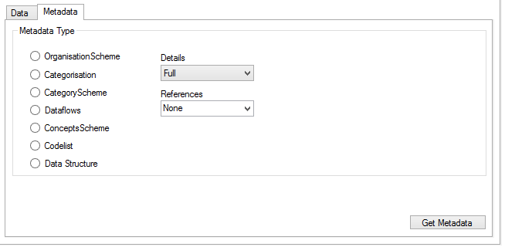

In this Tab you can choose the type of Metadata and get it through the WebService clicking on the button *Get Metadata*

In this case, it is possible to choose between

* full detail,
* AllStubs,
* ReferencedStubs,
* and the level of the References that you want to request.

In the drop down menu ,you can also write a reference to a "*Specific*" structure (or structures separated by commas).**REST**

It is possible to see, during the selection of the different "code” of the dimensions or attributes, the panel of the "Query Creator" which builds dynamically the query that has to be sent to the WebService 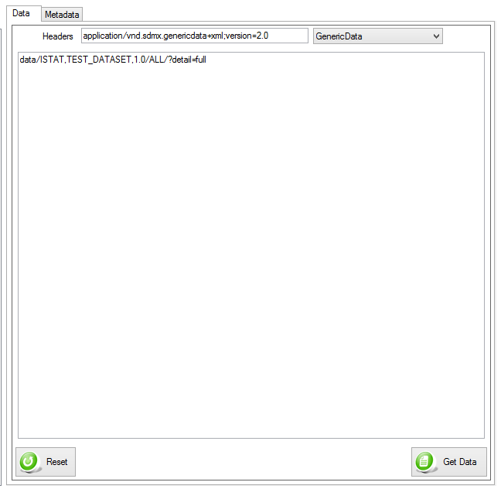

In REST communication mode, both version SDMX 2.0 and SDMX 2.1 you must modify the Header Rest parameter to specify the needed result

Can you choose between

* StructureSpecificData
* GenericData
* RDF
* DSPL
* JSON

It is also possible for both formats to choose the type FLAT

C:\Users\eidos\Desktop\Screeshot Client Documentation\Flat.png

This flag will change the value of the *DimensionAtObservation* in *AllDimensions*   
In this way you will request to the webservice to return all attributes and dimension at the observation level

To request data from the webservice you can click on the button

C:\Users\eidos\Desktop\Screeshot Client Documentation\GetData21.png

Or on the button

C:\Users\eidos\Desktop\Screeshot Client Documentation\Reset.png

to remove all the applied filters from the query

If you need to request the metadata, you can switch to tab "Metadata"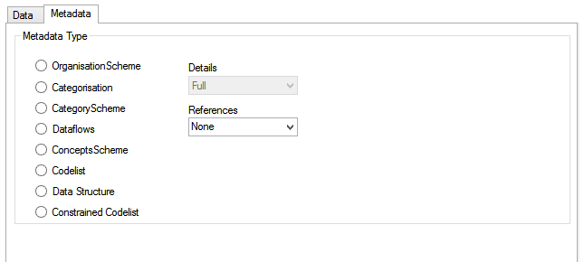

In this Tab you can choose the type of Metadata and get it through the WebService clicking on the button *Get Metadata*

Also in this case, it is possible to choose between

* full detail,
* AllStubs,
* ReferencedStubs,
* and the level of the References that you want to request.

In the drop down menu ,you can also write a reference to a "*Specific*" structure (or structures separated by commas). (only for Rest v2.1, for v2.0 the combobox is lock on Full)

**WebService Result**

Requesting data or metadata in both versions and in both communication mode  
The system will change the display on the tab "Results"

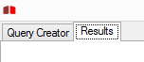

On this page you will see a text field with responses.

If the response isn’t over 5000 Characters the text will be xml formatted colors

If the response isn’t over 10Mb the text field show you only a preview of result

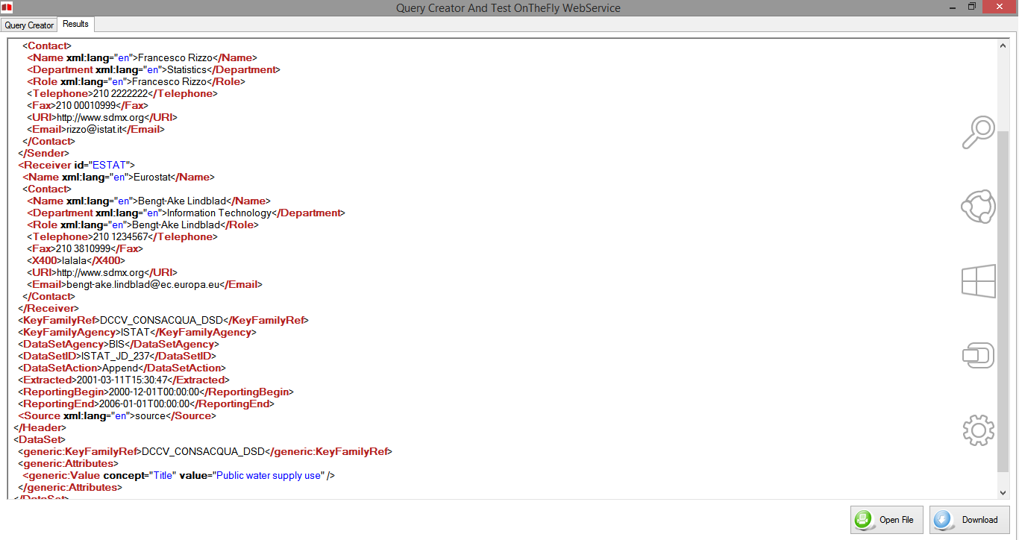

This page will also display any errors that the webservice will return in SDMX format

It is possible to show the result file in integral version in two ways:



Open a default Browser whit a file result url to show a result well formatted



Download: Open a Folder choose dialog where save the file

**Test Query**

This form is created in order to test the correctness of the result returned by the OnTheFly WS, and to check the correct syntax of the query

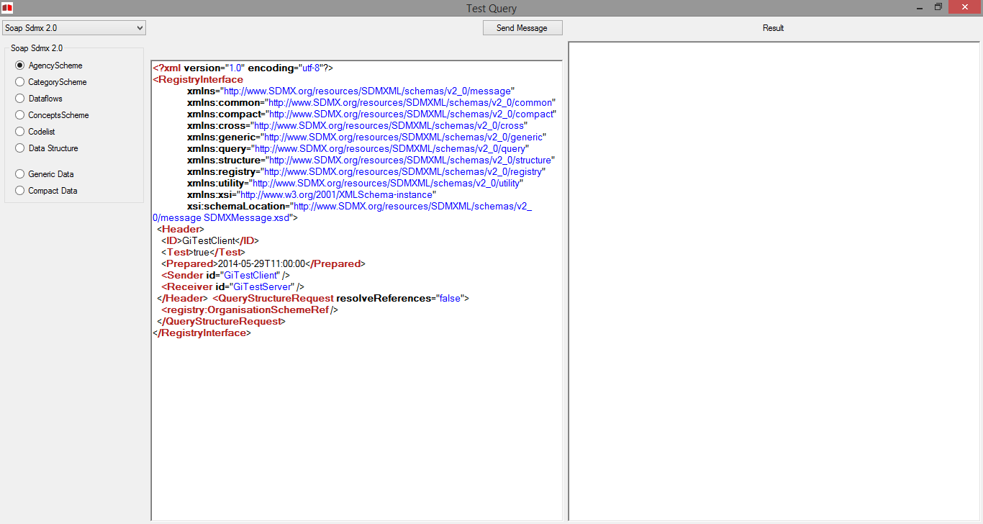

In the upper left corner there is a drop down menu where you can choose the way to communicate and the SDMX version

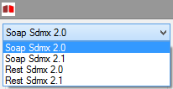

By choosing one of the values in the combo box the application will display the available metadata

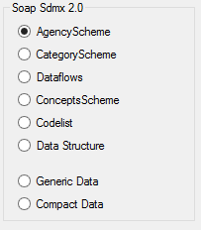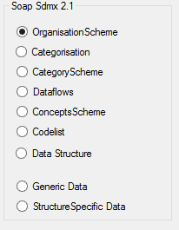

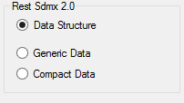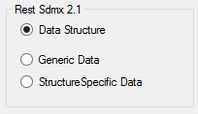

Selecting one of these EndPoint in the text field to the left will appear the preview of the query that you can edit

About the Rest calls, over the query, you can change the content-type header value in order to require a different format (Es: JSON, RDF…if available)



After changing the query you need to press the "*Send Message*" button and the query will be sent to the WebService



By pressing the button:



the application will be open the default Internet Browser to show the result file.