On the fly Test Client

Documentation

|  |  |  |  |  |  |
| --- | --- | --- | --- | --- | --- |
| **Type of Document** | Project documentation | | | | |
| **Reference:** |  | | | | |
| **Issue:** |  | **Revision:** |  | **Status:** | Draft |
| **Created by:** | Gino Mascotti | | | **Date:** | 04/07/2014 |
| **Updated by:** | Gino Mascotti | | |  | 01/10/2014 |
| **Approved by:** |  | | | | |

**Software Description**

This software was created for

1. Test the functionality of the “On the fly WebService”
2. Creating dynamic data queries with Sdmx 2.0 and Sdmx 2.1 standard
3. Test Sdmx Query in “On the fly WebService”

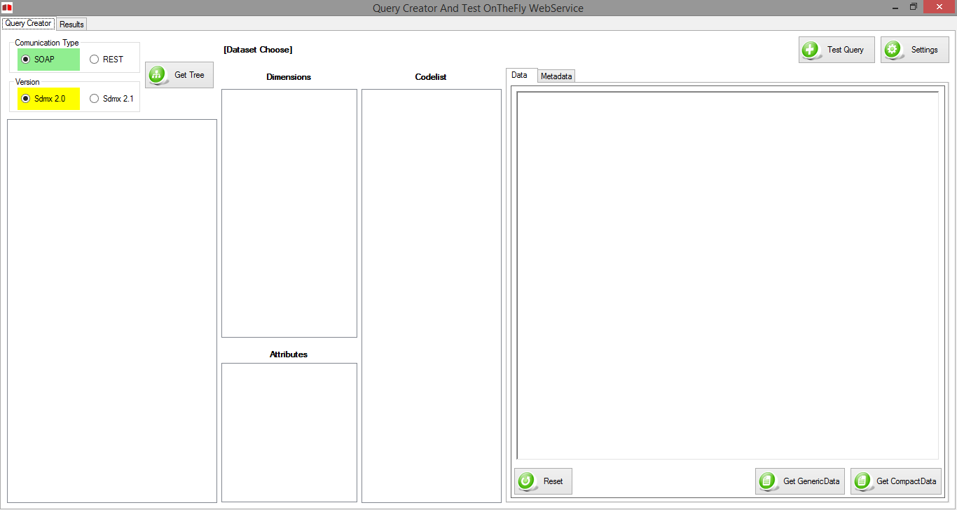

**Configuration**

First we need to change the ip address url is used where is the WebService.

In so doing allow the software to properly access different endpoints WebService

Then click on the button C:\Users\eidos\Desktop\Screeshot Client Documentation\Settings.png

This will open the page for editing the configuration

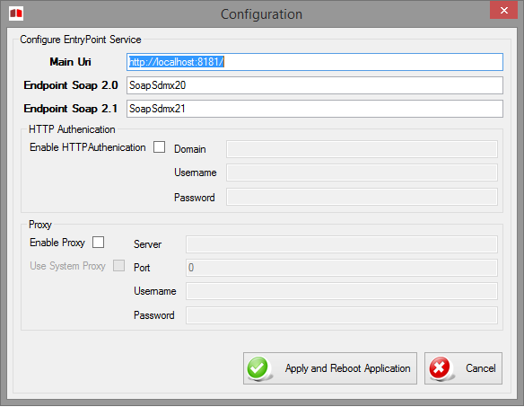

You Must indicate a Main Uri, (Server uri) ending ever with backSlash “/” and write a Soap 2.0 and Soap 2.1 EndPoint. For OnTheFly WebServices is ever SoapSdmx20 And SoapSdmx21

You can also choose to apply a HttpAutentication or a Server Proxy populating the appropriate fields.

To continue with the changes by clicking the "Apply and Reboot Application"

What precisely change services to new addresses and restart the application

If you want to exit from the configuration page, you can either press the "Cancel" button or close the form with the X in the upper right

**Navigate between Metadata**

First we need to choose the Comunication Type



and version of the SDMX



After create a treeview

C:\Users\eidos\Desktop\Screeshot Client Documentation\GetTree.png

this function will call the relative function of the WebService to upload CategoryScheme and CategorisationScheme so can build a tree structure with the Dataflow association

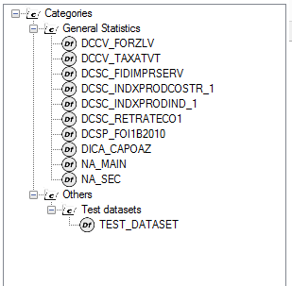

You can select only the dataflow

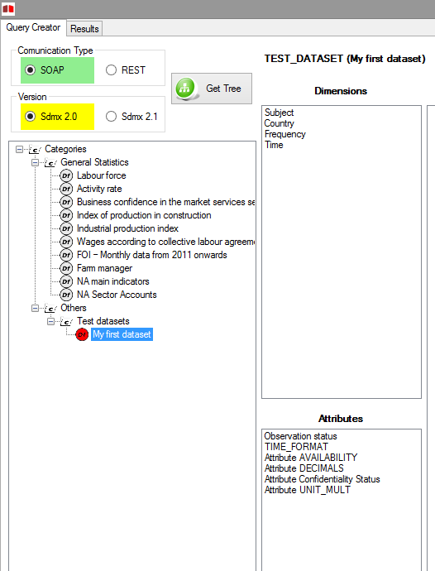

This will load into memory all the DSD associated with the selected dataflow

It will display the list of Dimension and Attributes

Selecting a Dimension or Attribute will be displayed with a tree structure associated with the codelist

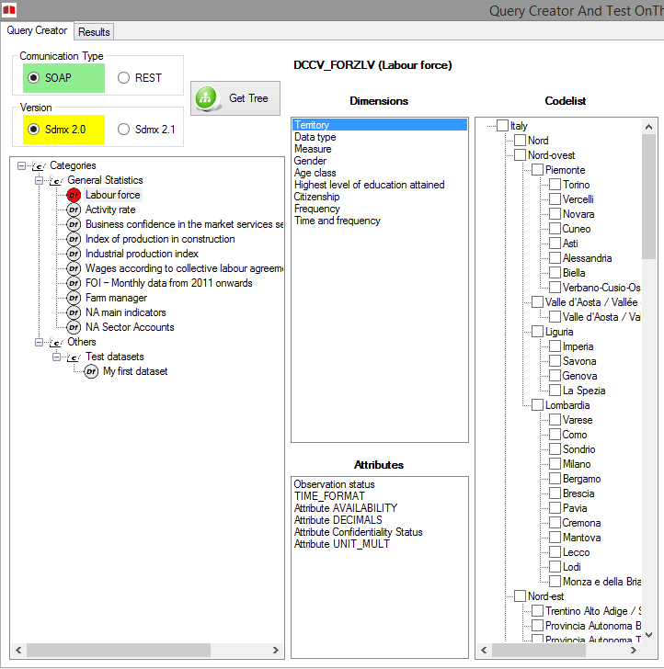

You can check one or more "Code" to put it in the "query creator"

The set of selections will create the Where condition of the select

By selecting the TimeDimension will display a datagrid where you can enter   
(in stadard SDMX) the start time and end time that we want to select in your query

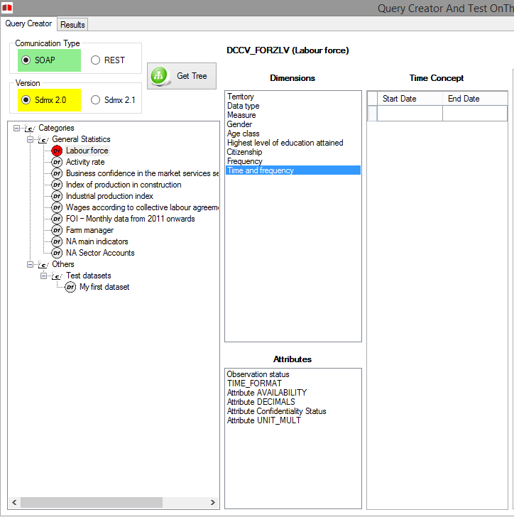

**QueryCreator**

**SOAP Sdmx 2.0**

Is possible see while selecting the different "code” of the dimension or attribute, the panel of the "Query Creator" which builds dynamically the query to send to the WebService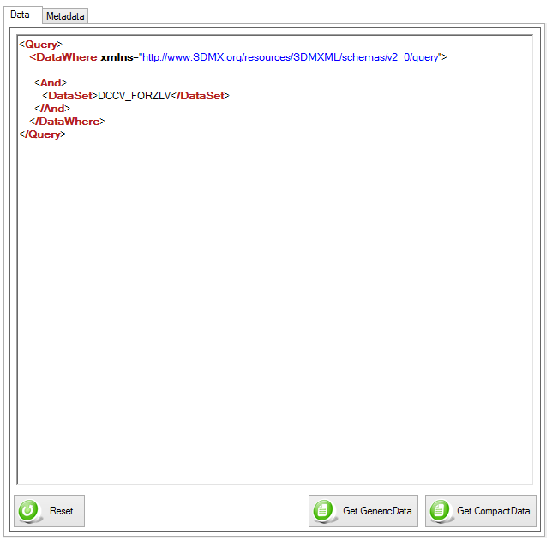

In the sdmx 2.0 version is possible

C:\Users\eidos\Desktop\Screeshot Client Documentation\GetGenericData20.png Request data in the format GenericData

C:\Users\eidos\Desktop\Screeshot Client Documentation\GetCompactData20.png Request data in the format CompactData

C:\Users\eidos\Desktop\Screeshot Client Documentation\Reset.png Remove all applied filters from the query

If you need to request the metadata, you can switch to tab "Metadata"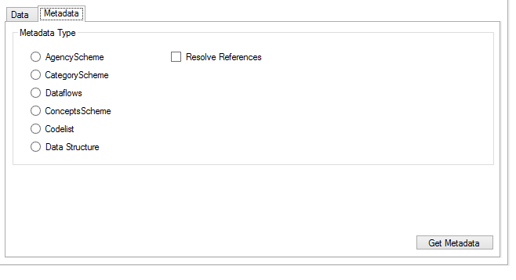

In this Tab you can choose a kind of Metadata and required this at webService clicking on the button “Get Metadata”

Is Possible also choose whether or not the request is “Resolve Reference”

**SOAP Sdmx 2.1**

Is possible see while selecting the different "code” of the dimension or attribute, the panel of the "Query Creator" which builds dynamically the query to send to the WebService 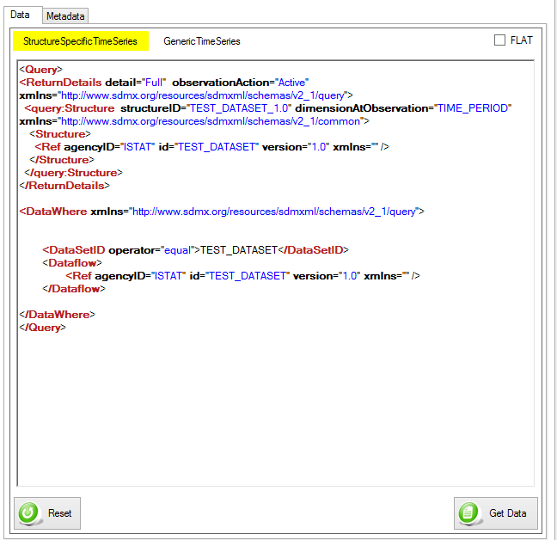

In SDMX 2.1 vesion you must select the type of structure that you want to return

C:\Users\eidos\Desktop\Screeshot Client Documentation\ChooseStructure.png

Can you choose between

* StructureSpecificTimeSeriesData
* GenericTimeSeriesData

It is also possible for both formats to choose the type FLAT

C:\Users\eidos\Desktop\Screeshot Client Documentation\Flat.png

This flag will change the value of the DimensionAtObservation in AllDimensions   
In this way you will request webservice to return all attributes and dimension at the observation level

To request data to webservice simply click on the button

C:\Users\eidos\Desktop\Screeshot Client Documentation\GetData21.png

Or

C:\Users\eidos\Desktop\Screeshot Client Documentation\Reset.png Remove all applied filters from the query

If you need to request the metadata, you can switch to tab "Metadata"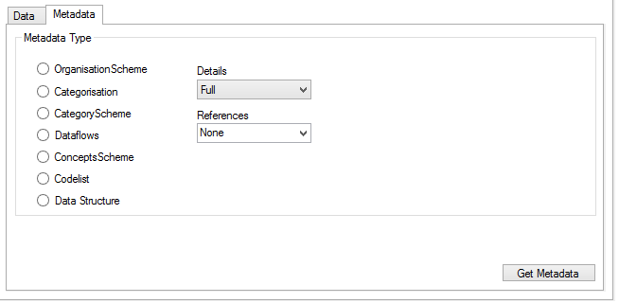

In this Tab you can choose a kind of Metadata and required this at webService clicking on the button “Get Metadata”

In this case it is possible to choose between full detail, AllStubs and ReferencedStubs and the level of the References that you want to request. In the drop down menu to the references you can also write if you want a reference of type "Specific" structure (or structures separated by commas) that you intend to take.

**REST**

Is possible see while selecting the different "code” of the dimension or attribute, the panel of the "Query Creator" which builds dynamically the query to send to the WebService 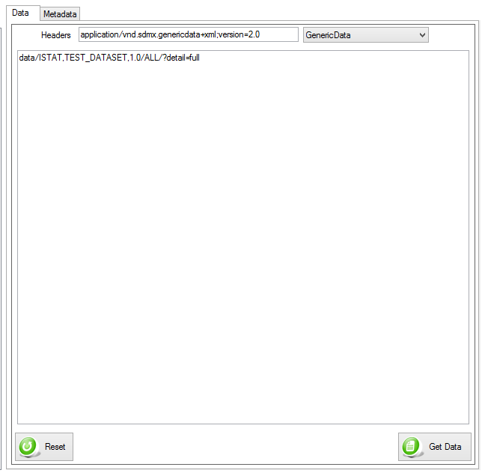

In REST comunication mode both version SDMX 2.0 and SDMX 2.1 vesion you must modify the Header Rest parameter for specify a result you want

Can you choose between

* StructureSpecificData
* GenericData

It is also possible for both formats to choose the type FLAT

C:\Users\eidos\Desktop\Screeshot Client Documentation\Flat.png

This flag will change the value of the DimensionAtObservation in AllDimensions   
In this way you will request webservice to return all attributes and dimension at the observation level

To request data to webservice simply click on the button

C:\Users\eidos\Desktop\Screeshot Client Documentation\GetData21.png

Or

C:\Users\eidos\Desktop\Screeshot Client Documentation\Reset.png Remove all applied filters from the query

If you need to request the metadata, you can switch to tab "Metadata"

In this Tab you can choose a kind of Metadata and required this at webService clicking on the button “Get Metadata”

Also in this case it is possible to choose between full detail, AllStubs and ReferencedStubs and the level of the References that you want to request. In the drop down menu to the references you can also write if you want a reference of type "Specific" structure (or structures separated by commas) that you intend to take.

**WebService Result**

Requesting data or metadata in both versions and in both comunication mode  
The system will change the display on the tab "Results"

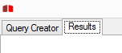

On this page you will see a text field with response.

If the response isn’t over 5000 Characters the text will be xml formatted colors

If the response isn’t over 10Mb the text field show you only a preview of result

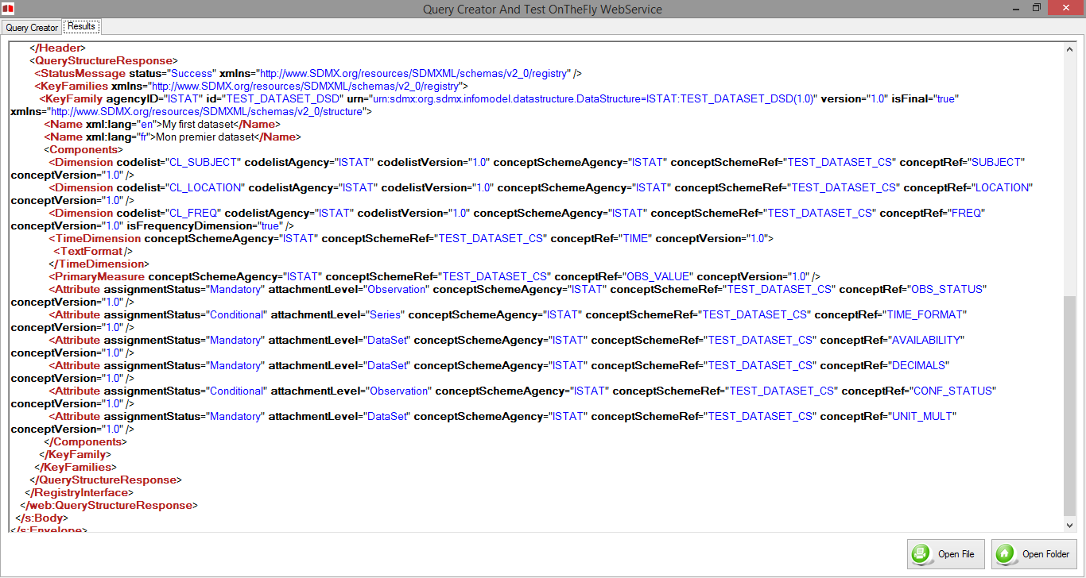

This page will also display any errors that the webservice will return in SDMX format

Is possible show the result file in integral version in two way:



Open a default Browser whit a file result url for show a result well formatted



Open a Folder where is saved the file

**Test Query**

This form is created for testing a correct result that OnTheFly return and check a correct sintax of a query

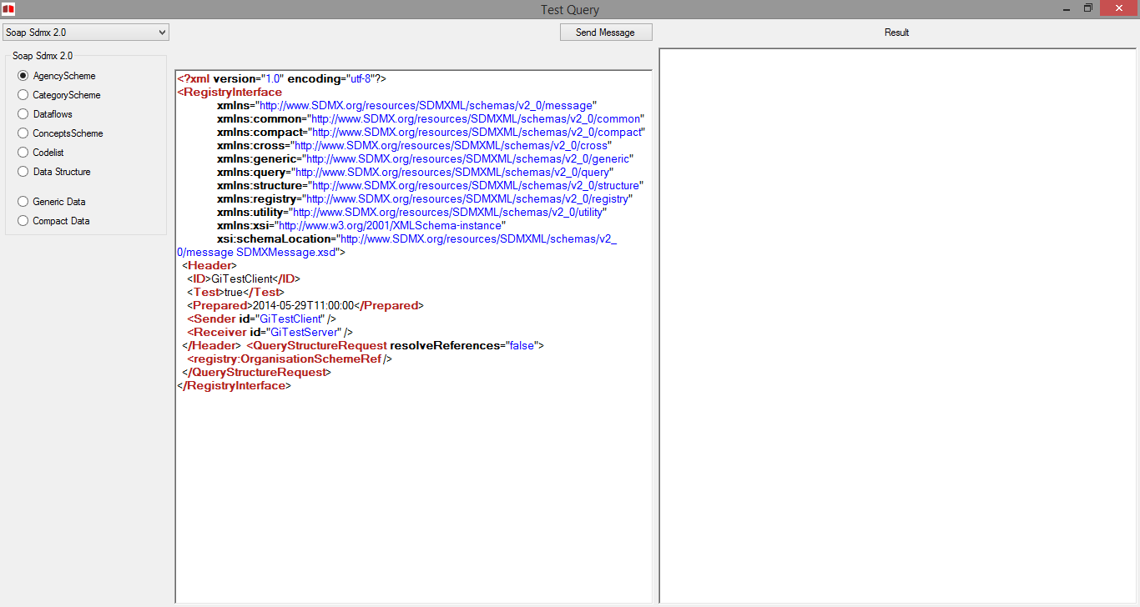

In the upper left corner there is a drop down menu where you can choose the way we communicate and the SDMX version

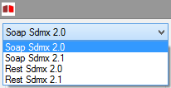

By choosing one of the values ​​from this menu will appear to the left of the list shown in endPoint OnTheFly WebServices

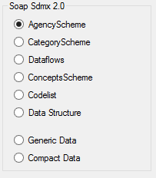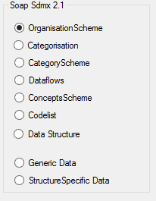

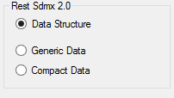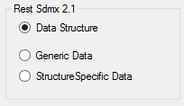

Selecting one of these EndPoint in the text field to the left will appear preview of the query that you can edit   
  
For Rest calls, over the query, you can change the contenttype header value to send to the WebService



After changing the query you need to press the "Send Message" and it will be sent to the WebService



and the text field will appear to the left of the answer WebService.   
By pressing the button:



Will be open default Browser whit a file result url for show a result well formatted