On the Fly Web Service

Web Service features

|  |  |  |  |  |  |
| --- | --- | --- | --- | --- | --- |
| **Type of Document** | Project update | | | | |
| **Reference:** |  | | | | |
| **Issue:** |  | **Revision:** |  | **Status:** | Draft |
| **Created by:** | Dario Camol | | | **Date:** | 30/09/2014 |
| **Updated by:** |  | | |  |  |
| **Approved by:** |  | | | | |

**Document Change Record**

|  |  |  |
| --- | --- | --- |
| Issue/ Revision | Date | Change |
| Start | 30/09/2014 | First draft |
|  |  |  |
|  |  |  |
|  |  |  |
|  |  |  |
|  |  |  |
|  |  |  |
|  |  |  |

Table of Contents

1 Available Web services 4

2 Constraints 5

2.1 Versioning: 5

2.2 ID 5

2.3 Agency/Organization scheme 5

2.4 TIME_FORMAT 5

2.5 FREQUENCY 6

3 Operation supported 7

3.1 2.0 WSDL Operations 7

3.1.1 Data 7

3.1.2 Registry-Oriented Web Service Functions to get Structural metadata 7

3.2 2.1 WSDL Operations 8

3.3 2.1 WADL Operations 9

3.3.1 Structural Metadata Queries 9

3.4 Data 10

3.4.1 Parameters used to further filter the desired results 10

4 Additional features 11

4.1 No-standard constraints 11

4.2 Fixed attributes 11

4.3 Flag 11

4.4 Streaming 11

4.5 TimeStamp 11

# Available Web services

The application makes available three endpoints for the following web services:

* Soap 2.0
* Soap 2.1
* Rest

Figure 1 : Web service endpoints

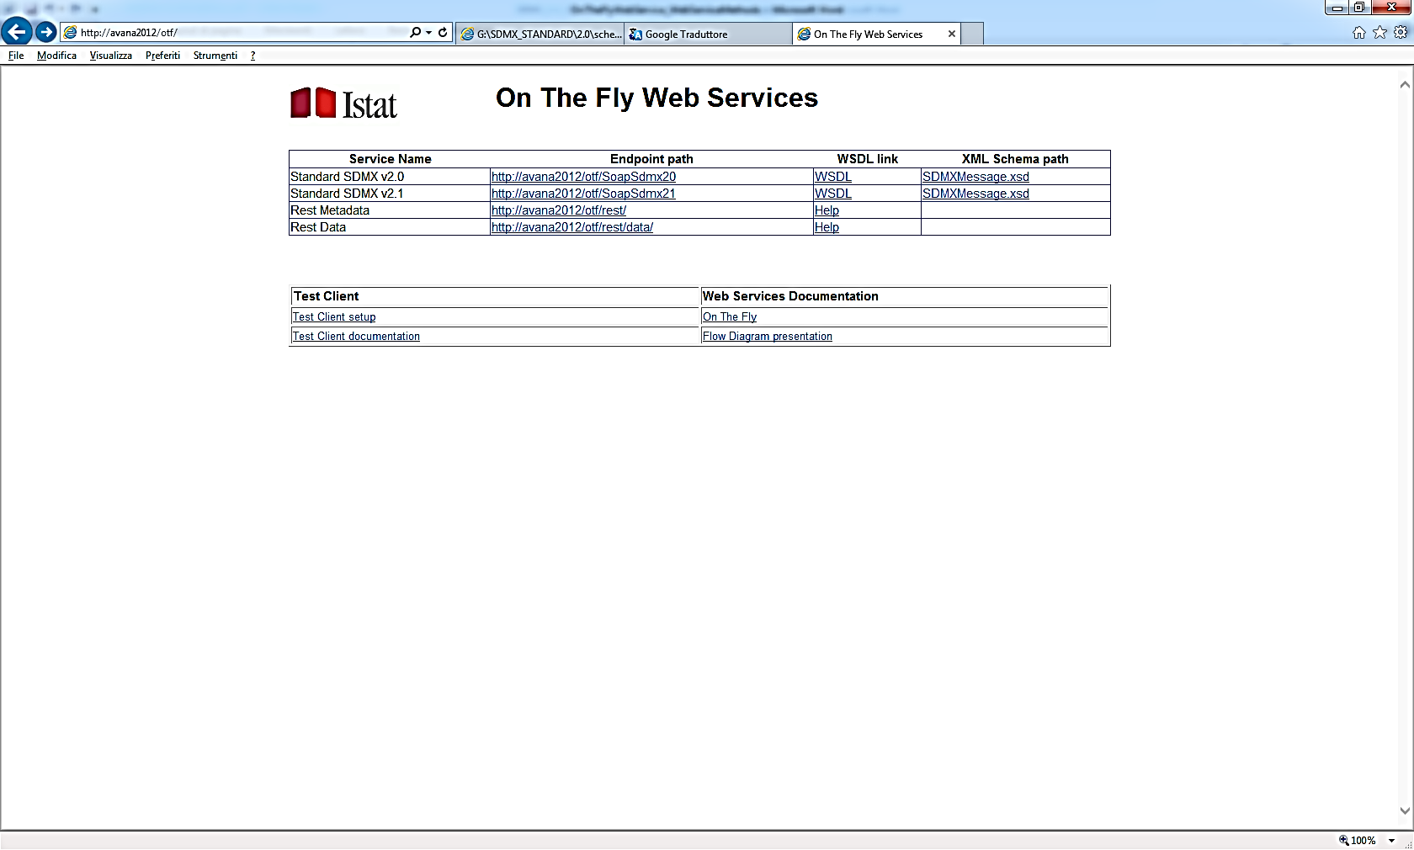Even though the version 2.0 of the standard does not define REST APIs the webservice supports the output for this format. The user is allowed to make a REST query, using the syntax defined in the 2.1 web service guidelines, and to receive a 2.0 data or metadata message. The user can switch the representation of the requested data from the 2.1 to 2.0 changing the content-type of its HTTP request.

Figure 2: Content-type

application/vnd.sdmx.structure+xml;version=2.0  
application/vnd.sdmx.genericdata+xml;version=2.0  
application/vnd.sdmx.compactdata+xml;version=2.0

application/vnd.sdmx.structure+xml;version=2.1  
application/vnd.sdmx.genericdata+xml;version=2.1  
application/vnd.sdmx.compactdata+xml;version=2.1

# Constraints

Due to the lack of information stored into the database it is not possible to make available all the features foreseen in a SDMX webservice.

Some assumptions have to be done:

## Versioning:

The version of every artefact returned by the webservices is fixed and customizable into the configuration[1] file

<add key="Version" value="1.0"/>

## ID

The ID of the following artefacts is generated at run-time following the rules customizable into the configuration1 file

* Category Scheme
* KeyFamily
* Codelist
* Concept Scheme

<!--For this format don't remove symbol {0}-->

<add key="DsdFormat" value="{0}_DSD"/>

<add key="ConceptSchemeFormat" value="{0}_CS"/>

<add key="CategorySchemeFormat" value="{0}_CategoryScheme"/>

<add key="CodelistFormat" value="CL_{0}"/>

## Agency/Organization scheme

The information related to the main agency and the organization scheme (ID and description) are and customizable into the configuration1 file

<add key="MainAgencyId" value="ISTAT">

<Name LocaleIsoCode="en"><![CDATA[Italian Statistical Institute]]></Name>

<Name LocaleIsoCode="fr"><![CDATA[Italian Statistical Institute]]></Name>

</add>

<add key="OrganisationScheme" value="AGENCIES">

<Name LocaleIsoCode="en"><![CDATA[ISTAT AGENCIES]]></Name>

<Name LocaleIsoCode="fr"><![CDATA[ISTAT AGENCIES]]></Name>

</add>

## TIME_FORMAT

The codelist of the attribute TIME_FORMAT (required in the Time series format) is available in the *AttributeConcepts.xml* file. In the data message it is generated dynamically on the base of the time dimension

## FREQUENCY

On the base of the information stored into the database it is not possible to identify the frequency dimension (mandatory in a Time Series format).

The application assumes that the field, of the fact table, named FREQ or FREQUENCY will be the frequency dimension.

If this field is missed, the codelist will be retrieved from the FrequencyCodelist.xml file. The value in the data message will be defined at runtime on the base of the time dimension.

# **Operation supported**

## 2.0 WSDL Operations

### Data

|  |  |
| --- | --- |
| WebMethod | Status |
| GetGenericData | Supported |
| GetCompactData | Supported |
| GetUtilityData | Not planned |
| GetCrossSectionalData | Not planned |

### Registry-Oriented Web Service Functions to get Structural metadata

|  |  |
| --- | --- |
| WebMethod | Status |
| QueryStructure | Supported |

#### QueryStructure queriable artefacts

* Dataflow
* Codelist
* ConceptScheme
* CategoryScheme
* KeyFamily
* AgencySchema

|  |  |
| --- | --- |
| resolveReferences | Status |
| true | Supported |
| false | Supported |

## 2.1 WSDL Operations

|  |  |
| --- | --- |
| WebMethod | Status |
| Data |  |
| GetStructureSpecificData | Not planned |
| GetGenericData | Not planned |
| GetStructureSpecificTimeSeriesData | Supported |
| GetGenericTimeSeriesData | Supported |
| Structure usage |  |
| GetDataflow | Supported |
| Structure |  |
| GetDataStructure | Supported |
| Item scheme |  |
| GetCategoryScheme | Supported |
| GetConceptScheme | Supported |
| GetCodelist | Supported |
| GetHierarchicalCodelist | Not planned |
| GetOrganisationScheme | Supported |
| GetReportingTaxonomy | Not planned |
| Other maintainable artefacts |  |
| GetStructureSet | Not planned |
| GetProcess | Not planned |
| GetCategorisation | Supported |
| GetProvisionAgreement | Not planned |
| GetConstraint (content) | Not yet implemented |
| XML Schemas (XSD) |  |
| GetDataSchema | Not planned |
| Generic query for structural metadata |  |
| GetStructures | Not planned |

Operatori nè sub query…e sub query

## 2.1 WADL Operations

### Structural Metadata Queries

|  |  |
| --- | --- |
| Resources defined | Status |
| datastructure | Supported |
| categoryscheme | Supported |
| conceptscheme | Supported |
| codelist | Supported |
| hierarchicalcodelist | Not planned |
| organisationscheme | Supported |
| agencyscheme | Supported |
| dataproviderscheme | Not planned |
| dataconsumerscheme | Not planned |
| organisationunitscheme | Not planned |
| dataflow | Supported |
| reportingtaxonomy | Not planned |
| provisionagreement | Not planned |
| structureset | Not planned |
| process | Not planned |
| categorisation | Supported |
| contentconstraint | Not planned |
| attachmentconstraint | Not planned |
| structure | Not planned |

|  |  |
| --- | --- |
| Detail | Status |
| Full | Supported |
| AllStub | Supported |
| ReferenceStub | Supported |

|  |  |
| --- | --- |
| References | Status |
| none | Supported |
| all | Supported |
| parents | Supported |
| parentsandsiblings | Supported |
| children | Supported |
| descendants | Supported |

## Data

### Parameters used to further filter the desired results

|  |  |
| --- | --- |
| Parameter | Status |
| startPeriod | Supported |
| endPeriod | Supported |
| updatedAfter | Supported |
| firstNObservations | Not yet implemented |
| lastNObservations | Not yet implemented |
| dimensionAtObservation | (AllDimensions) |
| detail | Not yet implemented |

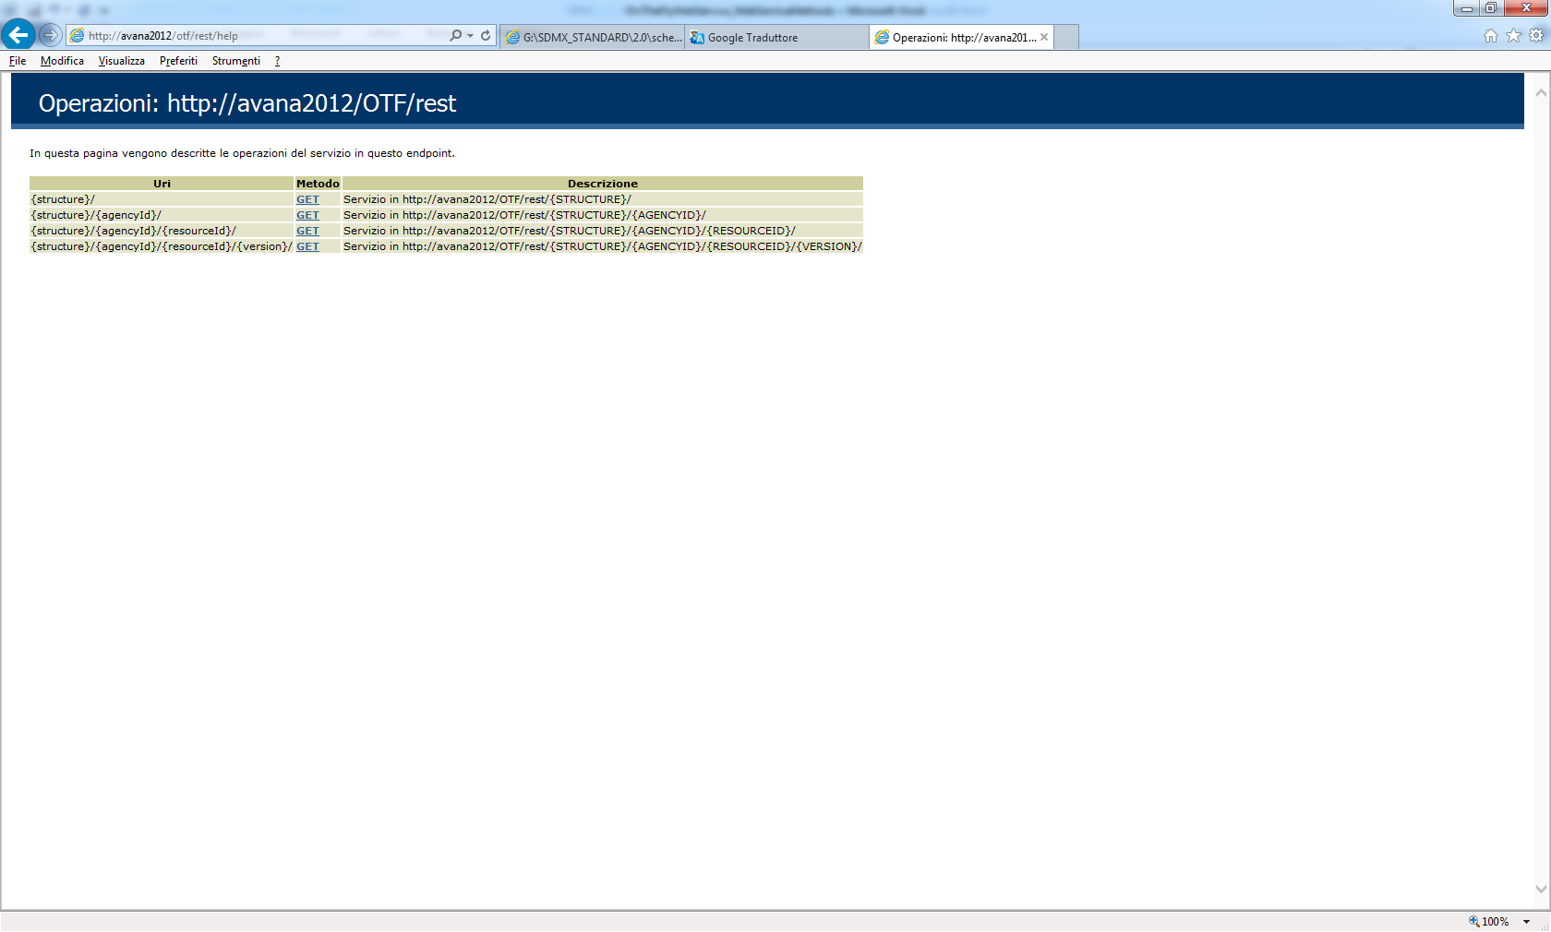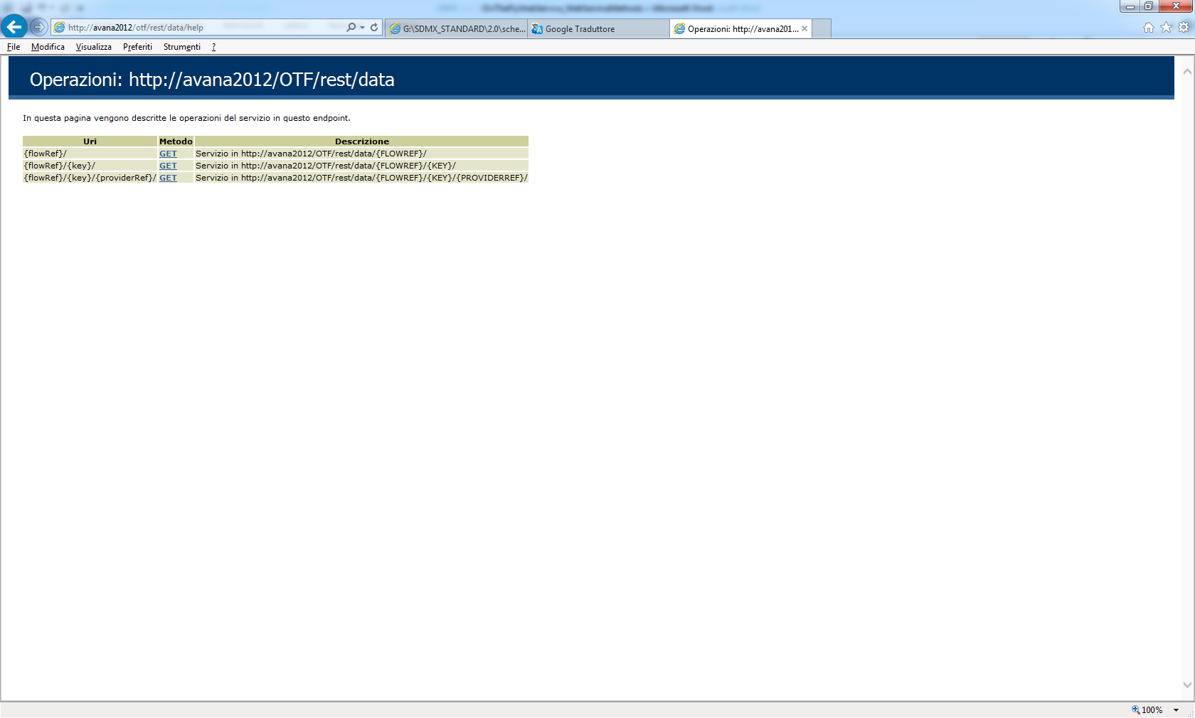

Figura 3 : Rest metadata web service

Figura 4 : Rest data web service

# Additional features

## No-standard constraints

The web services allows the usage of a set of no-standard constraints to perform the following operations:

* Get CL_COUNT

a codelist that returns the total number of the value present into a dataset

* Get CL_TIME_PERIOD

a codelist with two values: beginning and ending dates of the dataset

* Used dimension item

Return the dimension members filtered, that is the value of a dimension really used into a value.

## Fixed attributes

If the user needs a set of fixed attributes to add to the structural metadata, these attributes and their linked codelist can be set in the *AttributeConcepts.xml* file.

## Flag

The user is able to adopt the field FLAG of the fact table as OBS_STATUS attribute.

This features is into the configuration[2] file

## Streaming

The data messages are sent using streaming

## TimeStamp

The current version of the web services allow the user to specify the time stamp using the *ReportingBegin* tag for data and metadata 2.0

The RESTversion uses the *updateAfter* parameter

The SOAP 2.1 does not support TimeStamp in the current version due to validation issues on the v *ReportingBegin* tag.

1. <application path of the WS>/bin/ServiceConfiguration.xml
2. <application path of the WS>/bin/ServiceConfiguration.xml