Project Management System

Raji

**Software Requirements Specification**

Version 1.0

Danang, Jan 2025

**TABLE OF CONTENTS**

**TABLE OF CONTENTS** 2

1. DOCUMENT HISTORY 4

2. REFERENCE DOCUMENTS 4

3. INTRODUCTION 4

3.1 Purpose 5

3.2 In Scope 5

4. REQUIREMENT 5

5. OVERVIEW 6

5.1 Actors 5

5.2 System Use Case Diagram 6

5.3 System Pages Flow 6

6. SCREEN DESIGN 13

7. Data Structure 18

7.1 Entity Diagram 18

7.2 Database 18

8. NON-FUNCTIONAL REQUIREMENTS AND OTHERS 25

Performance 25

Security 25

Design Constraints 25

Standards Compliance 26

Reliability 26

Availability 26

Maintainability 26

Portability 26

9. APPENDIX

# **DOCUMENT HISTORY**

| **Date** | **Summary of Changes** | **Version** |
| --- | --- | --- |
| 17/01/2025 | Init SRS first version | PMS_SRS_sample_v1.0 |
|  |  |  |
|  |  |  |

# 

# **REFERENCE DOCUMENTS**

| **Document Name** | **Description** |
| --- | --- |
|  |  |
|  |  |
|  |  |
|  |  |
|  |  |
|  |  |
|  |  |

# 

# **INTRODUCTION**

The following subsections of the Software Requirements Specifications (SRS) document provide an overview of the entire SRS.

## ***Purpose***

* The Software Requirements Specification (SRS) will provide a detailed description of the requirements for the Project Management System (PMS). This SRS will allow for a complete understanding of what is to be expected of the PMS to be constructed. The clear understanding of the PMS and its’ functionality will allow for the correct software to be developed for the end user and will be used for the development of the future stages of the project. This SRS will provide the foundation for the project. From this SRS, the HMS can be designed, constructed, and finally tested.
* This SRS will be used by the software engineers constructing the PMS and Project manager. The software engineers will use the SRS to fully understand the expectations of this PMS to construct the appropriate software. Project Manager will be able to use this SRS as a “test” to see if the software engineers will be constructing the system to their expectations. If it is not to their expectations the end users can specify how it is not to their liking and the software engineers will change the SRS to fit the end users’ needs.

## ***In Scope***

* The software product to be developed is a Project Management System (PMS) designed to streamline and automate essential project management operations. The first subsystem is a Task and Workflow Management System, enabling users to create, assign, and track tasks efficiently. The second subsystem is a Collaboration and Communication System to facilitate seamless team interactions, document sharing, and discussions. The third subsystem is a Reporting and Analytics System, which provides real-time insights, progress reports, and performance tracking to aid decision-making. These three subsystems’ functionalities will be detailed in section 2—Overall Description.  
  The system will serve two main types of end users: team members and project managers. Both user types will have access to the Task and Workflow Management System and the Collaboration and Communication System. The Reporting and Analytics System will be restricted to project managers.
* The Project Management System’s primary objective is to provide an efficient and scalable tool for managing projects within organizations of varying sizes. The automation of project tracking, task assignment, and reporting will significantly reduce manual effort, ensuring streamlined operations even as project complexity increases.  
  The end users’ day-to-day project management tasks will be simplified through features like intuitive dashboards, automated notifications, and real-time collaboration. The system will prioritize user appropriateness, ease of use, quick error recovery, and overall high user satisfaction, making it an indispensable tool for effective project delivery.

# **REQUIREMENT**

***4.1 Purpose***

* + Project management
  + Member management
  + Team management
  + Task management
  + Timeline management
  + Increase productivity
  + Dicussing management
  + Data Management

***4.2 Requirement specification***

***4.2.1 Funtional Requirement***

***4.2.1.1 Task and workflow management***

**Task creation and customization**: User can create tasks with titles, description and priority. Tasks can be customized and update after be created.

**Workflow Automation**: Customized task with define statuses : to do, in progress, done, … Automatics change status when assigned or out of date.

**Task Assignment**: Acording to type of project, PM can assign tasks to members or member can assign to themsevlce.

**Time tracking**: User can track time spent on task by using built-in calendar

***4.2.1.2 Collaboration and Communication***

**Team communication**: Built-in comment functionally for task or project discussion. Comment threads for tasks with @mention for specific members.

**Notification**: Real-time notifications via in app like alert, or push notification when be assigned tasks or @mention in discussions. Alert when task nearing deadlines

***4.2.1.3 Reporting and analytics***

**Visual report**: Using chart for tracking project progress

* + - Burn-down chart for progress tracking
    - Gant chart for project timeline
    - Circle chart for show percentage of all status’s tasks

**Custom report**: Filter for generating reports by members, task type, priority,… And export report like pdf, csv or excel

***4.2.1.4 User Management***

**Role-based permission**: Admins or PM can defined roles and assign permission( create tasks, edit tasks,…)

**Group**: PM or admin can defiine a group and group member. Manage permission to access a group.

**Guests and skateholders access**: Limited, view-only access for stakeholders or external collaborators

***4.2.1.5 Integration and APIs***

**Third-Party Integrations** : Sync with calendar tools like Google Calendar and Microsoft Outlook,…

**Open APIs**: use RESTfull APIS for custom intergrations.

***4.2.2 Non-Funtional Requirement***

***4.2.2.1 Usability***

* Intuitive UI/UX with minimal clicks to access key features.
* Onboarding wizard for first-time users.
* Comprehensive help documentation and in-app tooltips.

***4.2.2.2 Performance***

* Handle up to 100 active users per project with no significant latency.
* Support for up to 50 concurrent project teams on a single server instance.
* Response time for user actions (e.g., task updates) < 1 second.

***4.2.2.3 Scalability***

* Horizontal scaling to support enterprise-level deployments.
* Multi-tenant architecture for large organizations.

***4.2.2.4 Security***

**Authentication**:

* Two-factor authentication and OAuth support.
* Using JWT for authentication

***4.2.2.5 Reliability***

**Error Handling**:

* Graceful error recovery with detailed logs.
* User-friendly error messages with troubleshooting steps.

***4.2.3 User Requirements***

**4.2.3.1 Team Members**

* Access to tasks, comments, and assigned projects.
* View personal productivity metrics (e.g., tasks completed weekly).
* Request project changes or additional resources.

**4.2.3.2 Project Managers**

* Full control over project creation and management.
* Access to team-level performance reports.
* Ability to adjust workflows, deadlines, and priorities dynamically.

***4.2.4 System Requirements***

**4.2.4.1 Hardware**

**Sever Requirements**:

* **Processor**: Quad-core, 3 GHz or higher.
* **RAM**: 16 GB (32 GB for enterprise setups).
* **Storage**: SSD, 1 TB minimum.

**Client Requirements:**

* Modern web browser (latest versions of Chrome, Firefox, Edge).

**4.2.4.2 Software**

**Backend**:

Node.js with Express.

**Frontend**:

NextJS, ShadnUI, Tailwind .

**Database**:

MongoDB and firebase for scalable data management.

**Hosting**:

Deployment on AWS.

# **OVERVIEW**

## ***Actors***

+ Project Manager(PM)

+ Members

## ***System Use Case Diagram***

### **Project Manager Usecase**

## 

### **Member usecase**

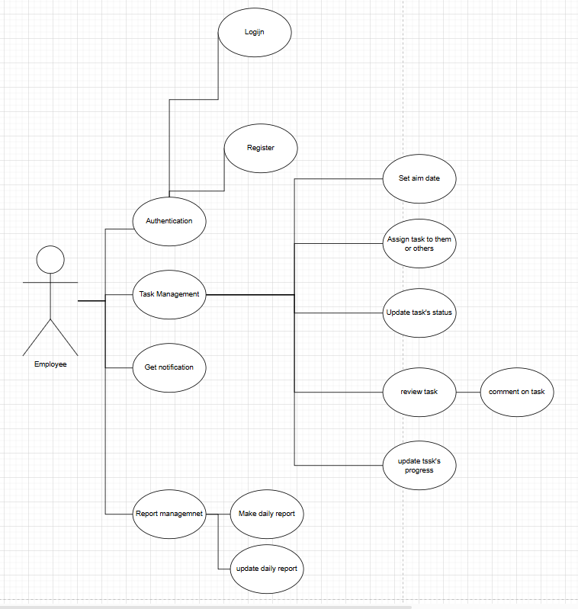

## ***System Pages Flow***

***5.3.1 Management flow***

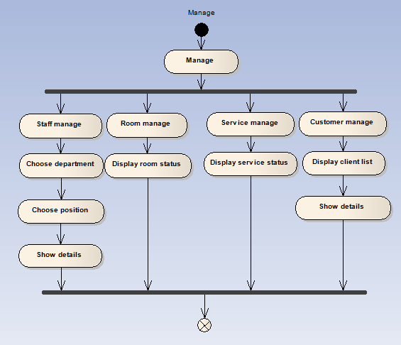

***5.3.2 Booking room flow***

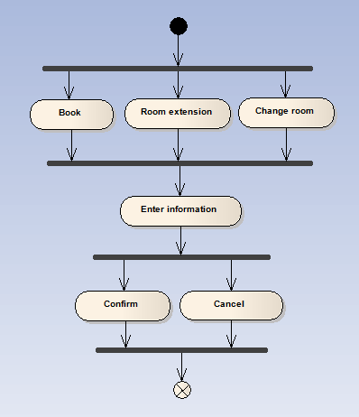

***5.3.3 Service providing flow***

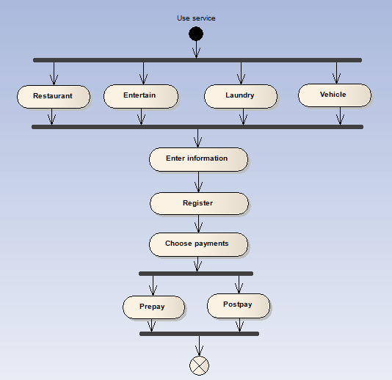

# **SCREEN DESIGN**

**+ Login**

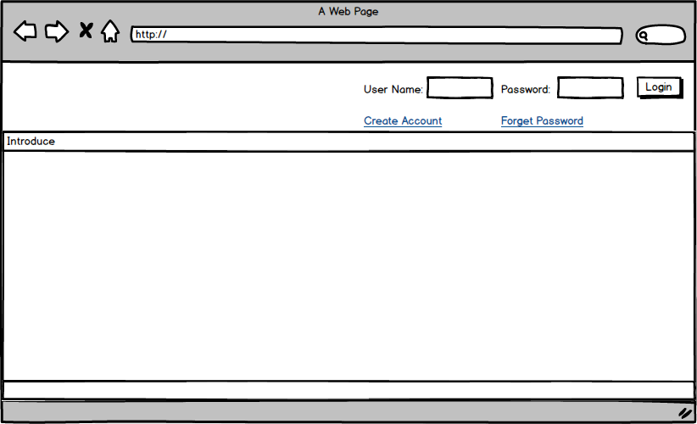

| **Screen** | Login screen | | | |
| --- | --- | --- | --- | --- |
| **Description** | Input your user name and password to login your account. If you do not have any account, you can click to Creat account link to creat new account or click to Forget password to be help. | | | |
| **Screen Access** | Defaut | | | |
| **Screen Content** | | | | |
| **Item** | | **Type** | **Data** | **Description** |
| User Name | | Textbox | Export From Database | Here, input your user name |
| Password | | Textbox | Export From Database | Input your password for your user name that you were submit. |
| Login | | Button |  | To login account, Affter fishnish typing username and password, click this button. If user name or password was wrong, you can’t access to the account. You must retype and try again. |
| Creat Account | | Link |  | To creat new account, you click here. New creat account layout will show. |
| Forget Password | | Link |  | When you forget your password, click here for help |

**+ Creat new account layout**

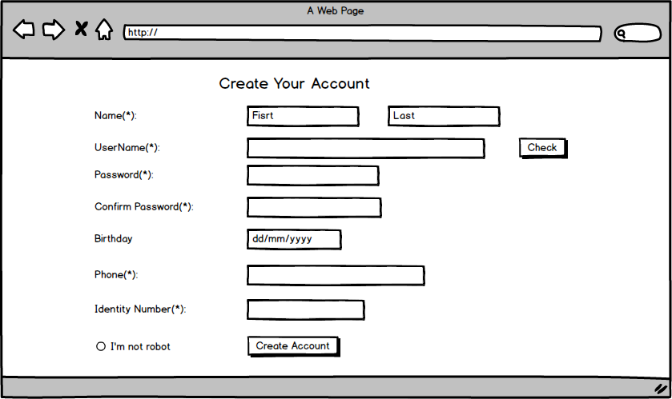

| **Screen** | Creat account | | | |
| --- | --- | --- | --- | --- |
| **Description** | | If you want to creat a new account, this screen will show you how. From login screen, click creat account link to view this layout. After completed insert yourself information, click Creat Account button to register a new account with OS. | | |
| **Screen Access** | | User click on creat account link from login layout. | | |
| **Screen Content** | | | | |
| **Item** | | **Type** | **Data** | **Description** |
| Name | | textbox | Insert your name (Fisrt name & last name) | Type text |
| Username | | textbox | Insert your elective user name. | Type text. |
| Check | | textbox | Check database | Click button to check, if username was be register. You must be type another untill os accept |
| Password | | textbox | Insert your register password. | Type text |
| Confirm Password | | textbox |  | Retype password from password item |
| Birthday | | Textbox (dd/mm/yyyy) | Insert your birthday | Type your birthday. |
| Phone | | Textbox (number) | Insert your phone number | Insert your cell phone |
| Identity Number | | Textbox (number) | Insert your identity number | Insert your identity number to confirm yourself. |
| I’m not robot | | Radio button |  | Click or not |
| Creat Account | | button |  | Click it to fishnish creat account process. If there an emty item, you have to comple to fishnish. |

**+ Booking room**

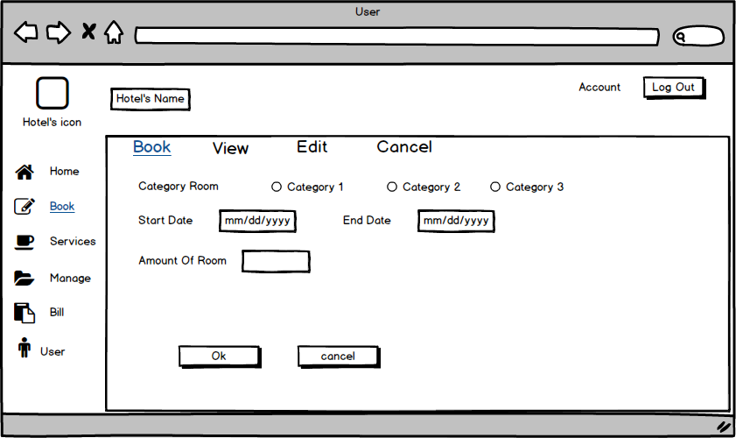

| **Screen** | Book | | | |
| --- | --- | --- | --- | --- |
| **Description** | | Describe how and what to do when you are booking room by your account on Hotel’s website | | |
| **Screen Access** | | Click Book from Book menu. ( Or default) | | |
| **Screen Content** | | | | |
| **Item** | | **Type** | **Data** | **Description** |
| Hotel’s icon | | Image box |  | Insert image of the hotel. |
| Hotel’s name | | Label |  | Insert name of the hotel. |
| Log out | | Button |  | Click Log out button to log out account, and comple a session. |
| Category room | | Radio check |  | Show 3 kind of room for you to choose one. |
| Start day | | Textbox |  | Insert date you start stating the hotel |
| End day | | Textbox |  | Insert date you going to leave. |
| Amount of room | | Number |  | Insert here how much do you want to reservation. |
| Ok | | button |  | Click Ok, You will submit a new resevation. Its ok if you entire the propose box. If not, you have to complete the text. |
| Cancel | | button |  | Cancel the booking room session when you click Cancel button here. |

**+ Booking (view)**

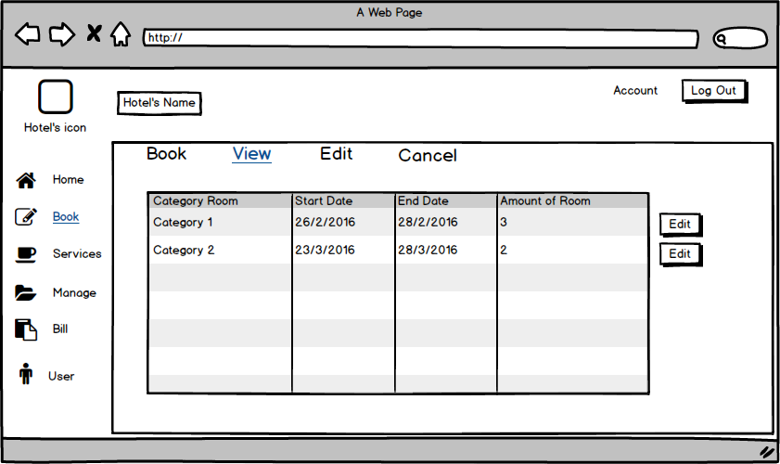

| **Screen** | View | | | |
| --- | --- | --- | --- | --- |
| **Description** | | It’s view show booking information. Here you can see what you were registered room, and you can change if you want. You click edit button to show edit screen. | | |
| **Screen Access** | | Click view item from Book menu. | | |
| **Screen Content** | | | | |
| **Item** | | **Type** | **Data** | **Description** |
| Table | | List data | Export from database | Descrisbing information about register room of user. |
| Edit | | Button |  | Button to change your register. |

**+ Booking (edit)**

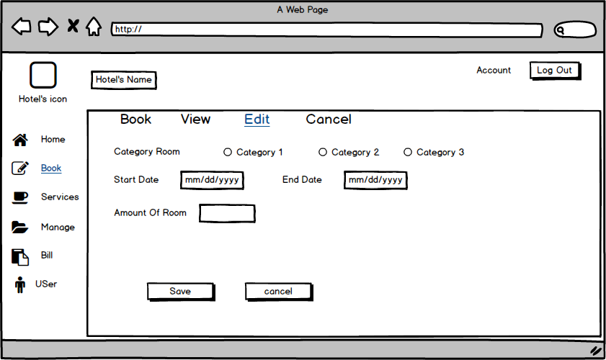

| **Screen** | Edit | | | |
| --- | --- | --- | --- | --- |
| **Description** | | Update or register again. Click save or cancel to finish | | |
| **Screen Access** | | Click edit item from Book menu | | |
| **Screen Content** | | | | |
| **Item** | | **Type** | **Data** | **Description** |
| Category room | | Radio checkbox |  | Show 3 kind of room for choose. You can choose one of them |
| Start day | | Textbox |  | Insert start day follow format |
| End day | | Textbox |  | Insert end day follow format |
| Amount of room | | Number |  | Insert amount of room you want to register |
| Save | | Button |  | Click it to Save and update information in this Form. The old data will be delete befor update new data. |
| Cancel | | button |  | Click this to cancel update, the data don’n be delete. |

**+ Booking (Cancel)**

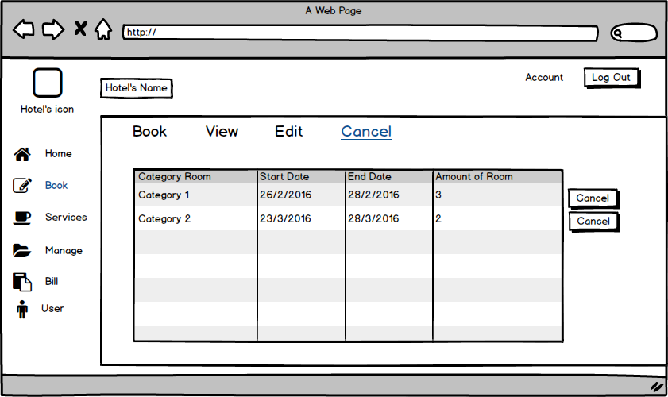

| **Screen** | Cancel | | | |
| --- | --- | --- | --- | --- |
| **Description** | | Update or register again. Click save or cancel to finish | | |
| **Screen Access** | | Click edit item from Book menu | | |
| **Screen Content** | | | | |
| **Item** | | **Type** | **Data** | **Description** |
| Table | | table | Export from database | Descrisbing information about register room of user. |
| Cancel | | Button |  | Click here if you want to Cancel your register befor. When Cancel button was be click, its will show you a dialog box to confirm your decide. |

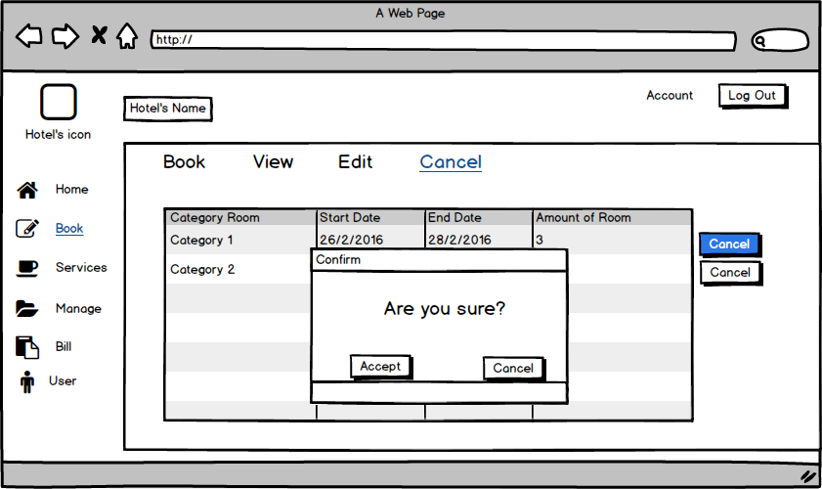

| **Screen** | Cancel | | | |
| --- | --- | --- | --- | --- |
| **Description** | | Update or register again. Click save or cancel to finish | | |
| **Screen Access** | | Click edit item from Book menu | | |
| **Screen Content** | | | | |
| **Item** | | **Type** | **Data** | **Description** |
| Accept | | button | List menu | If you click this button then the data in table will be delete, also in the database. Return Cancel screen but you will not see the table anymore . |
| Cancel | | button | Day, month, year (d/m/y) | Click Cancel button. Return Cancel screen, and nothing is change. |

**+ Service (Restaurant)**

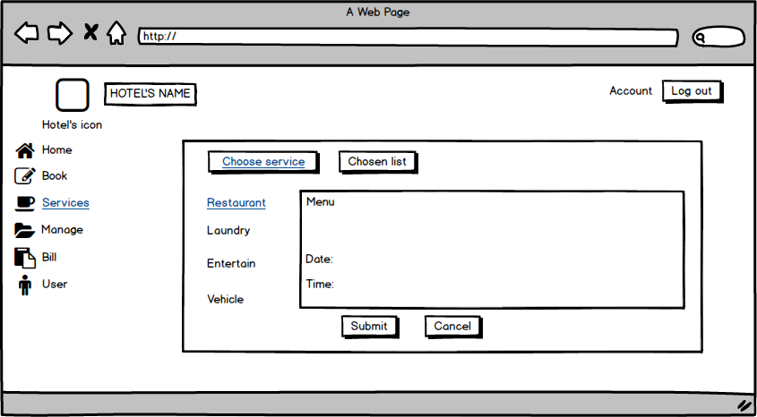

| **Screen** | Service Restaurant | | | | |
| --- | --- | --- | --- | --- | --- |
| **Description** | | Displays a list of the dishes, drinks and date, time. | | | |
| **Screen Access** | | Users click Submit, Cancel or Chosen list on Screen. | | | |
| **Screen Content** | | | | | |
| **Item** | | **Type** | **Data** | **Description** | |
| Menu | | Text | List menu | Display information of list menu. | |
| Date | | Date | Day, month, year (d/m/y) | Display information of day. | |
| Time | | Time | Time (h:m) | Display information of year. | |
| Submit | | Button |  | Submit | |
| Cancel | | Button |  | Cancel | |
| **Screen Actions** | | | | | |
| **Action Name** | | **Description** | | **Success** | **Failure** |
| Submit | | Click Submit to select menu list. | |  |  |
| Cancel | | Click Cancel to cancel | |  |  |
| Chosen list | | View chosen list | | Display a selected list |  |

**+ Service (Chosen list)**

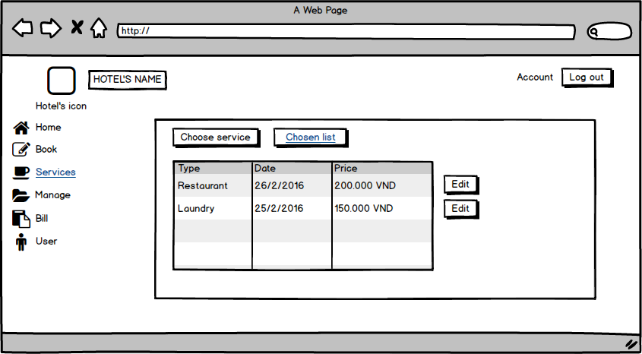

| **Screen** | Service Chosen list | | | | |
| --- | --- | --- | --- | --- | --- |
| **Description** | | Displays Chosen list. | | | |
| **Screen Access** | | Users click edit button on Screen. | | | |
| **Screen Content** | | | | | |
| **Item** | | **Type** | **Data** | **Description** | |
| Type | | Text | Service list | Display information of service. | |
| Date | | Date | Day, month, year (d/m/y) | Display information of day. | |
| Price | | Float | Money | Display Price. | |
| Edit | | Button |  |  | |
| Chosen list | | Button |  | Chosen list | |
| Choose service | | Button |  | Choose service | |
| **Screen Actions** | | | | | |
| **Action Name** | | **Description** | | **Success** | **Failure** |
| Edit | | Click Edit to edit information of services. | |  |  |

**+ Service (Laundry)**

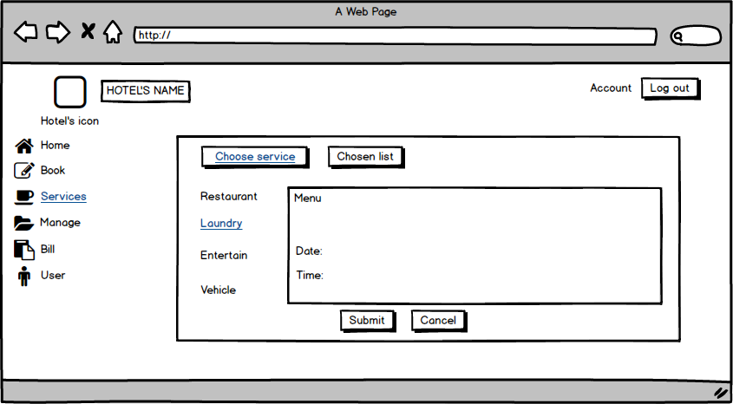

| **Screen** | Service Laundry | | | | |
| --- | --- | --- | --- | --- | --- |
| **Description** | | Displays a list of the service laundry. | | | |
| **Screen Access** | | Users click Submit, Cancel or Chosen list on Screen. | | | |
| **Screen Content** | | | | | |
| **Item** | | **Type** | **Data** | **Description** | |
| Menu | | Text | List menu | Display information of list menu. | |
| Date | | Date | Day, month, year (d/m/y) | Display information of day. | |
| Time | | Time | Time (h:m) | Display information of year. | |
| Submit | | Button |  | Submit | |
| Cancel | | Button |  | Cancel | |
| **Screen Actions** | | | | | |
| **Action Name** | | **Description** | | **Success** | **Failure** |
| Submit | | Click Submit to select menu list. | |  |  |
| Cancel | | Click Cancel to cancel | |  |  |
| Chosen list | | View chosen list | | Display a list of selected |  |

**+ Service (Entertainment)**

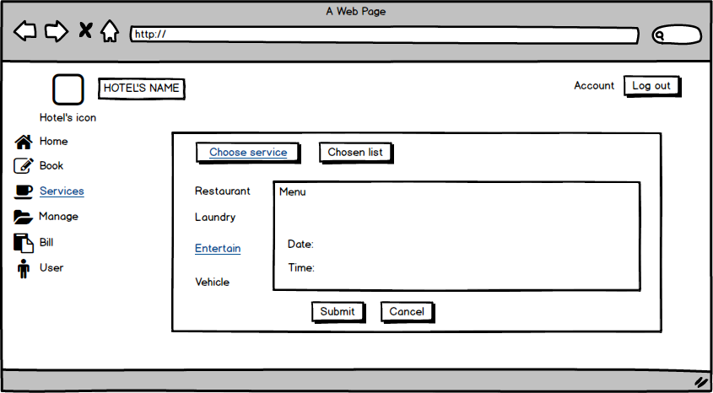

| **Screen** | Service Entertainment | | | | |
| --- | --- | --- | --- | --- | --- |
| **Description** | | Displays a list of the Service Entertainment. | | | |
| **Screen Access** | | Users click Submit, Cancel or Chosen list on Screen. | | | |
| **Screen Content** | | | | | |
| **Item** | | **Type** | **Data** | **Description** | |
| Menu | | Text | List menu | Display information of list menu. | |
| Date | | Date | Day, month, year (d/m/y) | Display information of day. | |
| Time | | Time | Time (h:m) | Display information of year. | |
| Submit | | Button |  | Submit | |
| Cancel | | Button |  | Cancel | |
| **Screen Actions** | | | | | |
| **Action Name** | | **Description** | | **Success** | **Failure** |
| Submit | | Click Submit to select menu list. | |  |  |
| Cancel | | Click Cancel to cancel | |  |  |
| Chosen list | | View chosen list | | Display a list of selected |  |

**+ Service (Vehicle)**

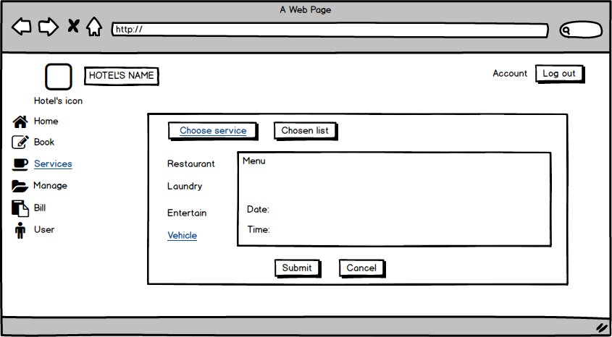

| **Screen** | Service Vehicle | | | | |
| --- | --- | --- | --- | --- | --- |
| **Description** | | Displays a list of the Service Vehicle. | | | |
| **Screen Access** | | Users click Submit, Cancel or Chosen list on Screen. | | | |
| **Screen Content** | | | | | |
| **Item** | | **Type** | **Data** | **Description** | |
| Menu | | Text | List menu | Display information of list menu. | |
| Date | | Date | Day, month, year (d/m/y) | Display information of day. | |
| Time | | Time | Time (h:m) | Display information of year. | |
| Submit | | Button |  | Submit | |
| Cancel | | button |  | Cancel | |
| **Screen Actions** | | | | | |
| **Action Name** | | **Description** | | **Success** | **Failure** |
| Submit | | Click Submit to select menu list. | |  |  |
| Cancel | | Click Cancel to cancel | |  |  |
| Chosen list | | View chosen list | | Display a list of selected |  |

**+ Manage Staff**

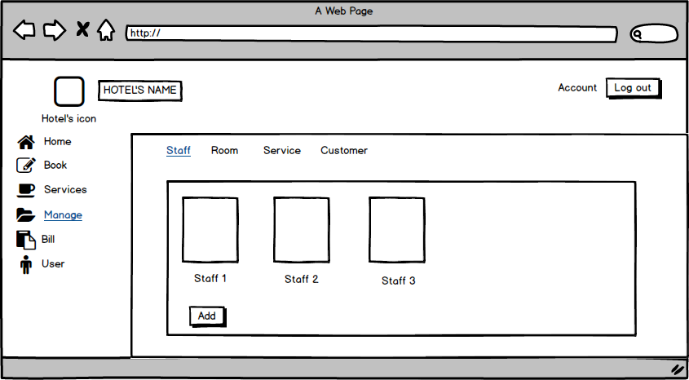

| **Screen** | Manage Staff | | | | |
| --- | --- | --- | --- | --- | --- |
| **Description** | | Displays a list Staff and add Staff. | | | |
| **Screen Access** | | Users click on add to add Staff | | | |
| **Screen Content** | | | | | |
| **Item** | | **Type** | **Data** | **Description** | |
| Staff 1 | | Text | information of Staff 1 | * Display information of Staff 1 | |
| Staff 2 | | Text | information of Staff 2 | * Display information of Staff 2 | |
| Staff 3 | | Text | information of Staff 3 | * Display information of Staff 3 | |
| Add | | Button |  | * User click on button to add Staff | |
| **Screen Actions** | | | | | |
| **Action Name** | | **Description** | | **Success** | **Failure** |
| Add | | User click on button to add Staff | | Display list of Staff. |  |

**+ Manage Staff (Add Staff)**

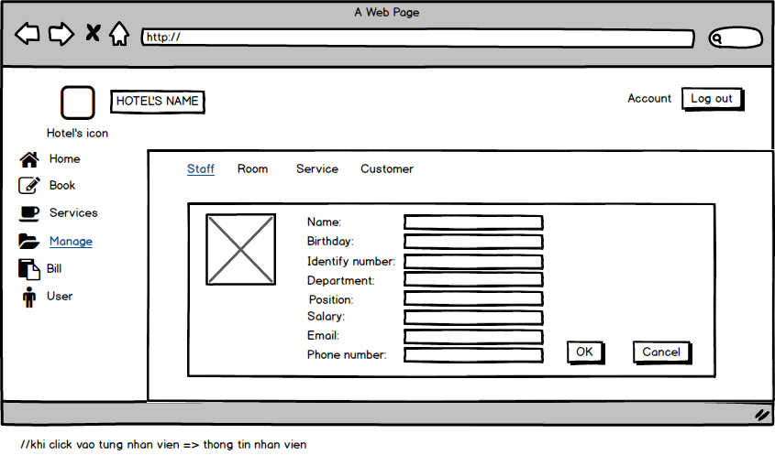

| **Screen** | Add Staff | | | | |
| --- | --- | --- | --- | --- | --- |
| **Description** | | Add Staff: Name, birthday, Email …… | | | |
| **Screen Access** | | Add information of Staff | | | |
| **Screen Content** | | | | | |
| **Item** | | **Type** | **Data** | **Description** | |
| Name | | Textbox | Name off staff | * User enter name | |
| Birthday | | Date | Dd/mm/yy | * User enter your birthday | |
| Identify number | | Number(15) | Number | * User enter Identify number | |
| Department | | Text | Department of staff | * User enter department | |
| Position | | Text | Position | * User enter your position | |
| Salary | | Number | Salary | * User enter your Salary | |
| Email | | text | email | * User enter your Email | |
| Phone Number | | Number | Phone number | * User enter your phone number | |
| Ok | | button |  | * User click to add | |
| Cancel | | button |  | * User click to cancel | |
| **Screen Actions** | | | | | |
| **Action Name** | | **Description** | | **Success** | **Failure** |
| Ok | | User click Ok to agree add information off staff. | | Display messgage “Ok”. | Display messgage “Failed”. |
| Cancel | | User click cancel to not agree add information off staff. | |  |  |

**+ Manage Staff (Edit Staff)**

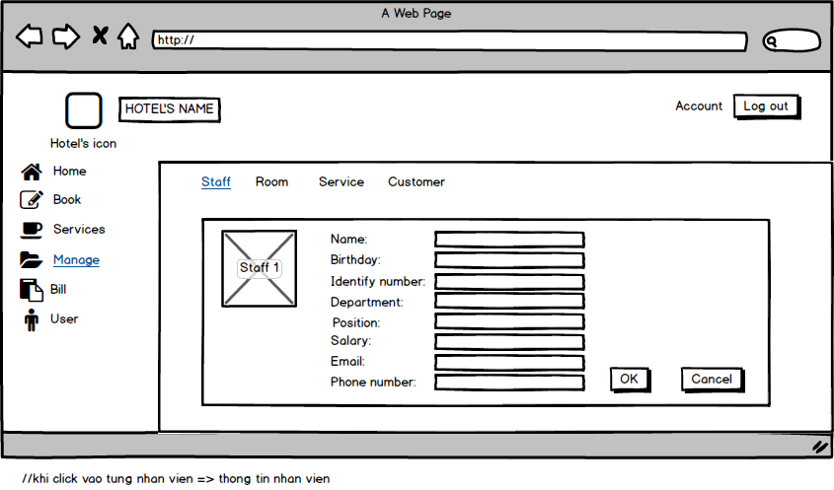

| **Screen** | Edit Staff | | | | |
| --- | --- | --- | --- | --- | --- |
| **Description** | | Edit Staff: Name, birthday, Email …… | | | |
| **Screen Access** | | Edit information of Staff | | | |
| **Screen Content** | | | | | |
| **Item** | | **Type** | **Data** | **Description** | |
| Name | | Textbox | Name off staff | * User enter name | |
| Birthday | | Date | Dd/mm/yy | * User enter your birthday | |
| Identify number | | Number(15) | Number | * User enter Identify number | |
| Department | | Text | Department of staff | * User enter department | |
| Position | | Text | Position | * User enter your position | |
| Salary | | Number | Salary | * User enter your Salary | |
| Email | | text | email | * User enter your Email | |
| Phone Number | | Number | Phone number | * User enter your phone number | |
| Ok | | Button |  | * User click to edit | |
| Cancel | | Button |  | * User click to cancel | |
| **Screen Actions** | | | | | |
| **Action Name** | | **Description** | | **Success** | **Failure** |
| Ok | | User click Ok to agree edit information off staff. | | Display messgage “Ok”. | Display messgage “Failed”. |
| Cancel | | User click Ok to not edit information off staff. | |  |  |

**+ Manage Staff (View Staff)**

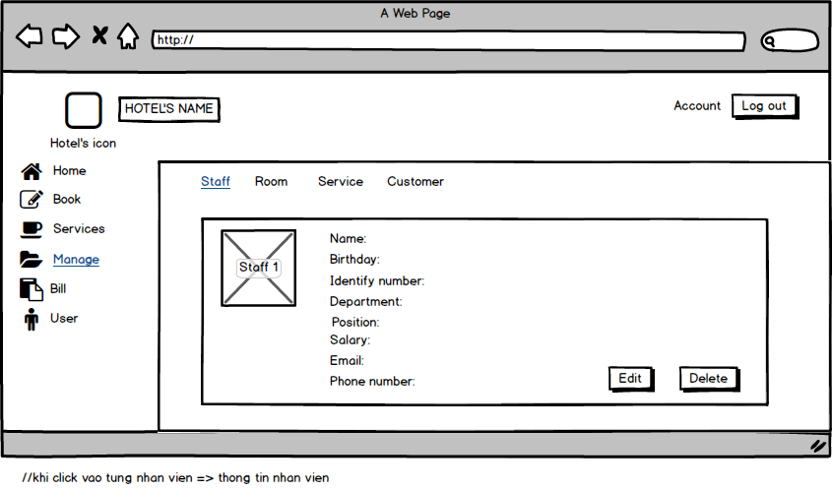

| **Screen** | View Staff | | | | |
| --- | --- | --- | --- | --- | --- |
| **Description** | | View Staff: Name, birthday, Email …… | | | |
| **Screen Access** | | View information of Staff | | | |
| **Screen Content** | | | | | |
| **Item** | | **Type** | **Data** | **Description** | |
| Name | | Textfield | Name off staff | * Displays name | |
| Birthday | | Date | Dd/mm/yy | * Displays birthday | |
| Identify number | | Number(15) | Number | * Displays Identify number | |
| Department | | Text | Department of staff | * Displays department | |
| Position | | Text | Position | * Displays position | |
| Salary | | Number | Salary | * Displays Salary | |
| Email | | Text | email | * Displays Email | |
| Phone Number | | Number | Phone number | * Displays phone number | |
| Edit | | Button |  | * User click to edit | |
| Delete | | Button |  | * User click to delete | |
| **Screen Actions** | | | | | |
| **Action Name** | | **Description** | | **Success** | **Failure** |
| Edit | | User click Edit to edit. | |  |  |
| Delete | | User click delete to delete | |  |  |

**+ Manage Staff (Delete Staff)**

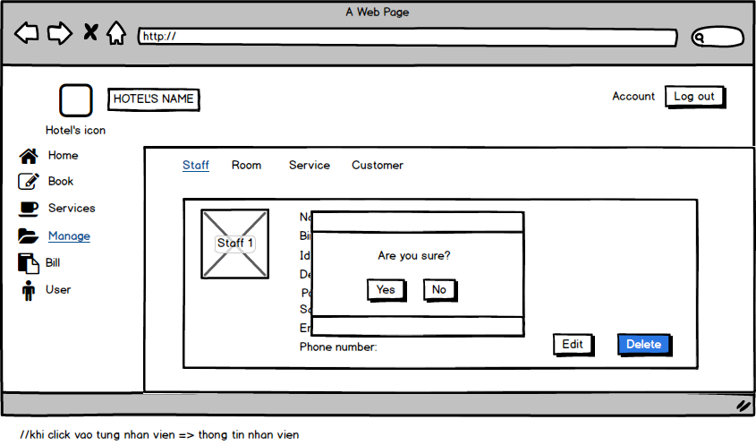

| **Screen** | Delete Staff | | | | |
| --- | --- | --- | --- | --- | --- |
| **Description** | | Delete Staff: Name, birthday, Email …… | | | |
| **Screen Access** | | Delete information of Staff | | | |
| **Screen Content** | | | | | |
| **Item** | | **Type** | **Data** | **Description** | |
| Name | | Textfield | Name off staff | * Displays name | |
| Birthday | | Date | Dd/mm/yy | * Displays birthday | |
| Identify number | | Number(15) | Number | * Displays Identify number | |
| Department | | Text | Department of staff | * Displays department | |
| Position | | Text | Position | * Displays position | |
| Salary | | Number | Salary | * Displays Salary | |
| Email | | Text | email | * Displays Email | |
| Phone Number | | Number | Phone number | * Displays phone number | |
| Yes | | Button |  | * User click to delete staff | |
| No | | Button |  | * User click to not delete staff | |
| **Screen Actions** | | | | | |
| **Action Name** | | **Description** | | **Success** | **Failure** |
| Yes | | User click to delete staff | | Display messgage “delete success”. |  |
| No | | User click to not delete staff | |  |  |

**+ Manage Room**

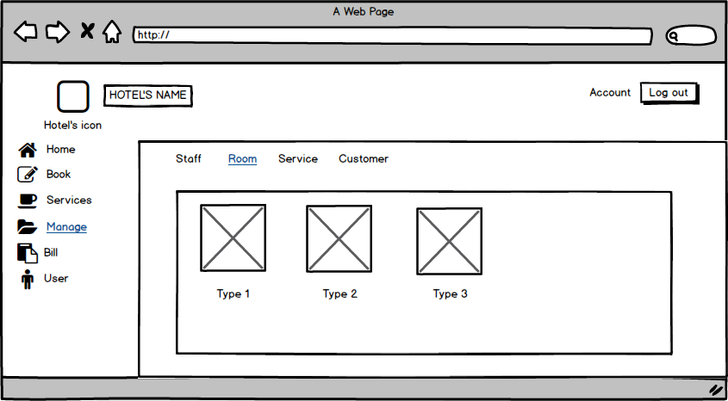

| **Screen** | Manage Room | |
| --- | --- | --- |
| **Description** | | Displays Room list and information |
| **Screen Access** | | View Room list and information |

**+ Manage Room (Add Room)**

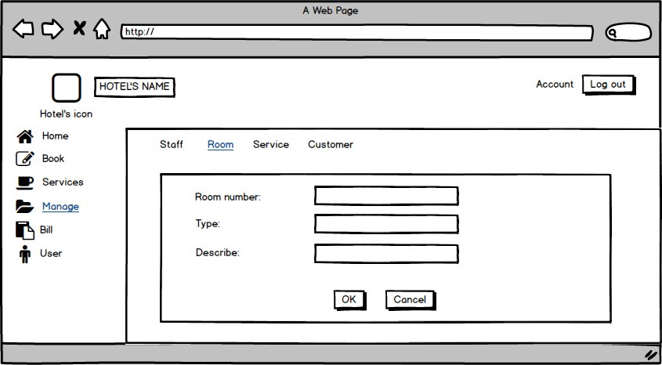

| **Screen** | Add Room | | | | |
| --- | --- | --- | --- | --- | --- |
| **Description** | | Add Room: Room number, type, Describe | | | |
| **Screen Access** | | Add information of Room | | | |
| **Screen Content** | | | | | |
| **Item** | | **Type** | **Data** | **Description** | |
| Room number | | Number | number | * enter number of room | |
| Type | | Text | Text | * enter type of room | |
| Describe | | Text | Text | * enter Describe of room | |
| Ok | | Button |  | * click to add room | |
| Cancel | | Button |  | * click to cancel | |
| **Screen Actions** | | | | | |
| **Action Name** | | **Description** | | **Success** | **Failure** |
| Ok | | User click Ok to agree add room | | Display messgage “Ok”. | Display messgage “Failed”. |
| Cancel | | User click cancel to cancel | |  |  |

**+ Manage Room (View Room)**

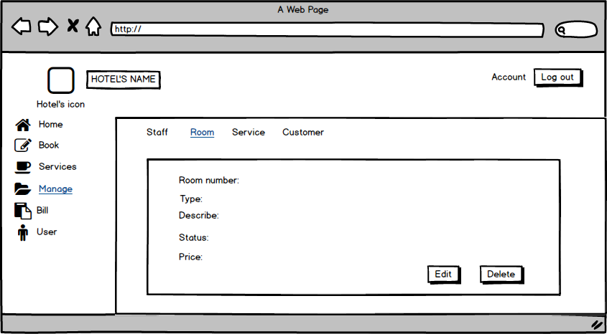

| **Screen** | View Room | | | | |
| --- | --- | --- | --- | --- | --- |
| **Description** | | View room: Room number, type, Describe, status, price | | | |
| **Screen Access** | | View information of Room | | | |
| **Screen Content** | | | | | |
| **Item** | | **Type** | **Data** | **Description** | |
| Room number | | Number | number | * Display number of room | |
| Type | | Text | Text | * Display type of room | |
| Describe | | Text | Text | * Display Describe of room | |
| Status | | Text | Text | * Displays status of room | |
| Price | | Number | Number | * Displays price of room | |
| Edit | | Button |  | * Click to edit | |
| Delete | | Button |  | * Click to delete | |
| **Screen Actions** | | | | | |
| **Action Name** | | **Description** | | **Success** | **Failure** |
| Edit | | User click Edit to edit. | |  |  |
| Delete | | User click delete to delete | |  |  |

**+ Manage Room (Edit Room)**

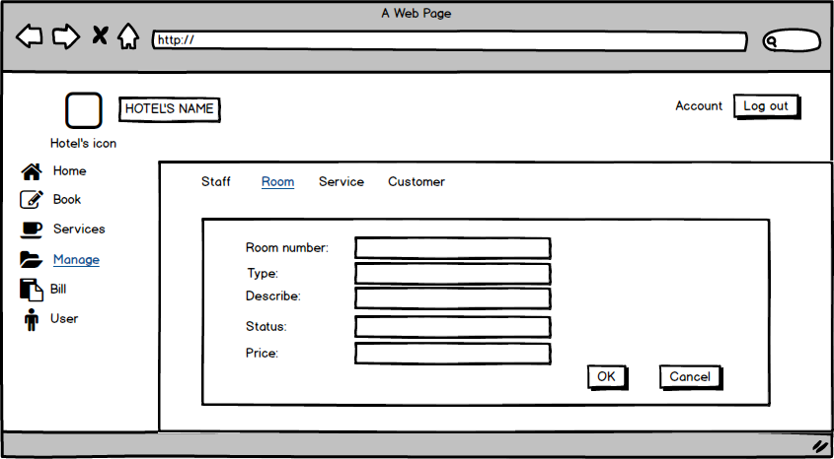

| **Screen** | Edit Room | | | | |
| --- | --- | --- | --- | --- | --- |
| **Description** | | Edit Room: Room number, type, Describe, status, price | | | |
| **Screen Access** | | Edit information of room | | | |
| **Screen Content** | | | | | |
| **Item** | | **Type** | **Data** | **Description** | |
| Room number | | Textbox | number | * enter number of room | |
| Type | | Textbox | Text | * enter type of room | |
| Describe | | Textbox | Text | * enter Describe of room | |
| Status | | Textbox | Text | * enter status of room | |
| Price | | Textbox | Number | * enter price of room | |
| Ok | | Button |  | * User click to edit | |
| Cancel | | Button |  | * User click to cancel | |
| **Screen Actions** | | | | | |
| **Action Name** | | **Description** | | **Success** | **Failure** |
| Ok | | User click Ok to agree edit information off room. | | Display messgage “Ok”. | Display messgage “Failed”. |
| Cancel | | User click Ok to not edit information off room. | |  |  |

**+ Manage Room (Delete Room)**

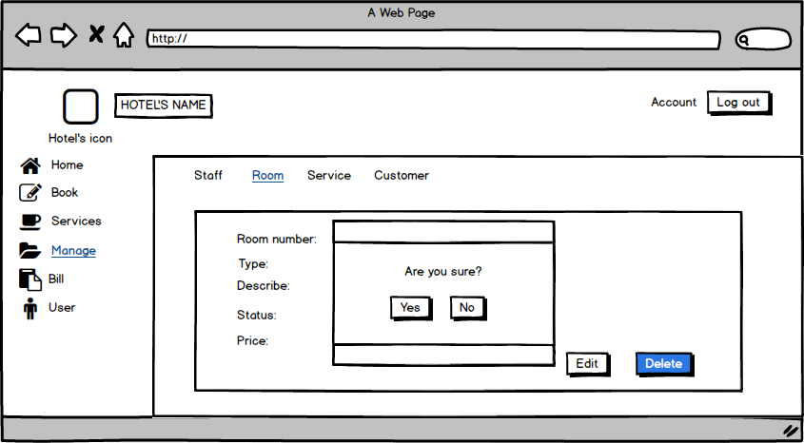

| **Screen** | Delete Room | | | | |
| --- | --- | --- | --- | --- | --- |
| **Description** | | Delete room: Room number, type, Describe, status, price | | | |
| **Screen Access** | | Delete information of room | | | |
| **Screen Content** | | | | | |
| **Item** | | **Type** | **Data** | **Description** | |
| Room number | | Textbox | number | * enter number of room | |
| Type | | Textbox | Text | * enter type of room | |
| Describe | | Textbox | Text | * enter Describe of room | |
| Status | | Textbox | Text | * enter status of room | |
| Price | | Textbox | Number | * enter price of room | |
| Yes | | Button |  | * User click to delete room | |
| No | | Button |  | * User click to not delete room | |
| **Screen Actions** | | | | | |
| **Action Name** | | **Description** | | **Success** | **Failure** |
| Yes | | User click to delete room | | Display messgage “delete success”. |  |
| No | | User click to not delete room | |  |  |

**+ Manage Service**

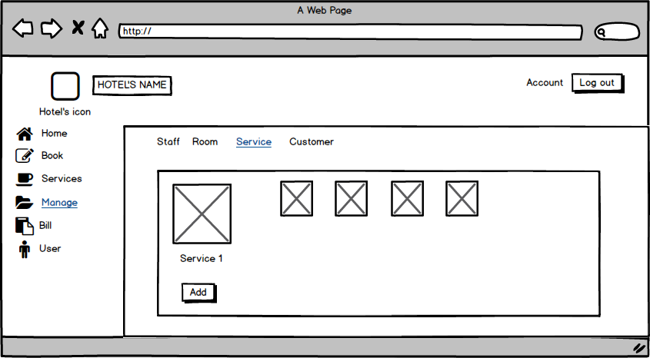

| **Screen** | Manage Service | | | | | |
| --- | --- | --- | --- | --- | --- | --- |
| **Description** | | Displays Service list and information for all the service of the Hotel. | | | | |
| **Screen Access** | | Click item Service on the menu Manage. | | | | |
| **Screen Content** | | | | | | |
| **Item** | | **Type** | **Data** | | **Description** | |
| Server1 | | link |  | | Server’s Name, link to Service information. | |
| Table List | | table |  | | Show list. The information and image about the server name. | |
| Add | | Button |  | | Add button, to add new Service | |
| **Screen Actions** | | | | | | |
| **Action Name** | | **Description** | | **Success** | | **Failure** |
| show service | | Show the information of all the service. | |  | |  |
| Add | | To add new service | | Show add service layout for you to input new service information. | | No action. |

**+ Manage Service (Add Service)**

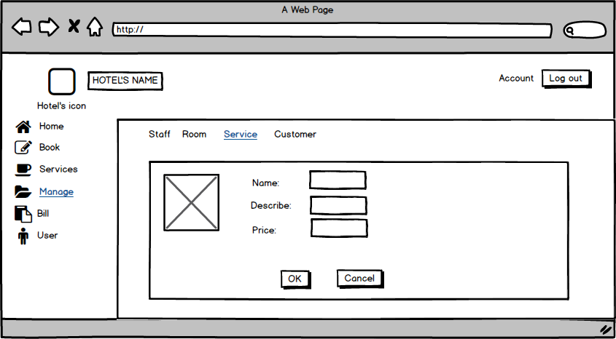

| **Screen** | Add new Service | | | | | |
| --- | --- | --- | --- | --- | --- | --- |
| **Description** | | Displays some textbox to input text. | | | | |
| **Screen Access** | | Click Add button from service manage screen. | | | | |
| **Screen Content** | | | | | | |
| **Item** | | **Type** | **Data** | | **Description** | |
| Image | | Image |  | | Image for the Service | |
| Name | | textbx (text) |  | | Here get service name that your’e input. | |
| Describe | | textbox (text) |  | | You can decribe some thing about the service. It’s will help the customer know what the service is? | |
| Price | | textbox (text) |  | | Input here how much the service cost. | |
| OK | | Button |  | | Click Ok to add the service to service manage screen. | |
| Cancel | | Button |  | | Cancel button to destroy. | |
| **Screen Actions** | | | | | | |
| **Action Name** | | **Description** | | **Success** | | **Failure** |
| Input information | | Input text | |  | |  |
| Click OK button | | Click on the OK button | | Add the service into service manage. | | No action or the service you were add not display in the service manage. |
| Click Cancel | | Click on the Cancel button | | Return to service manage screen and no thing update. | | No action, or new service will be add to service manage. |

**+ Manage Service (View Service)**

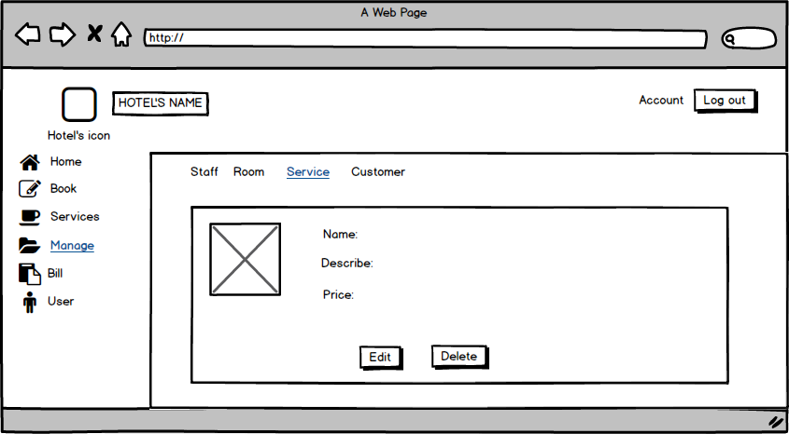

| **Screen** | View Service | | | | | |
| --- | --- | --- | --- | --- | --- | --- |
| **Description** | | Displays the service | | | | |
| **Screen Access** | | Click service name (link). | | | | |
| **Screen Content** | | | | | | |
| **Item** | | **Type** | **Data** | | **Description** | |
| Image | | Image |  | | Image for the Service | |
| Name | | Label (text) |  | | Show the service name. | |
| Describe | | Label (text) |  | | Show what you were describe for the service. | |
| Price | | Label (text) |  | | Show the price that you were input. | |
| Edit | | Button |  | | Go to Edit screen to change the information for the service. | |
| Delete | | Button |  | | Delete the service form service manage. | |
| **Screen Actions** | | | | | | |
| **Action Name** | | **Description** | | **Success** | | **Failure** |
| Click Edit button | | Click on the Edit button to do change service name, service cost or service description. | | Show the Edit screen for you to change the information. | | No action. |
| Click delete | | Click on the delete button. | | Show a message box to check your decide. | | No action. |

**+ Manage Service (Edit Service)**

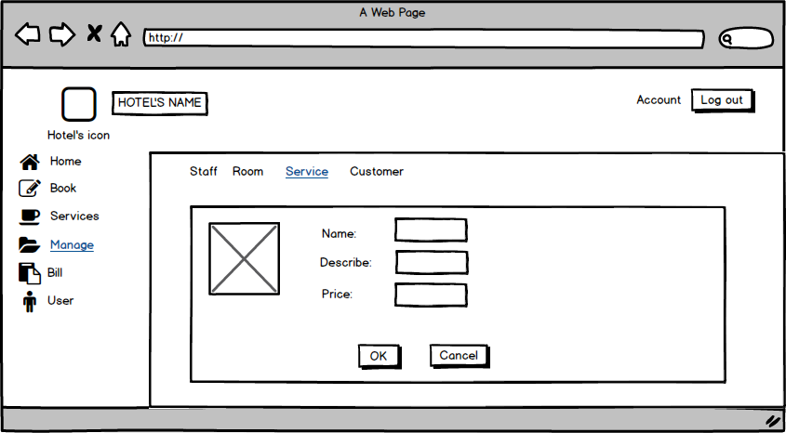

| **Screen** | Edit Screen | | | | | |
| --- | --- | --- | --- | --- | --- | --- |
| **Description** | | Show old the information of the service, but you can change the text. | | | | |
| **Screen Access** | | Click Edit button from View service screen. | | | | |
| **Screen Content** | | | | | | |
| **Item** | | **Type** | **Data** | | **Description** | |
| Image | | Image |  | | Image for the Service | |
| Name | | Textbox (text) |  | | Show the service name, (can change) | |
| Describe | | Textbox (text) |  | | Show what you were describe for the service. (can change) | |
| Price | | Textbox (text) |  | | Show the price that you were input. (can change) | |
| OK | | Button |  | | Click Ok to change and update new information about the service. | |
| Cancel | | Button |  | | To dispose the changing. | |
| **Screen Actions** | | | | | | |
| **Action Name** | | **Description** | | **Success** | | **Failure** |
| Change text | | Retype new text into the textbox. | |  | |  |
| Click OK button | | Click on the OK button to do change service name, service cost or service description. | | Update and show the change in service manage screen. | | No action. |
| Click Cancel | | Click on the Cancel button. | | Show a message box to check your decide. | | No action. |

**+ Manage Service (Delete Service)**

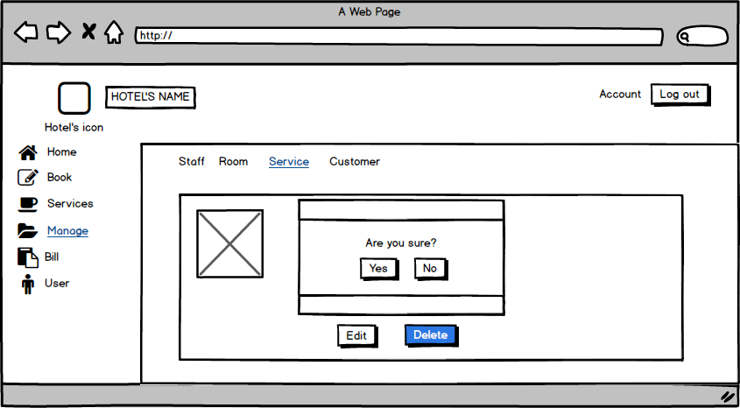

| **Screen** | Edit Screen | | | | | |
| --- | --- | --- | --- | --- | --- | --- |
| **Description** | | Show old the information of the service, but you can change the text. | | | | |
| **Screen Access** | | Click Delete button from View service screen. | | | | |
| **Screen Content** | | | | | | |
| **Item** | | **Type** | **Data** | | **Description** | |
| Image | | Image |  | | Image for the Service | |
| Messabox | |  | OS | | Show a messbox with a text “Are you sure” | |
| Yes | | Button |  | | To confirm you accept to delete the service. | |
| No | | button |  | | To confirm you don’t allow to delete the service. | |
| **Screen Actions** | | | | | | |
| **Action Name** | | **Description** | | **Success** | | **Failure** |
| Show messbox | | A message box will show with the text. | | Show the text | | No action. |
| Click Yes button | | Click on the Yes button to confirm the service will be delete. | | update and no see the service into service manage screen. The messabox disappear. | | The service still in the service manage screen. |
| Click No | | Click on the No button. | | Show a message box to check your decide. The messabox disappear. | | No action. |

**+ Manage Customer**

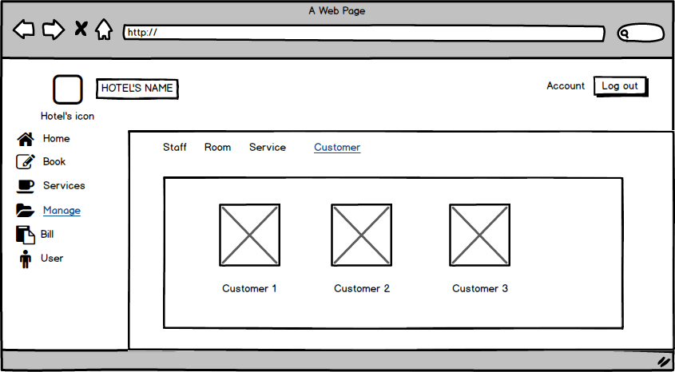

| **Screen** | Manage Customer | | | |
| --- | --- | --- | --- | --- |
| **Description** | | Show the customer information ( image and name) | | |
| **Screen Access** | | Click iteam Customer on the menu Manage. | | |
| **Screen Content** | | | | |
| **Item** | | **Type** | **Data** | **Description** |
| Image | | Image |  | Image for the Service |
| Customer1 | | link | Customer’s name | Link to Customer’s information. |

**+ Manage Customer (Add Service)**



**+ Manage Customer (View Customer)**

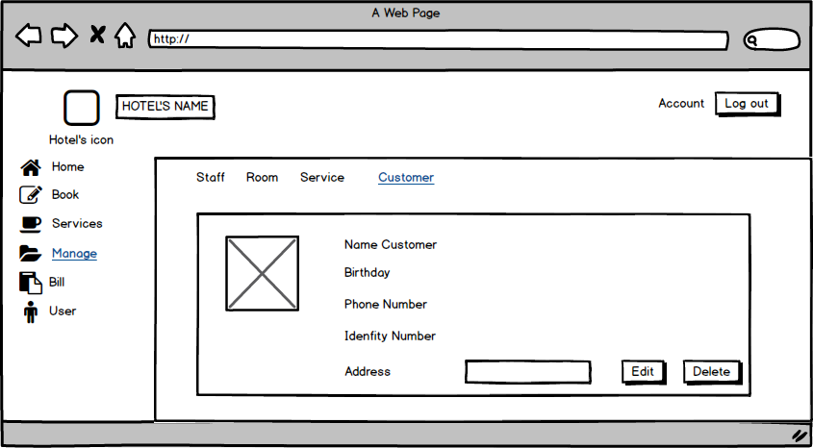

| **Screen** | View Customer | | | | | |
| --- | --- | --- | --- | --- | --- | --- |
| **Description** | | Show the customer information . | | | | |
| **Screen Access** | | Click Customer name (link) From customer manage. | | | | |
| **Screen Content** | | | | | | |
| **Item** | | **Type** | **Data** | | **Description** | |
| Image | | Image |  | | Image for the Service | |
| Name Customer | | Label (text) |  | | Show Name Customer | |
| Birthday | | Label (text) |  | | Show customer birthday. | |
| Phone number | | Label (text) |  | | Show phone number | |
| Identity number | | Label (text) |  | | Show identity number | |
| address | | Label |  | | Show customer address. | |
| Edit | | Button |  | | To edit Customer information | |
| Delete | | Buton |  | | To delete Customer | |
| **Screen Actions** | | | | | | |
| **Action Name** | | **Description** | | **Success** | | **Failure** |
| Click Edit button | | Click on Edit button to edit customer information. | | Show Edit customer Screen | | No action. |
| Click Delete button | | Click on the delete button to delete customer. | | The customer will be delete from Customer manage screen. | | No action, Or the information of the customer not be delete. |

**+ Manage Customer (Edit Customer)**

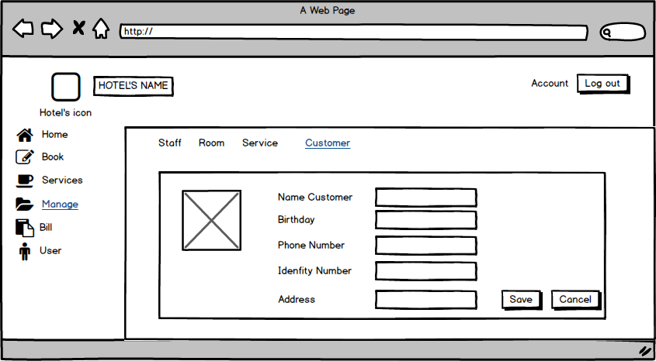

| **Screen** | Edit Customer Screen. | | | | | |
| --- | --- | --- | --- | --- | --- | --- |
| **Description** | | Show the customer information, and the textbox for change. | | | | |
| **Screen Access** | | Click Edit button from Customer View Screen. | | | | |
| **Screen Content** | | | | | | |
| **Item** | | **Type** | **Data** | | **Description** | |
| Image | | Image |  | | Show Image, Edit image | |
| Name Customer | | TextBox (text) |  | | Edit Name here | |
| Birthday | | TextBox (text) |  | | Edit customer birthday. | |
| Phone number | | TextBox (text) |  | | Edit phone number | |
| Identity number | | TextBox (text) |  | | Show identity number | |
| address | | TextBox (text) |  | | Edit customer address. | |
| Save | | Button |  | | To save and update Customer information | |
| Cancel | | Buton |  | | Exit and return to customer view screen | |
| **Screen Actions** | | | | | | |
| **Action Name** | | **Description** | | **Success** | | **Failure** |
| Click Save button | | Click on save button to save customer information. | | Update customer information on customer manage. | | No action. |
| Click Cancel button | | Click on the Canel button to exit. | | Return View Customer Screen. | | No action. |

**+ Manage Customer (Delete Customer)**

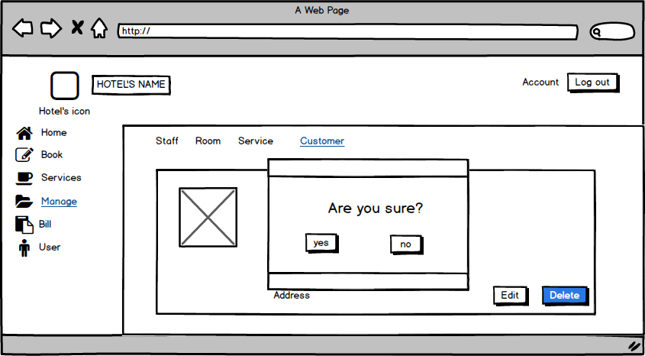

| **Screen** | Edit Customer Screen. | | | | | |
| --- | --- | --- | --- | --- | --- | --- |
| **Description** | | Show the customer information, and the textbox for change. | | | | |
| **Screen Access** | | Click Delete button from Customer View Screen. | | | | |
| **Screen Content** | | | | | | |
| **Item** | | **Type** | **Data** | | **Description** | |
| Image | | Image |  | | Show Image, Edit image | |
| Message box | |  |  | | Show message box | |
| Yes | | Button |  | | To confirm, you want to delete the customer information. | |
| No | | Buton |  | | Exit and return to customer view screen | |
| **Screen Actions** | | | | | | |
| **Action Name** | | **Description** | | **Success** | | **Failure** |
| Click Yes button | | Click on Yes button . | | The customer will delete. The information abou the customer who were delete will not show in customer manage. | | No action. |
| Click No button | | Click on the No button | | Return View Customer Screen. | | No action. |

**+ Bill**

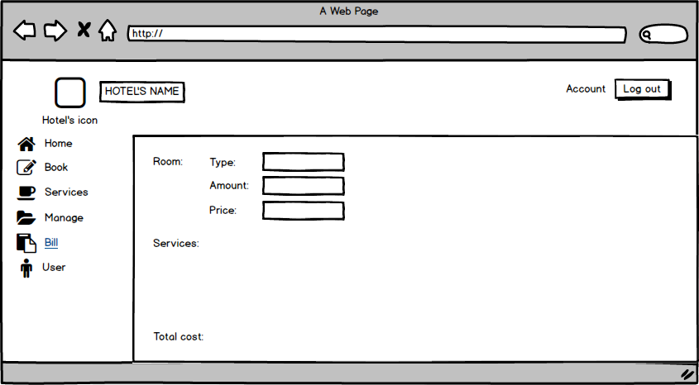

| **Screen** | Bill | | | |
| --- | --- | --- | --- | --- |
| **Description** | | Display information about type, amount, price of room and total cost. | | |
| **Screen Access** | | View information | | |
| **Screen Content** | | | | |
| **Item** | | **Type** | **Data** | **Description** |
| Type (Room) | | Text field | Type of room | * Display information about type of room |
| Amount (Room) | | Number | Number of room | * Display Number of room |
| Price (Room) | | Number | Price | * Display Price |
| Services | | Text field | Service list | * Display Service list |
| Total cost | | Number | Total cost | * Display Total cost |

**+ User**

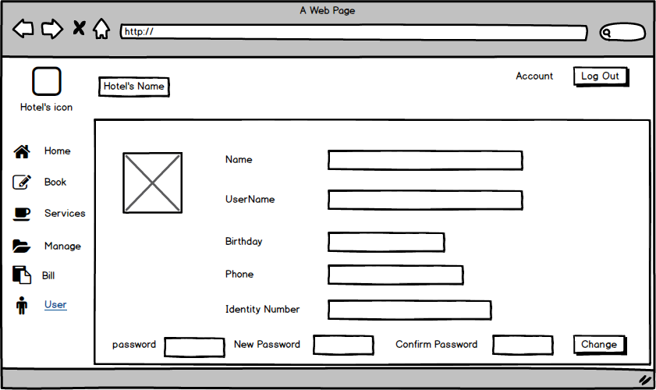

| **Screen** | User | | | |
| --- | --- | --- | --- | --- |
| **Description** | | This will show you : your’s name, your user name, password,Birthday, phone, Identity number. You also can change your password here if you want. | | |
| **Screen Access** | | Click edit item from Book menu | | |
| **Screen Content** | | | | |
| **Item** | | **Type** | **Data** | **Description** |
| name | | Text field | Export from database | * Show your full name |
| User name | | Tex field | Export from database | * Show your user name when you register with OS |
| Birthday | | Tex field | Export from database | * Your birthday will show here. You should be type exactly your birthday to receice gifts from the hotel manage for your birthday. |
| phone | | Tex field | Export from database | * Your cell phone number show here |
| Identity Number | | Tex field | Export from database | * Your identit to confirm yourseft to us. |
| password | | Text box | Insert your current password | * Text box here for you insert your current password. |
| New password | | Text box | Insert text | * New password for your account |
| Confirm password | | Text box | Insert text | * New password for your account. |
| Change | | button |  | * Click it to change your password. |

# **DATA STRUCTURE**

## ***Entity diagram***

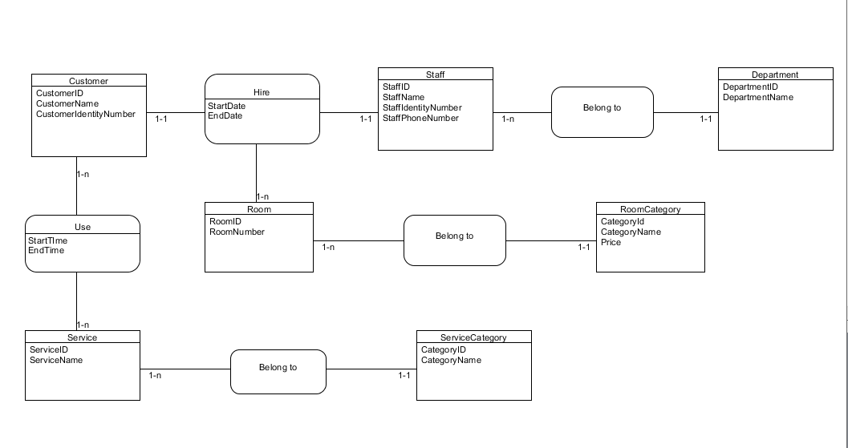

## ***Database***

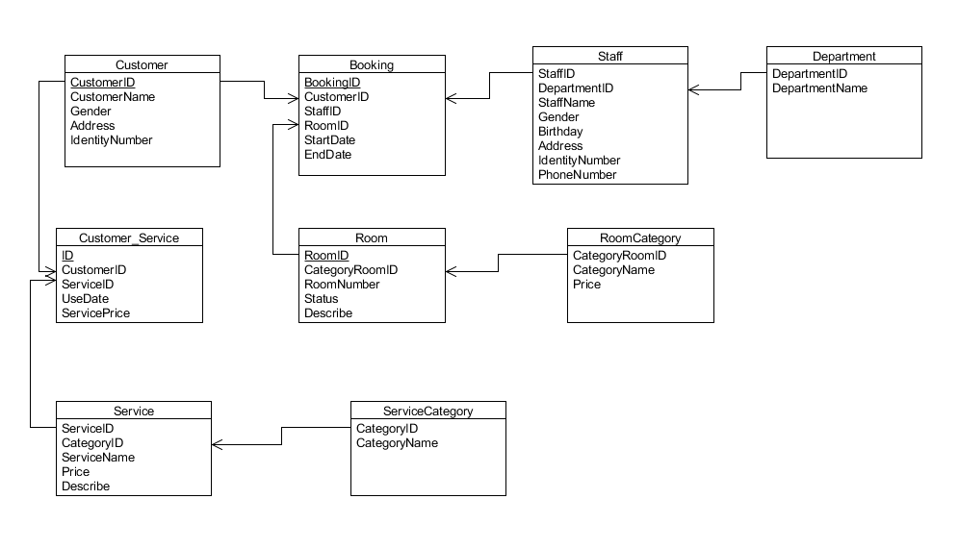

Null = Yes: allow empty value.

Null = No: disallow empty value.

PK: primary key.

FK: foreign key.

Int: 4-byte integer type.

Char: character type.

Money: monetary data types 8 bytes.

DateTime: date data type 8 bytes.

Nvarchar: Unicode data type.

| ROOM | | | | |
| --- | --- | --- | --- | --- |
| Field name | Data type | Null | Key | Note |
| RoomID | Int(4) | No | PK |  |
| CategoryRoomID | Int(4) | No | FK |  |
| Room number | Int(4) | No |  |  |
| Status | Char(1) | No |  | E: empty room  R: reserved room  B: busy room |
| Describe | Nvarchar(70) | Yes |  |  |

| ROOM CATEGORY | | | | |
| --- | --- | --- | --- | --- |
| Field name | Data type | Null | Key | Note |
| CategoryRoomID | Int(4) | No | PK |  |
| CategoryName | Char(8) | No |  |  |
| Price | Money(8) | No |  | Price(VND) |

| SERVICE | | | | |
| --- | --- | --- | --- | --- |
| Field name | Data type | Null | Key | Note |
| ServiceName | Int(4) | No |  |  |
| ServiceID | Int(4) | No | PK |  |
| Price | Float | No |  | Price(VND) |
| Describe | Nvarchar(70) | Yes |  |  |

| SERVICECATEGORY | | | | |
| --- | --- | --- | --- | --- |
| Field name | Data type | Null | Key | Note |
| CategoryID | Int(4) | No | PK |  |
| CategoryName | Varchar(20) | No |  |  |

| STAFF | | | | |
| --- | --- | --- | --- | --- |
| Field name | Data type | Null | Key | Note |
| StaffID | Int(4) | No | PK |  |
| DepartmentID | Int(4) | No | FK |  |
| StaffName | Nvarchar(20) | No |  |  |
| Gender | Char(1) | No |  | O: male  X: female |
| Birthday | DateTime(8) | Yes |  |  |
| Address | Nvarchar(20) | Yes |  |  |
| IdentityNumber | Int(9) | No |  |  |
| PhoneNumber | Int(11) | Yes |  |  |

| DEPARTMENT | | | | |
| --- | --- | --- | --- | --- |
| Field name | Data type | Null | Key | Note |
| DepartmentID | Int(4) | No | PK |  |
| DepartmentName | Nvarchar(20) | No |  |  |

| CUSTOMER | | | | |
| --- | --- | --- | --- | --- |
| Field name | Data type | Null | Key | Note |
| CustomerID | Int(4) | No | PK |  |
| CustomerName | Nvarchar(20) | No |  |  |
| Gender | Char(1) | No |  | O: male  X: female |
| Address | Nvarchar(20) | Yes |  |  |
| IdentityNumber | Int(9) | Yes |  |  |

| BOOKING | | | | |
| --- | --- | --- | --- | --- |
| Field name | Data type | Null | Key | Note |
| BookingID | Int(4) | No | PK |  |
| CustomerID | Int(4) | No | FK |  |
| StaffID | Int(4) | No | FK |  |
| RoomID | Int(4) | No | FK |  |
| StartDate | DateTime(8) | No |  |  |
| EndDate | DateTime(8) | No |  |  |

| CUSTOMER_SERVICE | | | | |
| --- | --- | --- | --- | --- |
| Field name | Data type | Null | Key | Note |
| ID | Int(4) | No | PK |  |
| CustomerID | Int(4) | No | FK |  |
| ServiceID | Int(4) | No | FK |  |
| ServicePrice | Float | No |  |  |

# **NON-FUNCTIONAL REQUIREMENTS AND OTHERS**

Performance

| **No.** | **Requirement** |
| --- | --- |
| 1. | The load time for user interface screens shall take no longer than two seconds. |
| 2. | The log in information shall be verified within five seconds. |
| 3. | Queries shall return results within five seconds. |

Security

| **No.** | **Requirement** |
| --- | --- |
| 1. | Customer Service Representatives and Managers will be able to log in to the Hotel Management System. |
| 2. | Customer Service Representatives will have access to the Reservation/Booking and Food subsystems |
| 3. | Managers will have access to the Management subsystem as well as the Reservation/Booking and Food subsystems |
| 4. | Access to the various subsystems will be protected by a user log in screen that requires a user name and password |

Design Constraints

| **No.** | **Requirement** |
| --- | --- |
| 1. | The Hotel Management System shall be a stand-alone system running in a Windows environment. |
| 2. | The system shall be developed using PHP and an MySQL database. |

Standards Compliance

| **No.** | **Requirement** |
| --- | --- |
| 1. | There shall be consistency in variable names within the system. The graphical user interface shall have a consistent look and feel. |

Reliability

| **No.** | **Requirement** |
| --- | --- |
| 1. | Specify the factors required to establish the required reliability of the software system at time of delivery |

Availability

| **No.** | **Requirement** |
| --- | --- |
| 1. | The system shall be available during normal hotel operating hours. |

Maintainability

| **No.** | **Requirement** |
| --- | --- |
| 1. | The Hotel Management System is being developed in PHP. PHP is an object oriented programming language and shall be easy to maintain. |

Portability

| **No.** | **Requirement** |
| --- | --- |
| 1. | The Hotel Management System shall run in any Microsoft Windows environment that contains the MySQL database |

Hardware

| **Type** | Tower |
| --- | --- |
| **CPU** | 1 x Xeon E3-1225v3 (3.2Ghz-1600Mhz-8Mb) |
| **Max CPU** | 1 |
| **RAM** | 4Gb 4 x UDIMM, 1600 MT/s Slots |
| **Disk** | 1Tb |
| **NIC** | Ethernet Gigabit |
| **Slot** | 4 x PCIe slots |
| **Power** | 290W |
| **Max power supply** | 1 |

# 