**EMPLOYEE LEAVE MANAGEMENT SYSTEM**

**DOCUMENTATION BACKEND**

* **Description:**

The Leave Management System provides users with an interface through which they can request leave directly from the portal, eliminating the need for any manual intervention by human personnel.

This application can be used from University to the IT Companies to get with best user experience.

* **Software/ Packages used:**
* Backend Packages

1. Express
2. Nodemon
3. Mongoose
4. Cors
5. Dotenv
6. Jsonwebtoken
7. Bcrypt

* **Directory Structure:**

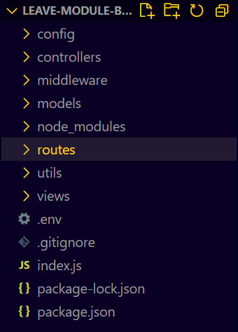

* **Endpoint - Login and Forgot Password Backend Implementation:**
* The initial Login details are given to the Employee from the Organization (Admin creates users from authorized dashboard), where we give them access to use the portal and can change their password.
* So, for more secure to their password we implemented the encryption and decryption to their password using the package called bcrypt. We can install this by using command “npm install bcrypt” in the terminal.
* For their retrieval of data, we send a JWT Token when they login. So, whenever they access any Endpoint from user interface, we decode the JWT Token and verify the user.
* Login Requirements:

1. User EmpId.
2. Password.

* To access JWT packages we need to install it from terminal using command “npm install jsonwebtoken”.