**Contents**

High level architecture

Software Architecture

Entity Relationship Diagram

Use Case Diagram

Architecture Views

Logical View

State Diagram: Verification status

Development View

Component Diagram

Process View

Activity Diagram: Log in

Activity Diagram: Admin Registration

Activity Diagram: Client Registration

Activity Diagram: Client - Add account

Activity Diagram: Client - Make payment

Activity Diagram: Client - Make transfer

Activity Diagram: Admin - View verification list

Activity Diagram: Admin - View client details

Sequence Diagram: Log in

Physical View

Deployment Diagram

## 

## 

## 

## 

## 

# High level architecture

## Software Architecture

The following are the platforms involved in our software development process:

* Flutter and Dart
* MySQL
* Biz.nf

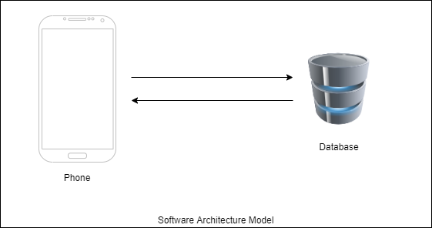

## 

## Entity Relationship Diagram

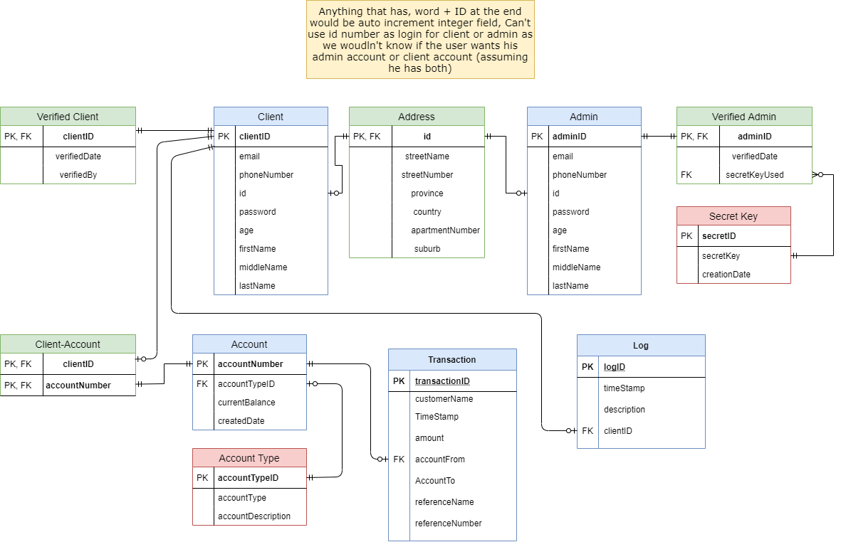

## Use Case Diagram

### 

# Architecture Views

## Logical View

### State Diagram: Verification status

This diagram shows the change in the behaviour of the verification status of the client and the processes that would lead to a change in status. This is the only attribute that changes state in our system, hence this is the only state machine diagram.

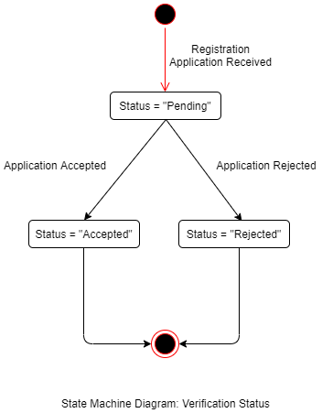

## Development View

### Component Diagram

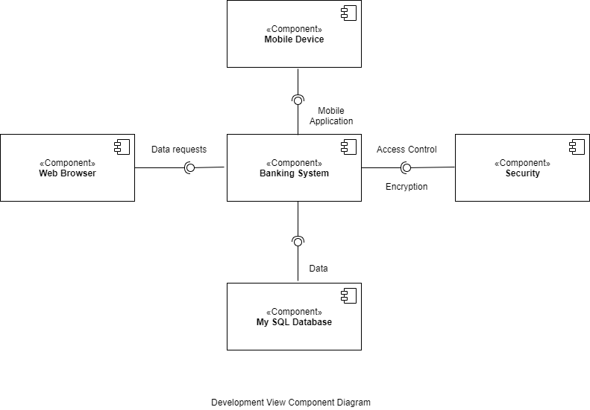

## Process View

Activity diagrams are a visual representation of a series of actions or flow of control.

### Activity Diagram: Log in

This diagram shows the login process of a user.

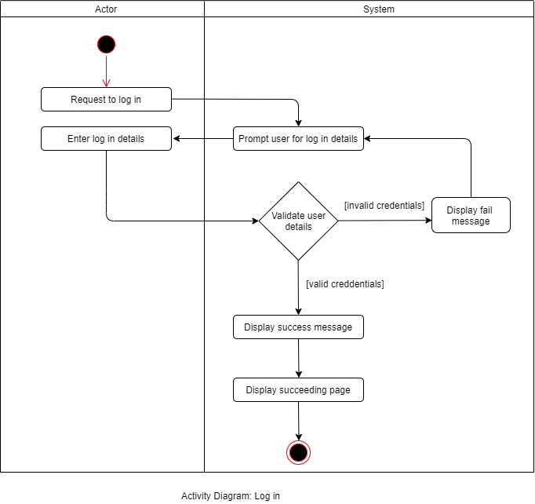

### Activity Diagram: Admin Registration

This diagram shows the registration process of an admin.

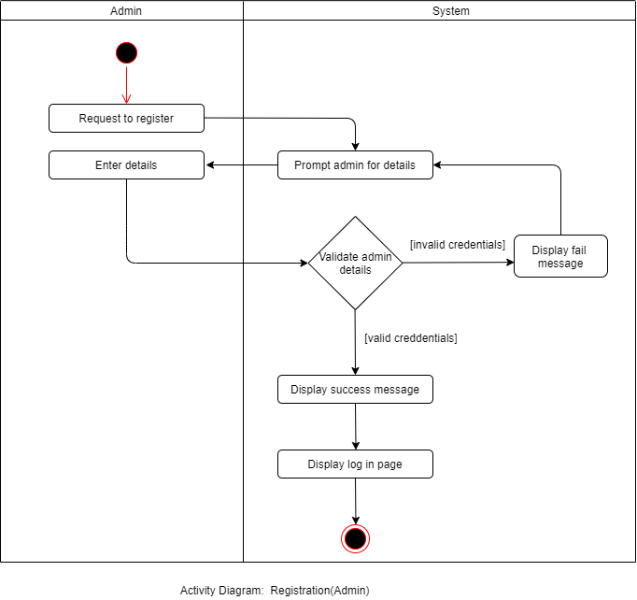

### 

### 

### Activity Diagram: Client Registration

This diagram shows the registration process of a client.

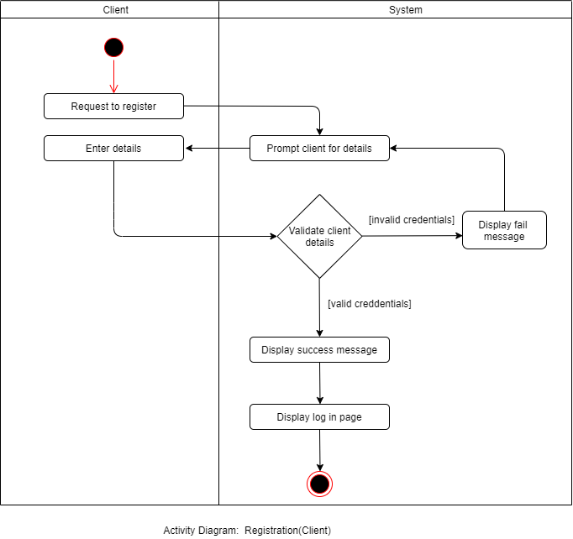

### 

### Activity Diagram: Client - Add account

This diagram shows the process taken when a client is creating an account.

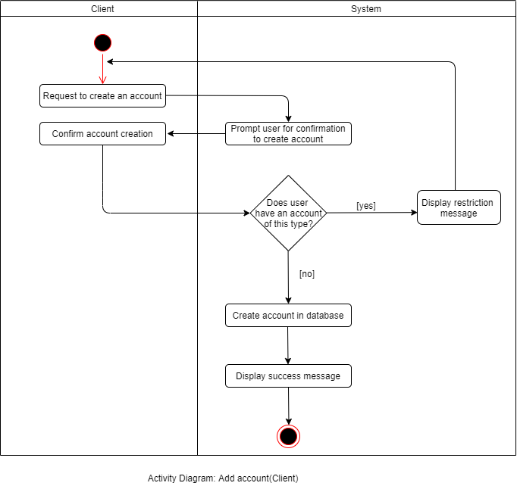

### 

### 

### 

### Activity Diagram: Client - Make payment

This diagram shows the process that is taken when a client is making a payment.

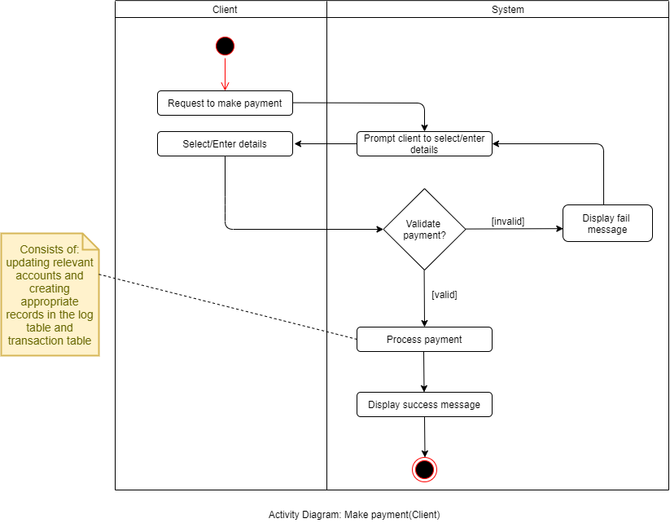

### Activity Diagram: Client - Make transfer

This diagram shows the process that is taken when a client is making a transfer.

### 

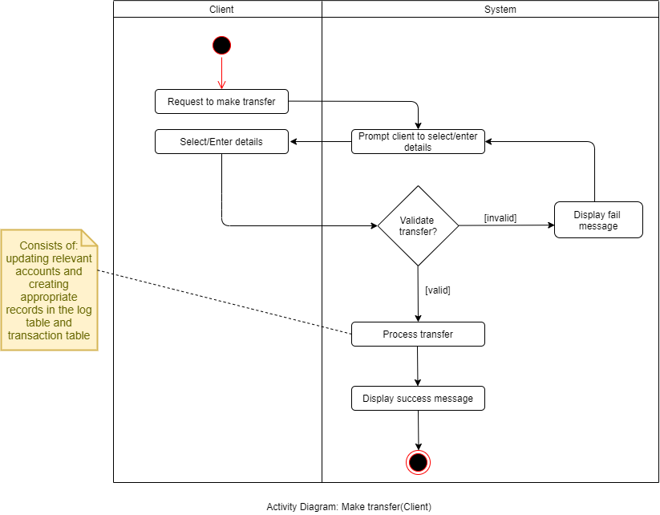

### Activity Diagram: Admin - View verification list

This diagram shows the process of an admin viewing the verification list.

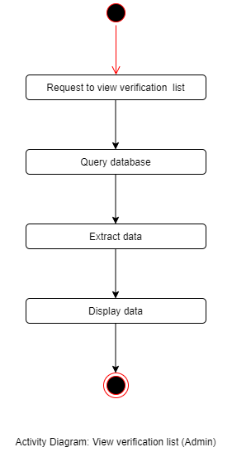

### 

### 

### 

### Activity Diagram: Admin - View client details

This diagram shows the process of an admin requesting to view a client’s details.

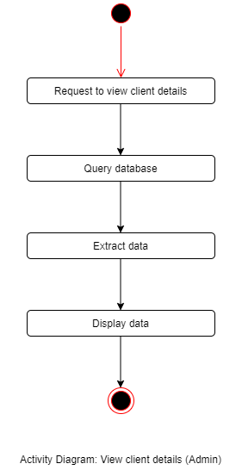

### 

### 

### Sequence Diagram: Log in

This diagram shows the login process of a user.

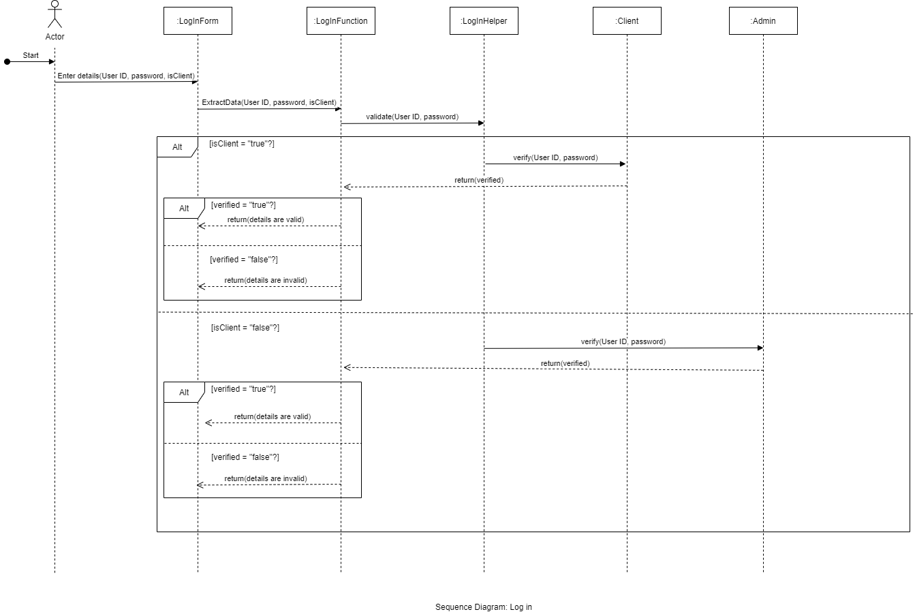

## Physical View

### Deployment Diagram

