Corpus
A corpus is a large and structured set of machine-readable texts that have been produced in a natural communicative setting. Its plural is corpora. They can be derived in different ways like text that was originally electronic, transcripts of spoken language and optical character recognition, etc.
A corpus is an essential tool for Natural Language Processing (NLP), serving as a fundamental resource. A corpus is a significant, organized collection of text or audio data that often includes a wide range of documents, texts, or voices in one or more specific languages.
WSD
We understand that words have different meanings based on the context of its usage in the sentence. If we talk about human languages, then they are ambiguous too because many words can be interpreted in multiple ways depending upon the context of their occurrence.
Word sense disambiguation, in natural language processing (NLP), may be defined as the ability to determine which meaning of word is activated by the use of word in a particular context. Lexical ambiguity, syntactic or semantic, is one of the very first problem that any NLP system faces. Part-of-speech (POS) taggers with high level of accuracy can solve Word’s syntactic ambiguity. On the other hand, the problem of resolving semantic ambiguity is called WSD (word sense disambiguation). Resolving semantic ambiguity is harder than resolving syntactic ambiguity.
For example, consider the two examples of the distinct sense that exist for the word “bass” −
- I can hear bass sound.
- He likes to eat grilled bass.
The occurrence of the word bass clearly denotes the distinct meaning. In first sentence, it means frequency and in second, it means fish. Hence, if it would be disambiguated by WSD then the correct meaning to the above sentences can be assigned as follows −
- I can hear bass/frequency sound.
- He likes to eat grilled bass/fish.

Evaluation of WSD
The evaluation of WSD requires the following two inputs −

A Dictionary
The very first input for evaluation of WSD is dictionary, which is used to specify the senses to be disambiguated.

Test Corpus
Another input required by WSD is the high-annotated test corpus that has the target or correct-senses. The test corpora can be of two types &minsu;
- Lexical sample − This kind of corpora is used in the system, where it is required to disambiguate a small sample of words.
- All-words − This kind of corpora is used in the system, where it is expected to disambiguate all the words in a piece of running text.

Approaches and Methods to Word Sense Disambiguation (WSD)
Approaches and methods to WSD are classified according to the source of knowledge used in word disambiguation.
Let us now see the four conventional methods to WSD −

Dictionary-based or Knowledge-based Methods
As the name suggests, for disambiguation, these methods primarily rely on dictionaries, treasures and lexical knowledge base. They do not use corpora evidences for disambiguation. The Lesk method is the seminal dictionary-based method introduced by Michael Lesk in 1986. The Lesk definition, on which the Lesk algorithm is based is “measure overlap between sense definitions for all words in context”. However, in 2000, Kilgarriff and Rosensweig gave the simplified Lesk definition as “measure overlap between sense definitions of word and current context”, which further means identify the correct sense for one word at a time. Here the current context is the set of words in surrounding sentence or paragraph.

Text1 = 'I went to the bank to deposit my money'
Text2 = 'The river bank was full of dead fishes'

The Lesk algorithm is the seminal dictionary-based method.

This is the definition from Wikipedia: "It is based on the hypothesis that words used together in text are related to each other and that the relation can be observed in the definitions of the words and their senses. Two (or more) words are disambiguated by finding the pair of dictionary senses with the greatest word overlap in their dictionary definitions. It searches for the shortest path between two words: the second word is iteratively searched among the definitions of every semantic variant of the first word, then among the definitions of every semantic variant of each word in the previous definitions and so on.Finally, the first word is disambiguated by selecting the semantic variant which minimizes the distance from the first to the second word."

Basically, the context is chosen from meaning of the nearest words. Following is the simplified pictorial representation of the same...

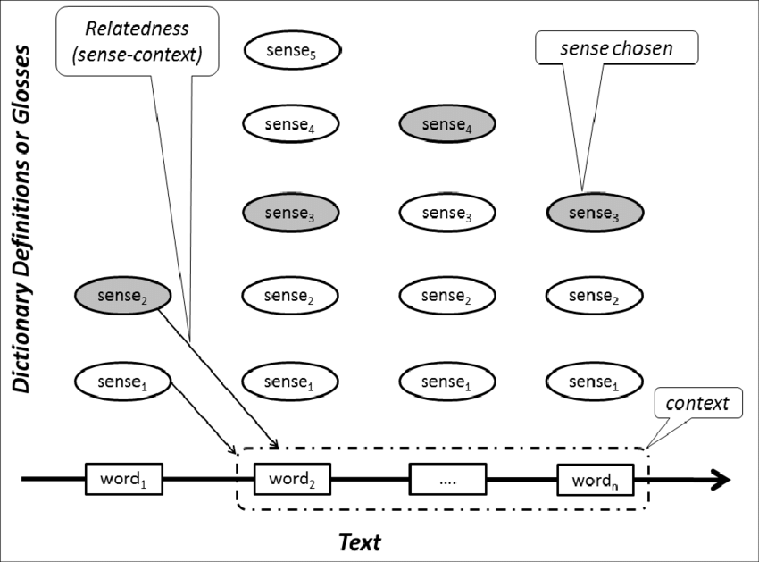
Refer the ppt chapter18.wsd.ppt

Supervised Methods
For disambiguation, machine learning methods make use of sense-annotated corpora to train. These methods assume that the context can provide enough evidence on its own to disambiguate the sense. In these methods, the words knowledge and reasoning are deemed unnecessary. The context is represented as a set of “features” of the words. It includes the information about the surrounding words also. Support vector machine and memory-based learning are the most successful supervised learning approaches to WSD. These methods rely on substantial amount of manually sense-tagged corpora, which is very expensive to create.
----Refer the ppt chapter18.wsd.ppt

Semi-supervised Methods
Due to the lack of training corpus, most of the word sense disambiguation algorithms use semi-supervised learning methods. It is because semi-supervised methods use both labelled as well as unlabeled data. These methods require very small amount of annotated text and large amount of plain unannotated text. The technique that is used by semi-supervised methods is bootstrapping from seed data.
Bootstrapping Algorithms:
While there is great variation between implementations, bootstrapping approaches in natural language processing all follow the same general format:
  - Start with an empty list of things.
2. Initialize this list with carefully chosen seeds.
3. Leverage the things in the list to find more things from a training corpus.
4. Score those newly found things; add the best ones to the list.
5. Repeat from step 3.
Stop after a set number of iterations or some other stop condition. The intuition for bootstrapping stems from the observation that words from the semantic category tend to appear in similar patterns and similar contexts. For example, the words “water” and “soda” are both in the semantic BEVERAGE category, and in a large text they will likely both be found in phrases containing drank or imbibed. The core intuition is that by searching for patterns like that we can find other BEVERAGEs, and then by finding patterns that contain those, we can find even more. The core feature of a bootstrapping algorithm is that each iteration is fed the same type of data as its input that it produces as its output. The output of the first iteration is used as the input of the second iteration, and so on. It should not be surprising that choosing the initial set of data (the seeds) from which all other data is “grown” is a critical factor (arguably the most critical factor) in the performance of the algorithm.

Unsupervised Methods
These methods assume that similar senses occur in similar context. That is why the senses can be induced from text by clustering word occurrences by using some measure of similarity of the context. This task is called word sense induction or discrimination. Unsupervised methods have great potential to overcome the knowledge acquisition bottleneck due to non-dependency on manual efforts.

Unsupervised methods overcome the problem of knowledge acquisition bottleneck. The performance of unsupervised method is always been lower than that of the other method used for disambiguation. Different methods in unsupervised approach are word clustering method in which words are clustered according to the semantic similarity based on single feature (e.g., subject-verb, adjective-noun, etc.) i.e. they are similar to that of target word. In another context clustering method the clusters are formed by finding the co-occurrence of word (not target) with the target word and then the centroid is calculated of the vector of words occurring in the same context. In another method called graph based method in which a graph is built on some grammatical relationship, in graph weights are assign to the edge according to the relatedness. An iterative algorithm is applied to get the word with highest degree node and finally minimum spanning tree is applied to disambiguate instance of target word. Problems with Unsupervised Approach are the instances in training data may not be assigned the correct sense. Clusters are heterogeneous. Number of cluster may differ from the number of senses of target word to be disambiguated.

Applications of Word Sense Disambiguation (WSD)
Word sense disambiguation (WSD) is applied in almost every application of language technology.
Let us now see the scope of WSD −

Machine Translation
Machine translation or MT is the most obvious application of WSD. In MT, Lexical choice for the words that have distinct translations for different senses, is done by WSD. The senses in MT are represented as words in the target language. Most of the machine translation systems do not use explicit WSD module.

Information Retrieval (IR)
Information retrieval (IR) may be defined as a software program that deals with the organization, storage, retrieval and evaluation of information from document repositories particularly textual information. The system basically assists users in finding the information they required but it does not explicitly return the answers of the questions. WSD is used to resolve the ambiguities of the queries provided to IR system. As like MT, current IR systems do not explicitly use WSD module and they rely on the concept that user would type enough context in the query to only retrieve relevant documents.

Text Mining and Information Extraction (IE)
In most of the applications, WSD is necessary to do accurate analysis of text. For example, WSD helps intelligent gathering system to do flagging of the correct words. For example, medical intelligent system might need flagging of “illegal drugs” rather than “medical drugs”

Lexicography
WSD and lexicography can work together in loop because modern lexicography is corpus based. With lexicography, WSD provides rough empirical sense groupings as well as statistically significant contextual indicators of sense.

Difficulties in Word Sense Disambiguation (WSD)
Followings are some difficulties faced by word sense disambiguation (WSD) −

Differences between dictionaries
The major problem of WSD is to decide the sense of the word because different senses can be very closely related. Even different dictionaries and thesauruses can provide different divisions of words into senses.

Different algorithms for different applications
Another problem of WSD is that completely different algorithm might be needed for different applications. For example, in machine translation, it takes the form of target word selection; and in information retrieval, a sense inventory is not required.

Inter-judge variance
Another problem of WSD is that WSD systems are generally tested by having their results on a task compared against the task of human beings. This is called the problem of interjudge variance.

Word-sense discreteness
Another difficulty in WSD is that words cannot be easily divided into discrete sub meanings.

