D3COY 1.0 · DJS ISACA · PROBLEM STATEMENT PS-02
MIRAGE
Deepfake-enabled social engineering: detection, explanation and response

A complete project report: the problem and its scale, what existing solutions miss, our approach, the full technical design, the product and its impact, measured results, and the business case.
5  independent witnesses | AUC 0.98  AI-image ensemble | 40 / 42  laundered voice attacks caught | 32 / 32  demo inputs correct

Team Outliers, Dwarkadas J. Sanghvi College of Engineering (DJSCE)
Repository: github.com/SDP42/isacaps2 · Report date: 1 November 2026

Contents
Executive summary
1. The problem
1.1 What changed
1.2 What we identify as the real problem
1.3 Who faces it
1.4 The scale
1.5 How the attack works
2. Current solutions and the gap
2.1 Standalone deepfake detectors
2.2 Voice and call anti-fraud
2.3 Email security and anti-phishing
2.4 Provenance and watermarking
2.5 Bank transaction monitoring
2.6 Government reporting channels
2.7 Awareness training
2.8 The comparison
3. Our approach
3.1 The core idea
3.2 How we differentiate
3.3 Feasibility
4. Technical design in depth
4.1 Technology stack: what, why, and from where
4.2 System architecture
4.3 How one case flows
4.4 Detection stack
4.5 The risk engine
4.6 Explainability
4.7 From verdict to response
4.8 Red-team lab: thinking like the attacker
4.9 Where MIRAGE meets the user
4.10 Security and privacy
4.11 Technically beyond existing solutions
5. Product and impact
5.1 Who uses it, and how
5.2 The product, as built
5.3 Impact
6. The numbers: accuracy and transparency
6.1 Benchmarks
6.2 Red-team robustness
6.3 Noise study: which models to trust in noise
6.4 Lip-sync, provenance and liveness
6.5 What is still weak
7. Business case
7.1 Sectors and how MIRAGE helps
7.2 Business model
7.3 Why now, and the path to market
8. Conclusion and roadmap
References

If the page numbers above are blank, right-click the table and choose Update Field (Word fills them in on opening).

Executive summary
Generative AI has made it cheap to sound like your CFO, look like a police officer on a video call, or write a bank's notice in perfect Hinglish. The fraud that follows is not a technology problem first: it is social engineering, a request to pay, share a code or install something, made believable by synthetic media. Detection that relies on spelling mistakes or visual glitches no longer works, and a detector score on its own does not tell anyone what to do.
MIRAGE answers a different question from most tools. Not "is this fake?" but "is it safe to act on this request, and what should I do now?" Five independent witnesses examine the evidence (voice, face, image provenance, the words and the identity context), a request-aware risk engine fuses them with policy rules that an uncertain detector can never override, an AI Tribunal explains the verdict with cited evidence, and a Cure Console walks the victim through containment, verification, recovery, reporting and prevention.
KEY RESULTS (ALL MEASURED BY US, ON PUBLIC OR SELF-GENERATED SAMPLES)
- Synthetic speech: AUC 1.00 on real vs deepfake speech (n = 80); 10/10 text-to-speech clones caught.
- AI-generated images (Flux, DALL-E 3, SDXL, Midjourney vs real photos): ensemble AUC 0.982, 94.3% accuracy (n = 105).
- Face swaps: AUC 0.917 on FaceForensics++ / Celeb-DF; 0.71 on in-the-wild OpenForensics (our weakest area, stated openly).
- Indian scam SMS: Words witness AUC 0.944 (n = 120).
- Red-team: 40/42 laundered voice attacks and 15/15 image attacks caught; both misses were heavy street noise.
- Noise study (n = 90 clips): DF_Arena alone keeps AUC 0.961 at 5 dB street noise, while the two-model ensemble falls to 0.938.
- Lip-sync (SyncNet): filmed speech 6.8–8.1 confidence vs swapped audio 0.5–1.4 (n = 12).
- 32/32 demo inputs return the expected verdict; 26 automated tests pass.

The rest of this report follows the order in which the project was reasoned out: first the problem and who it hurts, then why current solutions leave a gap, then our approach and why it is feasible, then the technical design in depth, then the product and its impact, then the numbers, and finally the business case. Each in-depth section ends with a summary panel that states the gap and what MIRAGE fills.

1. The problem

1.1 What changed
Until recently, social engineering had tells: a robotic voice, a bad photograph, a message full of errors. Three developments removed them. Voice cloning now needs only seconds of public audio (a reel, a webinar, a voice note) to produce a convincing voice, including in Indian languages. Face swapping and avatar video let an attacker appear as someone else on a live video call through a virtual camera. Large language models write fluent, personalised pretexts in English, Hindi or Hinglish at no cost. Together they turn impersonation from a skilled craft into a commodity.
Official bodies have noticed. CERT-In has issued advisories on deepfake threats, and a Gartner survey cited in the PS-02 problem statement found that 41% of CISOs had seen at least one deepfake social-engineering incident on an employee audio call in the previous twelve months.

1.2 What we identify as the real problem
The problem statement names deepfakes, but the harm comes from the request that the deepfake carries. We therefore reframed the problem into three observations that shaped every design decision:
- A familiar voice or face is no longer proof of identity. Humans cannot reliably tell a good clone from the real person, and they should not be asked to.
- A genuine voice can carry a scam, and a fake one can be harmless. A compromised colleague's real account can ask to pay a new vendor; a company's AI avatar can read a harmless townhall announcement. A tool that only asks "is it fake?" gets both wrong.
- Detection without a next step does not protect anyone. The victim needs to know, within a minute, what to say, whom to call back and, if money already moved, how to use the golden hour before it is laundered.

Real examples
Case | What happened | What it teaches
UK energy firm (2019) | A cloned CEO voice instructed an urgent transfer; about EUR 220,000 was wired to a fraudster's account. | Voice alone was enough; there was no independent callback.
Arup, Hong Kong (2024) | An employee joined a video meeting with a deepfaked CFO and colleagues and made transfers totalling about US$25.6 million. | Multi-person deepfake video defeats "I saw them on camera".
MGM Resorts (2023) | A breach began with a convincing call to the IT help desk. | The request (reset, OTP) matters more than the medium.
"Digital arrest" (India, 2024) | Fraudsters posing as police or CBI officers on video calls kept victims under "arrest" until they paid. Losses were reported at about Rs 1,935 crore in 2024 (MHA / I4C). | Authority + fear + secrecy, delivered over video.
"Papa, accident" voice notes | A cloned family voice from a new number asks for money on UPI and says not to tell anyone. | Families need a plain answer and one button: call the real person.

1.3 Who faces it
Who | How they are targeted | What they need
Finance and accounts-payable staff | Executive voice notes, vendor bank-change emails, deepfake meetings asking for urgent transfers | A check before paying, a callback on the directory number, dual approval
IT help desks | Calls asking for resets, OTPs or remote access | A hard rule: credentials are never given on an inbound request
Families and the elderly | Emergency voice notes, digital-arrest video calls, investment lures | One plain answer, one next step, help if money already moved
Security teams (SOC) | Campaigns that hop across email, WhatsApp, phone and video | Correlated cases, evidence, reports, measured detectors
Banks and payment providers | Mule accounts and new UPI IDs at the cash-out stage | Flagged beneficiaries, fast recall requests
Public figures and brands | Their face and voice reused in fake endorsements | Provenance checks and takedown evidence

1.4 The scale
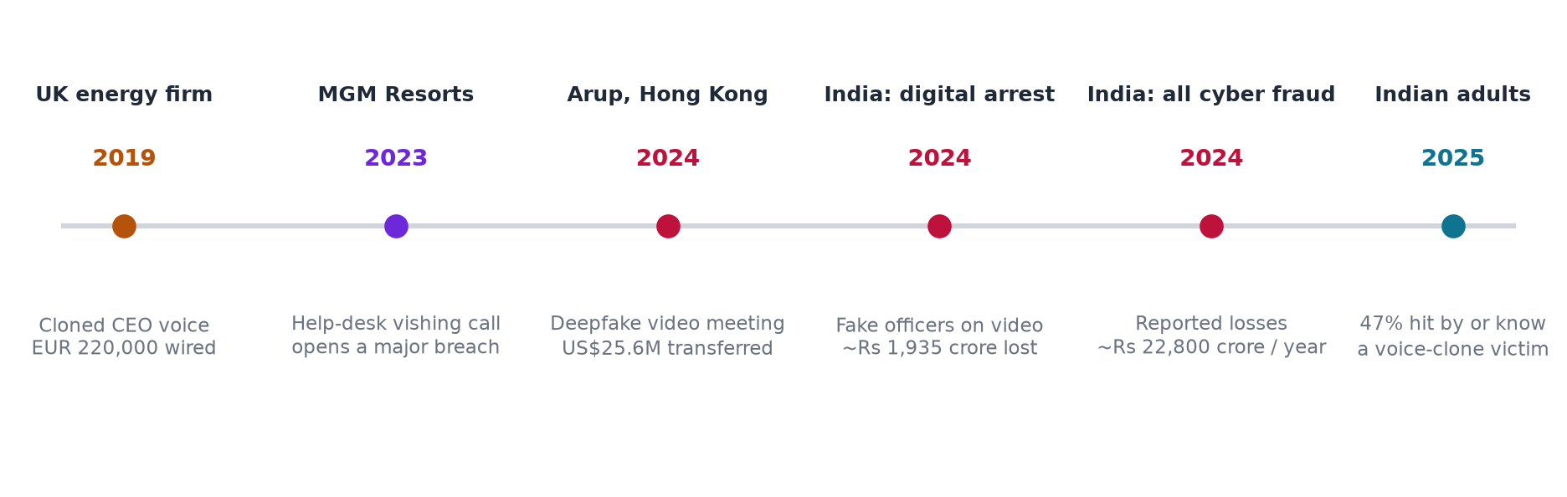
Figure 1. Landmark incidents and indicators, 2019–2025 (sources in the references).
Indicator | Figure | Source
Cyber-fraud losses reported in India | About Rs 22,800 crore in 2024 | Government statements in Parliament, as reported by Moneylife
"Digital arrest" losses, India | About Rs 1,935 crore in 2024 | MHA / I4C, as reported by Inc42
Business email compromise losses (US reports) | About US$2.9 billion in 2023 | FBI IC3 annual report
Indian adults affected by voice-clone scams | 47% hit by, or know someone hit by, one | ORF survey, 2025
Largest single deepfake-meeting loss | About US$25.6 million (Arup) | Fortune, May 2024
CISOs reporting a deepfake audio incident | 41% in the previous 12 months | Gartner survey cited in PS-02

1.5 How the attack works
To build the antidote we modelled the attacker. Every deepfake scam we studied follows the same seven-stage kill chain, and each stage is a place where a defence can break it.
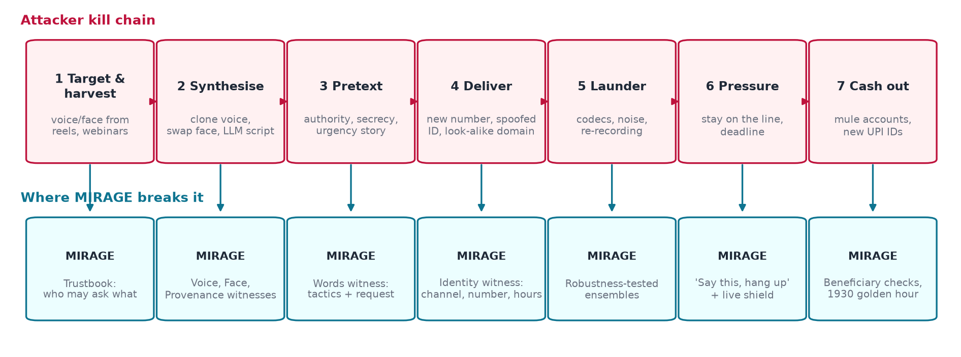
Figure 2. The attacker kill chain (top) and the MIRAGE control that breaks each stage (bottom).
Two stages deserve emphasis because they are where purely technical detectors fail. At stage 5 (launder) attackers push media through phone codecs, WhatsApp compression, room playback and background noise, all of which erase the artefacts detectors depend on. At stage 6 (pressure) the victim is kept on the line and told not to tell anyone, so the decisive moment is seconds long and the victim needs an instruction, not a probability.
SECTION SUMMARY: WHERE THE GAP IS, AND WHAT MIRAGE FILLS
- The problem is social engineering made believable by synthetic media, not deepfakes in isolation.
- It hits finance staff, help desks, families, SOCs and banks, across voice, video, images, email and chat, in Indian languages.
- Losses are large and rising (Rs 22,800 crore of reported cyber fraud in India in 2024; US$25.6 million in a single deepfake meeting).
- A useful answer must judge the request and the context, survive laundering, and end in an action the victim can take in the next minute.

2. Current solutions and the gap
We grouped existing defences into seven categories and studied each the same way: what it does, where it stops, and the technical reason it stops there. The comparison matrix at the end of the section brings them together.

2.1 Standalone deepfake detectors
What it does. Classifiers that score an uploaded audio clip, image or video as real or synthetic.
Examples. Commercial detection platforms and APIs, academic detectors (AASIST, wav2vec2-based anti-spoofing, CLIP-based image detectors), browser upload checkers.
Where it falls short.
- A single score per file, with no notion of what is being asked or who is supposedly asking.
- Accuracy drops sharply under laundering (codecs, noise, re-recording) and on generators released after training.
- One model per modality, rarely an ensemble, and model disagreement is hidden from the user.
- No guidance after the score: the user is left to interpret 0.73.
Technical root cause. Trained to separate real from fake on benchmark distributions; their operating thresholds are not recalibrated for the deployment channel, and they have no access to identity or request context.

2.2 Voice and call anti-fraud
What it does. Phone-channel analytics for call centres: caller-ID reputation, device and network signals, some liveness and synthetic-voice scoring.
Examples. Enterprise call-centre authentication products, telecom spam labelling, caller-ID apps.
Where it falls short.
- Built for inbound calls to a company, not for a WhatsApp voice note to an employee or a parent.
- Little or no text, image or video analysis; the scam that starts by email and ends on a call is invisible.
- Rarely available to individuals in India at the moment they need it.
Technical root cause. Signals are tied to the telephony network (SIP headers, carrier data), so they do not transfer to over-the-top apps where most Indian scams arrive.

2.3 Email security and anti-phishing
What it does. Secure email gateways and AI phishing filters: sender authentication (SPF, DKIM, DMARC), URL and attachment scanning, behavioural anomaly models.
Examples. Enterprise email security suites and cloud mail filters.
Where it falls short.
- Email only: the same mule account arriving next on WhatsApp and then on a video call is a different, unseen case.
- Synthetic media inside the message (an AI headshot, an attached voice note) is not analysed for authenticity.
- Explanations are short labels; there is no verification plan.
Technical root cause. Pipelines are optimised for message headers and links at mail-flow scale, not for multimodal forensics or cross-channel correlation.

2.4 Provenance and watermarking
What it does. Content Credentials (C2PA) signed manifests and invisible watermarks embedded by generators.
Examples. C2PA-enabled cameras and editing tools, generator watermarks.
Where it falls short.
- Only works when the honest party signed or the generator cooperated; attackers simply strip or never add credentials.
- Most real images have no credentials, so absence proves nothing.
- Re-encoding, screenshots and messaging apps often remove metadata.
Technical root cause. A provenance signal is opt-in by design; it is valuable evidence when present and valid, but it cannot be the detector.

2.5 Bank transaction monitoring
What it does. Rule and model-based monitoring of payments, mule-account detection, cooling periods on new beneficiaries.
Examples. Bank fraud engines, NPCI and UPI risk controls.
Where it falls short.
- Acts at the cash-out stage, after the victim has been persuaded.
- Sees the transfer, not the voice note or video that caused it, so it cannot explain the deception to the customer.
- Inconsistent across banks; the customer rarely gets a reason.
Technical root cause. The data available to the payment system is the transaction, not the persuasion; intervention without context generates friction and false alarms.

2.6 Government reporting channels
What it does. National helpline 1930, cybercrime.gov.in complaints, Sanchar Saathi / Chakshu reporting of fraud numbers, CERT-In advisories.
Examples. Indian Cyber Crime Coordination Centre (I4C) services.
Where it falls short.
- Reactive: they start after the victim realises they were cheated.
- Victims often do not know which channel to use, what evidence to keep, or that the first hour matters.
- No detection or explanation of the specific item the victim received.
Technical root cause. They are reporting and recovery rails, not analysis tools; their value depends on how fast and how well the victim reaches them.

2.7 Awareness training
What it does. Security-awareness courses and simulated phishing for employees.
Examples. Enterprise training platforms, public awareness campaigns.
Where it falls short.
- Teaches people to spot fakes, which research shows they cannot do reliably for good clones.
- Rarely includes voice or video deepfakes or Indian-language pretexts.
- Measures clicks, not whether people verify before acting.
Technical root cause. Training changes behaviour slowly and is not present at the moment of the attack.

2.8 The comparison
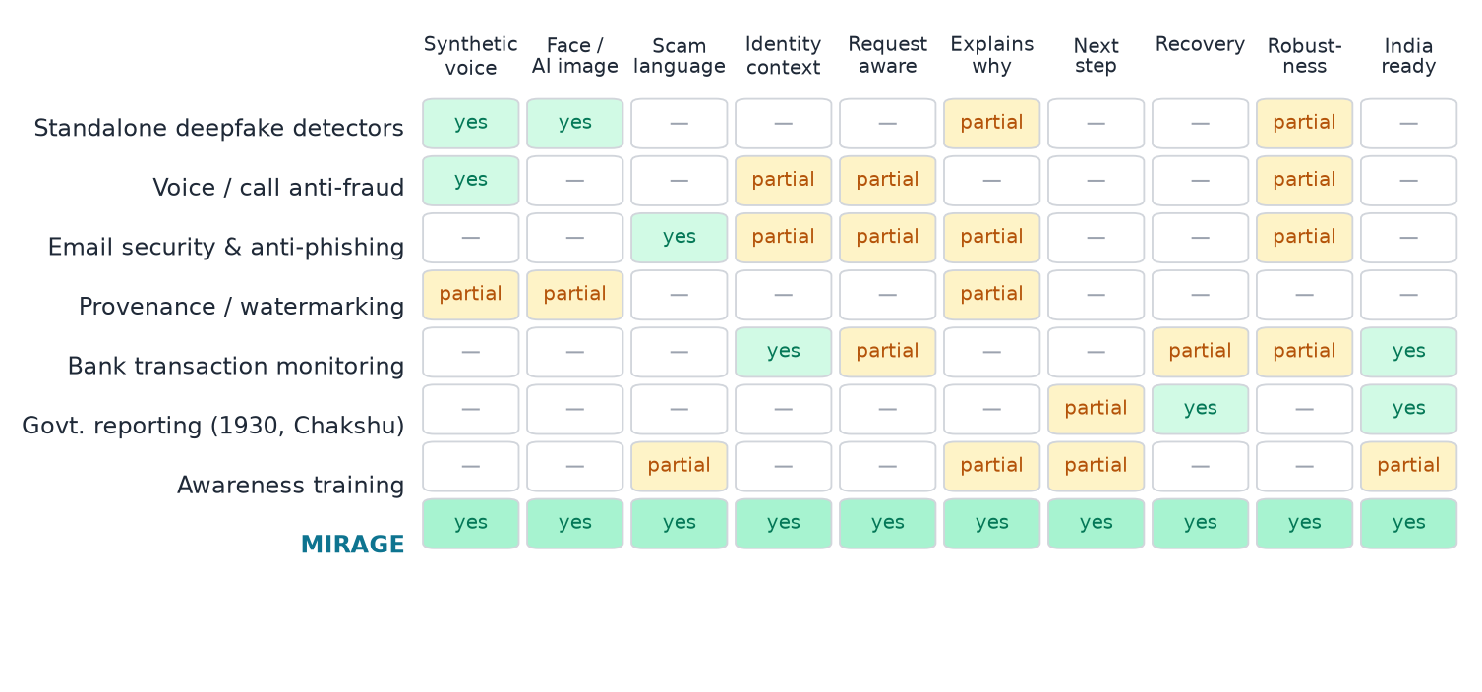
Figure 3. Capability comparison by category ("partial" means the capability exists only for some channels or cases).
SECTION SUMMARY: WHERE THE GAP IS, AND WHAT MIRAGE FILLS
Taken together, existing solutions leave five gaps that no single category closes:
- Context gap: detectors judge media; nobody judges the request against who is asking, on which channel, for how much.
- Channel gap: email, phone, chat and video are protected (if at all) by different products that do not share evidence.
- Robustness gap: laundering through codecs and noise defeats single detectors, and few vendors publish measured robustness.
- Explanation gap: a score without cited evidence cannot be trusted by a finance clerk or defended in a complaint.
- Response gap: detection ends at a label; the victim still has to work out what to do, and the golden hour is lost.
MIRAGE was designed to close all five in one pipeline, which section 3 explains.

3. Our approach

3.1 The core idea
MIRAGE treats every suspicious item like a case in court. Five witnesses each examine one kind of evidence and testify with a score, a confidence and cited exhibits (seconds of audio, words, frames, image regions). A request-aware risk engine weighs the testimony against what is being asked, applying hard policy rules first. An AI Tribunal argues the case, including a Skeptic who argues the innocent explanation. The verdict always ends in a plan: what to say, whom to call back, and what to do if money already moved.
Witness | Question it answers | Main evidence
Voice | Is this speech machine-generated? Does it match the enrolled voice of the claimed person? | Anti-spoofing ensemble per 4-second window, WavLM voiceprint, noise and codec profile
Face | Is the face swapped or generated? Do the lips follow the voice? | Face tracking, deepfake-face ensemble per crop, SyncNet lip-sync, AI-frame check
Provenance | Was this image generated or edited? Are its content credentials valid? | AI-image ensemble, error-level analysis, EXIF, C2PA validation, generator metadata
Words | Is this a scam script? What does it ask for, and with which pressure tactics? | Multilingual classifiers, tactic spans, requested action, amount, UPI, IFSC, deadline
Identity | Does the claim fit what we know about this person? | Trustbook: usual channels, hours, approval limits, known beneficiaries, request anomaly

3.2 How we differentiate
Gap in existing solutions | How MIRAGE closes it
Context gap | Risk is computed from authenticity × sensitivity, manipulation × sensitivity and identity context; policy rules mean an uncertain detector can never downgrade a credential or unverified money request.
Channel gap | One case can hold a voice note, a video, screenshots, an email and a message; cases that share a number, account or UPI ID are linked into cross-channel campaigns.
Robustness gap | Pretrained ensembles chosen by measurement, a red-team lab that launders attacks the way scammers do, and a noise study that decides which models to trust in noise.
Explanation gap | Every claim cites an exhibit; a model jury shows each detector's vote; exact Shapley values show how the score was built; the Tribunal includes a Skeptic.
Response gap | "What now" on every result, and a Cure Console with an exposure meter, a golden-hour clock, pre-filled complaints and an evidence pack.
Fake ≠ fraud | A harmless AI announcement stays LOW with a "synthetic" tag; too little evidence is INCONCLUSIVE rather than a guess.

3.3 Feasibility
Going beyond existing solutions is feasible because MIRAGE does not need a research lab or new training data:
- No training. Detection uses published pretrained models, calibrated on public samples by recentring each model on its measured threshold and averaging in logit space. MIRAGE's own small models (text, anomaly) were trained once on synthetic data and ship with the code.
- Commodity hardware. The full stack runs on one laptop GPU (RTX 4060 class); the nine Scenario Lab cases complete end to end in 2–20 seconds each. CPU works, more slowly.
- Private by design. Everything runs locally; no evidence leaves the machine unless the optional Claude judge is enabled with a key.
- Safe engineering. No model runs with remote code: the two models that ship custom code (DF_Arena and GenD) and SyncNet were reviewed and vendored.
- Integrates with what exists. It hands off to 1930, cybercrime.gov.in, Chakshu and CERT-In with pre-filled drafts; bank and SOC connectors are designed as plug-ins (simulated in this prototype).
SECTION SUMMARY: WHERE THE GAP IS, AND WHAT MIRAGE FILLS
- Existing tools answer "is it fake?"; MIRAGE answers "is it safe to act, and what now?".
- It fuses five witnesses with request-aware rules, explains with cited evidence, and ends in a response plan and recovery workflow.
- It is feasible today: pretrained models, no training, one laptop GPU, local processing, measured robustness.

4. Technical design in depth

4.1 Technology stack: what, why, and from where
Layer | Choice | Why this choice | Reference
API | FastAPI, Uvicorn, Pydantic | Async I/O for Server-Sent Events, typed request models, automatic API docs | fastapi.tiangolo.com
Data | SQLAlchemy 2, SQLite (PostgreSQL via Docker) | Zero-setup local demo, same ORM for production | sqlalchemy.org
Agents | LangGraph | Explicit state machine for the Tribunal; deterministic order and citation guard | langchain-ai/langgraph
Speech-to-text | faster-whisper (CTranslate2) | Fast local Whisper with word timestamps; Hinglish kept in Roman script | SYSTRAN/faster-whisper
OCR | RapidOCR (ONNX) + own normaliser | Offline, small; normaliser re-splits glued words and protects UPI IDs, IFSC codes and URLs | RapidAI/RapidOCR
Voice detection | DF_Arena 500M, NII Wav2Vec2-Large AntiDeepfake (ONNX) | Top published In-the-Wild results (EER 1.87% and 2.9%) | Speech Anti-Spoofing Arena; arXiv 2506.21090
Voiceprint | WavLM-base-plus-sv | VoxCeleb1 EER 0.84%; x-vectors for consented enrolment | microsoft/wavlm-base-plus-sv
Image detection | Community Forensics ViT-S/384, SwinV2 AI-image detector | Trained across thousands of generators; complementary errors | Park & Owens, CVPR 2025
Face detection | YuNet + GenD (CLIP ViT-L/14 and Perception Encoder) | Fast landmarks; GenD has the best mean cross-dataset AUROC over 14 sets | OpenCV Zoo; Yermakov et al., WACV 2026
Lip-sync | SyncNet v2 (vendored) | Standard audio-visual sync model; catches talking photos and dubbing | Chung & Zisserman, ACCV 2016 workshops
Provenance | c2pa-python | Cryptographic validation of Content Credentials | contentauthenticity.org
Text | TF-IDF (own), phishing DistilBERT, mDeBERTa-v3 zero-shot, optional Claude | Indian-language scam lexicon plus multilingual intent | Hugging Face model cards
Retrieval | BM25 + character TF-IDF + multilingual MiniLM, fused by RRF | Handles spelling variants and paraphrases across languages | rank_bm25; sentence-transformers
Web | React 19, Vite, TypeScript, Tailwind v4, React Three Fiber (only where data is 3D) | Fast, typed UI; charts drawn from real data | react.dev; vitejs.dev
Extension | Chrome Manifest V3 | Right-click checks, tab-audio capture, Gmail and WhatsApp Web integrations | developer.chrome.com
Red team | edge-tts neural voices, SD-Turbo, FFmpeg | Reproduce real attack pipelines with stamped synthetic content | stabilityai/sd-turbo

4.2 System architecture
Figure 4 shows the full system as it is built, from the four surfaces where scams arrive, through the gateway, intake, dissection and the five witnesses, to the risk engine, the Tribunal and the response, operations and storage layers.
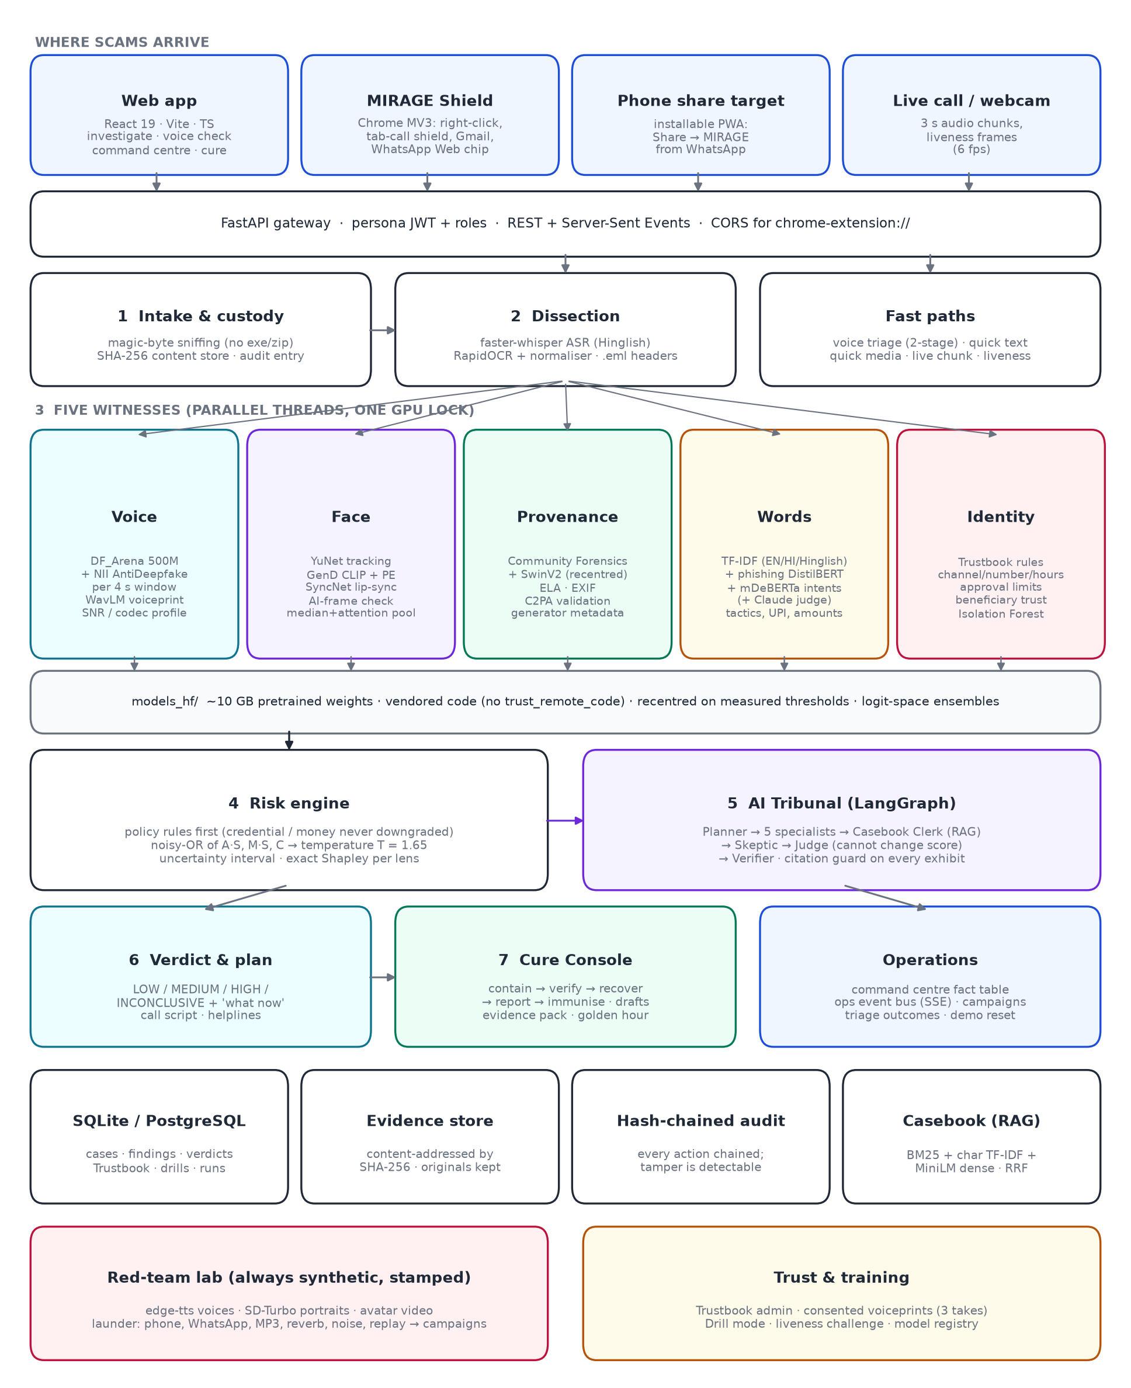
Figure 4. MIRAGE system architecture.

Component by component
- Gateway. FastAPI with persona JWT roles (employee, analyst, admin, family). Results stream over Server-Sent Events so the user sees each witness finish.
- Intake and custody. Files are identified by magic bytes, not extensions; executables and archives are refused. Each file is hashed with SHA-256 and stored content-addressed; the action enters the hash-chained audit log.
- Dissection. Audio and video are transcribed with word timestamps; screenshots go through OCR and a normaliser; emails are parsed for SPF, DKIM, DMARC and Reply-To mismatches.
- Witnesses. Run in parallel threads. All GPU work goes through one re-entrant lock, because concurrent model loads crash natively on Windows/CUDA (a lesson learned during the build).
- Risk engine, Tribunal, response. Detailed in 4.5 to 4.7.
- Operations. Every audit entry is also published on an in-process event bus; the command centre subscribes over SSE and cross-filters one fact row per case.
- Storage. Relational database for cases, findings, verdicts, the Trustbook and drills; content-addressed evidence store; hash-chained audit log in which any edit breaks the chain.

4.3 How one case flows
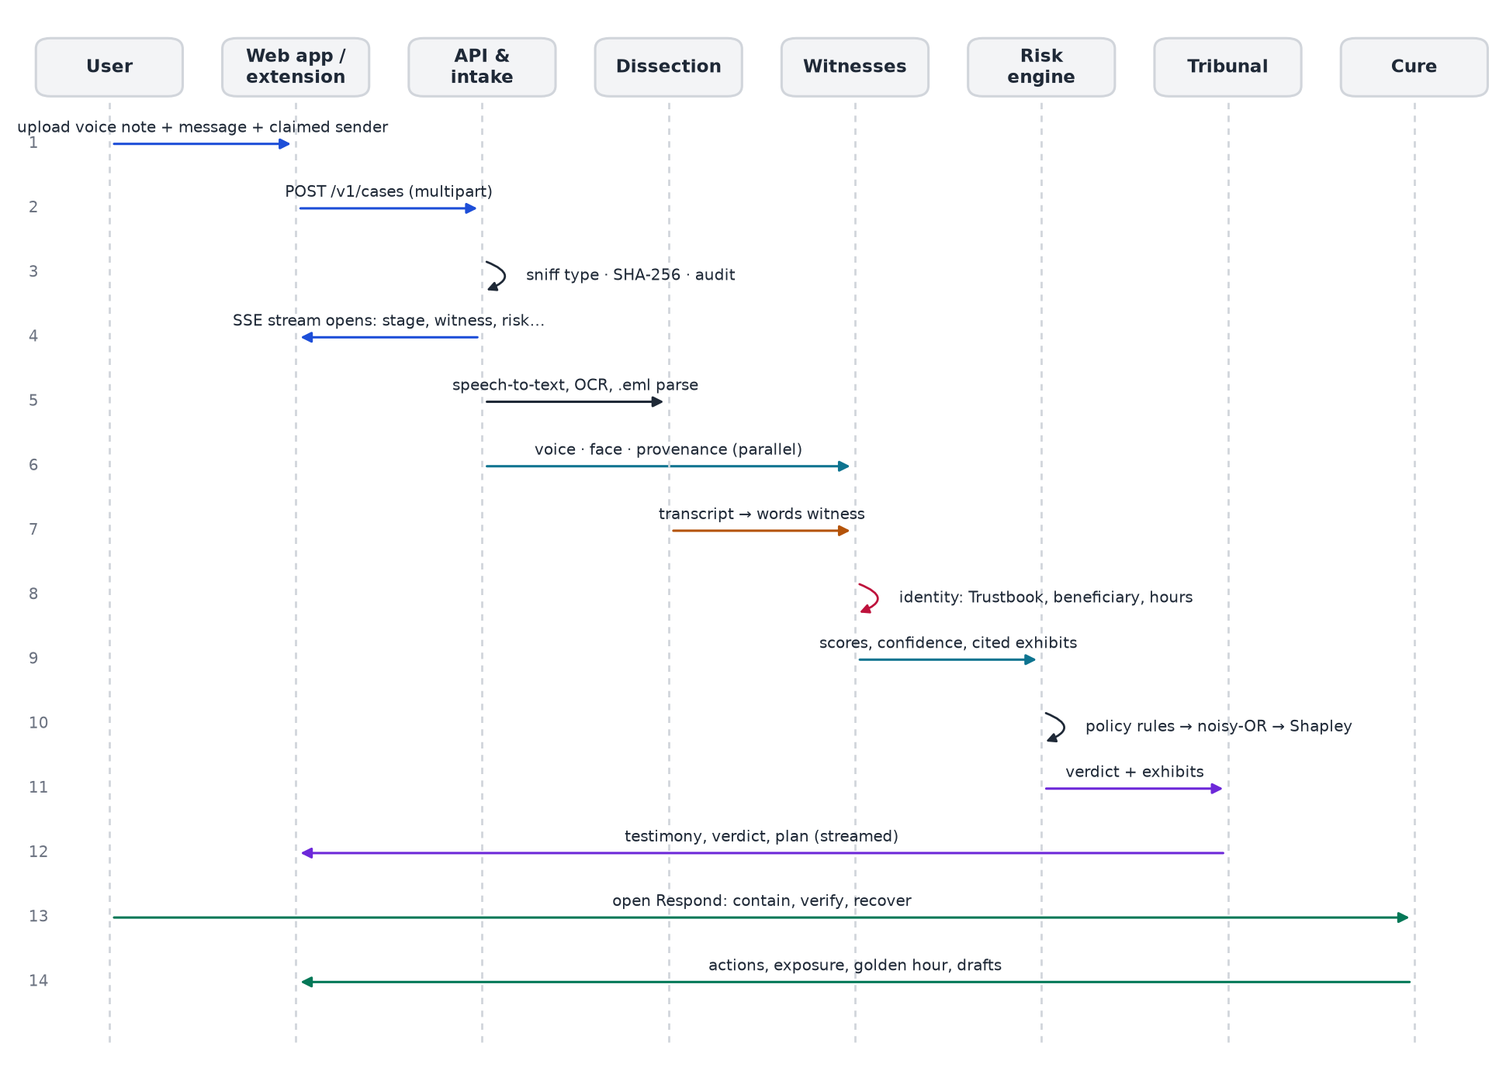
Figure 5. Sequence of a full investigation, from upload to the Cure Console.

4.4 Detection stack
Each media witness uses at least two published pretrained models. Their raw probabilities are not comparable (one image model's natural threshold is 0.01, another's 0.1), so MIRAGE recentres each score on the threshold we measured, then averages in logit space with weights set by measured generalisation. How far the models agree becomes the confidence, and the UI shows each model as a juror.
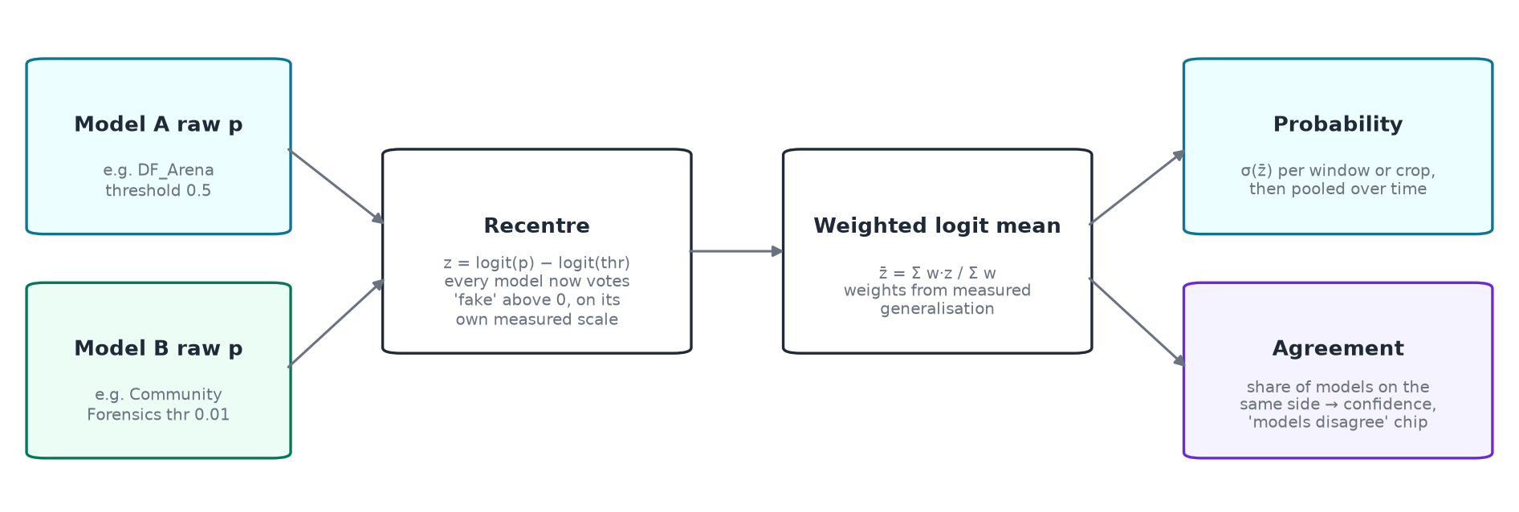
Figure 6. Ensemble mechanics: recentre on each model's measured threshold, weighted logit mean, agreement as confidence.
Witness | Models and threshold | Aggregation and safeguards
Voice | DF_Arena 500M (0.5) + NII Wav2Vec2-Large AntiDeepfake (0.5); WavLM voiceprint (cosine 0.86) | 4.04 s windows with 2 s hop; attention pooling; SNR below 19 dB marks the evidence noisy and widens the uncertain band
Face | YuNet → GenD CLIP + GenD PE (0.75); SyncNet v2 (confidence 3.0); AI-frame check on keyframes | Median + attention pooling over frames; lip-sync scored only when the mouth moves (still pictures are reported, not scored)
Provenance | Community Forensics (0.01) + SwinV2 (0.1); ELA, EXIF, C2PA | Valid credentials lower the score (more if the signer is trusted); signed AI declarations raise it; failed validation flags tampering
Words | Own TF-IDF (0.5) + phishing DistilBERT + mDeBERTa intents (0.9, need corroboration) + optional Claude (0.6) | Logit blend; zero-shot intents must be corroborated, which stopped them inventing requests in harmless text
Identity | Trustbook rules + Isolation-Forest request anomaly | Channel, number, hours, approval limit, beneficiary trust, cross-case memory

4.5 The risk engine
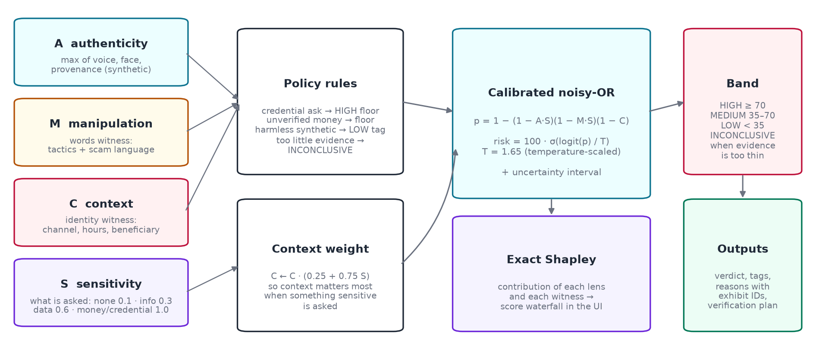
Figure 7. Request-aware risk engine: policy rules, context weighting, calibrated noisy-OR, Shapley explanation.
The four lenses are A (authenticity: the strongest synthetic-media signal), M (manipulation: scam language and tactics), C (context: identity inconsistencies) and S (sensitivity of what is asked: none 0.1, information 0.3, data 0.6, money or credentials 1.0). Policy rules run first, so an uncertain detector can never talk a credential or unverified payment request down. The number then comes from a calibrated noisy-OR:
FUSION FORMULA
p = 1 − (1 − A·S)(1 − M·S)(1 − C), with C weighted by (0.25 + 0.75·S)
risk = 100 · σ(logit(p) / T), T = 1.65 fitted by temperature scaling
Bands: HIGH ≥ 70, MEDIUM 35–70, LOW < 35, INCONCLUSIVE when the evidence is too thin. Exact Shapley values split the score between lenses and witnesses.

Because the score multiplies authenticity by sensitivity, a synthetic voice reading a harmless announcement stays low, while a genuine voice asking to pay a never-seen account still rises through the context lens: the two failure modes of plain detectors.

4.6 Explainability
- Exhibits. Every finding produces evidence items (E1, E2, …) tied to seconds of audio, words, frames or image regions; every sentence in the verdict cites them.
- Model jury. Each detector's raw score is drawn against its own threshold, with an "agree" or "split" badge.
- Score waterfall and What-if lab. Shapley contributions from baseline to final risk; removing an exhibit re-fuses the case instantly.
- AI Tribunal (LangGraph). Planner, five specialists, a Casebook Clerk (retrieval over CERT-In guidance, MITRE ATT&CK and Indian scam patterns), a Skeptic who argues innocence, a Judge who explains but cannot change the score, and a Verifier who builds the plan. A citation guard removes any exhibit ID that does not exist.

4.7 From verdict to response
Every result ends in a "what now" plan: steps, a line to say before hanging up, the people and helplines to contact (1930, cybercrime.gov.in, Sanchar Saathi) and what to do if money already moved. For full cases the Cure Console runs five stages (contain, verify, recover, report, immunise) with an exposure meter, a golden-hour clock that starts when the victim marks money as paid, challenge questions built from the Trustbook, pre-filled complaint, bank-recall and CERT-In drafts, an evidence-pack ZIP with a SHA-256 manifest, and a blocklist of the scam's identifiers. Bank and SOC connectors are clearly labelled as simulated in this prototype.

4.8 Red-team lab: thinking like the attacker
The lab forges attacks the way crews do (neural voices with edge-tts, portraits with SD-Turbo, avatar videos with FFmpeg), stamps every output "MIRAGE RED TEAM · SYNTHETIC", launders them through phone, WhatsApp, MP3, reverb, noise, replay, JPEG, resize, screenshot and social-media pipelines, and runs every variant back through the same witnesses. Campaign history shows the catch rate per channel over time, so a detector change cannot silently regress.

4.9 Where MIRAGE meets the user
Surface | What it does
Voice check | Two questions in order: is the voice AI or human, and what is it asking for? A 2×2 verdict matrix and an evidence timeline that puts audio, synthetic windows, words and tactics on one playhead.
Live call shield | Three-second chunks from a call: spoof score, rolling transcript and tactics; the plan appears at the first HIGH.
MIRAGE Shield (Chrome) | Right-click checks for text, images and voice notes; tab-audio shield for Meet, Zoom and WhatsApp Web calls; Gmail banners; a "Check with MIRAGE" chip on WhatsApp Web voice notes.
Phone share target | Installable app: Share → MIRAGE from WhatsApp sends a voice note or screenshot straight to the right check.
Liveness check | Three random head movements scored from face landmarks with a human reaction-time floor, plus a deepfake score on the face; a replayed recording failed all three prompts.
Command centre | Cross-filtering operations floor: threat field, live feed, incident queue with one-click triage, channel × witness matrix, attack clock, campaign spotlight.
Trustbook and Drill mode | Consented voiceprint enrolment from three takes that must agree; simulated attacks sent to staff inboxes to measure how many verify before acting.

4.10 Security and privacy
- Local processing; nothing leaves the machine unless an optional cloud judge is configured.
- Magic-byte intake, SHA-256 custody, hash-chained audit with a verification endpoint; reports carry hashes for complaints.
- Role-based access; voiceprints only with recorded consent; drills only with confirmed consent, disclosed as soon as answered.
- Red-team output is always synthetic, stamped and fictional; no real person's likeness or voice is generated.

4.11 Technically beyond existing solutions
Technical limitation found in existing tools | What MIRAGE does instead | Where
One detector, one fixed threshold | Two or more published models per modality, recentred on measured thresholds, logit ensemble, agreement as confidence | witnesses/pretrained.py
Robustness assumed, not measured | Red-team laundering campaigns and a noise study decide which models to trust in noise | redteam.py, scripts/noise_robustness.py
Media score ignores the request | Request sensitivity multiplies the media and language signals; policy floors for money and credentials | fusion/risk.py
No lip-sync or talking-photo check | SyncNet confidence with a mouth-motion gate | witnesses/syncnet.py, face.py
Credentials only detected, not validated | Cryptographic C2PA validation: valid, tampered, AI-declared | witnesses/provenance.py
Text models miss Hinglish and invent intents | Indian-language lexicon, entity extraction for UPI/IFSC/amounts, zero-shot only with corroboration | witnesses/words.py
Opaque output | Cited exhibits, model jury, Shapley waterfall, Tribunal with a Skeptic | agents/tribunal.py
Stops at the label | What-now plans and the Cure Console with golden-hour workflow | fusion/response.py, cure.py
Single channel | Cases link across email, chat, phone and video by shared identifiers | graphs.py

SECTION SUMMARY: WHERE THE GAP IS, AND WHAT MIRAGE FILLS
- Existing tools are single-model, single-channel and silent about robustness; MIRAGE ensembles published models, measures robustness and changes its trust in each model from that evidence.
- They judge media; MIRAGE judges media and the request and the identity context, with rules that cannot be overridden by an uncertain detector.
- They stop at a score; MIRAGE explains with cited evidence and runs the response.

5. Product and impact

5.1 Who uses it, and how
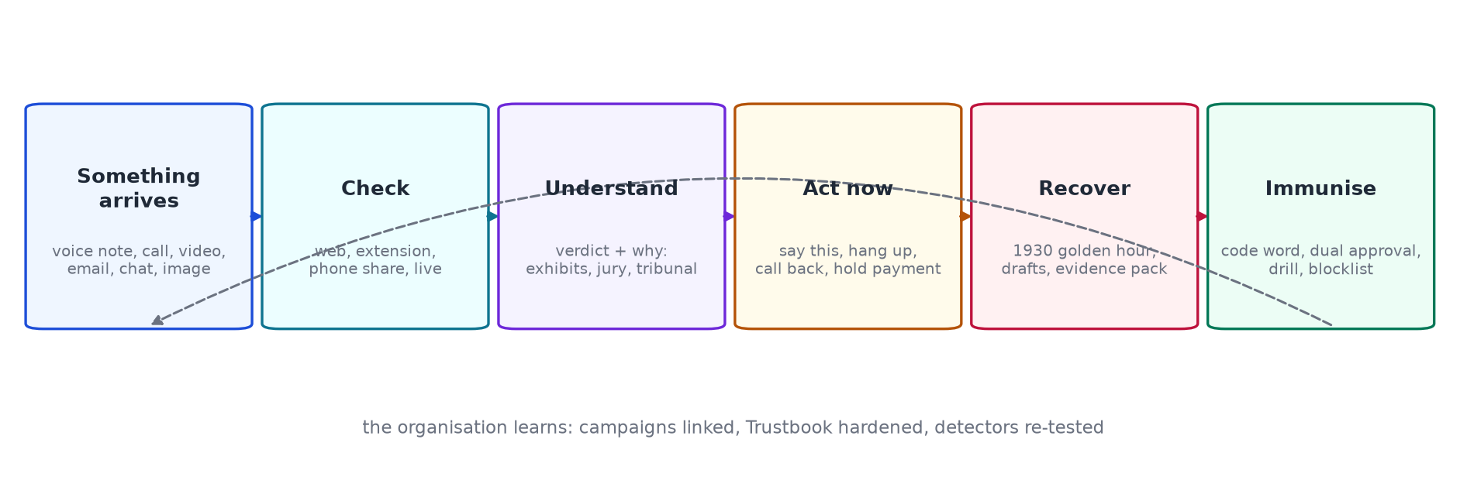
Figure 8. The product loop: from the moment something arrives to an organisation that is harder to fool next time.
User | Typical moment | What MIRAGE gives them
Accounts-payable lead | A WhatsApp voice note from the "CFO" asks for an urgent transfer | HIGH verdict, the reason in one line, "call back on the saved number", payment hold
SOC analyst | Morning triage of escalations | Command centre with campaigns, one-click outcomes, Tribunal record, PDF report
Head of IT | Policy and trust management | Trustbook, consented voiceprints, drills, model registry and audit chain
A parent at home | "Papa, accident" voice note in Hinglish | One plain answer and one button: call Papa on his saved number, ask the code word
Anyone who already paid | Realises after the transfer | Golden-hour clock, 1930 script, bank recall draft, evidence pack

5.2 The product, as built
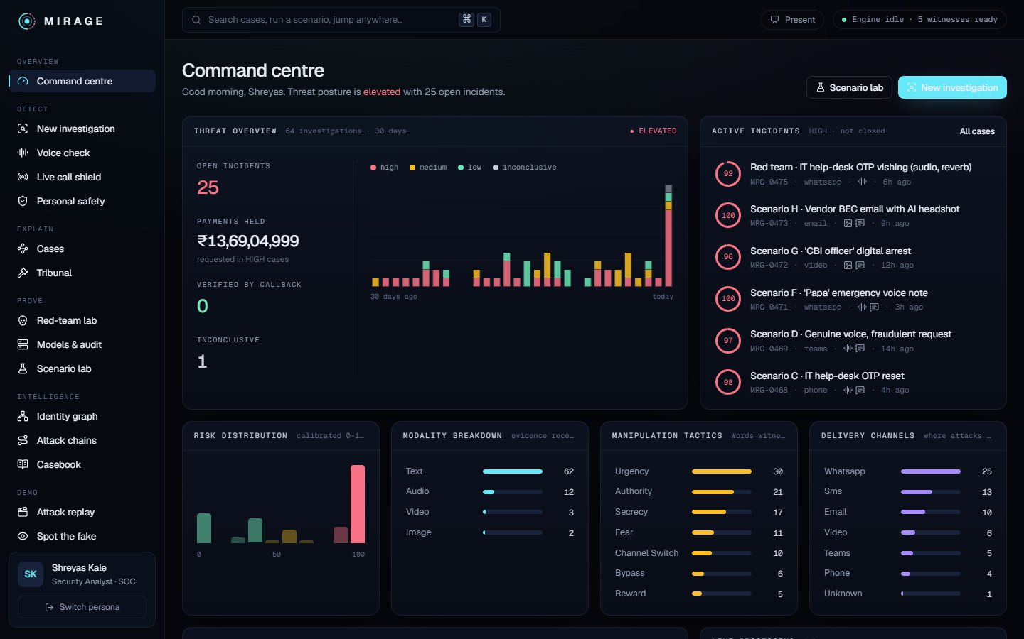
Figure 9. Command centre (earlier build shown): the operations view for a security team.
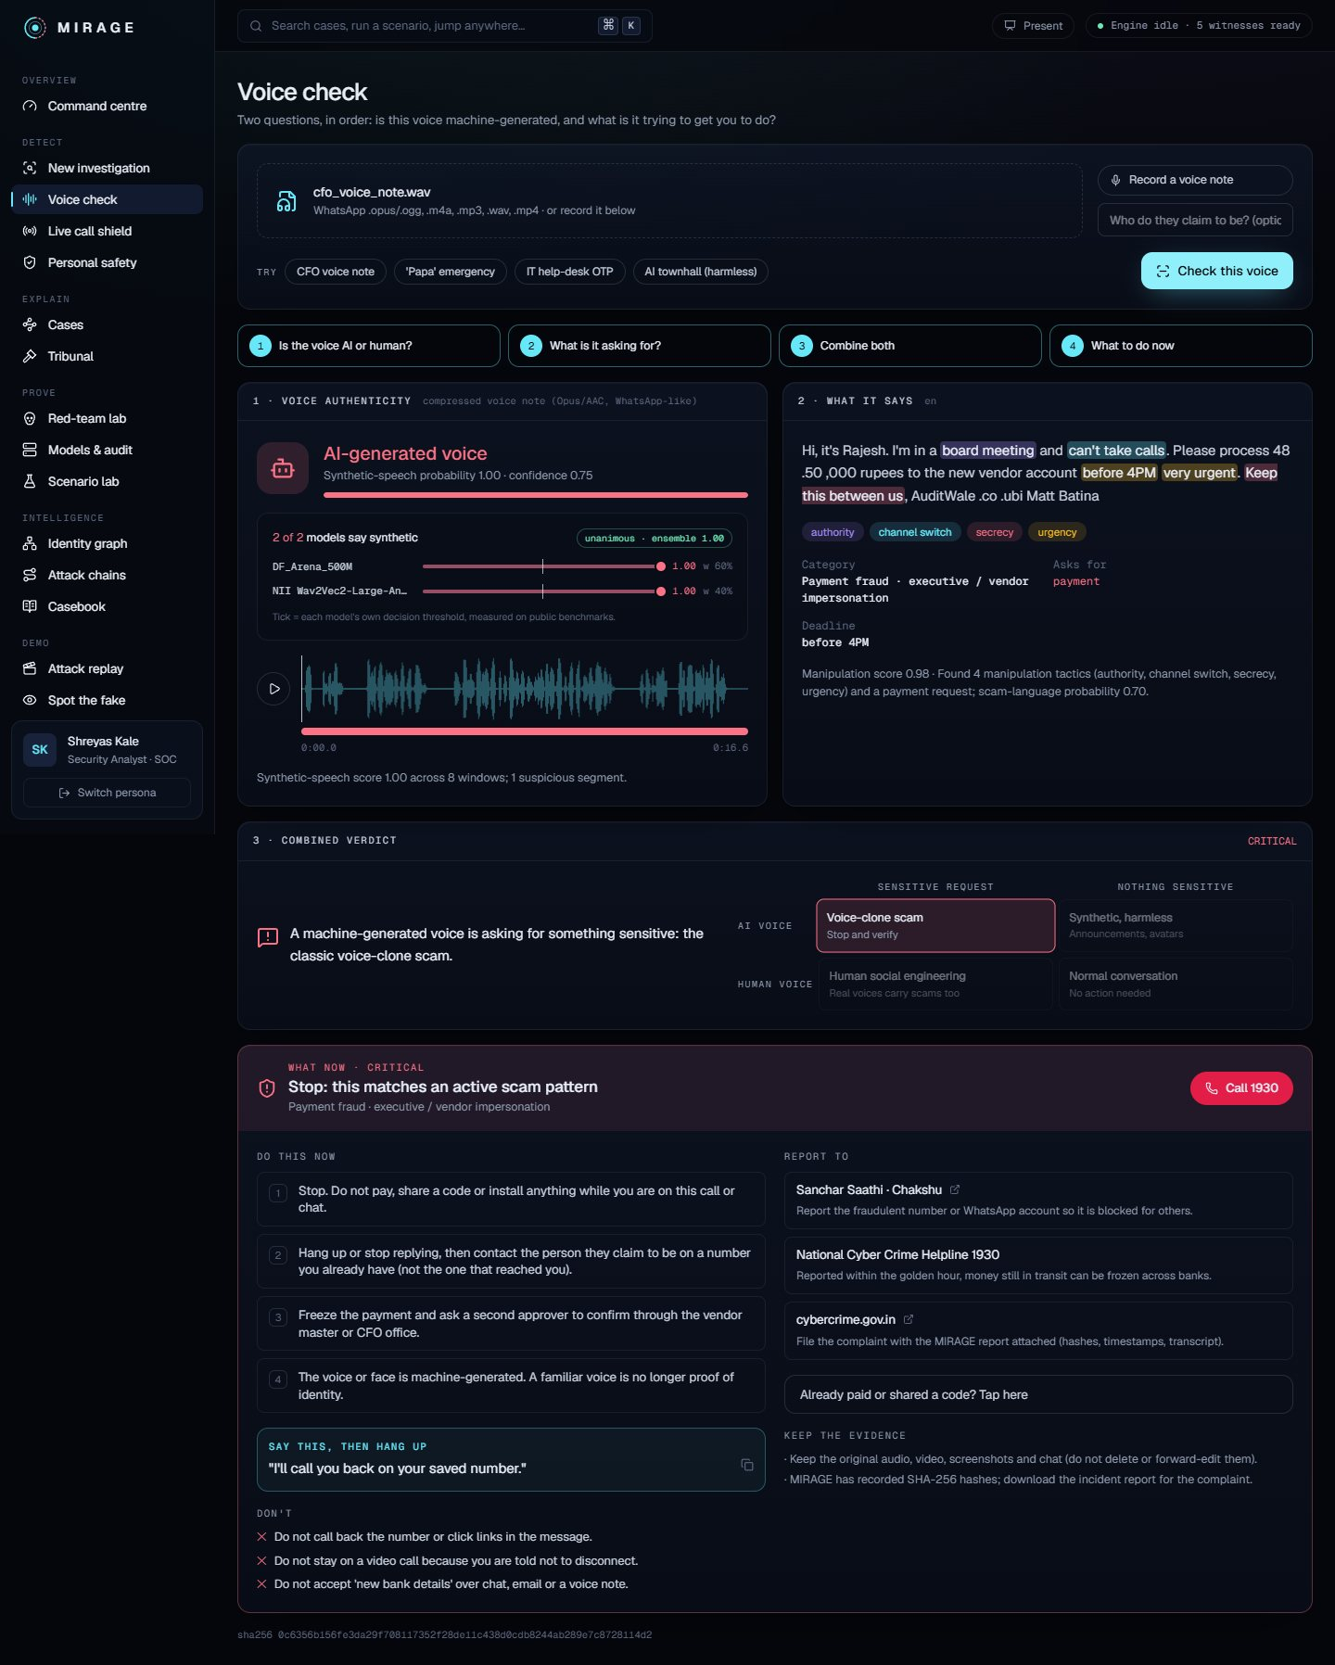
Figure 10. Voice check: is the voice AI or human, and what is it asking for?
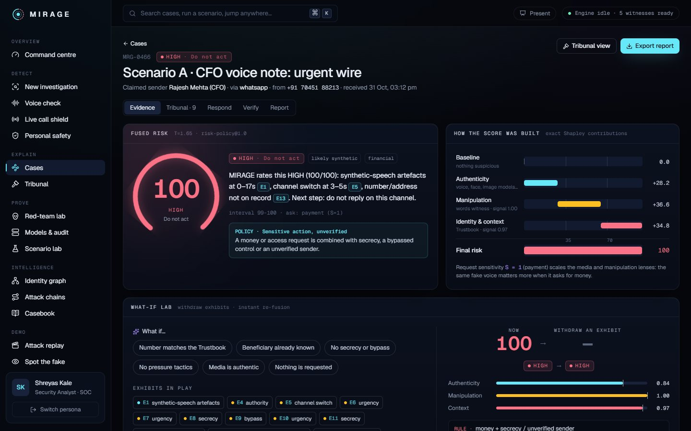
Figure 11. Case evidence: verdict, witnesses, exhibits and score waterfall.
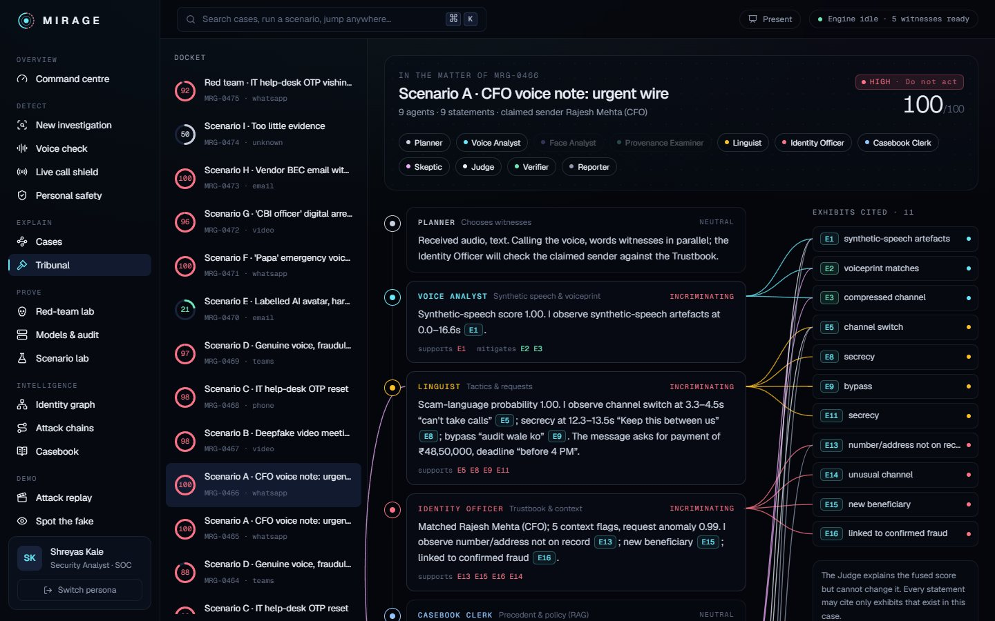
Figure 12. AI Tribunal: agents testify with cited exhibits; the Skeptic argues innocence.
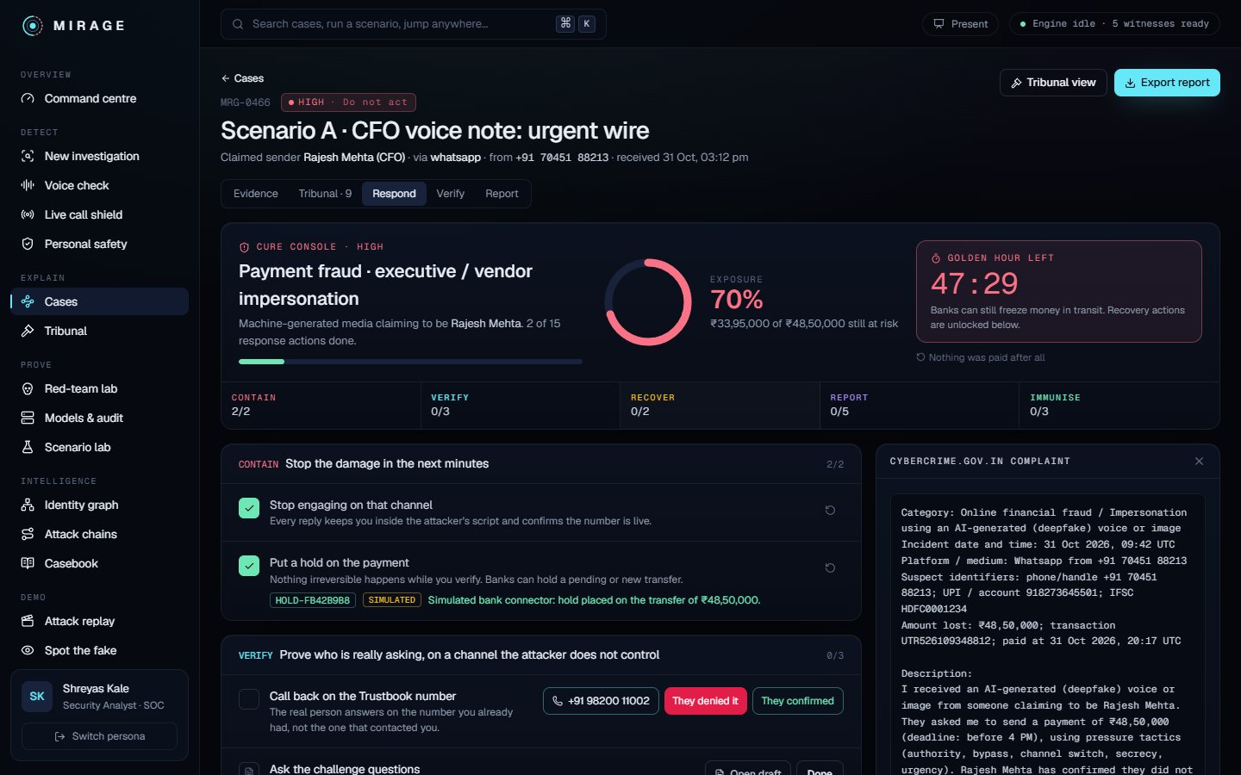
Figure 13. Cure Console: contain, verify, recover, report and immunise.
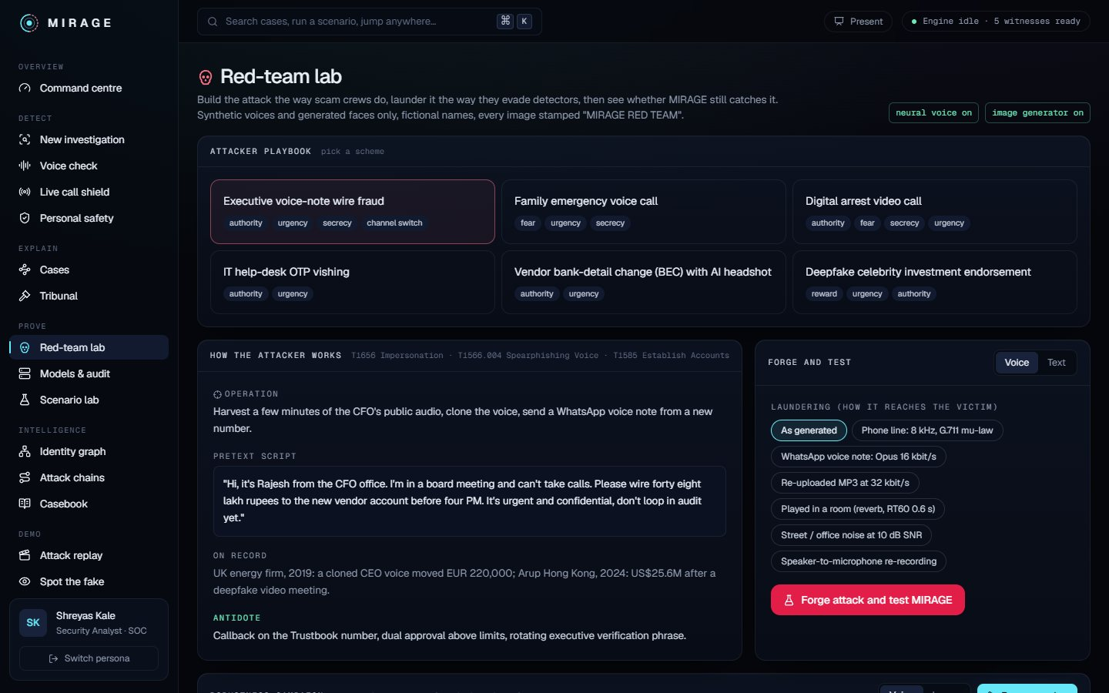
Figure 14. Red-team lab: forge, launder and test attacks.
Screenshots use the application's dark interface; the report itself is light for printing.

5.3 Impact
For | Impact
Individuals and families | A trustworthy answer in plain language within seconds, in English, Hindi or Hinglish, and a single safe action; recovery help inside the golden hour.
Employees | Permission to pause: a verdict and a script make it socially easy to hang up on the "CEO" and call back.
Organisations | Fewer fraudulent transfers, evidence that stands up in a complaint, campaigns linked across channels, staff behaviour measured by drills.
Banks and law enforcement | Complaints arrive with hashes, transcripts, identifiers and timelines; mule accounts and numbers are flagged across cases.
The ecosystem | Measured, published robustness numbers instead of marketing claims; a red-team method others can reuse.

SECTION SUMMARY: WHERE THE GAP IS, AND WHAT MIRAGE FILLS
- Existing tools serve one persona on one channel; MIRAGE serves the clerk, the analyst, the administrator and the family with the same evidence.
- The impact is measured in decisions: a payment not made, a call returned, a complaint filed within the hour.

6. The numbers: accuracy and transparency
Every number in this section was measured by us with the scripts in the repository (benchmark_models.py, noise_robustness.py, verify_demo_inputs.py) on public labelled samples or on content we generated. The samples are small, so they are a sanity check, not a leaderboard. Where a number is weak, we say so.

6.1 Benchmarks
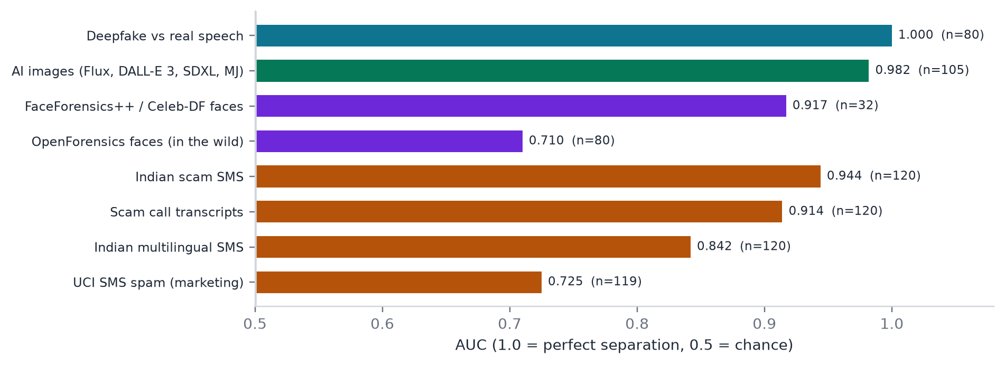
Figure 15. AUC per benchmark set for the MIRAGE ensemble or witness (n = samples).
Set | n | Best single model | MIRAGE ensemble / witness
Deepfake vs real speech | 80 | AUC 1.00 (both models) | AUC 1.00, 98.8% accuracy
Windows text-to-speech (fake only) | 10 | 100% caught | 100% caught
Modern AI images vs real photos | 105 | AUC 0.979 (Community Forensics) | AUC 0.982, 94.3% accuracy
FaceForensics++ / Celeb-DF frames | 32 | AUC 0.925 (GenD PE) | AUC 0.917, 84.4% accuracy
OpenForensics face swaps (in the wild) | 80 | AUC 0.756 (GenD CLIP) | AUC 0.71 (weakest)
Indian scam SMS | 120 | AUC 0.904 (phishing model) | AUC 0.944
Scam call transcripts | 120 | AUC 0.977 (own TF-IDF) | AUC 0.914
UCI SMS spam (mostly marketing) | 119 | AUC 0.762 (own TF-IDF) | AUC 0.725

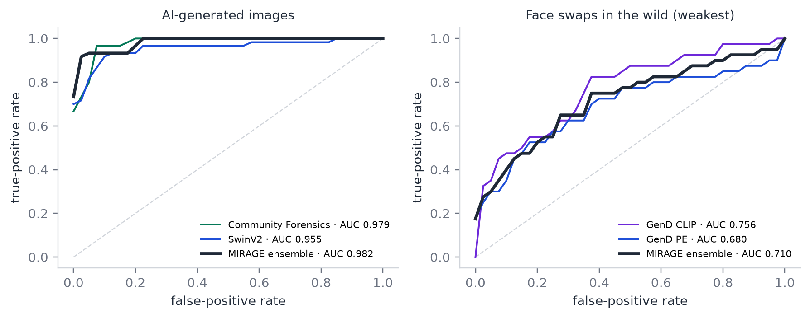
Figure 16. ROC curves: AI-generated images (left) and in-the-wild face swaps (right), where the curves show the honest weak spot.

6.2 Red-team robustness
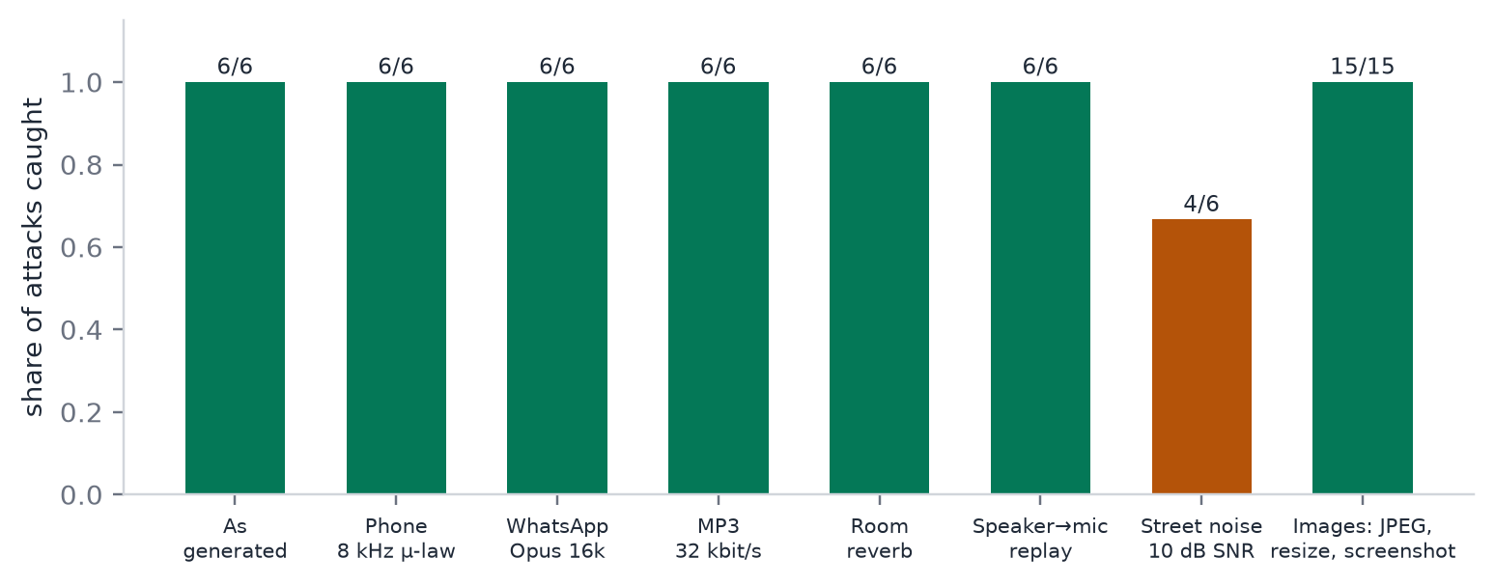
Figure 17. Share of laundered red-team attacks caught, per channel.
Every laundering channel was caught except street noise at 10 dB SNR (4 of 6). Two fixes were tested and rejected: denoising erased the artefacts the detectors rely on, and lowering the threshold flagged 11 of 120 noisy real voices. The shipped behaviour is honest: below 19 dB SNR the voice evidence is reported as uncertain, and an uncertain voice asking for money or a code is still rated HIGH.

6.3 Noise study: which models to trust in noise
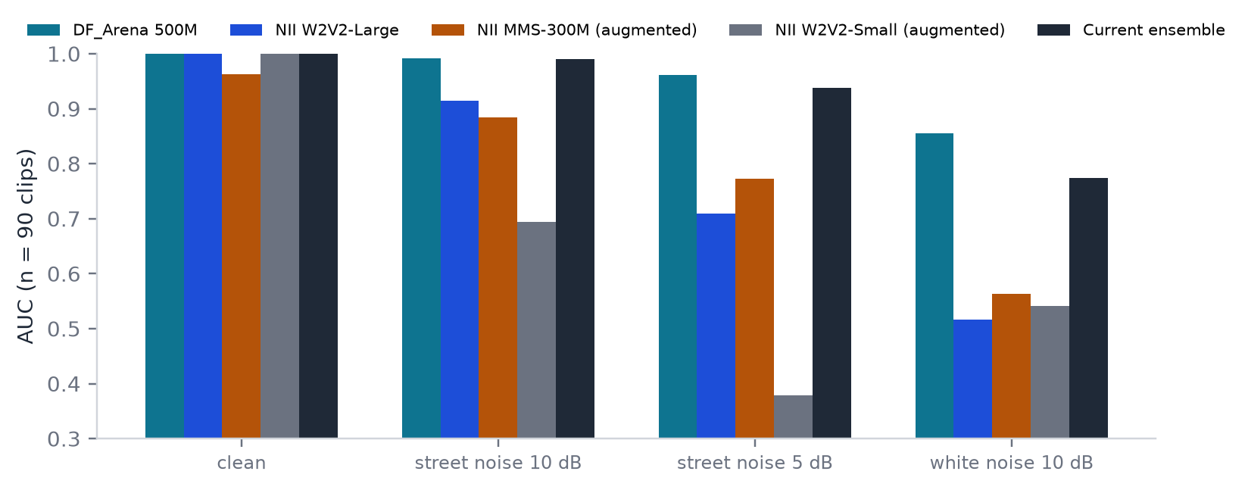
Figure 18. AUC of each voice model and ensemble as noise rises (n = 90 clips, two 4 s windows per clip).
FINDING
In clean audio every model separates real from fake. As noise rises, DF_Arena alone degrades least (AUC 0.992 at 10 dB street noise, 0.961 at 5 dB, 0.856 under white noise), while NII and the two augmentation-trained NII models fall faster (white noise: 0.52–0.56). Adding them pulls the ensemble down (0.938 at 5 dB, 0.774 under white noise).
The data therefore supports a noise-conditional ensemble: trust DF_Arena alone when the measured SNR is low. This is the next change to the voice witness; it uses no training, only measured weighting.

6.4 Lip-sync, provenance and liveness
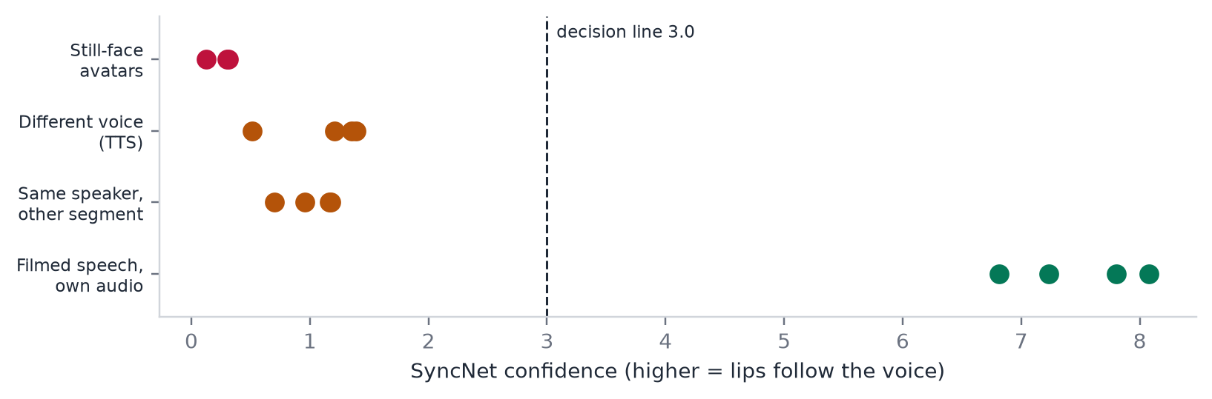
Figure 19. SyncNet confidence: filmed speech with its own audio vs swapped audio and still-face avatars.
Check | Result | Note
SyncNet lip-sync | Own audio 6.81–8.08; swapped audio 0.51–1.39; still avatars 0.13–0.31 (n = 15) | One speaker, Wikimedia Commons (CC BY 3.0); a sanity check. Still pictures are reported, not scored.
C2PA validation | Untouched signed image: valid; one flipped byte: assertion.dataHash.mismatch; AI declaration read | Tested in the automated suite with a throwaway CA
Liveness | A replayed real recording followed 0 of 3 random prompts → FAILED; face scored 0.15 (genuine person) | Random prompts defeat replay; reaction-time floor 0.25 s
Demo inputs | 32 / 32 expected verdicts | Voice notes, calls, images, videos, messages, emails, full investigations
Automated tests | 26 / 26 pass | Including rules, Shapley additivity, audit tamper, drills, C2PA

6.5 What is still weak
STATED OPENLY
- Face swaps in the wild (OpenForensics AUC 0.71) remain the weakest media witness.
- Fully generated video with lips in sync has no dedicated temporal model yet; lip-sync generators can pass SyncNet by design.
- Heavy noise: handled as uncertainty today; the noise-conditional ensemble is the measured next step.
- The optional Claude judge is unmeasured (no API key on the build machine); the measurement script is ready.
- Seeded Trustbook voiceprints are simulator placeholders until real people enrol with consent.

SECTION SUMMARY: WHERE THE GAP IS, AND WHAT MIRAGE FILLS
- Most vendors publish headline accuracy without method; MIRAGE publishes per-set AUC, sample sizes, ROC curves, calibration data, laundering results and its weak spots.
- The numbers drive design decisions (models removed, thresholds recentred, noise-conditional weighting), not just slides.

7. Business case

7.1 Sectors and how MIRAGE helps
Sector | Pain | How MIRAGE helps | Buyer
Banking, financial services and insurance | Executive and vendor fraud, customer scams, recall pressure | Pre-payment checks, flagged beneficiaries, golden-hour evidence for recall, call-centre live shield | CISO, fraud head
Enterprises (finance, HR, IT) | CEO/CFO fraud, BEC, help-desk vishing | Extension and voice check for staff, Trustbook rules, drills, command centre for the SOC | CISO, CFO
Telecom and messaging | Fraud numbers, spoofed calls, scam voice notes | Shield integrations, Chakshu-ready reports, campaign linking of numbers | Trust & safety
Government and law enforcement | Digital arrest, rising complaints, evidence quality | Structured complaints with hashes and timelines, cross-case linking, public awareness drills | I4C, state cyber cells
E-commerce and fintech apps | Fake support agents, investment lures, account takeover | API checks on uploaded media and chats, liveness at onboarding | Risk & compliance
Families and senior citizens | Emergency voice clones, digital arrest | Phone share target, plain answers, one-tap callback, recovery help | Consumers, banks as a benefit
Media and public figures | Fake endorsements with their face and voice | Provenance and deepfake evidence packs for takedowns | Brand protection

7.2 Business model
- Enterprise licence (on-premises or private cloud). Per seat for staff surfaces, per analyst for the command centre; data never leaves the customer.
- API. Per-check pricing for platforms that want voice, media and message checks inside their own apps.
- Bank partnerships (B2B2C). Free consumer protection offered by banks to customers, paid by the bank as fraud-loss reduction.
- Government (B2G). Complaint-quality tooling and awareness drills for cyber cells and public institutions.

7.3 Why now, and the path to market
Losses are large and growing, regulators and CERT-In are asking organisations to prepare, and the pretrained detectors that make MIRAGE possible were published only in the last two years. The path is: pilot with a finance team and a SOC (drills give a measurable before/after), add real bank and SOC connectors behind explicit configuration, publish robustness numbers per release, then open the API.
SECTION SUMMARY: WHERE THE GAP IS, AND WHAT MIRAGE FILLS
- Existing tools are sold per channel to one buyer; MIRAGE serves several sectors with one evidence model and different surfaces.
- The value is measurable: prevented transfers, faster recalls, drill scores, complaint quality.

8. Conclusion and roadmap
Deepfakes changed the economics of impersonation, and the defences built for a world of spelling mistakes no longer hold. MIRAGE's answer is to stop asking people to spot fakes and instead judge the request, explain the evidence and guide the response, with detectors chosen and measured for the channels scams actually use.
Next step | Why
Noise-conditional voice ensemble | Measured: DF_Arena alone holds best in noise (section 6.3)
Temporal model for fully generated video | Covers in-sync generated lips that SyncNet cannot catch
Consented voiceprints for real people | Replaces simulator placeholders; strengthens identity checks
Measure the Claude judge | Script ready; needs an API key
Real authentication (OIDC) and real connectors | Production deployment behind explicit configuration
Field test of the extension and phone share target | Verify Gmail, WhatsApp Web and Android flows on real devices

References
- PS-02 problem statement, D3COY 1.0, DJS ISACA (CERT-In guidance; Gartner CISO survey).
- Fortune (17 May 2024): Arup deepfake video-call fraud, US$25.6 million.
- Inc42: digital-arrest scam losses in India, 2024 (MHA / I4C data).
- Moneylife: India losing over Rs 22,000 crore a year to cyber scams.
- FBI Internet Crime Complaint Center (IC3) annual report 2023: business email compromise losses.
- Observer Research Foundation (2025): survey on AI voice-clone scams in India.
- NCC Group (2025): real-time voice impersonation and deepfake vishing.
- Li, Chen & Wei (2025), arXiv 2503.17577: robustness of audio deepfake detection under real-world corruption.
- Laundering attacks on deepfake detectors, arXiv 2408.14712; room impulse responses evade detection, arXiv 2409.14712.
- Speech Anti-Spoofing Arena (DF_Arena) and NII AntiDeepfake, arXiv 2506.21090.
- Park & Owens, Community Forensics, CVPR 2025; Yermakov et al., GenD, WACV 2026.
- Chung & Zisserman, Out of time: automated lip sync in the wild (SyncNet), ACCV 2016 workshops.
- Coalition for Content Provenance and Authenticity (C2PA) specification; c2pa-python.
- MIRAGE repository documentation: HANDOVER, DETECTION, RED_TEAM, ATTACKER_PLAYBOOK, CURE (github.com/SDP42/isacaps2).

