Learning Outcomes | Question Number
Develop competence in identifying types of function, determine the domain, codomain and range of a function. | Q1
Develop competence in solving equations and plotting the graphs. | Q1, Q2
Develop competence in the rules of differentiation & integration and its application. | Q3, Q4
Perform simple arithmetic on real and complex numbers and illustrate the result geometrically. | Q5, Q6

Answer ANY 5 Questions

QUESTION 1

(a) (i) f(2) = |4 – 6 – 7| = 9
[m1, a1]
(ii) 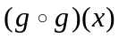= 5(5x – 1) – 1 = 25x – 6
[m1, a1]
(iii) Let y = g(x)
y = 5x – 1
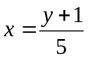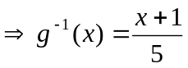
[m1, a1]
(iv) 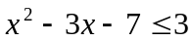
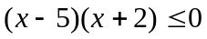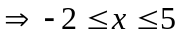

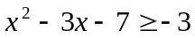
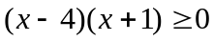 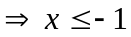 or 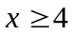

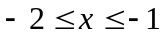 or 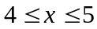
[m2, a2]

(b) (i)
x | 0 | 1 | 2 | 3 | 4 | 5 | 6 | 7 | 8
y | 0 | 14 | 24 | 30 | 32 | 30 | 24 | 14 | 0
[a3]
(ii) 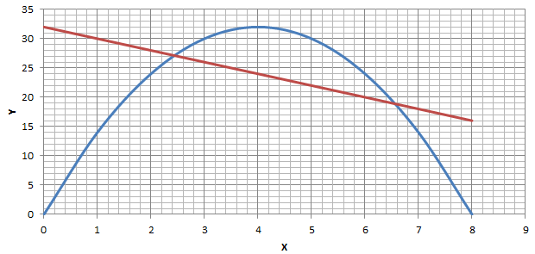
y = 16x – 2x²
y = -2x + 32
[a4, each axis 1 mark, graph 2 marks]
(iii) The straight line: y = -2x + 32
x = 2.4 and 6.6
[a3, line 1 mark, each value of x 1 mark]
[Total 20 marks]

QUESTION 2
(a) x + 4y + 2 = 0 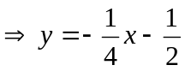
Let m be the slope of the line
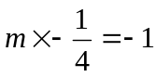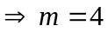
The line equation
(y – 1) = 4(x – (-2))
y = 4x + 9
[m2, a1]

(b) 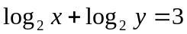
xy = 8  x = 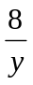 -------(1)
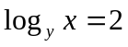
x = y²
y³ = 8 y = 2
From (1)
x = 4
[m2, a2]

(c) 3^{2x+1} – 10(3^{x}) + 3 = 0
(3)3^{2x} – 10(3^{x}) + 3 = 0
3^{x} = or 3^{x} = 3
x = -1 or x = 1
[m2, a2]
(d) (i) cos⁴ x + sin⁴ x =
(cos² x + sin² x)² – 2 cos² x sin² x =
sin² 2x = 
1 – 2 sin² 2x =  cos 4x =
[m4]
(ii) cos⁴ x + sin⁴ x =
cos 4x =
4x = 120º, 240º, 480º, 600º
x = 30º, 60º, 120º, 150º
[m1, a4]
[Total 20 marks]

QUESTION 3

(a) (i) = [-2 cos(2 – 3x)] [ -3 sin(2 – 3x)] = 3 sin(4 – 6x)
[m2, a1]
(ii) 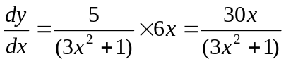
[m2, a1]

(b) x²y + xy² = 6
2xy + x²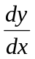+ y² + 2xy = 0 = 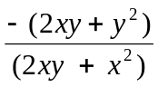
At the point (1,2), slope = 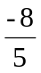
[m4, a1]

(c) (i) y = 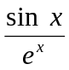 = 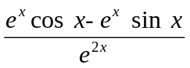= 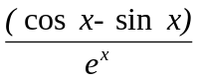
[m2]
when x = 0, y = 0
= 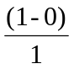 = 1
[m1, a1]
(ii) = 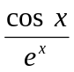– y
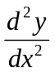= 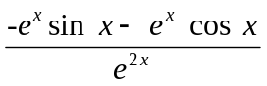–
= -(–) – 2() – = -2 – 2y
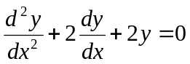
[m5]
[Total 20 marks]

QUESTION 4
(a) (i) 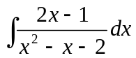= ln |x² – x – 2| + c
[a2]
(ii) 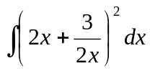= 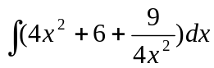= 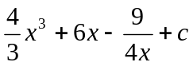
[m2, a1]
(iii) 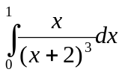= 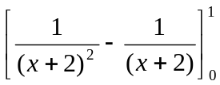= 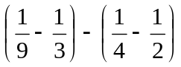= 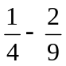= 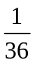
[m4, a1]
(b) 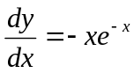
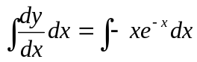
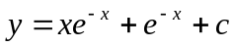

When x = 0, y = 2
2 = 1 + c 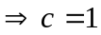

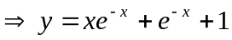
[m4, a1]

(c) At intersection points
5 + x – x² = x + 4
x² = 1 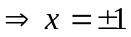
[m2]
Area = 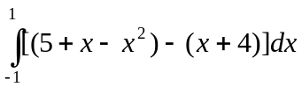 = 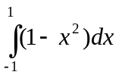= 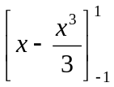= 
[m2, a1]
[Total 20 marks]

QUESTION 5
(a) (i) x = 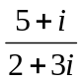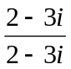= 1 – i
y = 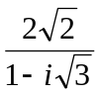×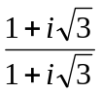= + 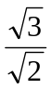i
[m2, a2]

(ii) modulus of x = 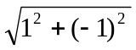= 
[a1]
principal argument of x = tan⁻¹(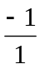) = -45⁰
[a1]
modulus of y = 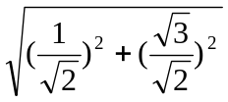=
[a1]
principal argument of y = tan⁻¹() = 60⁰
[a1]
x + y = 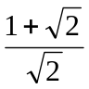+ 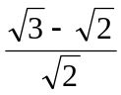i
modulus of x + y = 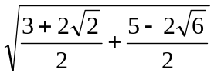= 1.722
[m1, a1]
(b) (i) 1 + 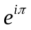= 1 + (-1) + 0 = 0
[m2, a1]
(ii) (A) cos 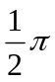+ i sin= 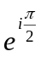
[a2]
(B) 1 + i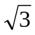 = 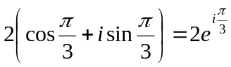
[m3, a2]
[Total 20 marks]

QUESTION 6

(a) z³ = -1
(z + 1)(z² – z + 1) = 0
z = -1 or z = 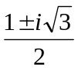
[m2, a3]

(b) 1 – i= 2(cos 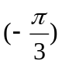+ i sin )
[m2]
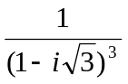= [2(cos + i sin )]⁻³ = 2⁻³(cos+ i sin) = 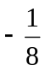
[m2, a1]

(c) z = (p + i)⁴ = (p⁴ – 6p² + 1) + i(4p³ – 4p)
When z is real
4p³ – 4p = 0
p = 0 or p = 1
[m2, a3]

(d) 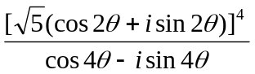= 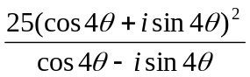×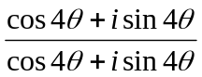
= 25(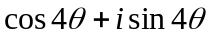)³
= 25 (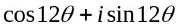)
modulus = 25, argument = 12
[m3, a2]
[Total 20 marks]

