Answer ANY 5 Questions

QUESTION 1

(a) Given that 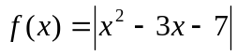 and g(x) = 5x – 1. Find
(i) f(2)
[2 marks]
(ii) 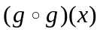
[2 marks]
(iii) 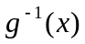
[2 marks]
(iv) the values of x given that 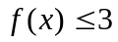.
[4 marks]

(b) (i) Copy and complete the table below for the equation y = 16x – 2x².

x | 0 | 1 | 2 | 3 | 4 | 5 | 6 | 7 | 8
y | 0 |  | 24 | 30 |  |  | 24 | 14 | 0
[3 marks]
(ii) By using a scale of 2 cm to 1 unit on x-axis and 2 cm to 4 unit on y-axis, draw the graph of y = 16x – 2x² for 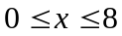.
[4 marks]
(iii) Draw a suitable straight line on your graph in (b)(ii) to find all the values of x which satisfy the equation 18x – 2x² – 32 = 0 for . State these values of x.
[3 marks]
[Total 20 marks]

QUESTION 2

(a) Find an equation of the line that passes through the point (-2, 1) and perpendicular to the line x + 4y + 2 = 0.
[3 marks]

(b) Solve the simultaneous equations:
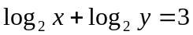
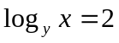
[4 marks]

(c) Solve the equation 3^{2x+1} = 10(3^{x}) – 3.
[4 marks]

(d) Given that cos⁴ x + sin⁴ x = .
(i) Without using calculator or table, prove that cos 4x = .
[4 marks]
(ii) Hence, or otherwise, solve the following equation for 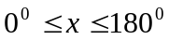.
cos⁴ x + sin⁴ x =
[5 marks]
[Total 20 marks]

QUESTION 3

(a) Find  in the following cases:
(i) y = cos² (2 – 3x)
[3 marks]
(ii) y = ln (3x² + 1)⁵
[3 marks]

(b) Find the gradient for the curve xy(x + y) = 6 at the point (1,2).
[5 marks]

(c) If e^{x}y = sin x,
(i) find the value for when x = 0.
[4 marks]
(ii) prove that 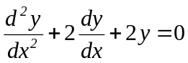.
[5 marks]
[Total 20 marks]

QUESTION 4

(a) Find
(i) 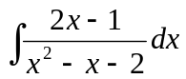
[2 marks]
(ii) 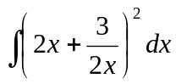
[3 marks]
(iii) 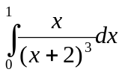
[5 marks]
(b) Find the equation of y, given that 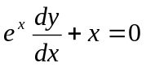and y = 2 when x = 0.
[5 marks]
(c) Find the area enclosed by the curve y = 5 + x – x² and the line y = x + 4.
[5 marks]
[Total 20 marks]

QUESTION 5

(a) Given that x = 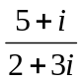and y = 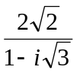.
(i) Express x and y in the form of a + ib where a and b are real.
[4 marks]
(ii) Find the modulus and the principal argument of x and y. Find the modulus for x + y.
[6 marks]

(b) Given that 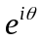= cos + i sin,
(i) evaluate 1 + 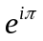
[3 marks]
(ii) express the following in the exponent form:
(A) cos 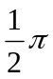+ i sin
[2 marks]
(B) 1 + i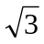
[5 marks]
[Total 20 marks]

QUESTION 6

(a) Find all the roots of the equation z³ = -1.
[5 marks]

(b) Using De Moivre’s theorem, evaluate 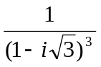.
[5 marks]

(c) Given that z = (p + i)⁴, where p is real. Find the values of p if z is real.
[5 marks]

(d) Using the De Moivre’s theorem, find the modulus and argument of the following.
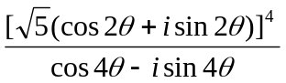
[5 marks]
[Total 20 marks]

Formulae

Quadratic equation

If 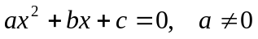  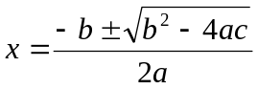 | If has roots and,  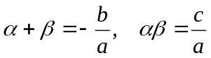

Exponential and logarithm

a^{m} a^{n} = a^{m + n}  a^{m} a^{n} = a^{m – n}  (a^{m})^{n} = a^{mn}  (ab)^{n} = a^{n}b^{n}  a^{-n} = 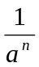  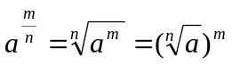  a⁰ = 1 | log_{a} (xy) = log_{a} x + log_{a} y  log_{a} (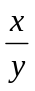) = log_{a} x – log_{a} y  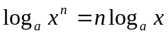  log_{a} a = 1  log_{a} 1 = 0  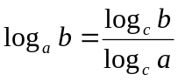

Trigonometry

sin² + cos² = 1  tan² + 1 = sec²  1 + cot² = cosec²  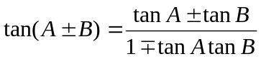 |   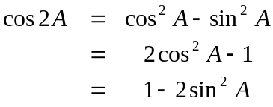  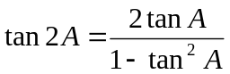  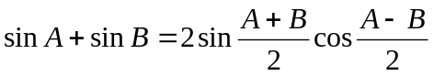  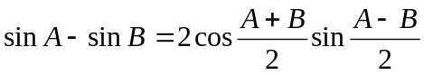  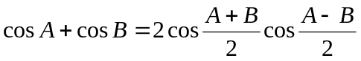  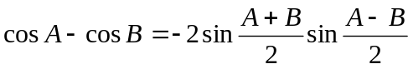

Differentiation and Integration

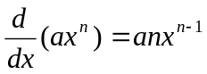  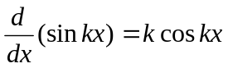  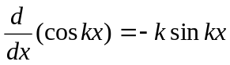  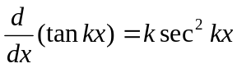  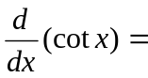-k cosec² kx  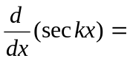 k sec kx tan kx  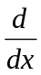(cosec kx) = -k cosec kx cot kx | 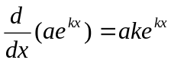  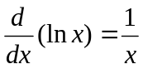  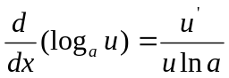  If y = u, 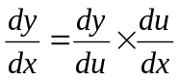  If y = uv, 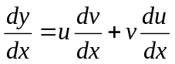  If y = 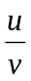, 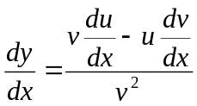

Integration

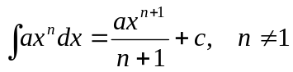  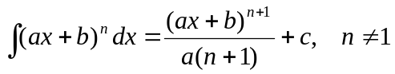  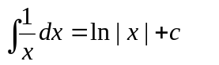  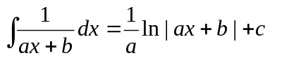  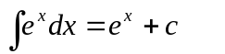 | 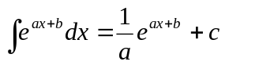  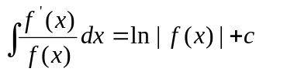  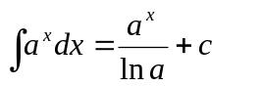  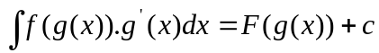  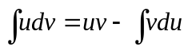

Complex Numbers

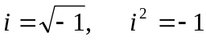  Conjugate  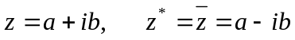  De Moivre’s Theorem  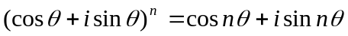 | 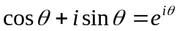  z = 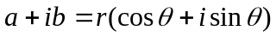  Modulus = | z | = r = 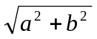  Argument = arg z = 