1. R₁ and R₂ are 2 relations from A = {p, q, r} to B = {1, 2} where R₁ = {(p,1), (q,2)} and R₂ = {(p,1), (q,1), (r,2)}.
(a) Represent R₁ and R₂ pictorially.
(b) Find the domain for R₁.
(c) Is R₁ is a function? Why?
(d) Is R₂ is a function? Why?

2. If x and f(x) are real, state the domain and range for the function
(a) f(x) = 
(b) f(x) = 
(c) f(x) = |x|
(d) f(x) = (x – 1)² – 3
(e) f(x) = 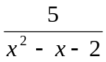
(f) f(x) = 5 + e^{x}
(g) f(x) = log x + 3
(h) f(x) = sin 2x + 1
(i) f(x) = 2 + tan x

3. Find the domain of x if
(a) 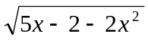is real
(b) f(x) = 0.3x² – 0.2x, and 0.1 ≤ f(x) ≤ 0.5
(c) 2 < 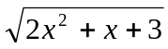 < 3
(d) | 2x² – 4x – 3| > 3
(e) ln |2x| > 2
(f) 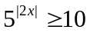

4. Find the range of f(x) where
(a) f(x) = 2x² – 7x + 3 for 0 ≤ x ≤ 4
(b) f(x) = 8 + 2x – x² for -1 ≤ x ≤ 5
(c) f(x) = sin x for 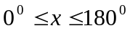
(d) f(x) = 2 – cos x for 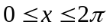
(e) f(x) = 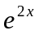for

5. x, y are the real numbers such that -1 x, y1.
- If (x, y) P x² + y² = 1. Is P a function? Explain.
- If (x, y) Q x = y – 1. Is Q a function? Explain.
- Repeat question (b) if - x, y.

6. Given that f(x) = x³ – 8 and g(x) = x – 2. Find
(a) (f + g)(x)
(b) (g – f)(x)
(c) (fg)(x)
- (g/f)(x)
- (fg)(x)
- (gf)(x)
- h⁻¹(x) and h⁻¹(10) given that h(x) = x² – 4x + 5.

7. Given that f(x) is a linear function such that f(2) = 5 and f(4) = 8.
(a) Find f(x).
(b) Find f ^{–1}(x) and f ^{–1}(-2).

8. f is the function ‘add 2 to x and then square’
(a) Write f in the form f(x)
(b) Find f(1), f(-1), f(0).
(c) If f(x) = 25, find the value of x,

9. A function f is given by f(x) = x² – x + 1. Find
(a) f(2)
(b) the image of -2
(c) f(r)
(d) f(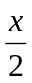)

10. Given that f(x – 2) = 6x² + 4, find
(a) f(x)
(b) f(3)
(c) f(x – 1)

11. If f(x) = x² + x – 3, find f(x + h) where h is a constant.
Hence express 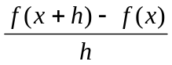 in its simplest form.

12. If f(x) = 3x + 1, find
(a) f(a)
(b) f(b)
(c) f(a + b). Is f(a + b) = f(a) + f(b)?

13. Express in logarithmic form.
(a) 7³ = 343
(b) 5⁻² = 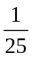
(c) 27^{2/3} = 9
(d) 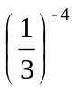= 81
(e) 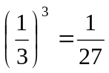

14. Express in exponential form.
(a) log₇ 49 = 2
(b) log₅ 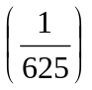= – 4
(c) log₄ 2 = 
(d) log_{1/2} 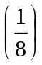= 3
(e) log_{1/2} 16 = – 4

15. If f(-x) = f(x), f is called an even function, but if f(-x) = -f(x), f is called an odd function. Which of the following functions are even, which are odd and which are neither?
(a) 2x
(b) 3x²
(c) x³
(d) 2 – 3x
(e) 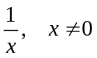
(f) sin x
(g) ln |x|
(h) log 5x
(i) cos 3x
(j) tan 2x
(k) 