- Find the slope and the y-intercept of the line.
(a) 11x – 3y = 54
(b) y = -6
(c) -22x = 52 + 12y
(d) 44x – 30y = 712
(e) 13x + 3y = 57
(f) 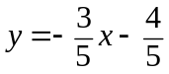

- Write an equation of the line that contains the given point and has the given slope.
(a) (4, -5), slope = -4
(b) (-12, -10), slope = 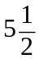
(c) (44, -10), slope = 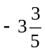
(d) (0, 1) , slope = 2
(e) (1, 9), slope =
(f) (-7, 7), slope = 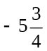

- Write an equation of the line that passes through the given two points.
(a) (3, -4), (6, 2)
(b) (-2, 7), (8, 12)
(c) (0, 5), (20, 25)
(d) (-3, -7), (27, -52)
(e) (44, 13), (112, 166)
(f) (2, 7), (26, 143)

- Write an equation of the line.
  - y –intercept = -4, x –intercept = -2
  - y-intercept = -35, x-intercept = -7
  - y-intercept = 12, x-intercept = -4
(d) y-intercept = 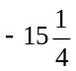, x-intercept = 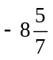
(e) y-intercept = 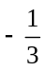, x-intercept = 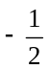
(f) y-intercept =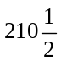, x-intercept = 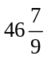

- State whether the lines are parallel, perpendicular, or neither.
(a) 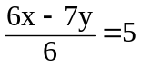 and y =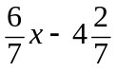
(b) x = -3y – 31 and x + 3y = -31
(c) 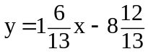 and 38y = 104 + 26x

(d) 6x – 17y = -686 and 2x + y = -2
(e) 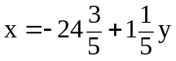and y = 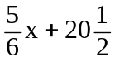
(f) 5x – 4y = -174 and -12y = -522 – 15x

6. (a) Write an equation of a line that passes through the point ( -8, 24) and is
parallel to the following equation:
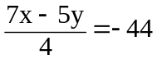
- Write an equation of a line that passes through the point ( -5, -25) and is perpendicular to the following equation: 9x – 17y = 380
- Write an equation of a line that passes through the point ( 18, 11) and is perpendicular to the following equation: x = -92 + 10y
- Write an equation of a line that passes through the point ( -32, -7) and is parallel to the following equation: y = 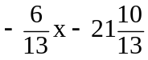
- Solve the following equations
(a) 2(5x +3) – 6(x – 4) = 48
(b) 2x – 7(3- 2x) = 4(x + 8)
(c) 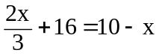
(d) 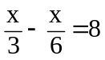
(e) a + 9 + 4(a – 2) = -1
(f) 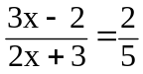

8. Solve each system of equations using the substitution method
- 13x + 7y = -378 and x – 4y = 39
- 17x – y = -139 and 10x + 12y = -472
- 10x + 9y = -453 and 2x – 17y = 41
- 4x + 3y = 84 and 8x + 3y = 204

9. Solve each system of equations using the elimination method
- y = 4x – 136 and 3x – 8y = 189
(b) 18x + 11y = 522 and 10x = 112 – 16y
(c) 19x + 3y = 459 and 22x + 3y = 513
(d) 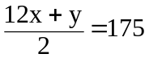and 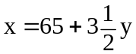

10. Write an equation for a parabola that passes through the given points
(a) (-3, -22), (2, 3), (0, -1)
(b) (-3, 0), (1, -16), (-2, -1)
(c) (0, -23),(-5, 2), (4, -79)
(d) (-5, -3), ( 4, 78), (2, 46)

11. Solve each equation by factoring
(a) x² + 7x – 55 = -25
(b) 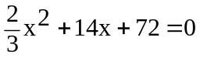
(c) 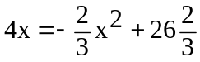
(d) -7x² - 34 = -11x²-11x +11
(e) x² +10x - 9 = 2x²
(f) 7x² –10x + 6 = 2x² + x

- Repeat Questions 11 use
- quadratic formula
- complete the square method

13. Given that f(x) = x² – 3x + 6 and g(x) = x + 6, solve the equations
(a) f(x) = 2g(x)
(b) f(x) = g(2x)
(c) f(2x) = g(x) – 3

14. If f(x) = 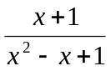, find the value of k (where k 1) such that f(k) = f(1)

15. Find the range of values of p for which each of the given equations has two distinct real roots.
(a) x² + 2px – 5p = 0
(b) p(x² – 1) = 3x + 2
(c) x(x + 3) = p(x – 1)

16. Solve the given simultaneous equations
(a) 2x – 3y = 4
x² – 3xy + 3y² = 7
(b) x + 2y = 3
3x² + 7xy + 2y² = 12
- 4x + y + z = a
x + 4y + z = b
x + y + 4z = c
express the answer in terms of a, b and c
(d) x³ + y³ = 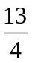
xy = 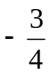
(e) 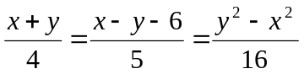

17. Solve the following questions:
(a) Find the two consecutive integers whose sum is 117.
(b) To stimulate his daughter in the pursuit of problem solving, John offered to pay her $8 for every question correctly solved and fine her $5 for every incorrect solution. At the end of the first 26 problems of this problem set, neither owned any money to the other. How many problems did the daughter solve correctly?
(c) The area of a right triangle is 17.5 cm². One leg is 2 cm longer than the other. What is the length of the shortest side?
(d) In a lake the bud of a water lily was observed, one cubit (an ancient unit of length) above the water, and when moved by the gentle breeze, it sunk in the water at two cubits’ distance. Find the depth of the water.

18. If α and β are the roots of the equation 2x² – x – 4 = 0, find the values of
(a) α² + β²
(b) (α – β)²
(c) 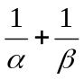

19. Solve for the unknown.
(a) 3^{18 + 3x} = 27 (b) 4^{2 + 3x} = 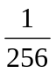 (c) 2^{2x – 10} = 4
(d) 16^{1 + x} = 8^{x + 2} (e) 3^{x – 6} – 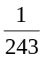 = 0 (f) 8^{x – 1} = 32^{x – 3}
(g) 3^{x} × 2^{2x – 3} = 18 (h) 2^{x} × 5^{x + 1} = 
(i) 3^{2x – 3} – 4 × 3^{x – 2} + 1 = 0

20. Given that log₃ 2 = p and log₃ 5 = q, express in terms of p and q
(a) log₃ 60
(b) log₃ 6.4
(c) log₁₀ 2

21. Solve for the unknown.
(a) log₂ 8 + log₂ 32 = v
(b) log₃ 27 – log₃ 243 = a
(c) log₃ t – log₃ 9 = 2
(d) log₄  – log₈ = v
(e) log₈ 64 – log₁₆ a = 
(f) log₉ 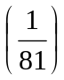+ log₄ 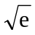 = 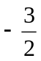
(g) log_{1/4} 64 + log_{1/2} 16 = r
(h) log_{1/4} 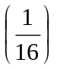 + log₂₇ p =
(i) log₂ x⁴ + log₂ 4x = 12

22. If log₄ x = p, show that log₂ x = 2p. Hence find the value of k if log₄ k = 2 + log₂ k

23. Solve the simultaneous equations
(a) log₂ x – log₄ y = 4
log₂ (x – 2y) =5
- 9^{x} = 27^{y}
64^{xy} = 512^{x+1}

24. Evaluate the following without using tables or calculator.
(a) cos 0° (b) cos 90° (c) cos 180°
(d) cos 270° (e) tan 0° (f) tan 90°
(g) tan 180° (h) tan 270° (i) cos (−30°)
(j) cos (−60°) (k) cos (−45°) (l) sin (−30°)
(m) sin (−60°) (n) sin (−45°)

25. Solve for x in the following equations. (0° ≤ x ≤ 360°)
(a) 2 sin x – 1 = 0 (b) 2 sin 3x – 1 = 0
(c) sin x + 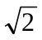= - sin x (d) 3 tan²x – 1 = 0
(e) cot x cos²x = 2 cot x (f) 2 sin²x – sinx – 1 =0
(g) 2 sin²x + 3 cos x – 3 = 0 (h) 2 cos(3x – 1)= 0
(i) sin 2x = sin x (j) 1 – 2sin x – 4 cos 2x = 0

(k) sin 5x + sin 3x = 0 (l) cos(x + 60°) = 2 sin(x + 30°)

26. Prove that
(a) cos⁴ A – sin⁴ A = cos 2A
(b) 