(1) Find 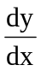 in the following cases:
(a) y = 2x⁵ + 3x² – 1 + 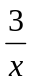 (b) y =6x⁻⁴ +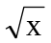- 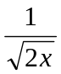 (c) y = (4x – 5)⁶
(d) y = 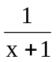 (e) y = 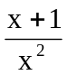 (h) y = 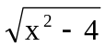
(i) y = 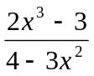 (j) y = (x² – 1)³(3x + 1)⁴
(2) Find in the following cases:
(a) y = cos x (b) y = sin x (c) y = tan x (d) y = sec x
(e) y = cosec x (f) y = cot x (g) y = sin 2x (h) y = cos(x²)
(i) y = tan (5x – 4) (j) y = sin² x (k) y = cos³ 3x
(l) y = 6 sin² 2x (m) y = 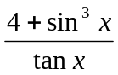 (n) y = cos(x³ + 4x + 5)
(o) y = cos(3 – 5 sin 7x)

(3) Find in the following cases:
(a) y = log₁₀ x (b) y = log_{a} x (c) y = ln x (d) y = e^{3x}
(e) y = a³ (f) y = a^{x} (g) y = 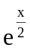 (h) y = e^{3 – x}

(i) y = ln 4x (j) y = sin x^{(ln x)}

(4) Find in the following cases:
(a) y = e^{sin x} (b) y = ln (3 – 4 cos x) (c) y = x² tan x
(d) y = e^{5x}(3x+1) (e) y = x cos 2x (f) y = e^{2x}ln 5x
(g) y = x² ln (sin x) (h) y = x³ sin 5x (i) y = 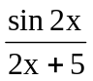
(j) y = x⁵ sin 2x cos 4x (k) x² + 2xy + 3y² = 4 (l) x³ + y³ + 3xy² = 8
(m) y = 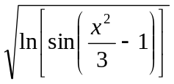 (n) y = 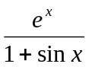

(5) If x² + y² – 2x – 6y + 5 = 0, find and 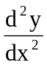at x = 3, y = 2.

(6) Find the values of x for which the function y = f(x), defined by y(3x – 2) = (3x-1)²
has maximum and minimum values and distinguish between them.

(7) Find the maximum and the minimum values of the function f(x) = 2 sin x + cos 2x for 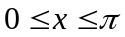.

(8) A rectangular field is to be bounded by a fence on three sides and by a straight stream on the fourth side. Find the dimension of the field with maximum area that can be enclosed with 1000 feet of fence.

(9) If x² + y² = 1, prove that 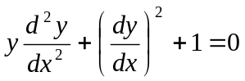

(10) If y = e^{-x} sin2x, prove that 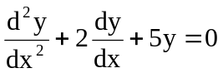

(11) y = cos 2t, x = sin t. Find and

(12) Given that y = A cos wt, prove that 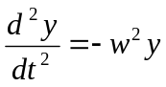

(13) Use the derivative formula for sin x and the identity
cos x = sin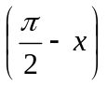
to obtain the derivative formula for cos x.

(14) x and y are two nonnegative number, if the sum of x and y are 1000, find the maximum product of x and y.

(15) A curve defined by the parametric equations
Find the tangent line at 

