(1) Find
(a) 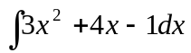 (b) 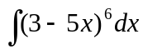
(c) 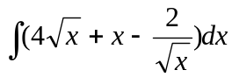 (d) 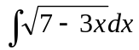
(e) 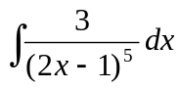 (f) 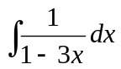
(g) 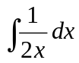 (h) 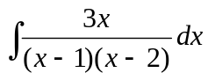
(i) 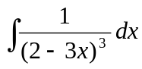 (j) 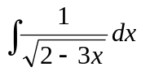
(k) 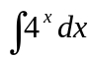 (l) 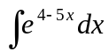
(m) 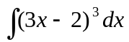 (n) 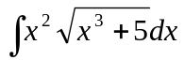
(o) 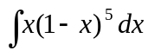 (p) 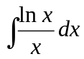
(q) 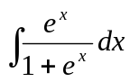 (r) 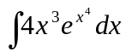
(s) 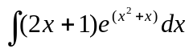 (t) 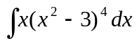
(u) 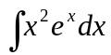 (v) 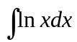

(2) Evaluate
(a) 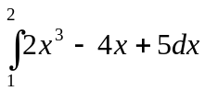 (b) 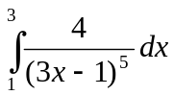
(c) 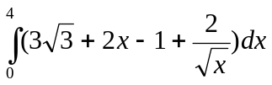 (d) 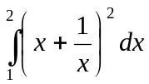
(e) (f)
(g) 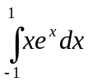 (h) 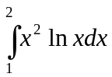
(h) 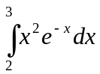 (i) 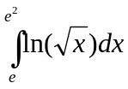
(j) 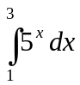 (k) 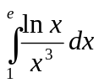
(l) 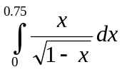

(3) Find the area bounded by
(a) the curve y = x² – x + 3, the x-axis and the lines x = 2 and x = 4.
(b) the curve y = 2 + x – x² and the line y = x + 1
(c) the x-axis, the lines y = 2x – 5, x = -1 and x = 2.

(4) Find an expression for y in terms of x, given that 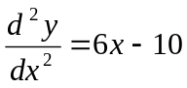and that when
x = 1, y = 1 and 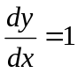.

(5) The gradient of a curve is given by 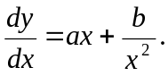 If the curve passes through the point (-1, -4) and has a turning point at the point (1, 0), find its equation.

(6) Evaluate 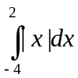, where |x| is defined as the magnitude of x.

