(1) Simplify
(a) i ²¹ (b) i ⁵⁰⁰ (c) i ⁻² (d) i ^{–9} (e) i ^{4k}, k is positive integers.

(2) Write down the roots of the following equations:
(a) x² – 4 = 0 (b) x² + 2 = 0 (c) 4x² + 9 = 0
(d) x² – 2x + 2 = 0 (f) x² – x + 1 = 0 (g) 2x² + 3x + 2 = 0

(3) Write down the conjugates of the following complex numbers:
(a) 3 + 5i (b) 2 – i (c) i - 5
(d) The answer for questions 2(a), 2(b) and 2(c)

(4) Express the following questions in the form a + ib:
- (5 + 8i) + (2 + i)
- (5 – 9i) – (2 – 6i) + (3 – 4i)
- (6 – 3i)(2 + 5i)
- (2 + i)(3 – 2i)(4 + 3i)
- (2 + 3i)(2 – 3i)
- 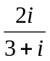
- 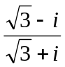
- 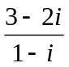
- 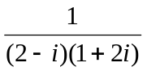
- 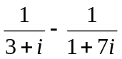
- 3 + 4 i + 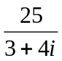

(5) Find the square roots for the following complex number:
- 2 i
- –4 i
- 8 + 6 i
- 21 – 20 i

(6) Find the complex factors for the following quadratic expression
- x² + 1 (b) 9x² + 4 (c) 2x² + 18
(7) If z₁ = (2 + i), z₂ = (-2 + 4 i) and 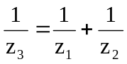, evaluate z₃ in the form a + i b.

(8) Find the modulus and principal argument of each of the given complex number.
(a) 1 – i (b) –2 + i (c) –3 (d) 4 i

(9) Find the modulus and principal argument of each of the given complex number. Give the argument in radians, either as a multiple of or correct to 3 decimal places.
(a) 5 – 3 i (b) – i (c) 5 (d) 2 + i

(10) If z = r (cos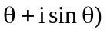, where r > 0 and 0 < < ½ , find in term of r and the modulus and principal argument of
(a) –z (b) iz (c) z² (d) z / z*

(11) Write the following complex numbers in the polar form:
(a) 6 + 8 i (b) 1 + i (c) –3 + 4 i (d) 2 – i

(12) Represent all the complex numbers in (11) in an argand diagram.

(13) Find z₁ – z₂ for the following questions. Represent the vectors of z_{1,} z₂ and (z₁ – z₂) in an argand diagram.
(a) z₁ = 3 + 2 i, z₂ = 4 + i (b) z₁ = -4 + i, z₂ = 2 – i

(14) Find the images of z₁ and z₂ in 13(a) and (b) under the transformation of
- Rotation of 90º clockwise about the origin
- Rotation of 90º anti-clockwise about the origin
- Rotation of 180º about the origin

(15) If is a complex cube root of unity (the roots of z³ = 1), find the value of ³ and
² + + 1. Hence find the value of ³ + ⁴ + ⁵.

(16) Find the roots of the following equations in the form a + ib.
(a) z³ – 8 = 0 (b) z³ + 1 = 0

(17) Express in the form re^{iθ}, each of the complex number:
(a) 1 + i (b) 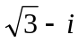 (c) (1 + i)( ) (d) 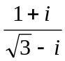

(18) Use De Moivre’s theorem to prove that

(cos pθ + i sin pθ) (cos qθ + i sin qθ) = cos (p + q)θ + i sin (p + q)θ

Hence simplify 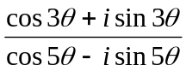

(19) If w = 1 + i and z = 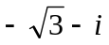, find 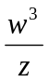in the form re^{iθ} where r > 0 and 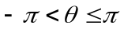

(20) Solve (1 + 3i)p – 2p = -5 + 9i, where p is a complex number.

(21) Show that for any complex number e^{iθ}, 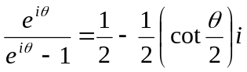

(22) Use De Moivre’s theorem to simplify the following expression
(a) (cos 2θ + i sin 2θ)(cos 5θ + i sin 5θ) (b) 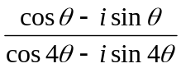

(23) Prove the following using De Moivre’s theorem
cos 4θ = 8 cos⁴ θ – 8 cos² θ + 1

(24) In the quadratic equation x² + (p + iq)x + 3i = 0, p and q are real. Given that the sum
of the squares of the roots is 8, find all the possible values of p and q.

(25) Find the complex number z which satisfies the equation
(a) 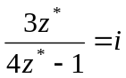 (b)(z + i)* = 2iz + i

