Answer All Questions (Total 100 marks)

QUESTION 1 (25 Marks)

(a) (i) f(3) = 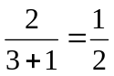
[m1, a1]
(ii) (fg)(x) = 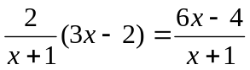
[m1, a1]
(iii) (g o f)(x) = 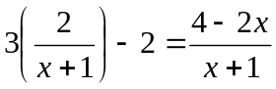
[m2]
Let y = (g o f)(x)
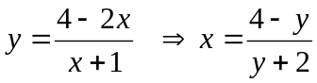
(g o f)⁻¹(x) = 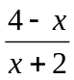
[m2, a1]

(b) 9x – 8 = a(ax + b ) + b = a²x + ab + b
a² = 9  a = 3 since a > 0
ab + b b = -2
[m3, a2]

(c) 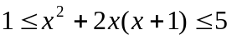
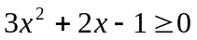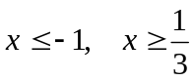
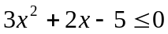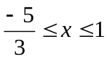
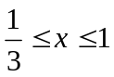
[m5, a2]

(d) 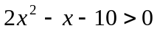
(2x² – 5)(x + 2) > 0
Domain = {x < -2, x > }
Range = {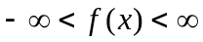}
[m2 a2]

QUESTION 2 (50 Marks)

(a) 4x – 3y = 2
y = 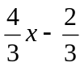 m = 
The equation:
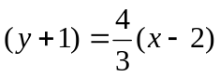
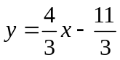
[m2, a1]

(b) Let the quadratic function be f(x) = ax² + bx + c
When x = 0, f(x) = 10 c = 10
When x = 1, f(x) = 0
b = -a – 10 ----- (1)
At maximum point, x = 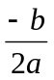
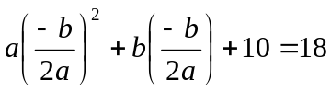
a² + 52a + 100 = 0
(a + 2)(a + 50) = 0
a = -2 or a = -50

When a = -2, b = -8
f(x) = -2x² – 8x + 10

When a = -50, b = 40
f(x) = -50x² + 40x + 10
[m5, a2]

(c) x² + xy = 2 ------(1)
xy + y² = 14 ------(2)
- + (2)
(x + y)² = 16 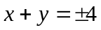---------(3)
From (1)
x(x + y) = 2 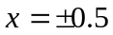

When x = 0.5, y = 3.5
When x = -0.5, y = -3.5

x = 0.5, y =3.5 or x = -0.5, y = -3.5
[m3, a4]

(d) 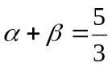, 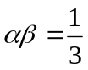
[m1]
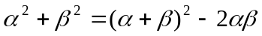 = 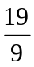
[m2, a1]

(e) 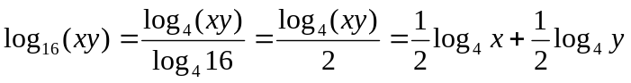
[m3]
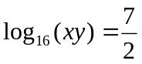
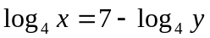 ---------- (1)
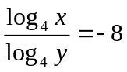
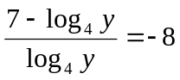
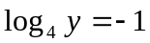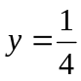
From (1)
log₄ x = 7 – (-1) x = 65536
[m3, a2]

(f) 6(4^{x} + 9^{x}) = 13(6^{x})
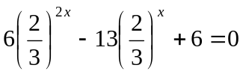
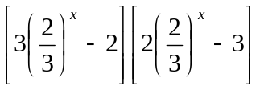= 0
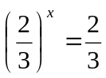 or 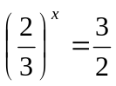
x = 1 or x = -1
[m6, a2]

(g) tan(x – y) = 2
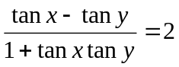
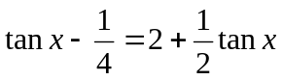
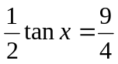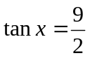
[m3]
(h) 5 cos 2x + 20 sin 2x + 13
= 18 cos² x + 40 sin x cos x + 8 sin² x
= 2 (9 cos x + 2 sin x) (cos x + 2 sin x)
[m3]
5 cos 2x + 20 sin 2x + 13 = 0
2 (9 cos x + 2 sin x) (cos x + 2 sin x) = 0
9 cos x + 2 sin x = 0 or cos x + 2 sin x = 0
tan x = -4.5 or tan x = -0.5,
x = 102.53⁰, 153.43⁰, 282.53⁰, 333.43⁰
[m3, a4]

QUESTION 3 (25 Marks)

(a)
x | 0 | 1 | 2 | 3 | 4 | 5 | 6 | 7
y | 0 | 3 | 4 | 3 | 0 | -5 | -12 | -21
[a6]

(b) 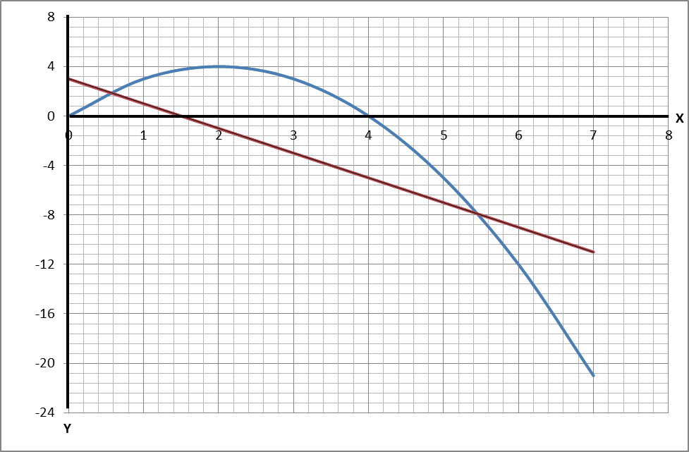
y = 4x – x²
y = -2x + 3
y = -2
[a9, each axis 2 marks, graph 5 marks]

(c) The straight line: y = -2x + 3
x = 0.6 and 5.5
[a6, draw line and line equation 4 marks, each value of x 1 mark]

(d) As shown in graph (b)
[a4, draw line 1 mark, shade the region 3 marks]

