Answer All Questions (Total 100 marks)

QUESTION 1 (25 Marks)

(a) Given that 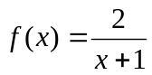 and g(x) = 3x – 2. Find

(i) f(3)
[2 marks]

(ii) (fg)(x)
[2 marks]
(iii) (g o f)⁻¹(x)
[5 marks]

(b) Given that
f ^{n}(x) = f(f ^{n – 1}(x)), n = 2, 3, 4….

If f(x) = ax + b (a > 0) and f ²(x) = 9x – 8, find the values of a and b.
[5 marks]

(c) A square has side x cm and a rectangle has sides x cm and 2(x + 1) cm. If the total area of the square and the rectangle is between 1 cm² and 5 cm², what is the range of the values of x?
[7 marks]

(d) If x and f(x) are real, state the domain and range for the function
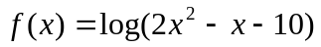
[4 marks]

QUESTION 2 (50 Marks)

(a) Find the equation of the straight line that passes through the point (2, -1) and parallel to the line 4x – 3y = 2.
[3 marks]

(b) Find two quadratic functions of x which are zero at x = 1, which take the value 10 when x = 0 and which have a maximum value of 18.
[7 marks]

(c) Solve the given simultaneous equations
x² + xy = 2
xy + y² = 14
[7 marks]

(d) If α and β are the roots of the equation 3x² – 5x + 1 = 0, find the value of
α² + β².
[4 marks]

(e) Show that
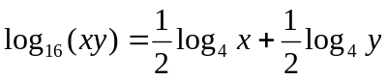.

Hence, or otherwise, solve the simultaneous equations
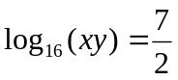
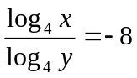
[8 marks]

(f) Solve the equation
6(4^{x} + 9^{x}) = 13(6^{x})
[8 marks]

(g) If tan(x – y) = 2 and tan y = , find the value of tan x.
[3 marks]

(h) Prove that
5 cos 2x + 20 sin 2x + 13 = 2 (9 cos x + 2 sin x) (cos x + 2 sin x).

Hence, or otherwise, solve the following equation for 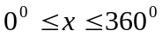.
5 cos 2x + 20 sin 2x + 13 = 0
[10 marks]

QUESTION 3 (25 Marks)

(a) Copy and complete the table below for the equation y = 4x – x²

x | 0 | 1 | 2 | 3 | 4 | 5 | 6 | 7
y | 0 |  |  |  |  |  |  | -21
[6 marks]

(b) By using a scale of 2 cm to 1 unit on x-axis and 2 cm to 4 units on y-axis, draw the graph of y = 4x – x² for 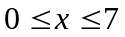.
[9 marks]

(c) Draw a straight line on your graph to find all the values of x which satisfy the equation 6x – x² = 3 for . State these values of x.
[6 marks]

(d) Shade the region which defined by the inequalities 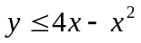, 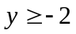 and 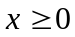.
[4 marks]

Formulae

Quadratic equation

If 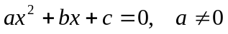  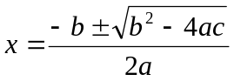 | If has roots and,  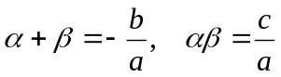

Exponential and logarithm

a^{m} a^{n} = a^{m + n}  a^{m} a^{n} = a^{m – n}  (a^{m})^{n} = a^{mn}  (ab)^{n} = a^{n}b^{n}  a^{-n} = 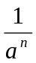  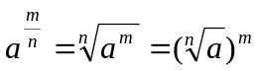  a⁰ = 1 | log_{a} (xy) = log_{a} x + log_{a} y  log_{a} (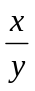) = log_{a} x – log_{a} y  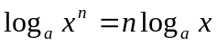  log_{a} a = 1  log_{a} 1 = 0  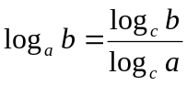

Trigonometry

sin² + cos² = 1  tan² + 1 = sec²  1 + cot² = cosec²  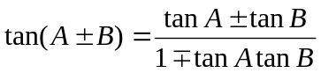 | 