Answer All Questions (Total 100 marks)

QUESTION 1 (50 Marks)

(a) (i) y = 3x⁴ – 2x² + x – 2 + 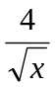
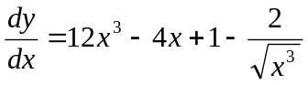
[a3]
(ii) 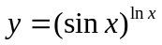
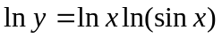
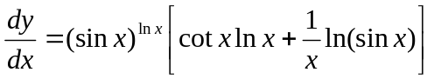
[m3, a1]
(iii) 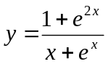
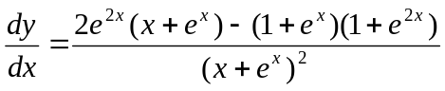
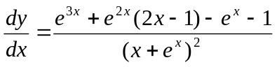
[m3, a1]
(iv) 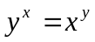
x ln y = y ln x
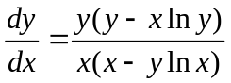
[m4, a1]

(b) (i) (A) 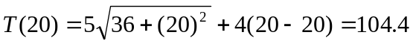
T(20) = 10.44 seconds
[m1, a1]
(B) 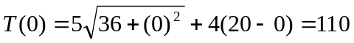
T(0) = 11 seconds
[m1, a1]
(ii) 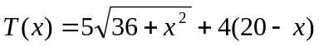 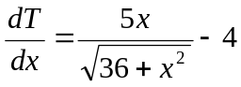
At minimum time, 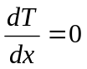
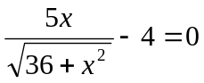 x = 8
[m4]
When x = 8
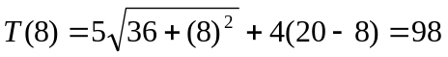= 9.8 seconds
[m1, a1]
(c) (i) y = e^{-x} sin2x
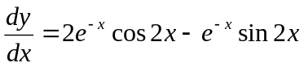
[m2]
When x = 0
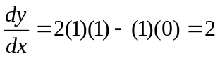
[m1, a1]
(ii)
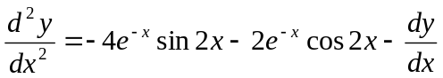
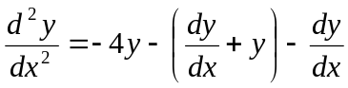
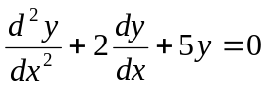
[m4, a1]

(d) x = sin² θ 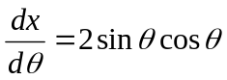
y = 2 sinθ 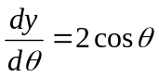
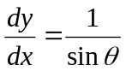
Tangent line equation
y – 2 sin θ = 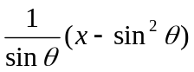
x – y sinθ + sin²θ = 0
[m5]

(e) (i) g’(x) = 3[f(x)]²f ’(x)
g’(2) = 21
[m4, a1]
(ii) h’(x) = 3x²f ’(x³)
h’(2) = -36
[m4, a1]

QUESTION 2 (50 Marks)

(a) (i) 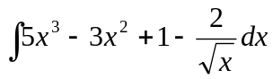
= 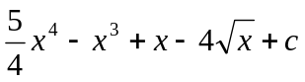
[m2, a1]

(ii) 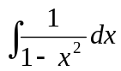= 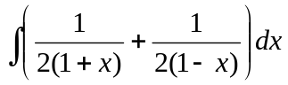
= 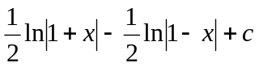
[m3, a1]
(iii) Let 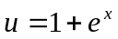 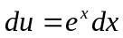
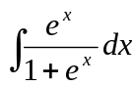 = 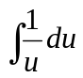= ln |u| + c = ln |1 + e^{x}| + c
[m3, a1]

(b) (i) 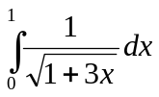 = 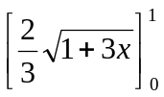= 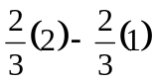 = 
[m2, a1]
(ii) Let 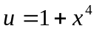 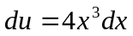
When x = 0, u = 1
When x = 2, u = 17
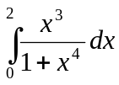 = 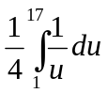= 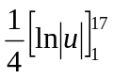= 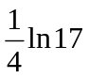= 0.708
[m3, a1]
(iii) Let u = ln x 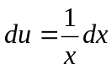
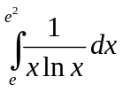= 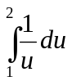= 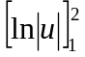= ln 2 = 0.693
[m3, a1]

(c) Let u = x + 4 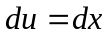
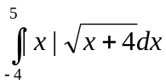
= 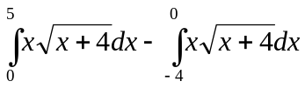 = 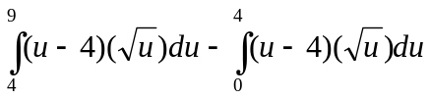= 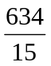
[m5, a1]

(d) (i) 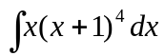= 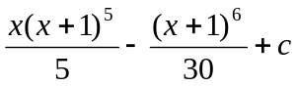= 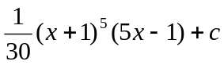
[m3, a1]
(ii) Let u = x + 4 , x = u – 1
= 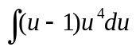
= 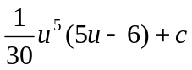=
[m3, a1]

(e) Area
= 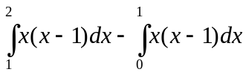
= 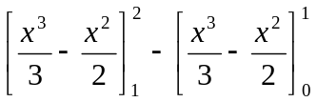= 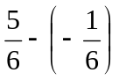 = 1 unit²
[m6, a1]

(f) 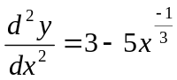
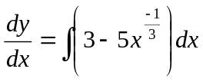 = 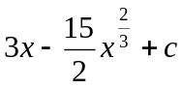
When x = 1, 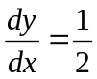
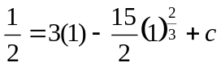 c = 5
y = 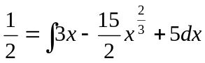 = 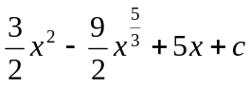

When x = 1, y = 5
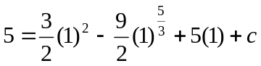 c = 3

When x = 8,
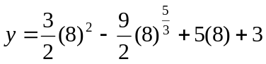= -5
[m6, a1]

