Answer All Questions (Total 100 marks)

QUESTION 1 (50 Marks)

(a) Find  in the following cases:
(i) y = 3x⁴ – 2x² + x – 2 + 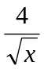
[3 marks]
(ii) 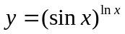
[4 marks]
(iii) 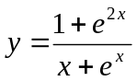
[4 marks]
(iv) 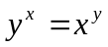
[5 marks]

(b) A crocodile is stalking prey located 20 metres further upstream on the opposite bank of a river. Crocodiles travel at different speeds on land and in water. The time taken for the crocodile to reach its prey can be minimised if it swins to a particular point, P, x metres upstream on the other side of the river as shown in the diagram below.

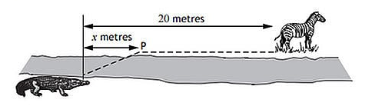

The time taken, T, measured in tenths of a second (10⁻¹ seconds), is given by
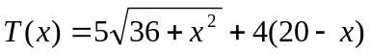

- Assume the prey doesn’t move, calculate the time (in seconds) taken if the crocodile
- does not travel on land.
[2 marks]
- swims the shortest distance possible.
[2 marks]
- Assume the prey doesn’t move, find the value of x which minimises the time taken and hence calculate the minimum possible time (in seconds).
[6 marks]

(c) If y = e^{-x} sin2x,
(i) find the expression for . Find the value for when x = 0
[4 marks]
(ii) prove that 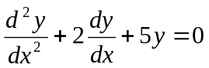
[5 marks]

(d) The parametric equation of a curve are: x = sin² θ, y = 2 sinθ. Show that the tangent to the curve at the point P(sin² θ, 2 sinθ) has an equation
x – y sinθ + sin²θ = 0.
[5 marks]

(e)
x | f(x) | f ’ (x)
2 | 1 | 7
8 | 5 | -3

Given the above table of values, find
(i) g’ (2), given that g(x) = [f(x)]³.
[5 marks]
(ii) h’ (2), given that h(x) = f(x³).
[5 marks]

QUESTION 2 (50 Marks)

(a) Find the following indefinite integrals:
(i) 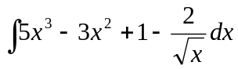
[3 marks]
(ii) 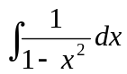
[4 marks]
(iii) 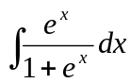
[4 marks]

(b) Evaluate
(i) 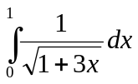
[3 marks]
(ii) 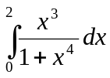
[4 marks]
- 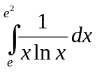
[4 marks]

(c) Using the substitution u = x + 4, evaluate 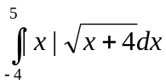.
[6 marks]

(d) Find 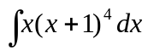by using
(i) integration by parts.
[4 marks]
(ii) integration by substitution.
[4 marks]

(e) Find the total area enclosed by the curve y = x(x – 1), the line x = 2 and the
x-axis.
[7 marks]

(f) y is a function of x and 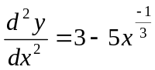. If 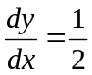and y = 5 when x = 1, find the value of y when x = 8.
[7 marks]

Formulae

Quadratic equation

If 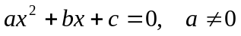  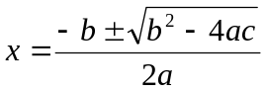 | If has roots and,  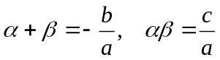

Exponential and logarithm

a^{m} a^{n} = a^{m + n}  a^{m} a^{n} = a^{m – n}  (a^{m})^{n} = a^{mn}  (ab)^{n} = a^{n}b^{n}  a^{-n} = 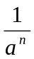  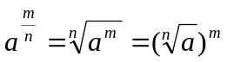  a⁰ = 1 | log_{a} (xy) = log_{a} x + log_{a} y  log_{a} (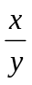) = log_{a} x – log_{a} y  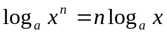  log_{a} a = 1  log_{a} 1 = 0  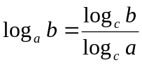

Trigonometry

sin² + cos² = 1  tan² + 1 = sec²  1 + cot² = cosec²  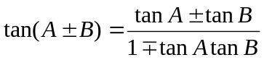 | 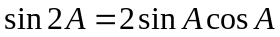  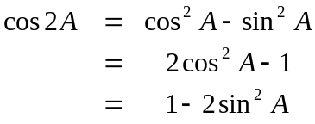  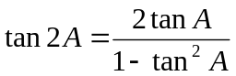  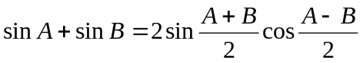  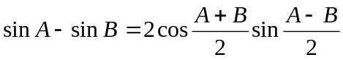  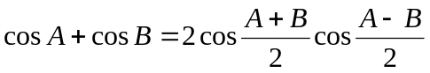  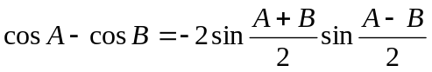

Differentiation and Integration

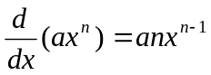  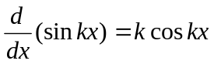  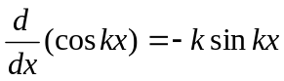  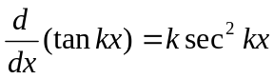  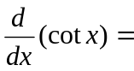-k cosec² kx  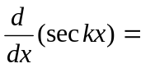 k sec kx tan kx  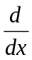(cosec kx) = -k cosec kx cot kx | 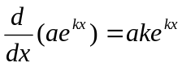  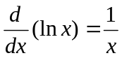  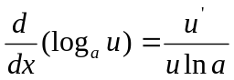  If y = u, 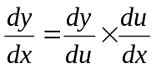  If y = uv, 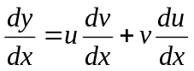  If y = 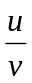, 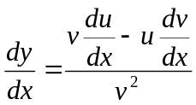

Integration

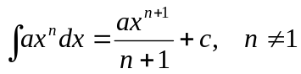  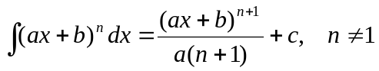  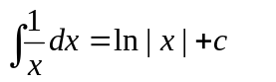  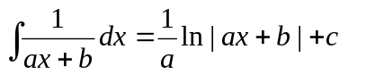  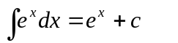 | 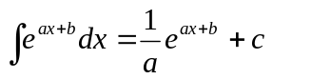  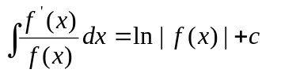  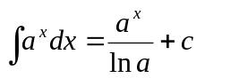  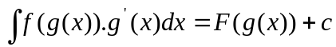  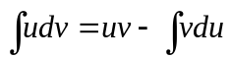

Complex Numbers

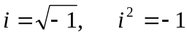  Conjugate  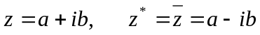  De Moivre’s Theorem  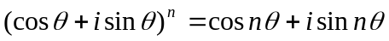 | 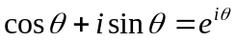  z = 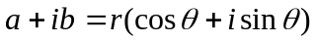  Modulus = | z | = r = 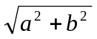  Argument = arg z = 