Q2: Build Mira, design, implementation and evaluation
Two-page write-up
Submitted by Santosh Rasputra

Design and architecture
Mira runs as one n8n workflow with 5 agents. An Orchestrator classifies each request and routes it to the Planner, Risk Assessor, Status Reporter (which also writes stakeholder updates) or Milestone Tracker. Counts, tables, dates and the health rating are computed by code. The model (gpt-4o-mini, temperature 0, JSON mode) writes short narrative only, and validators remove unknown task ids, risk ids, phases, milestones and ungrounded figures. Vague input is answered by a sufficiency gate with no model call. n8n gives visual workflows and file upload; Langfuse gives traces with tokens and cost.
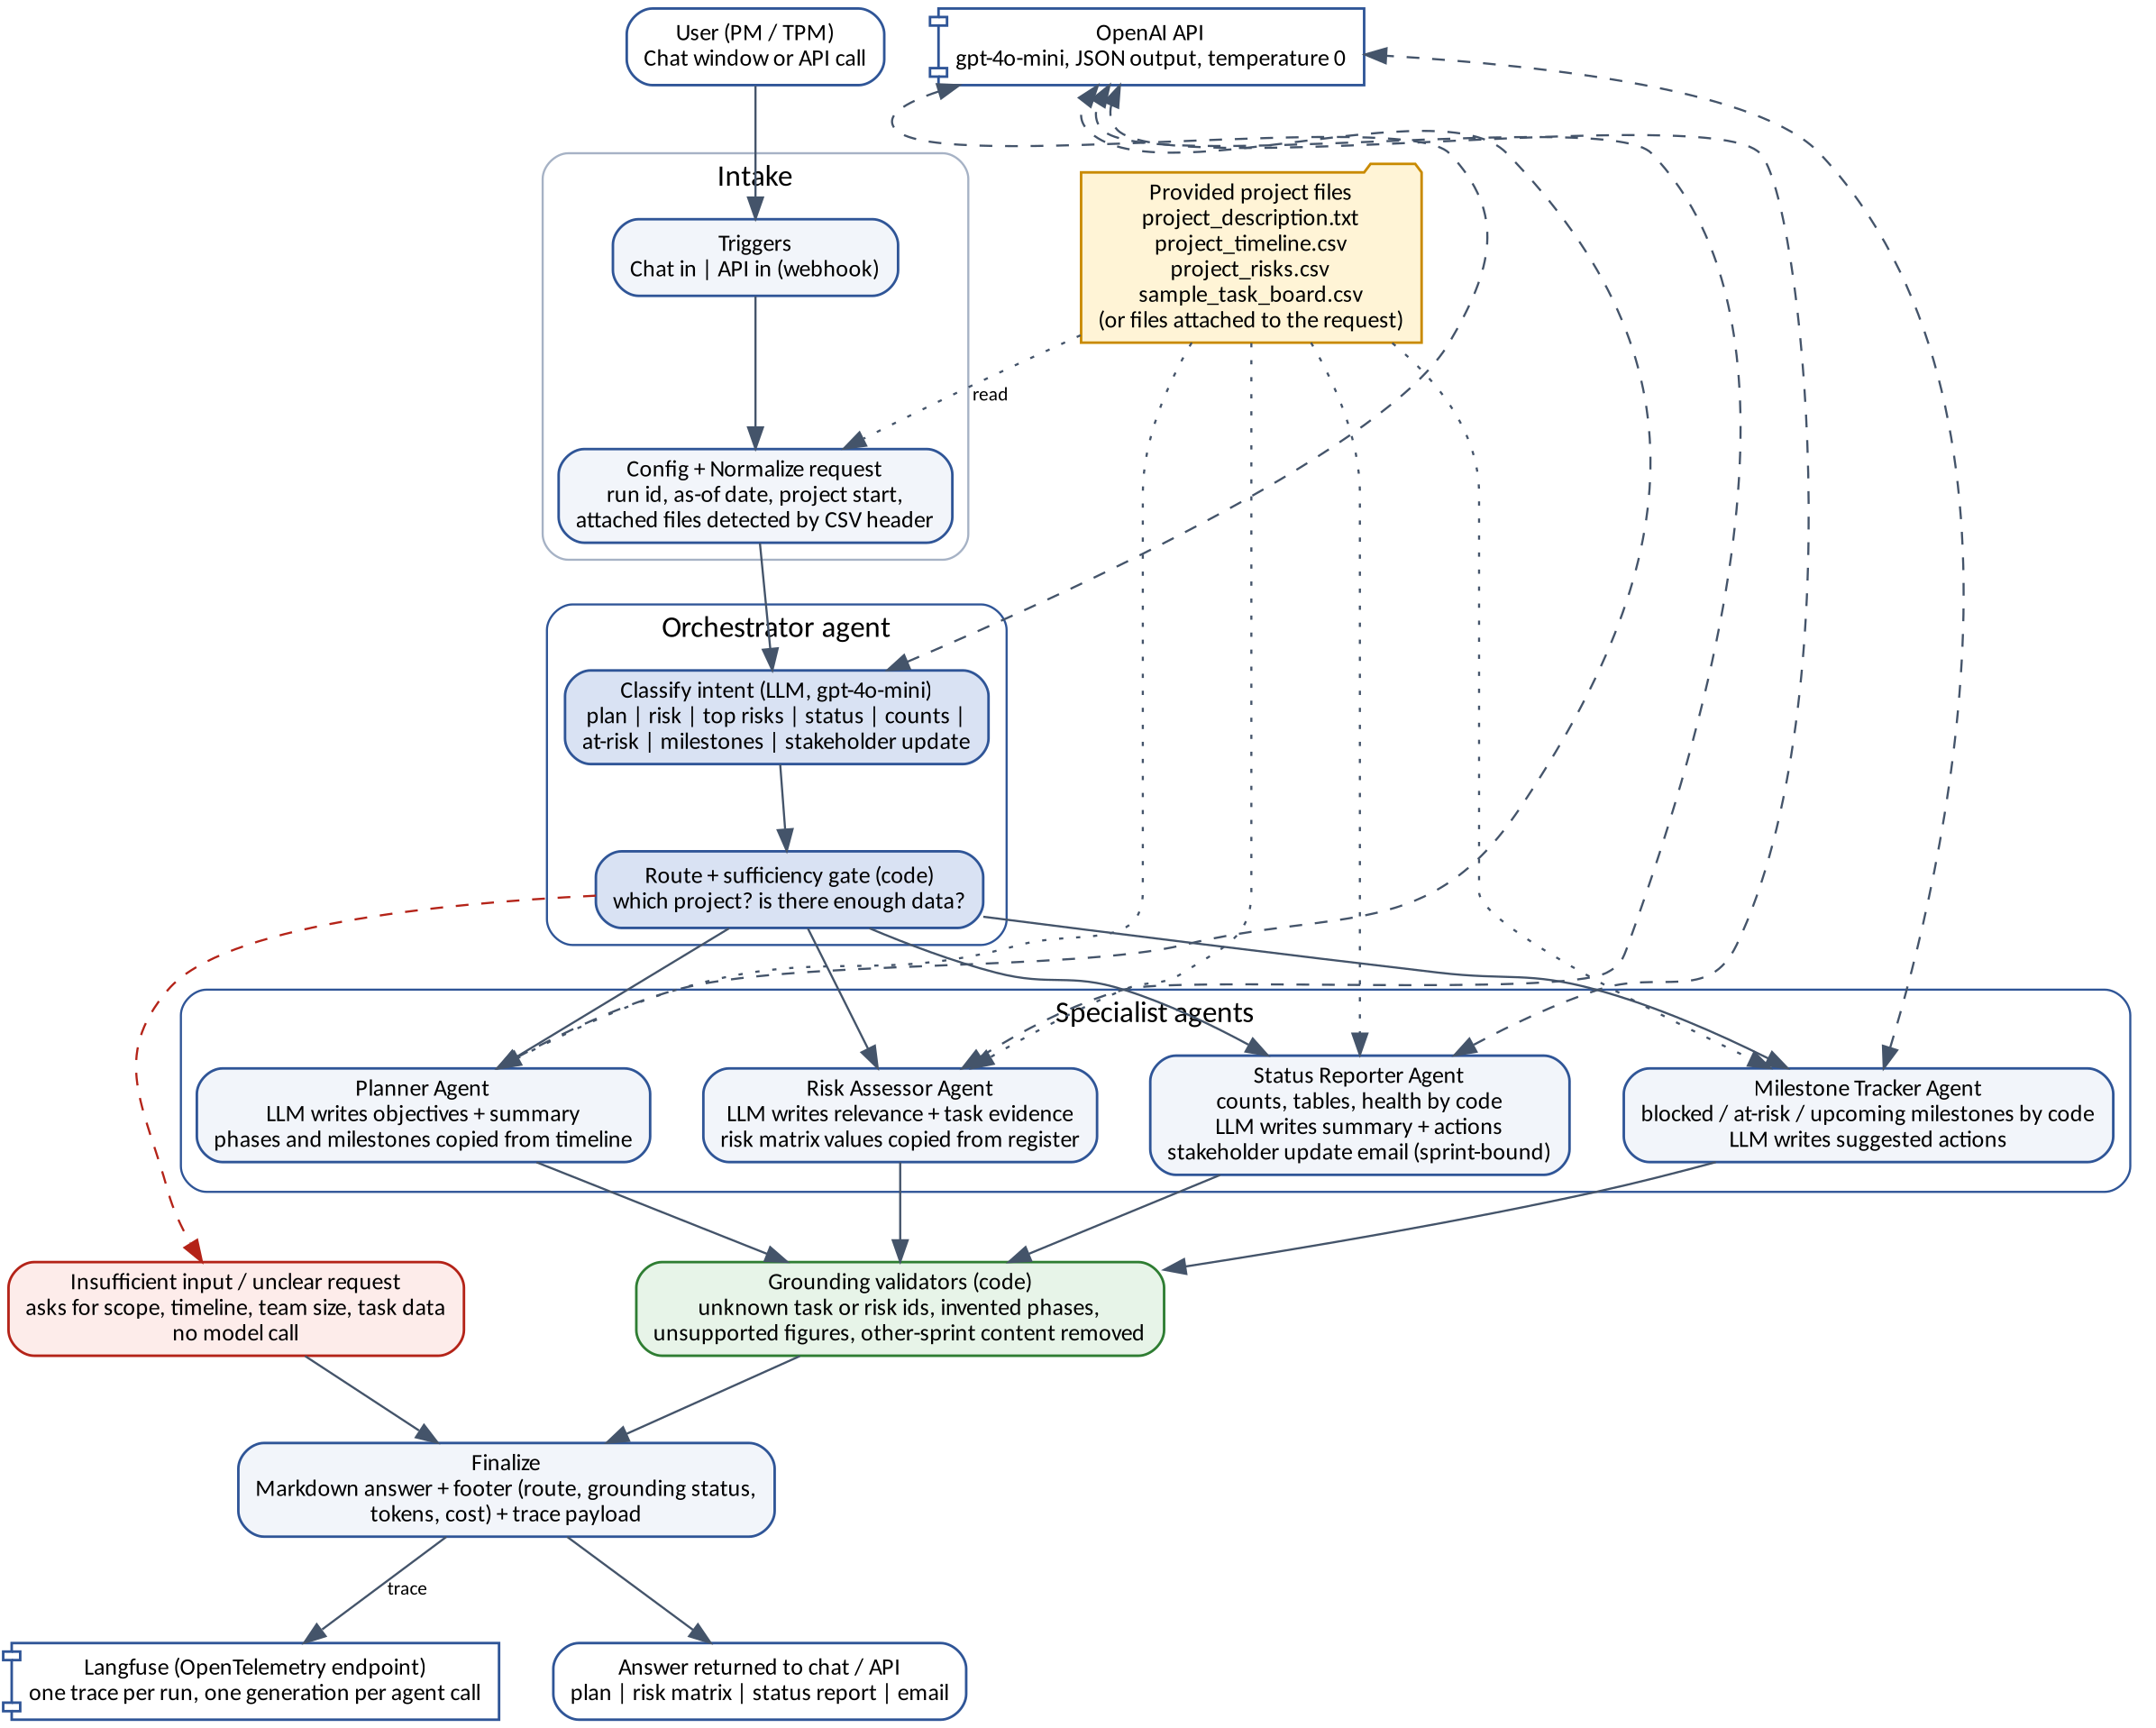

Implementation
Core: plan, risk assessment (and top N), weekly status report, task counts. Extended: blocked and overdue alerts, upcoming milestones (EX-1) and a stakeholder update email with audience tone (EX-2). Observability: every request sends an OpenTelemetry trace to Langfuse (a span per step, a generation per model call). Baseline: all 12 inputs run through a test harness with a pass or fail per expected element. Live result with gpt-4o-mini on n8n Cloud: 12 of 12 baseline tests pass (all 12 inputs, final workflow, 18 October 2026; full outputs are in the test results document). Offline guardrail tests with a stand-in model also pass: invented content, invalid model output and a model outage. T12 passed after a guardrail removed a false “sprint complete” claim; its trace is marked REVIEW because the guardrail intervened.

Cost and evaluation
Cost per plan | USD 0.00078 measured (2 calls, 1,715 input and 879 output tokens at USD 0.15 and USD 0.60 per 1M). The plan takes the longest to run, 10.9 seconds.
Cost per request, all types | USD 0.0001 to 0.0008 measured; USD 0.0003 average over the 12 tests, about 3.2 seconds average. About USD 0.12 per user per month at 20 requests per working day.
Metric 1: groundedness | Share of plan content traceable to the files. Target 100%, enforced by validators.
Metric 2: accuracy | Counts, lists and health rating equal the board. Target 100%, computed by code.
Metric 3: risk relevance | Share of risk notes a reviewer rates as specific to the project. Target 90% or more.
Metric 4: guardrail interventions | Share of requests with something removed (REVIEW). Target below 15%.

Observations
- The problem statement says 3 tasks are Done; the board has 5 (T001 to T005). Mira reports the board.
- The sample data has no "today". Mira uses 24 April 2026 and project week 1 from 30 March 2026, and states both in the answer. Both can be changed in the request.
- The live model needed the guardrails. They removed a goal whose evidence quote was paraphrased (T1, fixed by accepting close wording), dropped a false “sprint complete” claim from the stakeholder email (T12), and corrected the first top-risk ranking, which did not use board evidence (T7, fixed by ranking in code). The final T12 output passed; its trace is marked REVIEW because the guardrail intervened.
- The model wrote US-style dates in the email. Code now converts every date in an answer to UK style.

