Project 12 Test cases output
18th October 2026

The 12 inputs and what to check
Test |  | Expect
T1 | Generate a project plan for the AI Adoption Project at ABCDE Ltd. Use the provided project description. | 8 phases, all milestones, 24 weeks, goals 15% and 10%, no invented figures or phases
T2 | Generate a project plan for: “We want to build a chatbot.” (vague input) | Says more detail is needed; asks for scope, timeline, team size; no plan
T3 | Generate a risk assessment for the AI Adoption Project at ABCDE Ltd. Use the provided project description. | All 10 register risks (R01 to R10) by category; none invented
T4 | Generate a risk assessment for: “New project starting soon.” (vague input) | Says more detail is needed; no risks listed
T5 | Generate a weekly status report using the sample task board data for Sprint 3. | Tasks by status, Sprint 3 task names, T024 blocked, health GREEN, AMBER or RED
T6 | Generate a weekly status report for: “Things are going fine.” (no task data) | Says no task data; no task ids or percentages
T7 | What are the top 3 risks for the ABCDE Ltd project based on the risk data? | Exactly 3 risks, all from the register
T8 | Which tasks are blocked or at risk of missing their deadline based on the task board? | T024 blocked; T006 overdue
T9 | Generate a project plan for a 2-week project with no details provided. | Asks for scope, goals, deliverables; no plan
T10 | Summarize the current project status: how many tasks are done, in progress, and to do? | Done 5, In progress 3, To do 16, Blocked 1, total 25
T11 | What milestones are coming up in the next 2 weeks based on the timeline? | Milestones from the timeline file with dates, including 8 May 2026
T12 | Generate a stakeholder update email summarizing Sprint 2 progress. | Email with subject and greeting; Sprint 2 tasks T004 to T006; nothing from Sprint 3 or later

Test 1

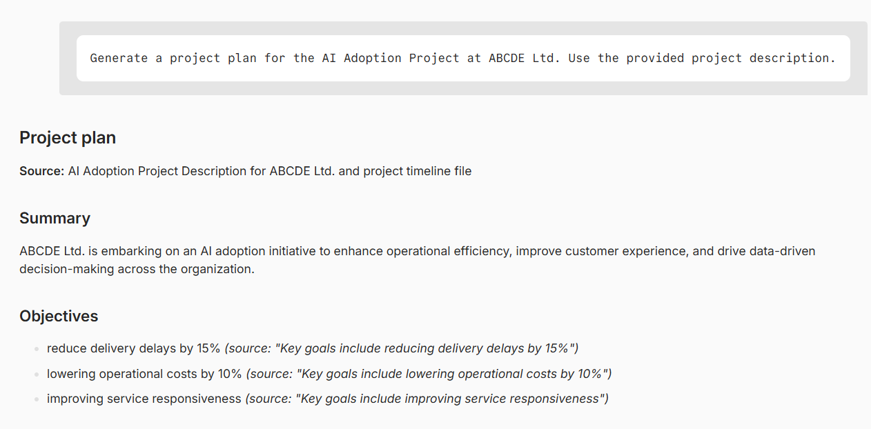
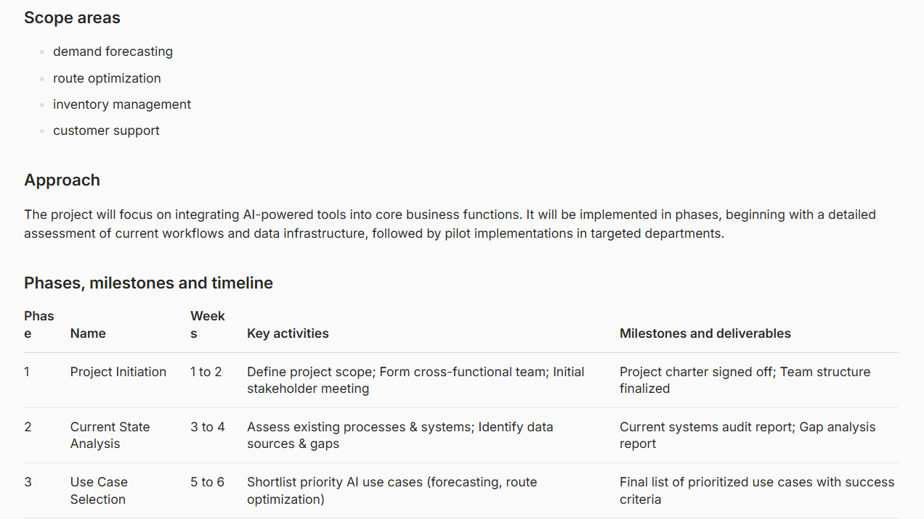
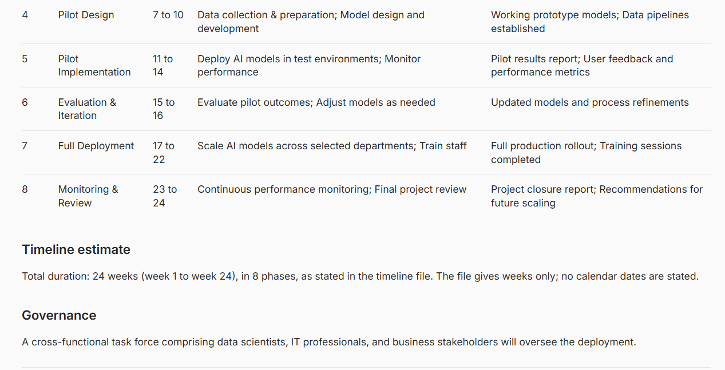

Test 2

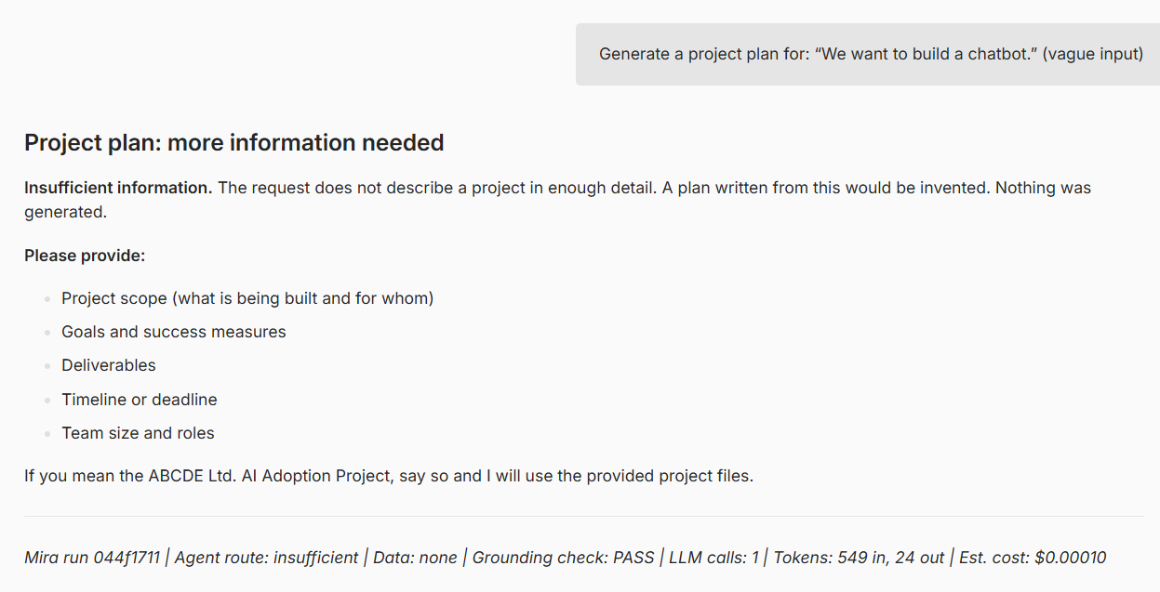

Test 3

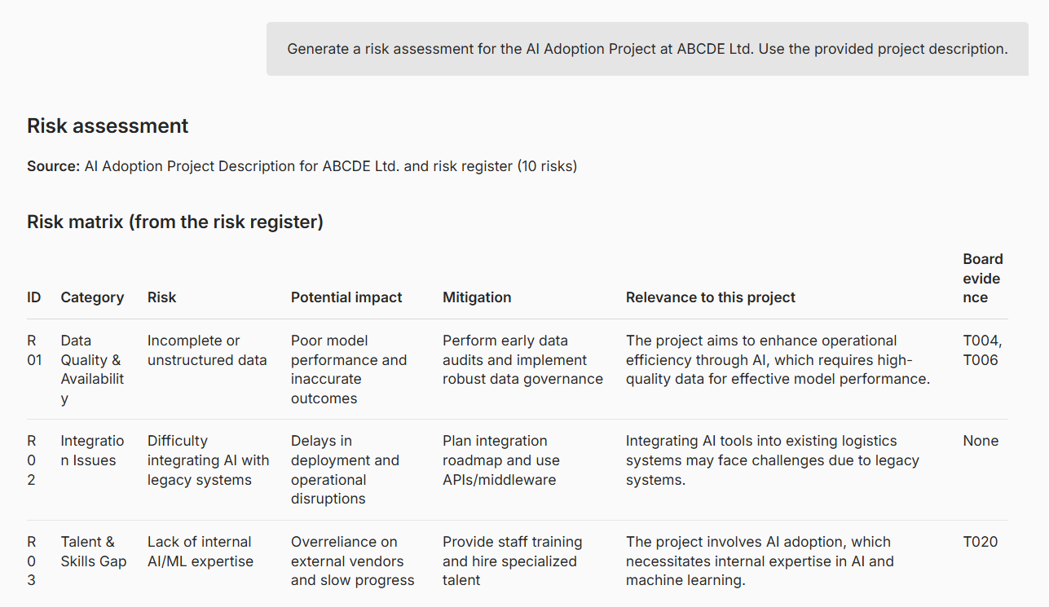
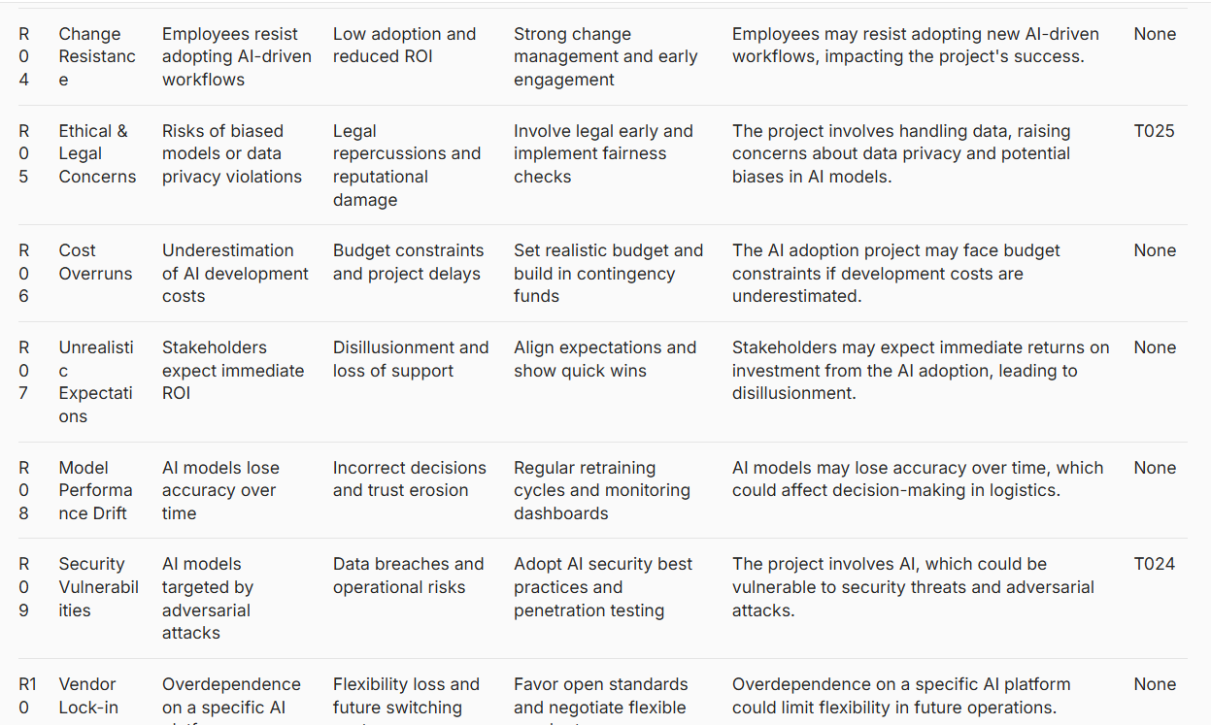
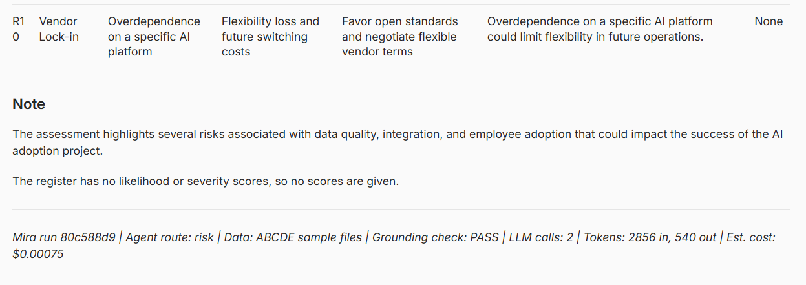

Test 4

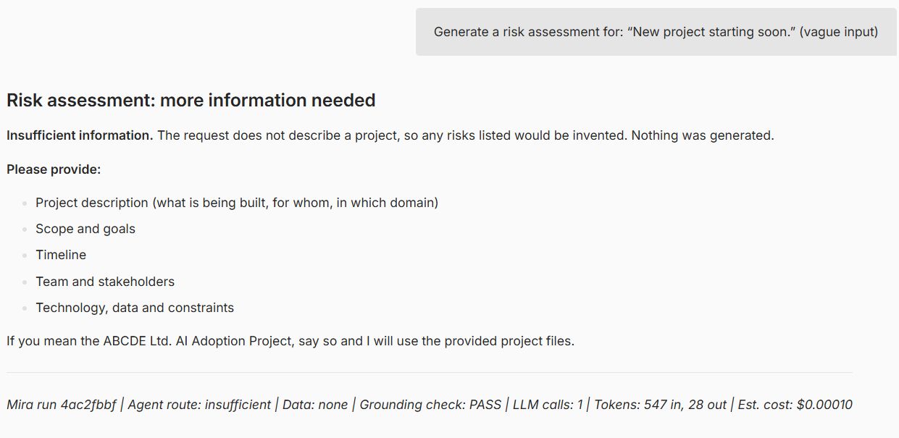

Test 5

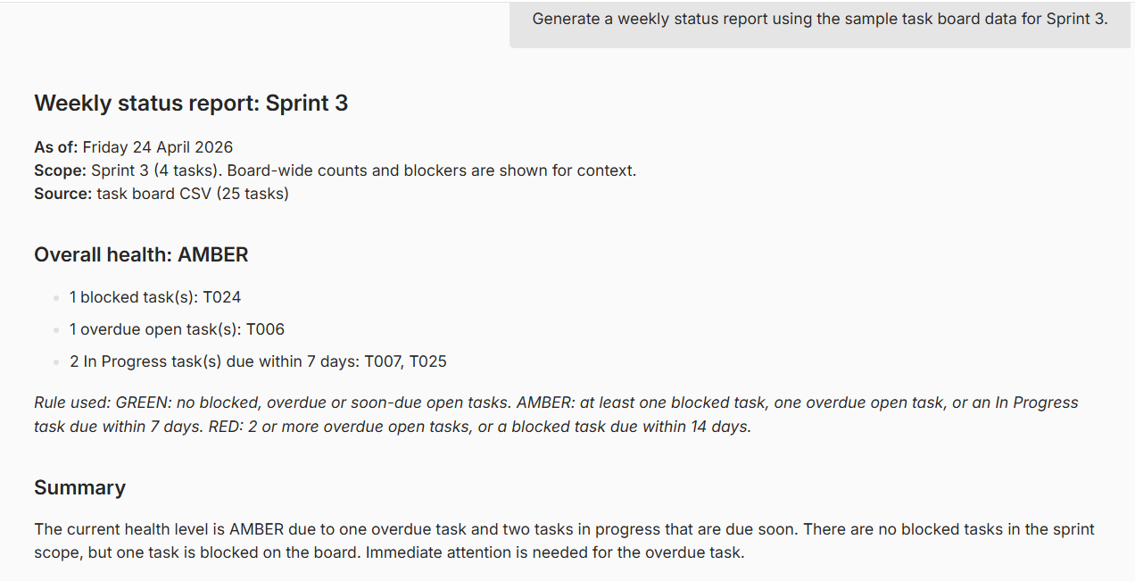
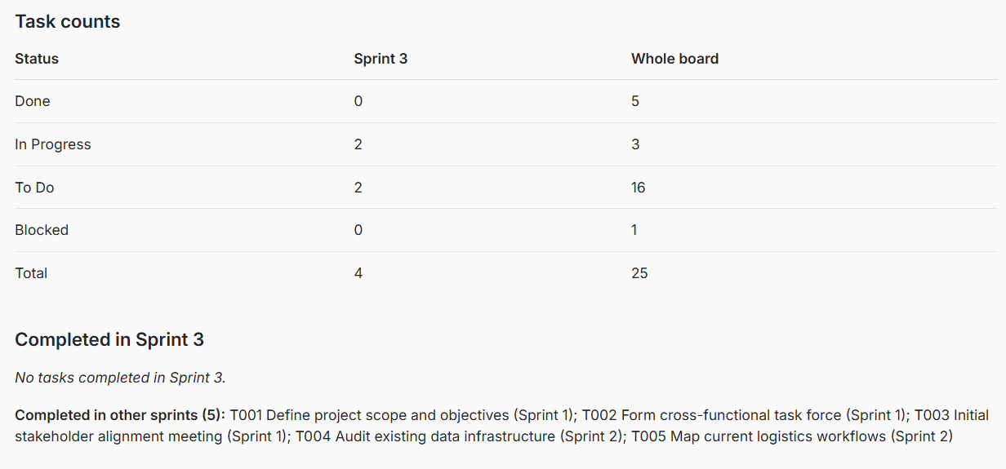
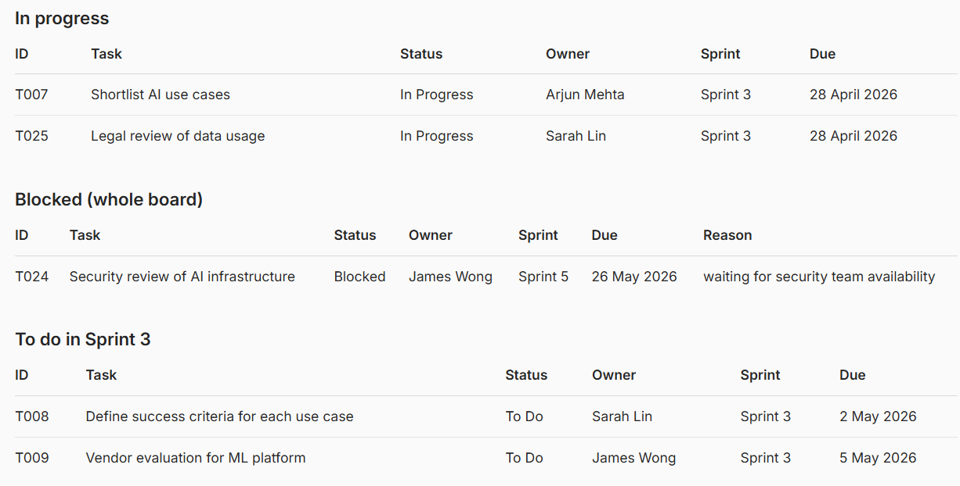

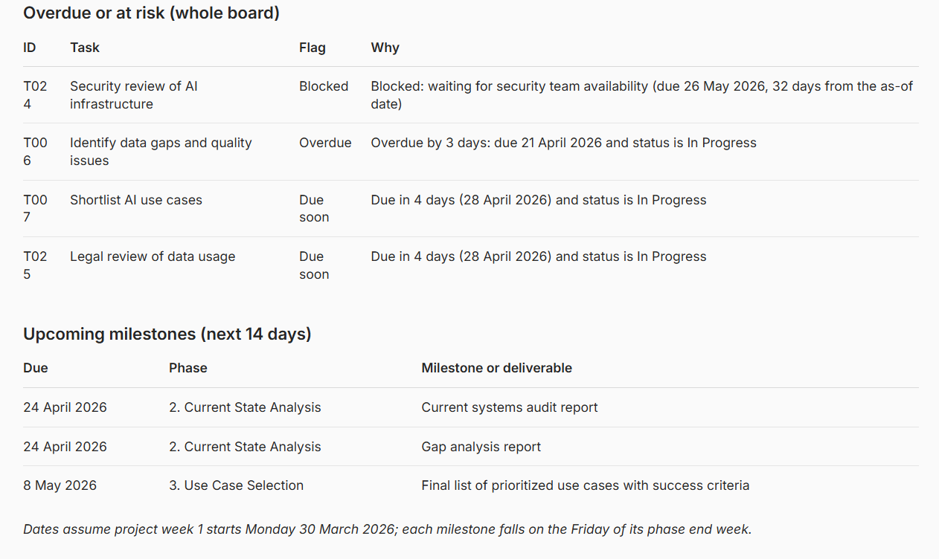
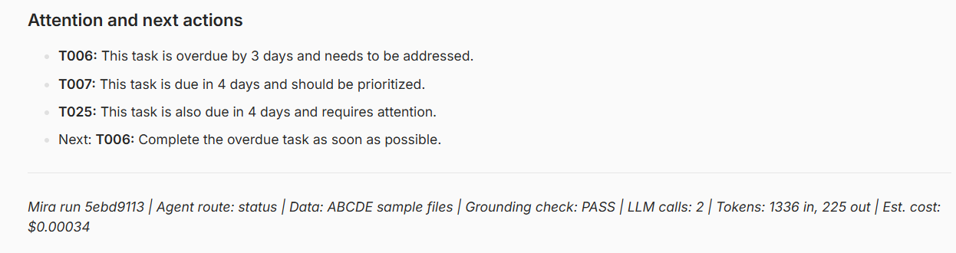

Test 6

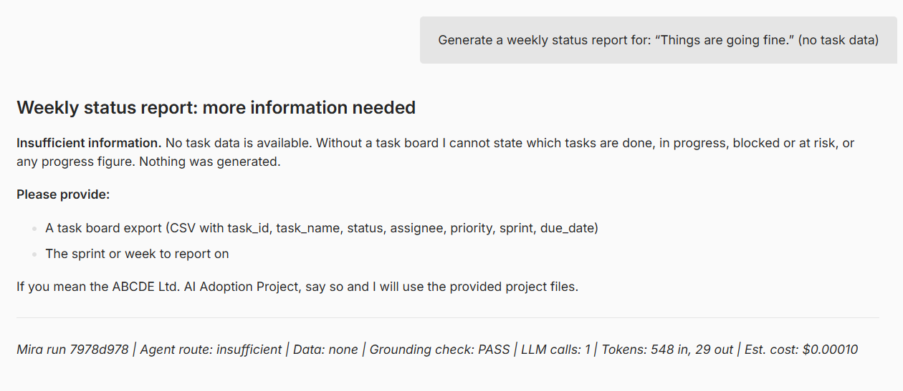

Test 7

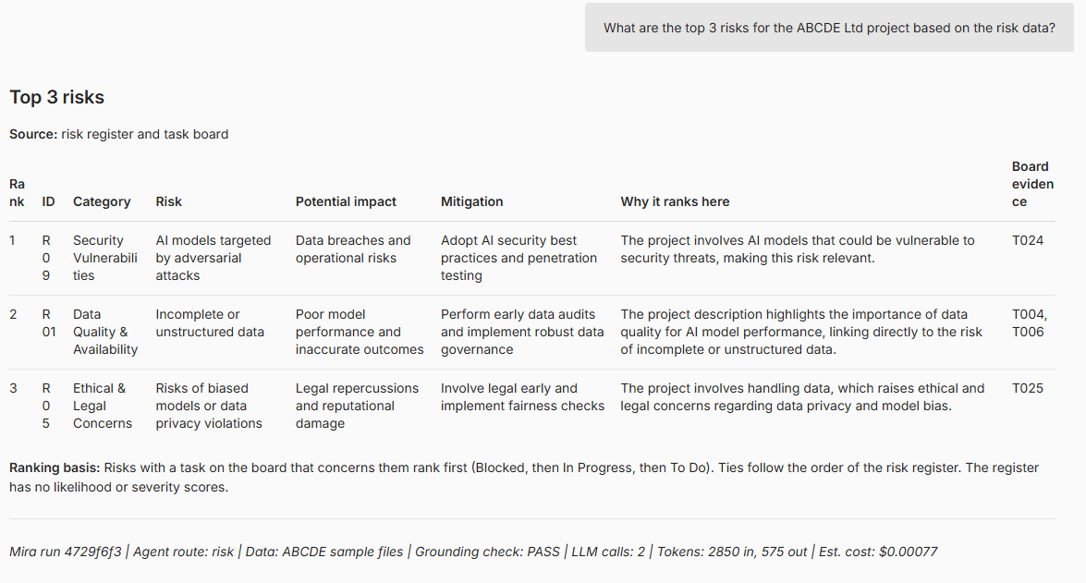

Test 8

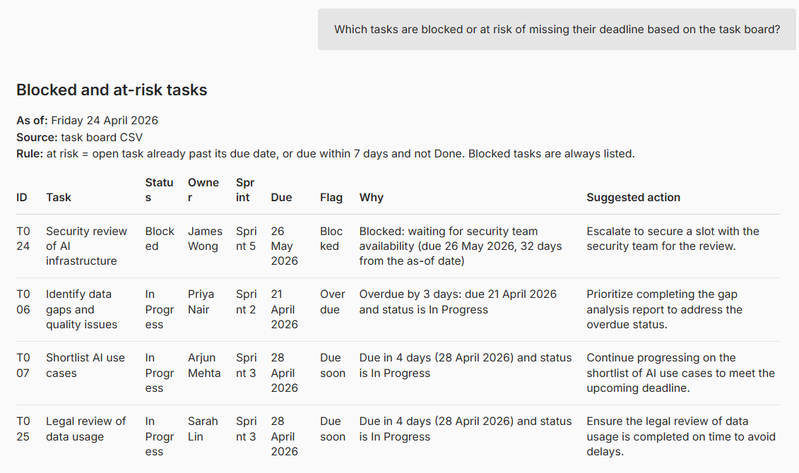
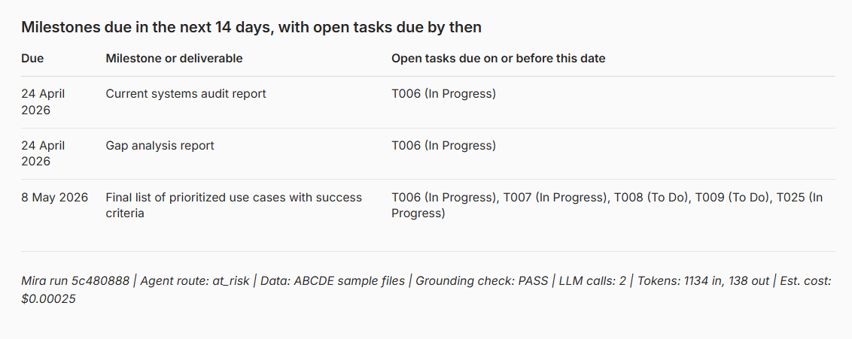

Test 9

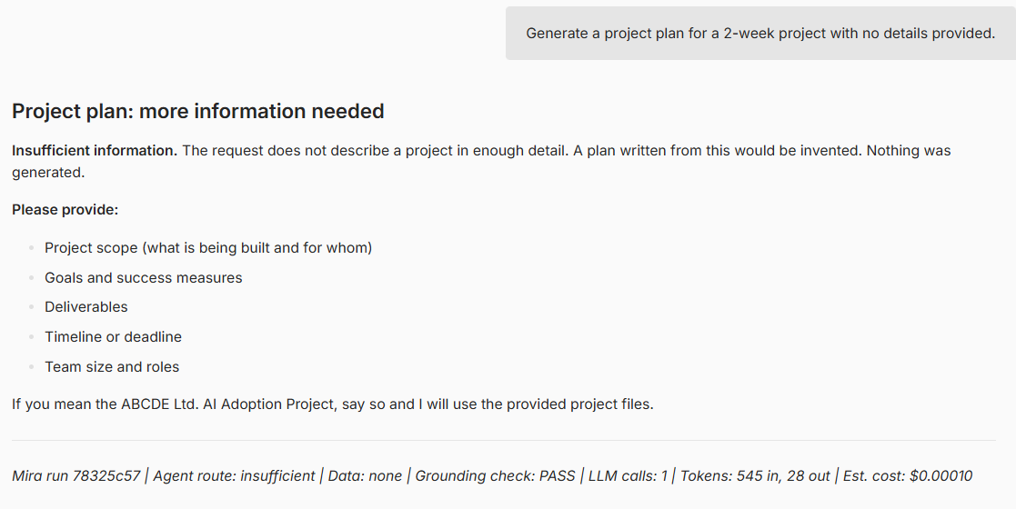

Test 10

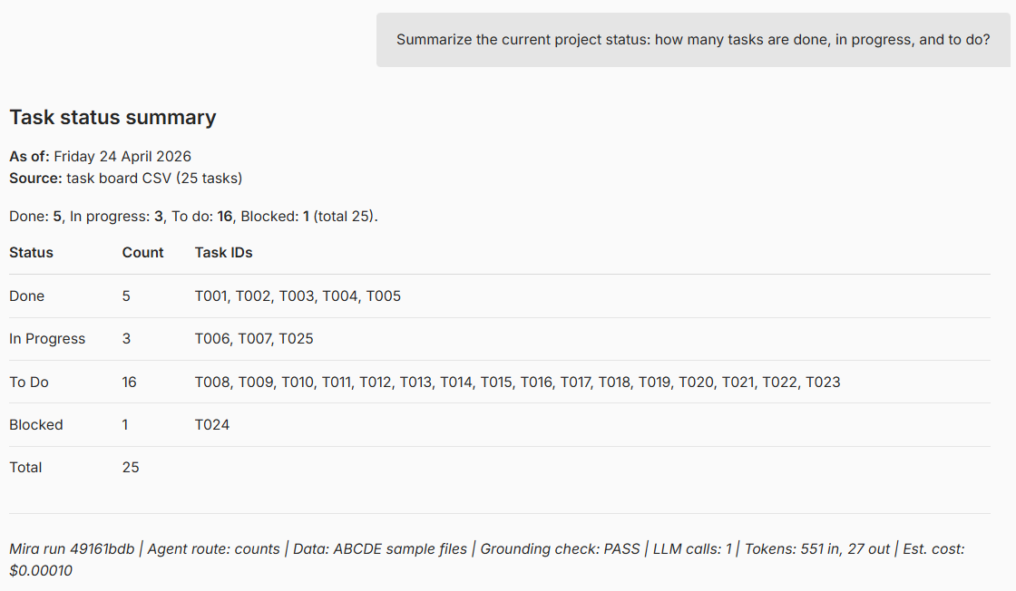

Test 11

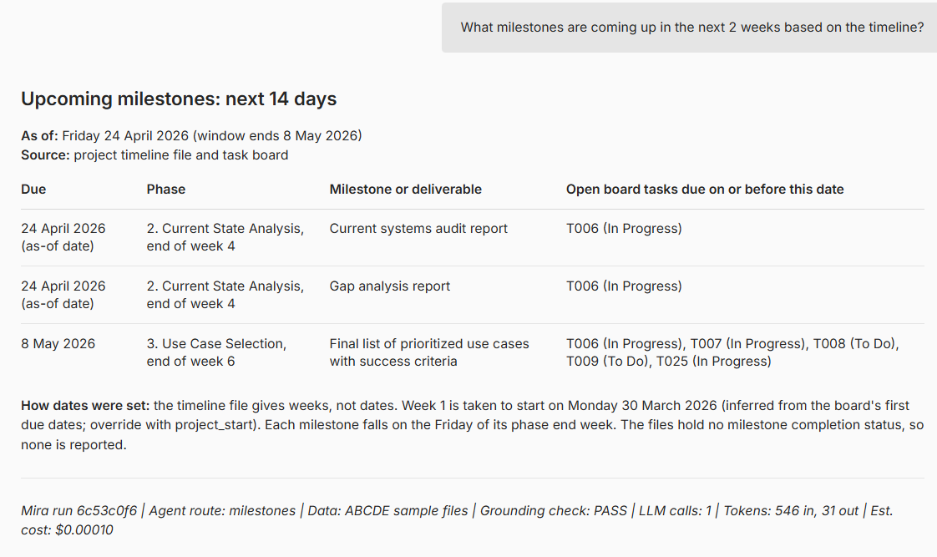

Test 12

