Mira Design and Evaluation Evidence
Workflow diagrams and evaluate-fix-retest record
Prepared for the Mira capstone submission. This supplement closes the design-flow and evaluation-loop evidence items in the Scope of Work. It uses the final Q1-Q4 v1.1 documents, repository workflow, 12-test results and 18 October 2026 Langfuse export.

Evidence summary
Live baseline | 12 of 12 tests passed on gpt-4o-mini through n8n Cloud on 18 October 2026.
Trace export | 78 unique requests, 119 model generations and 431 observations. Nine requests were marked REVIEW after guardrail intervention.
Trace detail | Trace IDs are listed with the matching T1, T7 and T12 retest records.
Interpretation | REVIEW records a guardrail intervention. For T12 the unsupported completion claim was removed and the final test output passed.
The flow maps below describe the implemented paths. Code computes counts, dates, phase tables, task lists and health; language-model output is validated against the supplied records before Mira returns an answer.

W-1 Request intake and routing
Diagram 1. Request intake and routing.
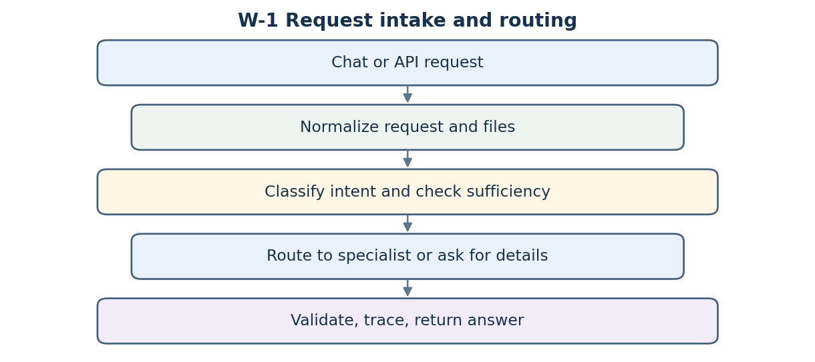
Control point: Unclear and insufficient requests return a request for missing details; supported requests go to one specialist route.

W-2 Project plan
Diagram 2. Project plan.
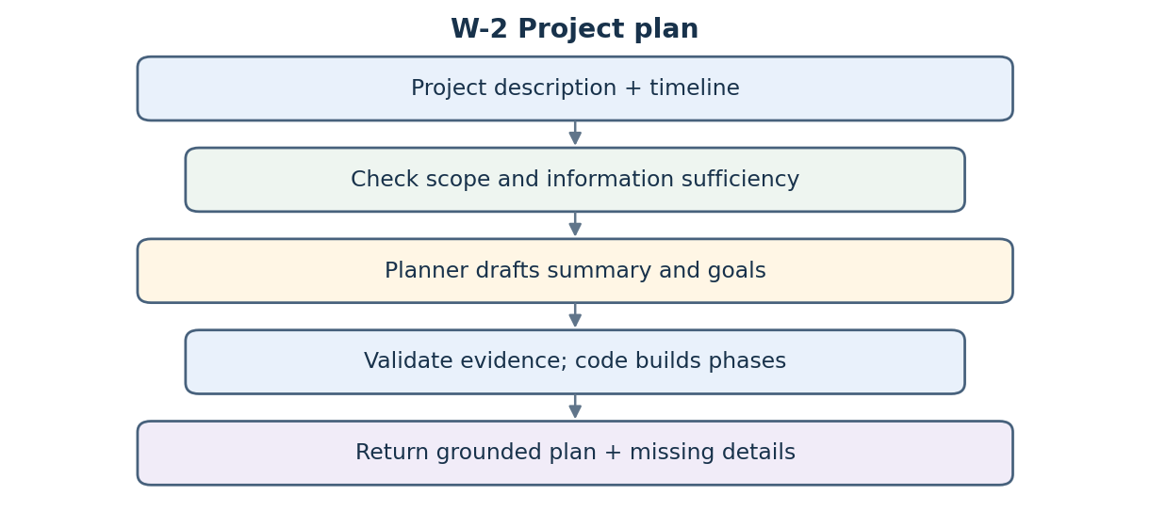
Control point: The plan uses the description and timeline; objective evidence and phase details are checked before rendering.

W-3 Risk assessment
Diagram 3. Risk assessment.
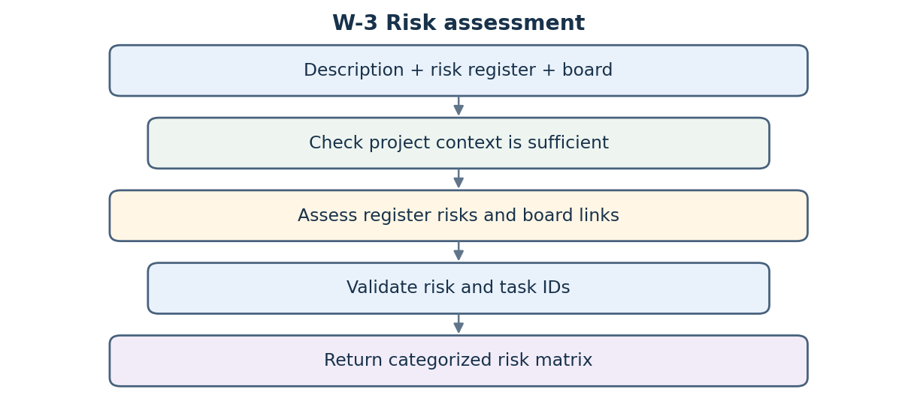
Control point: Only the ten register risks and validated board links are retained; numeric scores are not invented.

W-4 Weekly status report
Diagram 4. Weekly status report.
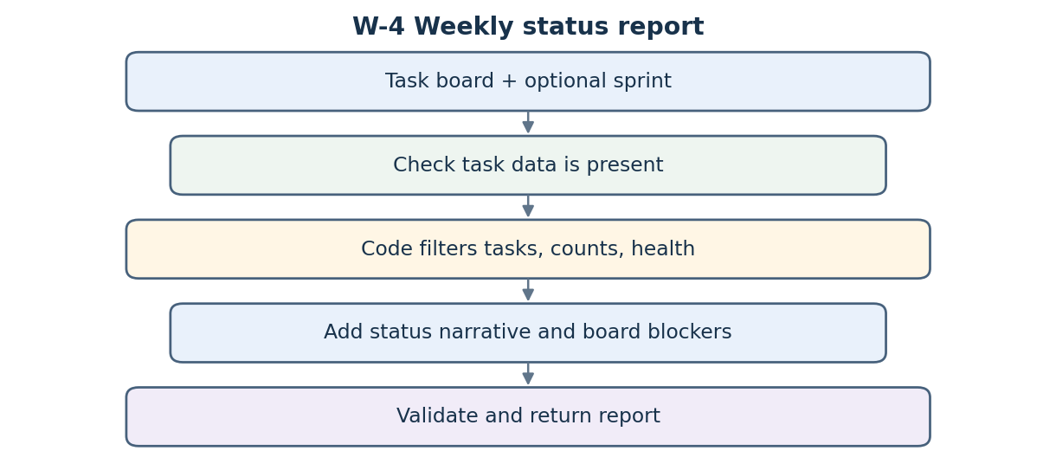
Control point: Counts, sprint filters and health are computed from the board; the full-board blocker is shown separately.

W-5 Tracking questions
Diagram 5. Tracking questions.
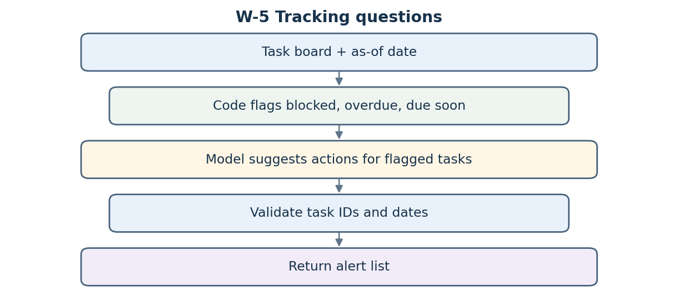
Control point: The as-of date is explicit; task IDs and dates are validated before suggested actions are shown.

W-6 Stakeholder update
Diagram 6. Stakeholder update.
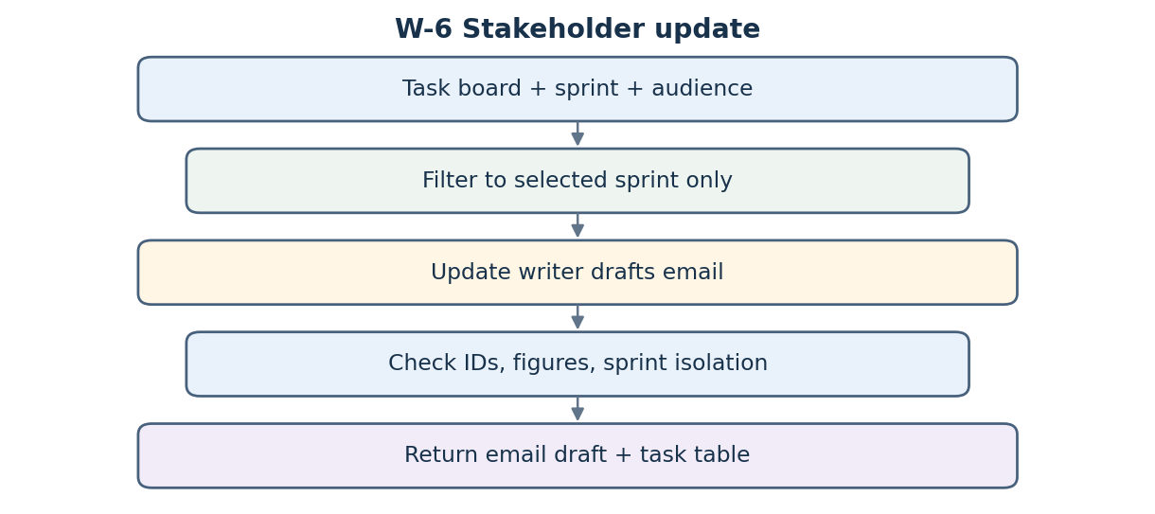
Control point: Only the selected sprint is supplied to the writer; output validation enforces sprint isolation.

W-7 Evaluate, fix, retest
Diagram 7. Evaluate, fix, retest.
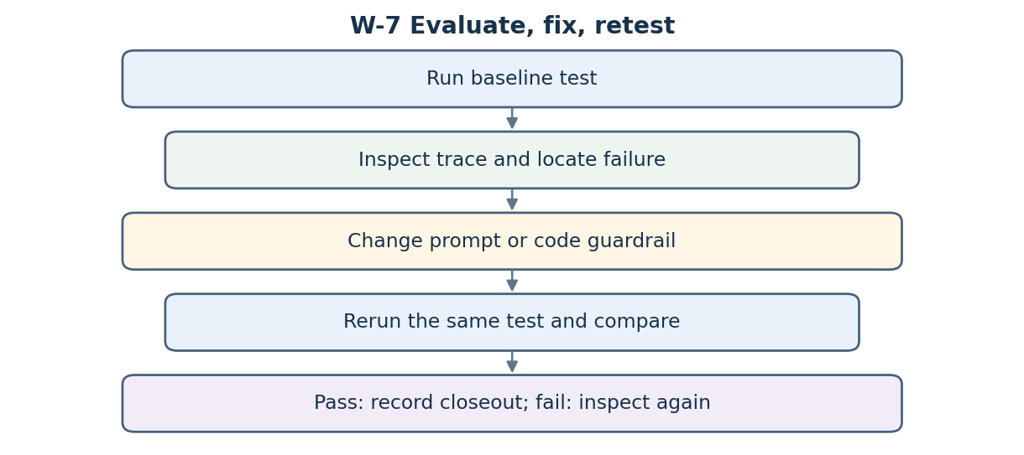
Control point: The same input is rerun after a prompt or code change, then actual output is compared with expected criteria.

Evaluate fix retest record
Three live-model findings were corrected and checked against the same baseline test. The test result is the final harness result; trace status remains REVIEW when a guardrail removed content.
Test and trace | Finding | Change made | Rerun result | Status
T1  55391c8a5f480165d5b5026ca1ef6d3c | A grounded project goal was paraphrased, so its evidence quote did not pass the original strict match. | Validator accepts close wording while preserving the source-grounding requirement. | All 8 phases and milestones present; all 3 goals retained; T1 passes. | PASS
T7  7d00d1eeadf782a70b7deb6e2daf25dd | Initial top-risk ordering did not consistently use current task-board evidence. | Ranking moved into deterministic code using the accepted board-link rule. | Exactly 3 register risks returned, ranked R09, R01, R05; T7 passes. | PASS
T12  04630f193996ee832ff0936a3e78483b | Writer claimed Sprint 2 was complete while T006 remained in progress and overdue. | Added a sprint-completion guardrail; unsupported completion paragraph is removed. | Final email reports 2 of 3 done and T006 overdue; T12 passes. | PASS; trace REVIEW
Source evidence: repository tests/out/results_real.md and results_real.json; Langfuse trace export in docs/observability/. The 12 baseline tests pass. The SOW Appendix C should be read with the repository files in this refreshed package.

