Decoding Raw BLS Files
Tom Kuiper

VDR Data Stored on Disk

To see how the data are unpacked, here is the start of the first record (after the record header) in hexadecimal:
kuiper@venus-ravi2:/mnt/PESD_data$ od -j 152 -N 32 -x /mnt/PESD_data/vsr1a.1w1.10-113-2200.raw
0000230 f4ef fef9 f810 fdf1 f7ce dc06 0622 4629
0000250 e2c1 210d e925 c909 01cd 3523 fa50 36f3
Reading directly from the disk as int8:
kuiper@venus-ravi2:/mnt/PESD_data$ od -j 152 -N 32 -t d1 /mnt/PESD_data/vsr1a.1w1.10-113-2200.raw
0000230 -17 -12 -7 -2 16 -8 -15 -3
-50 -9 6 -36 34 6 41 70
0000250 -63 -30 13 33 37 -23 9 -55
-51 1 35 53 80 -6 -13 54
In this case, od has apparently swapped alternate bytes because
In [3]: -(256-0xf4)
Out[3]: -12
In [4]: -(256-0xef)
Out[4]: -17
In [5]: -(256-0xfe)
Out[5]: -2
In [6]: -(256-0xf9)
Out[6]: -7
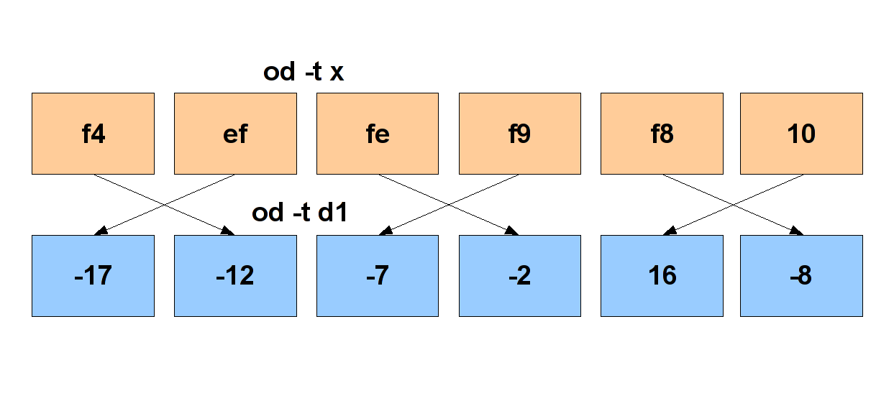
The same first few data bytes from that file were read into a buffer with a Python fd.read() through an sshfs mount. The first 16 bytes in the buffer were
ef f4 f9 fe 10 f8 f1 fd
ce f7 06 dc 22 06 29 46
Note that the data were byte swapped in the same what that od -t d1 byte-swapped the data. These were then unpacked with
struct.unpack("!16b",buf[0:16]),
adding 0.5 to round the numbers:
-16.5, -11.5, -6.5, -1.5,
16.5, -7.5, -14.5, -2.5,
-49.5, -8.5, 6.5, -35.5,
34.5, 6.5, 41.5, 70.5
So the Python fd.read() does the same alternate byte swapping.

Verification

vdr_io was run on both ravi1 (i686) and ravi2 (x86_64). The data of a different BLS file were examined on both:
ops@ravi1:/raid5$ od -j 152 -N 16 -t d1 vsr1a.1w1.10-147-2015
0000230 -33 -29 -13 11 -45 -1 25 -15
0000240 -9 -41 -20 30 -21 -68 -29 -9
and
kuiper@venus-ravi2:/mnt/PESD_data$ od -j 152 -N 16 -t d1 vsr1a.1w1.10-147-2015.raw
0000230 -33 -29 -13 11 -45 -1 25 -15
0000240 -9 -41 -20 30 -21 -68 -29 -9
There is no difference in the data were packed on a 32-bit and 64-bit host.

Data Packing

To see what it should be I revised venus-ravi2:/usr/local/ravi/post_proc/check_header.c to print out the first few values from a data file along with a header:
check_header -l localhost /mnt/PESD_data/vsr1a.1w1.10-113-2200.raw
kuiper@venus-ravi2:/usr/local/ravi/post_proc$ cd /mnt/PESD_data/
kuiper@venus-ravi2:/mnt/PESD_data$ check_header -l localhost vsr1a.1w1.10-113-2200.raw
print_rcd>>>
type VSRD
rec len 2000152
rec ver 3
soft ver 25
spc id 13
vsr id 0
schan id 2
bps 8
sample rate 1000
sdplr 0
prdx_dss_id 0
prdx_sc_id 0
prdx_pass_num 0
prdx_uplink_band X
prdx_downlink_band X
trk_mode 1
uplink_dss_id 0
ddc_lo 306
rf_to_if_lo 8100
data_error 0
year 2010
doy 113
sec 79800
data_time_offset 31
frov== 8430000000.000000
fro 0.000000
frr 0.000000
sfro -24000000.000000
rf_freq 8406000000.000000
schan_accum_phase 0.000000
schan_phase_poly 0.000000
schan_phase_poly -0.000000
schan_phase_poly 0.000000
schan_phase_poly 0.000000
schan_label 8
schan_label 4
schan_label 0
schan_label 6
print_rcd>>>
Record data size = 2000000
Total record size = 2000152
Samples per record = 1000000
8 bits per sample
Getting record
Got record
8 bits per sample
2 samples per 32 bit word
Allocating FFT data size = 1024
Getting data
First word, net order: fef9f4ef
First word, host order: eff4f9fe
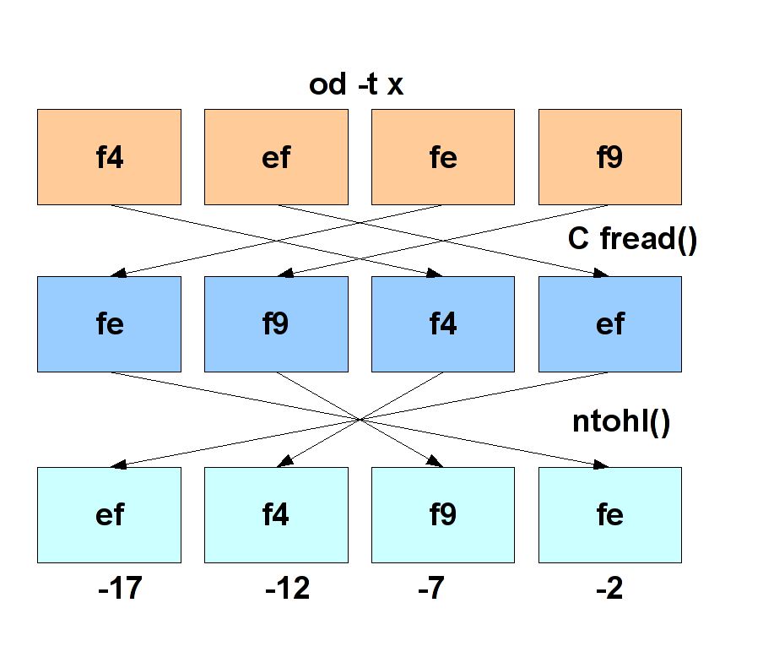
So in reading from disk, it appears that the C program has swapped bits with a 16-bit granularity relative to od -t x. The bottom row of the adjacent figure shows the extracted complex numbers, (R1,I1), (R2,I2), ...
Got data
-1.5 -11.5
-6.5 -16.5
-2.5 -7.5
-14.5 16.5
-35.5 -8.5
6.5 -49.5
70.5 6.5
41.5 34.5
33.5 -29.5
13.5 -62.5
-54.5 -22.5
9.5 37.5
....
The data are complex, listed above as (real imaginary) pairs. In this case, there are eight bits for each part of the complex sample. Comparing the above output with the data on disk, the first two complex numbers appear to be stored as
[I2][I1][R2][R1]
which makes using the struct module inconvenient.

Algorithm

On the assumption that get_vdr_data_samples does the right thing, let's consider what it does. It takes num_32bit_word words from one subchannel record (schan_rcd_t *rcd). Each word is converted from 'network' to 'host' order with ntohl. To take the first 32-bit word as an example, the 'network' order 32-bit word is 0xfef9f4ef and the host order word is 0xeff4f9fe. nthol(0xf9feeff4) converts this to 0xf4effef9. It then parses the converted word for cmplx_samp_per_32bit_word complex samples/word and turns them into complex data (FFTW_COMPLEX *data). For 8 bits/sample, this yields two complex numbers.

Consider the case of 8 bit samples. It takes a 32-bit word and byte-swaps it to handle the Endian difference between the Sun VSR and Linux i86 ravi. Consider the case of 8-bit samples and 32-bit words. After byte-swapping the packing is [I2][I1][R2][R1] for 8-bit samples. So:
- The function takes the 32 bit word and shifts it left 24 bits, leaving the rightmost eight:
[R1][00][00][00]. It then shifts that back 24 bits leaving the real part of the first sample:
[SS][SS][SS][R1] where 0xff if the sign bit of [R1] is 1, or )x00 otherwise.
- It then shifts the word left 8 bits and right 24 bits:
[I1][R2][R1][00]
[SS][SS][SS][I1]. This gives the imaginary part of the first sample.
- Then it takes the word and shifts it left 16 bits and right 24 bits for the real part of the second sample:
[R2][R1][00][00]
[SS][SS][SS][R2].
- Finally, it shifts the word left 0 bits and right 24 bits for the imaginary part of the second sample:
[SS][SS][SS][I2].
The C code is:
for (j = 0; j < samp_per_32bit_word; j++)
{
/* left shift & right shift data to obtain isamp and qsamp, this
* isolates and sign extends the current sample in the vme_data word */
isamp = ntohl(rcd->data[i]) << (32 - (bits_per_sample * (j + 1)));
isamp >>= (32 - bits_per_sample);

qsamp = ntohl(rcd->data[i]) << (16 - (bits_per_sample * (j + 1)));
qsamp >>= (32 – bits_per_sample);
}

Unpacking BLS Raw Data in Python

The raw buffer which Python read from disk contained ef f4 f9 fe ... but C does a 16-bit swap when it takes these data as input, giving f9 fe ef f4.... This is R2, R1, I2, I1. So the simplest approach is not to use nthol() and to interchange the real and imaginary numbers in the above algorithm.

I wrote a C module to unpack BLS data the way the ravi2 post_proc programs do, namely, using function get_vdr_data_samples (file get_vdr_samples.c). I then wrote a Python test program
In [1]: run test_vdr_support.py
...
1000 complex ksamples/sec
2 complex 8 bit samples per 32-bit word
Reading 500000 32-bit words
2000000 data bytes read
Read 500000 32-bit words
First 16 bytes:
ef f4 f9 fe 10 f8 f1 fd ce f7 06 dc 22 06 29 46
[(-1.5-11.5j), (-6.5-16.5j), (-2.5-7.5j), (-14.5+16.5j), (-35.5-8.5j), (6.5-49.5j), (70.5+6.5j), (41.5+34.5j)]
...
In [2]: len(cmplx_samples)
Out[2]: 1000000

Appendix – Unpacking Data as U64

For 64-bit words the packing would
[I4][I3][R4][R3][I2][I1][R2][R1]
To get the first real R1, bit-shift left (64-8), then right (64-8):
<< (bits_per_word – 1*bits_per_sample) : [R1][00][00][00][00][00][00][00]
>> (bits_per_word – bits_per_sample) : [SS][SS][SS][SS][SS][SS][SS][R1]
I1: left (64-24), right (64-8):
<< (bits_per_word – 3*bits_per_sample) : [R1][00][00][00][00][00][00][00]
>> (bits_per_word – bits_per_sample) : [SS][SS][SS][SS][SS][SS][SS][R1]
R2: left (64-16), right (64-8)
<< (bits_per_word – 2*bits_per_sample) : [R1][00][00][00][00][00][00][00]
>> (bits_per_word – bits_per_sample) : [SS][SS][SS][SS][SS][SS][SS][R1]
I2: left (64-32), right (64-8)
<< (bits_per_word – 4*bits_per_sample) : [R1][00][00][00][00][00][00][00]
>> (bits_per_word – bits_per_sample) : [SS][SS][SS][SS][SS][SS][SS][R1]
R3: left (64-40), right (64-8)
<< (bits_per_word – 5*bits_per_sample) : [R1][00][00][00][00][00][00][00]
>> (bits_per_word – bits_per_sample) : [SS][SS][SS][SS][SS][SS][SS][R1]
I3: left (64-56), right (64-8):
<< (bits_per_word – 7*bits_per_sample) : [R1][00][00][00][00][00][00][00]
>> (bits_per_word – bits_per_sample) : [SS][SS][SS][SS][SS][SS][SS][R1]
R4: left (64-48), right (64-8)
<< (bits_per_word – 6*bits_per_sample) : [R1][00][00][00][00][00][00][00]
>> (bits_per_word – bits_per_sample) : [SS][SS][SS][SS][SS][SS][SS][R1]
I4: left (64-64), right (64-8)
<< (bits_per_word – 8*bits_per_sample) : [R1][00][00][00][00][00][00][00]
>> (bits_per_word – bits_per_sample) : [SS][SS][SS][SS][SS][SS][SS][R1]
So the revised algorithm should be
for (j = 0; j < samp_per_word; j++)
{
/* left shift & right shift data to obtain isamp and qsamp, this
* isolates and sign extends the current sample in the vme_data word */
isamp = ntohl(rcd->data[i]) << (bits_per_word - (bits_per_sample * (j + 1)));
isamp >>= (bits_per_word - bits_per_sample);
qsamp = ntohl(rcd->data[i]) << (bits_per_word - (bits_per_sample * (j + 3)));
qsamp >>= (bits_per_word – bits_per_sample);
}
This is somewhat academic, though, because the function treats the input buffer as U32. This is possibly less efficient that making use of U64 so a revised algorithm may be worth considering, but not now.

