# SDRplay DX Cluster Plugin V1.3

## Overview

The DX Cluster plugin translates DX spots that are recorded in DX Cluster telnet servers into annotations on the Main SP spectrum display.

## Plugin GUI Information

There are few controls in the plugin panel – see the key below for details…

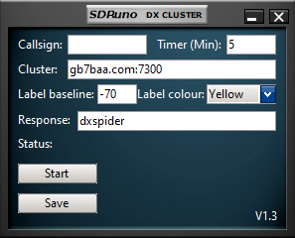

6

4

7

9

8

5

3

2

1

## Key:

1. Callsign – a valid registered amateur radio operator callsign is required to log into the telnet server with.
2. Timer – each DX spot will be removed from the Main SP spectrum display after the time specified here (in minutes)
3. Cluster – a valid DX cluster telnet server hostname and port number are required. The format is hostname:port – you can check whether this is valid in a telnet application (such as PuTTY) if you are having a problem.
4. Label baseline – for each new callsign annotation, the value specified in dBm here will be the lowest that the text will be displayed at. Other callsigns that are either at the same or nearby frequencies will be raised to avoid text overlapping.
5. Label colour – use the dropdown to select from a list of pre-defined colours for the text, markers, and lines.
6. Response – text expected to be received after login. This confirms successful login (default: “dxspider”)
7. Status – here you will see if the plugin is connected to the telnet server and how many DX spots are currently being managed. Note that this number is a total across all bands and so will most likely differ from the amount of DX spots you can see in the spectrum display.
8. Start – Start and Stop the plugin connecting to the specified telnet server.
9. Save – this button will store the callsign, cluster, timer, label baseline and the label colour in the SDRuno ini file. These parameters will be recalled when the plugin is next loaded.

## Quick Start

The DX Cluster plugin for SDRuno is launched from the SDRuno Plugin Control Panel. Make sure the callsign is correct and valid (see note below). Also make sure the cluster server:port field is valid. The response field must be correct for the server being connected to. Press Start and the plugin should then start to count the number of DX spots that are being added to the DX cluster server in real time. Tune to the band of interest and if there are any DX spots being recorded, they will automatically be annotated on the Main Panel spectrum display. Press Stop when you are finished. Pressing Save will store the values ready for the next time you want to use the plugin.

Note: if you use the same callsign in different DX applications, they could conflict. To avoid this, add an extension to the callsign consisting of a dash followed by a number (e.g. G4ABQ-2 or G4ABQ-33).