**SDS-Mini-Project**

**Sem-3**

**Group members:**

|  |  |  |  |
| --- | --- | --- | --- |
| **S. No.** | **Name** | **SRN** | **Section** |
| 1. | K Manish Gowd | PES1UG19CS200 | C |
| 2. | Justin James | PES1UG19CS198 | C |
| 3. | Harshit Khashoo | PES1UG19CS183 | C |
| 4. | Dhanush Patel YP | PES1UG19CS141 | C |

**Report**

**1. Abstract:**

This dataset consists of the weather records for a month taken with the observations being taken down and noted per hour. It consists of various aspects of weather like precipitation, humidity, wind speed, wind bearing, visibility, loud cover, pressure, temperature, apparent temperature against a particular instant of time. The summary and the daily summary are noted down appropriately as per the parameters collected. With the help of the appropriate operations on the given statistics, we were able to infer a great deal of information for the population. So, coming to the data, we first displayed various forms of data in various forms of visual representation such as graphs, scatterplot, charts, etc after performing the necessary operations such as dropping the redundant and repeated observations, outliers, typos and inconsistent capitalization. We then standardized the data for bringing it down to a common scale and then displayed it. The normality of the data had also been tested simultaneously using the histogram. For the hypothesis testing we performed the above operations in addition to ensuring proper precautions in ensuring the normality of the data and then came up with the appropriate conclusion based upon the appropriate z-score and the P-value obtained with the help of z-score.

**2. Introduction:**

**Problem statement**: Displaying the various weather patterns in the graphical form alongside coming up with an appropriate conclusion for the hypothesis testing with our hypothesis being whether or not the sample is representative of the population.

Most of the parameters are numerical with the remaining few being categorical. The objective of this project is to make optimum use of the dataset to extract maximum and most relevant information out of the dataset for various purposes. The first section of the project would consist of descriptive statistics while the second half would contain inferential statistics. With the help of the relationships generated between various variables, we can appropriately put this to a great use by inferring various parameters from it. While this is just a sample of 720 records, we can easily put this to a great use to infer about various weather parameters on the other given days with optimal accuracy and precision along with minimal margin of error. Along with determining at the end whether or not the sample is representative of the population. Determining the correlation b/w various numerical variables in the dataset at the end. Coming up with an appropriate conclusion finally based on the results obtained.

**3. Dataset:**

Source: <https://www.kaggle.com/muthuj7/weather-dataset>

This dataset consists of the weather records for a month taken with the observations being taken down and noted per hour. It consists of various aspects of weather like precipitation, humidity, wind speed, wind bearing, visibility, loud cover, pressure, temperature, apparent temperature against a particular instant of time. The summary and the daily summary are noted down appropriately as per the parameters collected.

Most of the parameters are numerical with the remaining few being categorical. The objective of this project is to make optimum use of the dataset to extract maximum and most relevant information out of the dataset for various purposes. The first section of the project would consist of descriptive statistics while the second half would contain inferential statistics. With the help of the relationships generated between various variables, we can appropriately put this to a great use by inferring various parameters from it. While this is just a sample of 720 records, we can easily put this to a great use to infer about various weather parameters on the other given days with optimal accuracy and precision along with minimal margin of error.

**4. Preprocessing or Data Cleaning:**

Techniques used:

* Correction of inconsistent capitalization and typos.
* Dropping of excessively repetitive and redundant parameters and observations.
* Replacement of NaN with 0.
* Replacing NaN by techniques such as imputing by interpolation, etc.
* Removal of outliers before testing for normality of the distribution

Reasons for cleaning:

* For easier data processing and visualization
* For better and more accurate results
* For easier and better inferences

**5. Exploratory Data Analysis: What are the insights obtained from EDA. Represent**

**them in terms of various graphs along with explanation.**

Insights obtained from EDA:

* Most of the days are partly cloudy

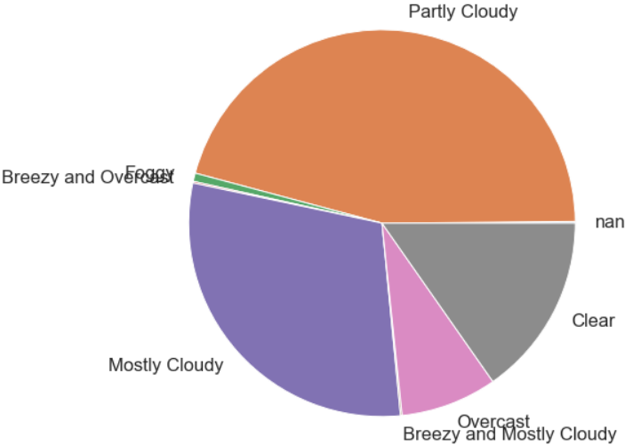

* Most of the numerical parameters in the dataset are normally distributed.

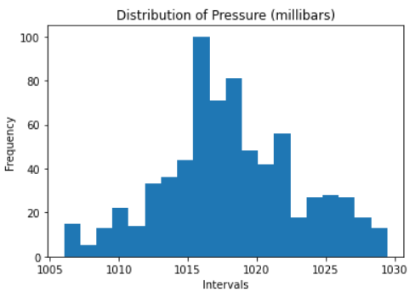

* Breezy and overcast weather resulted in having the highest wind speed

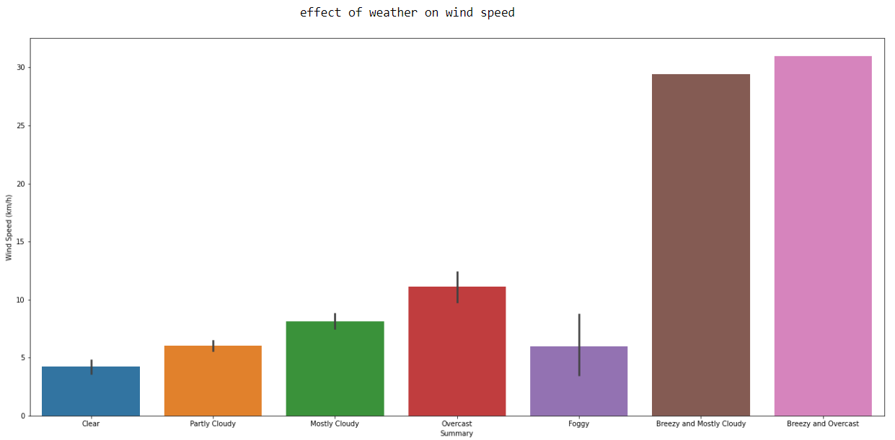

* The sample is representative of the population.



* The sample had been taken during the rainy season during the month of September.
* Since, the sample had been taken during a particular month, it wouldn’t be right to treat is as the population and then collect a smaller sample from it to check whether a random sample would be representative of the population.
* So, a better approach for hypothesis testing would be the to take a known statistic for the entire population (applicable in this case) and then compare the statistics of the dataset to the one of population.
* All the numerical variables have some kind of correlation with each other since this is a weather-based dataset, so all the numerical variables would somehow influence each other.

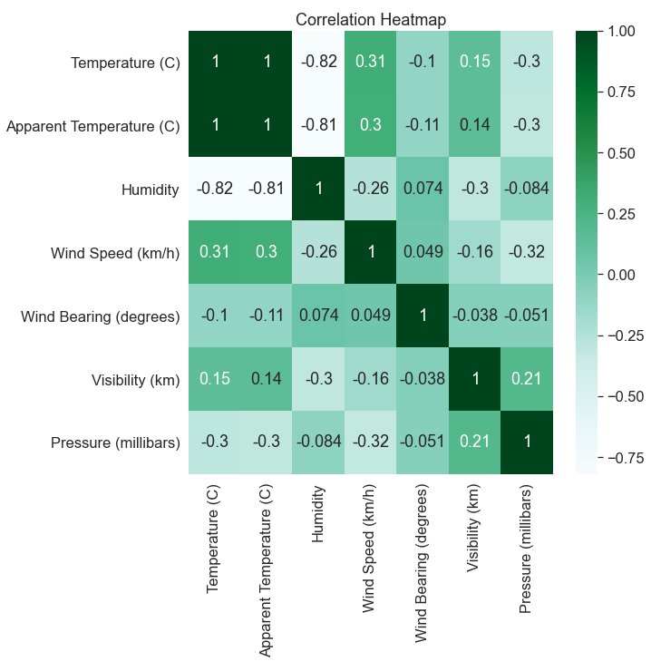

* Since the volume wouldn’t be constant all the time, it would be better to reduce the threshold value for statistical significance from 0.05 to 0.01.

**6. Hypothesis Testing:**

## Prerequisites:

* We need to convert the temperature to K since that is the SI unit. Therefore add 273.15 to each unit of temperature.
* We also need to convert the pressure to pascal since that's it's SI unit.  
  Since the pressure is in millibars, convert it in terms of bars by dividing by 1000.  
  We know that 1 bar = 10,000 Pa.
* Therefore, multiply by the pressure in bar by 10,000 to obtain the pressure in terms of its SI units.

We know that for a closed system, temperature is directly proportional to pressure.

But the graph for the sample dataset doesn't seem to depict it. It rather approximates an inverse relationship between pressure and temperature.

### Can we prove that the sample is not representative of the population?

The general assumption here is that the temperature and pressure are directly related to each other.

### Therefore:

## b. Statistical tests

**H0**: **The sample is representative of the population. i.e. T α P** for the sample  
  
**H1**: **The sample is not representative of the population i.e. T is not proportional to P for the sample.**

Since the sample size is appreciably large enough, we can approximate it to a sample from a normal distribution. Also, since the standard deviation is also known, it's safe to say that we can use the z-table in order to perform the statistical tests.

Since the general belief is that temperature and pressure are directly related to each other, i.e. **(T α P)**

Therefore, the following equation would be true:

**(T = kP)** (where k is an arbitrary constant)

**T/P = k**

Therefore, we have to ensure that the value of k remains as constant as possible with minimum possible deviation and negligible error. It's also crucial to avoid any possible bias in order to ensure proper results.

We know that the average of the ratio of standard temperature (273.15 K) and standard pressure (10,000 bar) is a constant i.e. 0.0027315

Using z-score to standardize the data: We obtained the mean of the ratio as 0.002868 We obtained the standard deviation of the ratio as 6.569896069161947e-05

Therefore,

x=0.002868  
μ=0.0027315  
σ = 6.569896069161947e-05

Therefore, the z-score is as follows:

**z = (x - μ) / σ**

Upon, solving, we obtain, P-value=0.038694142721681285

### 5% statistical significance:

Since P-Value is less than 0.05, (taking at 5% statistical significance), we reject H0, the original hypothesis, and accept our claim that there is no specific relationship between temperature and pressure to be plausible

But we know that pressure is directly proportional to temperature only at constant volume. We also know that the volume doesn't always remain constant. The change in volume to most extent would be practically significant. But the changes at times are definitely statistically significant. That's the main reason why we the null hypothesis was rejected by taking 5% statistical significance.

Therefore, a better solution is to increase the level of accuracy and bring the level of statistical significance down to 1%, which obviously seems to be a better choice in this scenario.

### 1% statistical significance:

So, since P-value is greater than 0.01, (taking at 1% statistical significance), we do not reject H0, the original hypothesis, and continue with the accepted fact i.e. the null hypothesis

### Therefore, we can confidently conclude that the null hypothesis is supported.

**7. Results and Discussion of your problem statement**

**With the assistance of data and results proved above, we obtain various inferences on the nature of the dataset as mentioned below:**

Most of the days were rainy and cloudy in nature since the observations in the dataset have been from the month of September, during which monsoon/rainy season is prevalent in most parts of the Northern Hemisphere in and around the Tropic of Cancer. We can also easily infer and predict the weather in the forthcoming couple of months, using the given statistics to find the parameters. We can also predict the weather in the similar months in the upcoming few years, but at the same time, we would also need to take into account the rising rate of various environmental effects like greenhouse effect leading to global warming thereby leading to imbalanced seasons which result in excess droughts and floods. The average temperature of the earth is also rising slowly but steadily. So, it wouldn't be wrong to say that the inferences and predictions made in the future i.e. after 5 years and more... wouldn't be plausible as they are for the near future, thereby leading to an increase in the degree of uncertainty and many more assumptions and null hypotheses being rejected. But we can predict the weather to some extent in general even in the upcoming years, just that the degree of uncertainty would be witnessing an exponential rise, which isn't of any help to the statisticians even by the slightest of means.

So, take care of the environment as well :)