**Sample Translation App**

***Usage***

***02/24/2022***

***Table of Contents***

1 Introduction 3

2 Requirements: 3

3 Setup 3

3.1 Configure API Key 3

4 Testing 4

5 Usage 4

5.1 Start the web server 4

5.2 Open a Web Page 5

6 Enter text to be translated 6

6.1 English to French 6

6.2 French to English 7

# Introduction

This is a simple client/server web application built in Python using the Flask web framework that utilizes a SYSTRAN TranslateAPI translation endpoint to perform translations.

The call to the SYSTRAN TranslateAPI occurs in ‘…\simple-translation-web-app\server\machinetranslation\translator.py’:

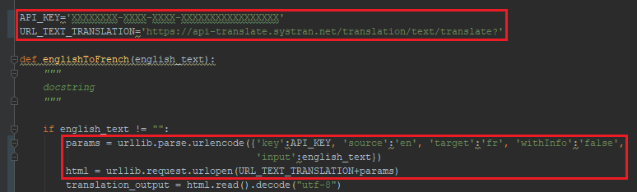

# Requirements:

* Python Version >= 3.6.0
* Flask v1.1.4

>> pip3 install flask==1.1.4

# Setup

## Configure API Key

From ‘…\simple-translation-web-app\server\machinetranslation\translator.py’ enter your API key:

# Testing

To ensure the translation code is performing as expected, you may run the following unit test from ‘…\simple-translation-web-app\server\machinetranslation’

>> python3 tests.py

Output the tests should complete successfully indicated by the ‘OK’ as can be seen below.

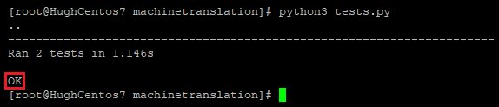

TRS Helper has been vigorously and rigorously tested using automated Unit and System tests, with Functional tests of all reporting capabilities performed in both a Windows, and CentOS 7 environment.

# Usage

## Start the web server

This will start the Flask server running on port ‘8081’

From ‘…\simple-translation-web-app\server\’

>> python3 server.py

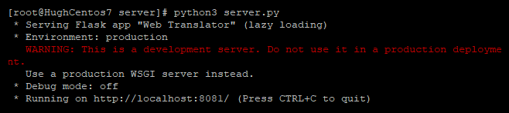

## Open a Web Page

Open a web browser to ‘localhost:8081’:

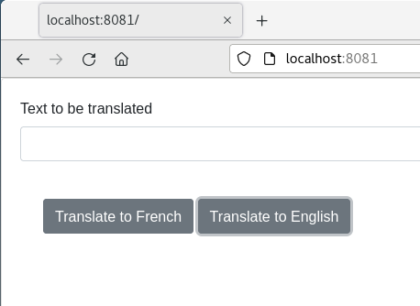

# Enter text to be translated

## English to French

## French to English

